SUBCOURSE EDITION
OD0475 8

PRINCIPLES OF HYDRAULICS – M1 TANK





US ARMY M1 ABRAMS TANK SYSTEMS MECHANIC

MOS/SKILL LEVEL: 63E30

PRINCIPLES OF HYDRAULICS - M1 TANK

SUBCOURSE NO. OD0475
EDITION 8
US Army Correspondence
Course Program

9 Credit Hours
NEW: 1988

GENERAL

The purpose of this subcourse is to introduce hydraulic principles and the components which will usually be found in most hydraulic systems.

With this information as a foundation, the identification, operation and function of M1 Abrams tank hydraulic system components will be discussed.

Nine credit hours are awarded for successful completion of this subcourse. This subcourse consists of two lessons with two to three tasks each and an examination.

Lesson 1: BASIC HYDRAULIC PRINCIPLES AND COMPONENTS

Task 1: Describe the basic principles of a hydraulic system.

Task 2: Identify typical components of a hydraulic system.

Task 3: Describe a hydraulic circuit diagram and identify hydraulic symbols.

Lesson 2: M1 SERIES TANK HYDRAULICS

TASK 1: Identify the major M1 series tank hydraulic system components.

Task 2: Explain the operation and purpose of the M1 series tank hydraulic system components.

i

PRINC. OF M1 HYDRAULICS - OD0475

TABLE OF CONTENTS

Section Page

TITLE i

TABLE OF CONTENTS ii

Lesson 1: BASIC HYDRAULIC PRINCIPLES AND
COMPONENTS 1

TASK 1: Describe the basic principles of a
hydraulic system 1

TASK 2: Identify typical components of a
hydraulic system 18

TASK 3: Describe a hydraulic circuit
diagram and identify hydraulic symbols 73

Practical Exercise 1 91

Answers to Practical Exercise 1 94

Lesson 2: M1 SERIES TANK HYDRAULICS 96

TASK 1: Identify the major M1 series tank
hydraulic system components 96

TASK 2: Explain the operation and purpose
of the M1 series tank hydraulic system
components 106

Practical Exercise 2 123

Answers to Practical Exercise 2 125

REFERENCES 126

ii

PRINC. OF M1 HYDRAULICS - OD0475 - LESSON 1/TASK 1

LESSON 1

BASIC HYDRAULIC PRINCIPLES
AND COMPONENTS

TASK 1. Describe the basic principles of a hydraulic system.

CONDITIONS

Within a self-study environment and given the subcourse text, without assistance.

STANDARDS

Within one hour

REFERENCES

No supplementary references are needed for this task.

1. Introduction

This subcourse has been designed to disseminate information and guidance to personnel responsible for the operation of military equipment using hydraulic power control systems and the specific hydraulic systems found within the M1 tank.

Lesson one' is concerned primarily with the principles of hydraulics and the operation of hydraulic equipment. Included will be general information describing the properties and characteristics of the fluids and types of pumps, motors, valves, and controls that control these hydraulic systems. Also included will be instructions regarding the functions of reservoirs, strainers, and filters.

Lesson two will center on identifying major M1 tank hydraulic systems and the operation and purpose of these hydraulic system components.
1

PRINC. OF M1 HYDRAULICS - OD0475 - LESSON 1/TASK 1

2. Basic Hydraulic Principles

Hydraulics is the science of transmitting force and/or motion through the medium of a confined liquid. In a hydraulic device, power is transmitted by pushing on a confined liquid.

Figure 1 shows a simple hydraulic device. The transfer of energy takes place because a quantity of liquid is subject to pressure. To operate liquid power systems, the operator should have a knowledge of the basic nature of liquids.
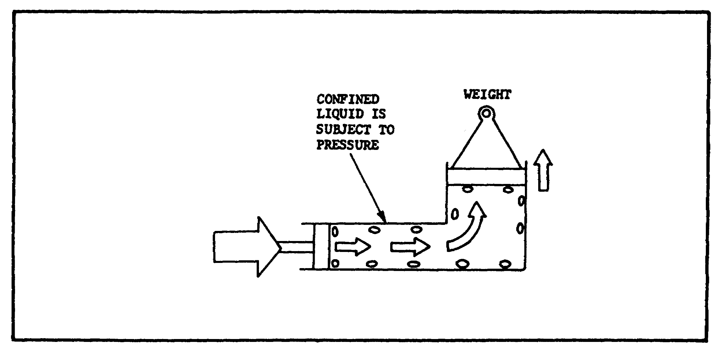

FIGURE 1. A BASIC HYDRAULIC DEVICE.

a. Force and Pressure.

(1) Pressure. Pressure is responsible for pushing, or exerting a force or torque. It is a term used to define how much force is exerted against a specific area. The technical definition of pressure is, in fact, force per unit area.

(a) Pressure can be said to be a tendency to expand (or a resistance to compression) that is present in a fluid which is being squeezed. A fluid, by definition, is any liquid or any gas (vapor). For example, the air that fills an automobile tire is a gas, and obeys the laws of fluids. When a tire is inflated, more air is squeezed into the tire than it easily holds. The air inside the tire resists the squeezing by pushing outward on the casing of the tire. The outward push of the air is pressure.

2

PRINC. OF M1 HYDRAULICS - OD0475 - LESSON 1/TASK 1

(b) Equal pressure throughout the area of confinement is a characteristic of any pressurized fluid, whether gas or liquid. For instance, in the tire example it is known that the outward push of the air is uniform throughout. If it were not, the tire would be pushed into odd shapes because of its elasticity. There is a major difference, however, between a gas and a liquid. Liquids are only very slightly compressible (see figure 2).

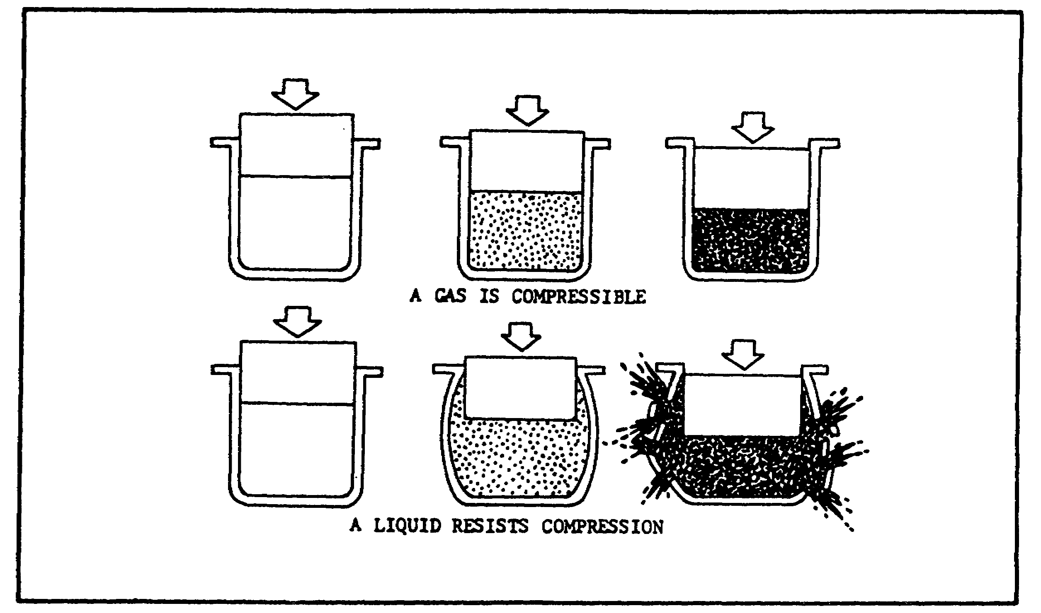
FIGURE 2. COMPRESSIBILITY OF GAS AND LIQUID.

(c) When a confined liquid is pushed on, there is a pressure build-up (figure 1, page 2). The pressure is still transmitted equally throughout the container. This behavior of a fluid is what makes it possible to transmit a push through pipes, around corners, up, down, and so on. In hydraulic systems, a liquid is used because its near-incompressibility (figure 2) makes the action instantaneous, as long as the system is full of liquid.

(d) It is fundamental that pressure can be created by squeezing or pushing on a confined fluid only if there is a resistance to flow. There are two ways to push on a fluid, either by the action of some sort of mechanical pump, or by the weight of the fluid itself.

3

PRINC. OF M1 HYDRAULICS - OD0475 - LESSON 1/TASK 1

1 The great pressure in the depths of the ocean is an example of pressure due entirely to the weight of a fluid. The pressure is due to the weight of the water and increases in proportion to the depth. Knowing the weight of a cubic foot of water, the pressure at any depth can be calculated exactly. Figure 3 shows a column of water one foot square and ten feet high. To determine the pressure at the bottom of the column, we calculate that since a cubic foot of water weights 62.4 pounds, and there are 10 cubic feet in this example, the total weight of the water is 624 pounds. At the bottom, this weight covers 144 square inches (the equivalent of one square foot). Each single square inch of the bottom is subject to 1/144 of the total weight, or 4.33 pounds. The pressure at this depth, therefore, is 4.33 pounds per square inch (psi).
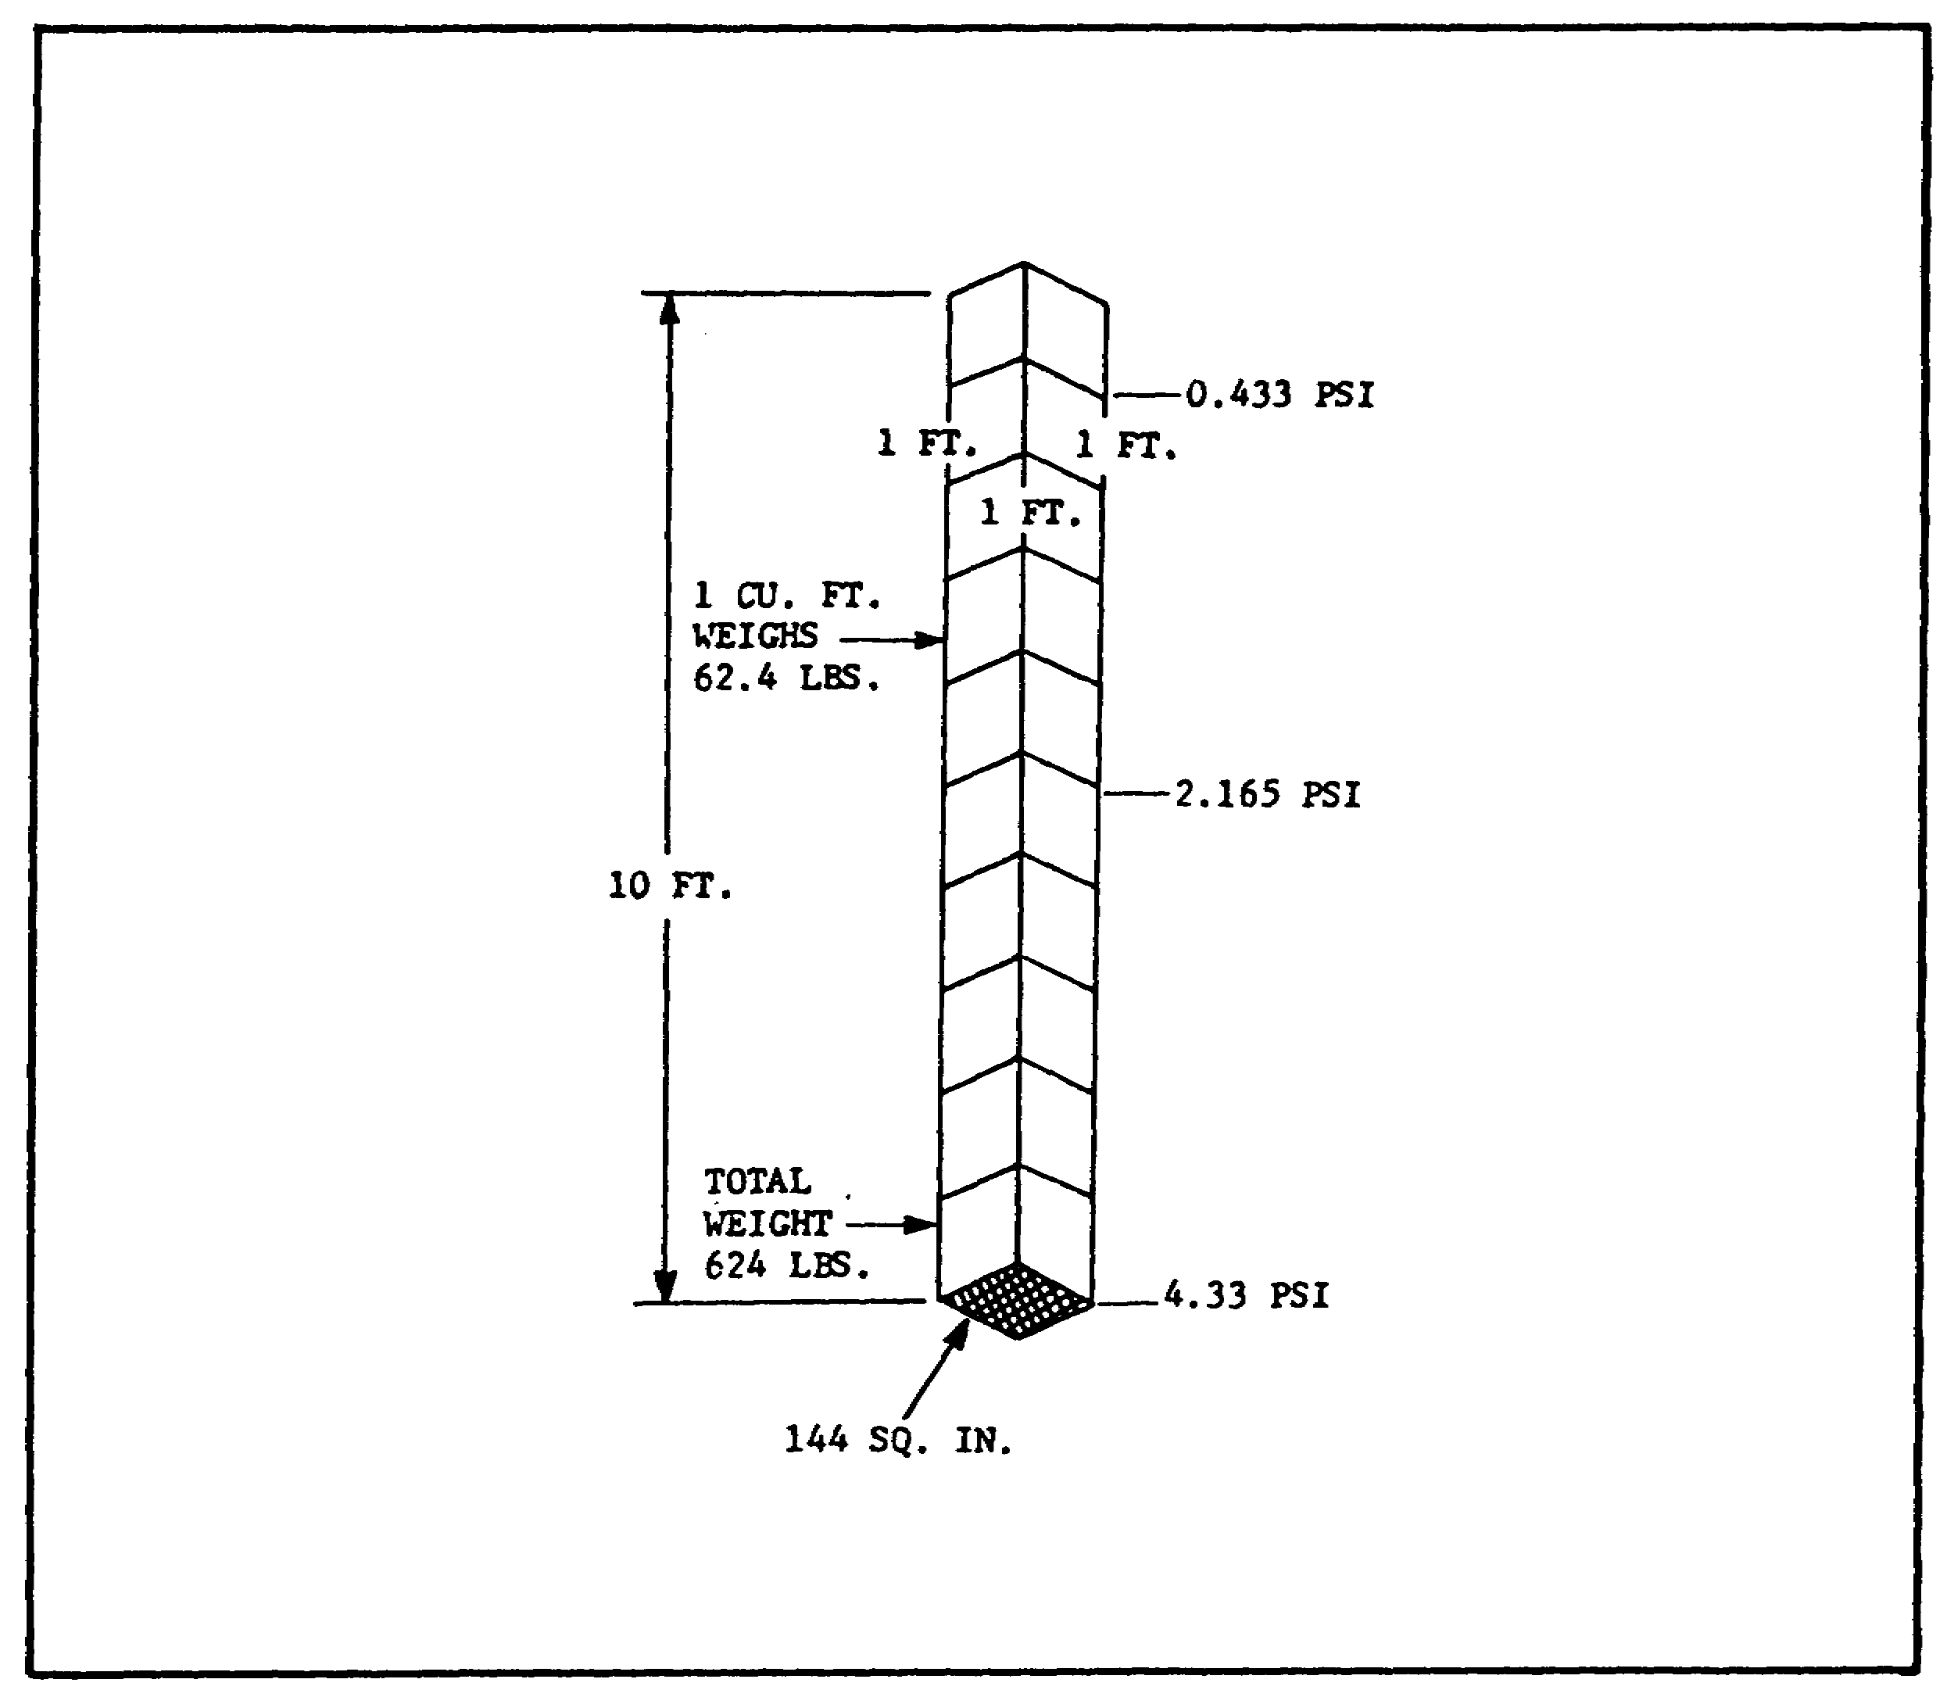

FIGURE 3. WATER COLUMN.

4

PRINC. OF M1 HYDRAULICS - OD0475 - LESSON 1/TASK 1

2 A similar pressure of 4.33 pounds per square inch (psi) can be applied to a liquid with a pump, as shown in figure 4. If the liquid is trapped under a piston which has an area of 10 square inches, and a weight is placed on the piston so that it pushes down with 43.3 pounds of force, the pressure is again 4.33 psi.
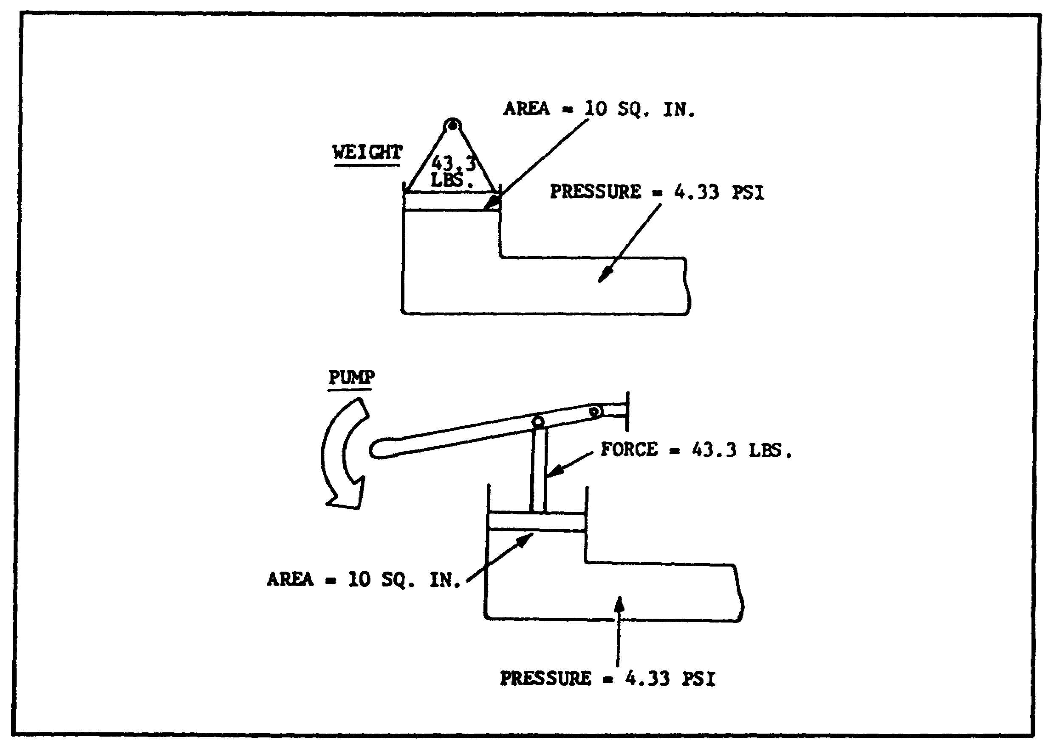

FIGURE 4. PUMP PRESSURE.

(2) Force. Force is anything which tends to produce or modify motion. It is a push or a pull, usually expressed in pounds. Weight (the force of gravity on an object) is one kind of force. The container in figure 4 could just as easily be turned on its side and pressure be expended on the piston with a spring or a crankshaft driven by an engine. In any case, a pressure is created in the liquid in proportion to the force.

(3) Head. Before the concept of pressure, "head" was the only way pressure could be measured. The scientist Torricelli proved, for instance, that if you punch a hole in the bottom of a tank, the

5

PRINC. OF M1 HYDRAULICS - OD0475 - LESSON 1/TASK 1

water runs out faster when the tank is full, and slows down as the level lowers.

(a) It is known now that this occurs because pressure at the bottom is highest when the tank is full, but decreases as the water level goes down. Torricelli knew only that there was a difference in "head", or in the height of the column of water. Head was thus a measure of pressure, but it could be expressed only as "feet of water".

(b) Today, a head is still defined as the vertical distance between two levels in a fluid. In figure 3, on page 4, the head between the top and bottom of the water is 10 feet. A 10 foot head of water is equivalent to 4.33 psi. Each foot of water thus is equivalent to 0.433 psi. A 5 foot head would be 2.165 psi, and so on.
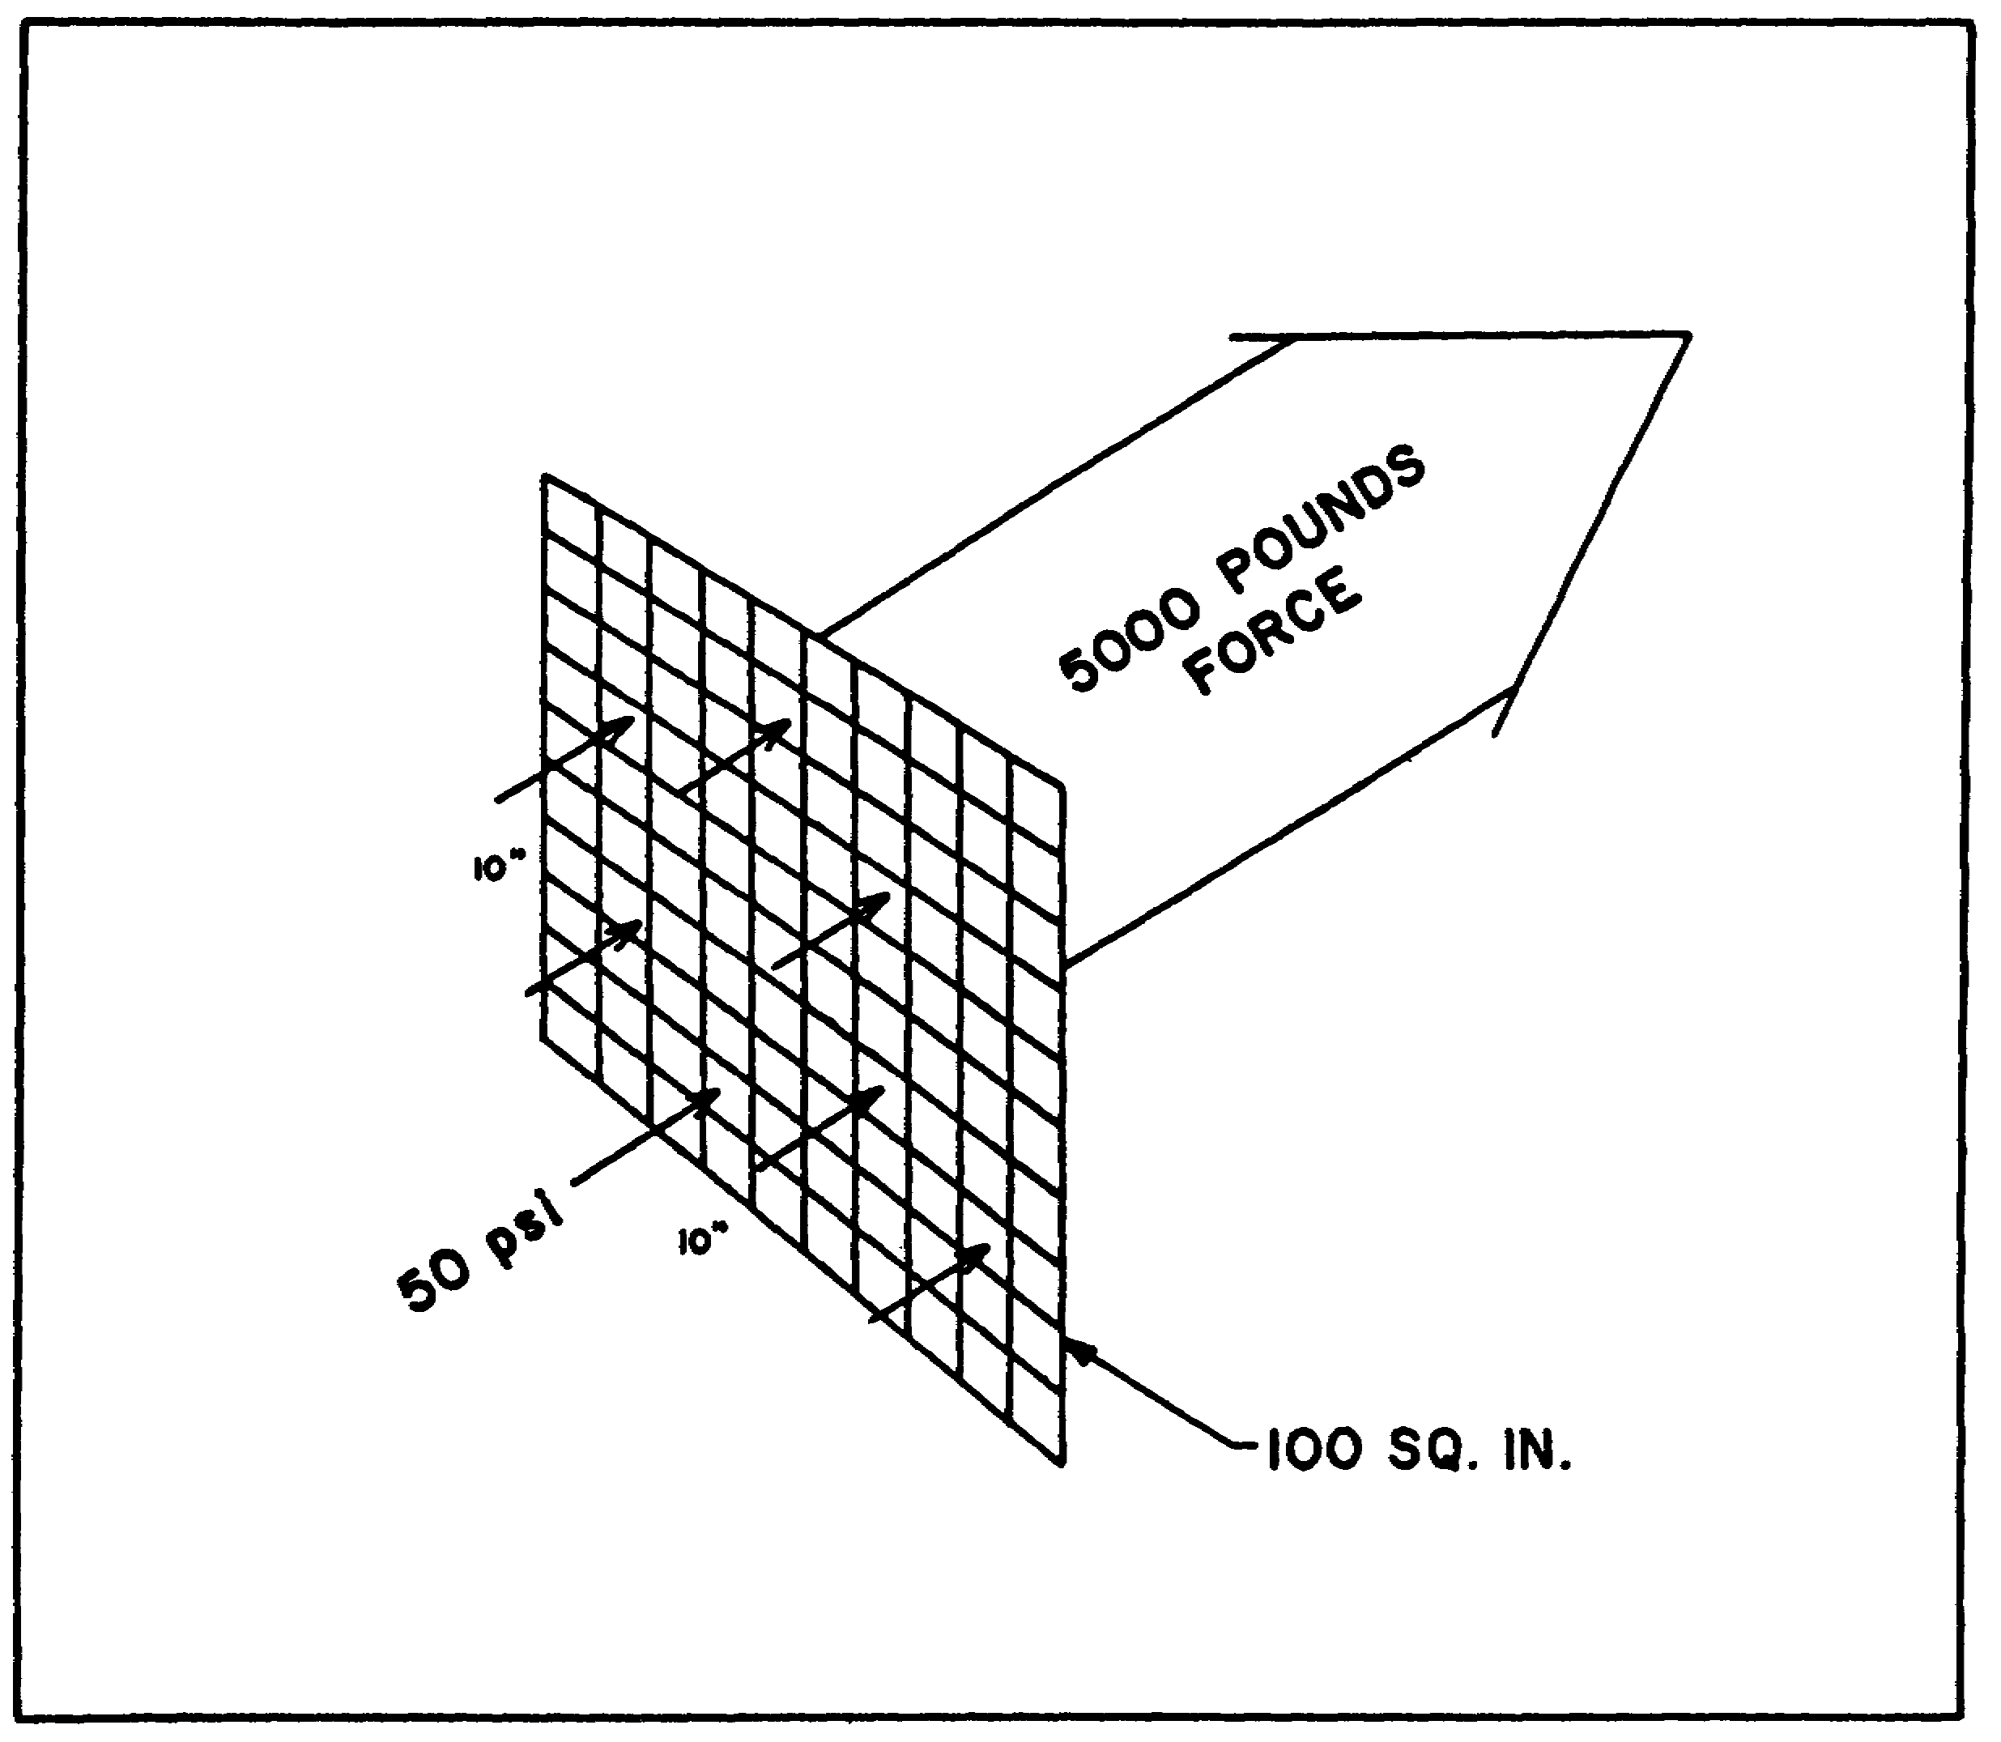

FIGURE 5. FORCE, PRESSURE, AND AREA.

6

PRINC. OF M1 HYDRAULICS - OD0475 - LESSON 1/TASK 1

(4) Relationship Between Force and Pressure. The relationship between force (F), pressure (P), and area (A) is expressed in the following mathematical formula:

F (pounds) = (psi) x A (square inches)

Figure 5, on the previous page, shows a pressure of 50 psi being applied to an area of 100 square inches. The total force on the area is therefore 5000 pounds.

(5) Atmospheric Pressure. The earth has an atmosphere of air, extending some 50 miles up; and this air has weight. This air then creates a head of pressure and this pressure, created by the earth's atmosphere, is called atmospheric pressure. A column of air one square inch in cross-section and the height of the atmosphere would weigh 14.7 pounds at sea level. Thus, the earth's atmospheric pressure is 14.7 psi at sea level. The role of atmospheric pressure in most hydraulic systems is significant. Figure 6 shows the interaction of hydraulic and atmospheric pressures under three sets of conditions.
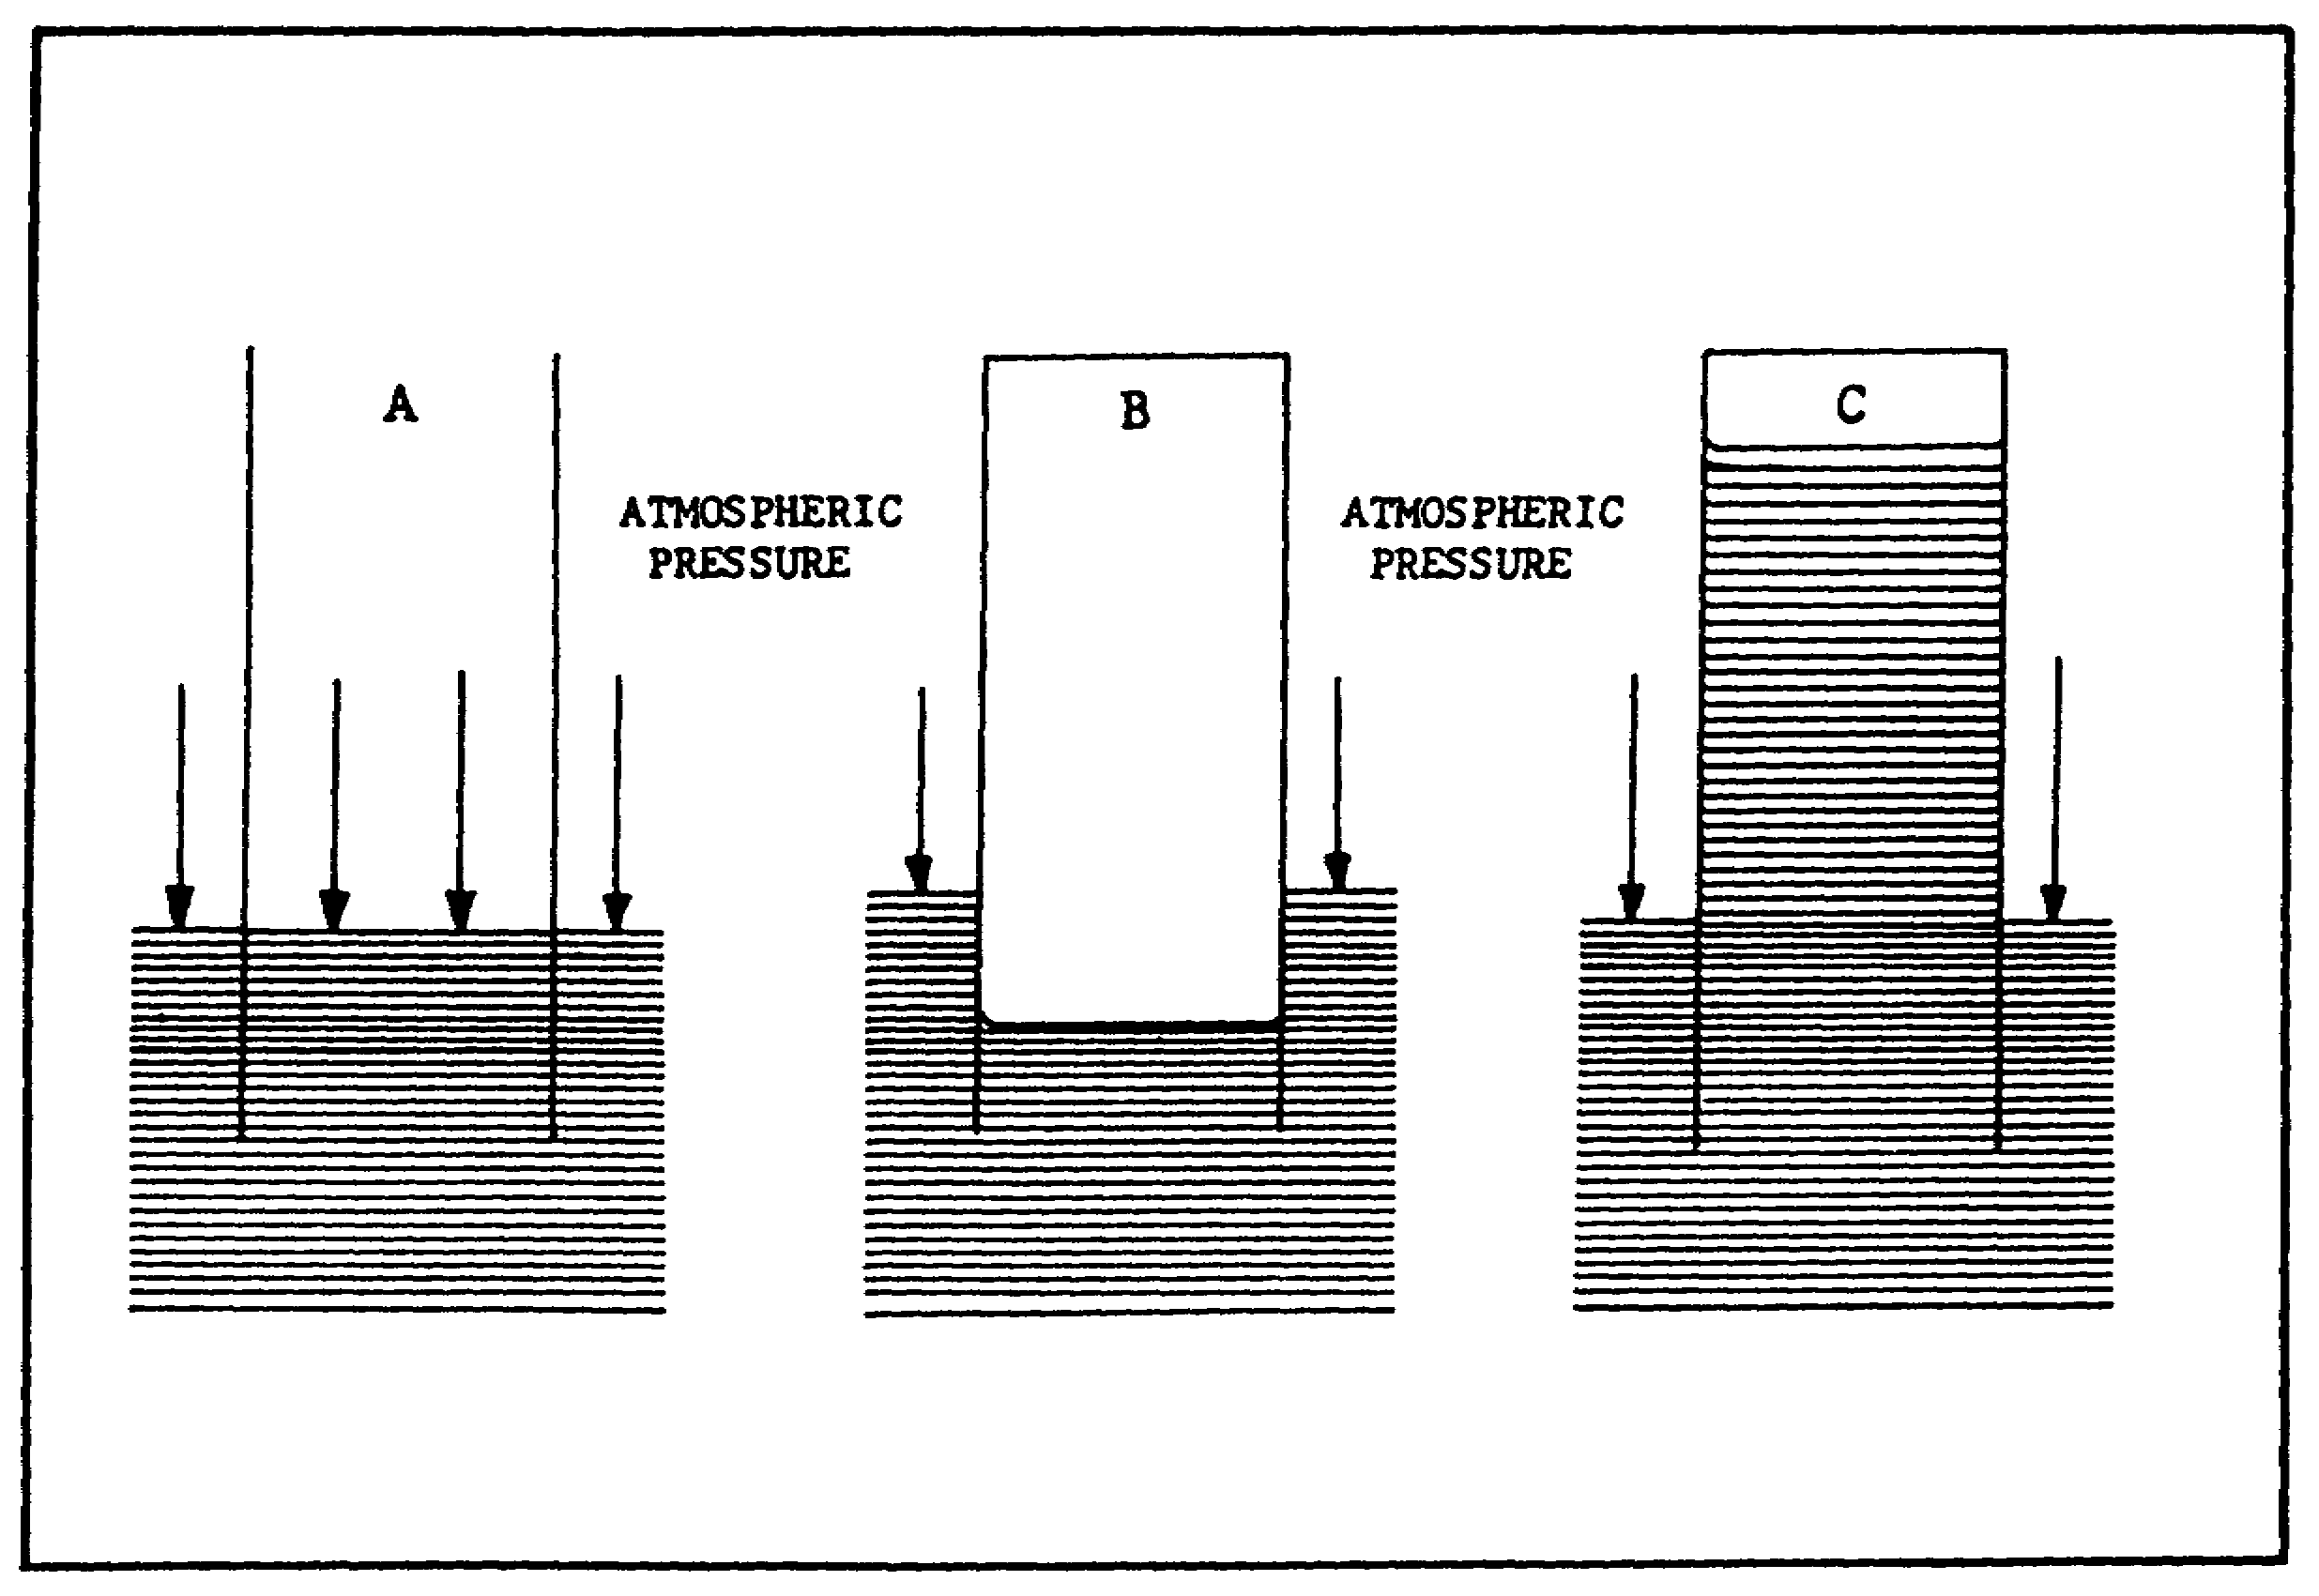

FIGURE 6. INTERACTION OF HYDRAULIC AND
ATMOSPHERIC PRESSURE.

7

PRINC. OF M1 HYDRAULICS - OD0475 - LESSON 1/TASK 1

(a) Tube A, in figure 6 on the previous page, is open at both ends. When placed in liquid, there is no effect on liquid level except to raise it in proportion to the amount of liquid displaced by the submerged tube wall.

(b) Tube B, in figure 6, is closed at its upper end. Placing this tube in a liquid forces the level of the liquid within the tube down because the air trapped in the tube must occupy space. Therefore, it displaces the liquid. The level outside the tube rises in proportion to the volume of the cylinder wall and the volume of trapped air below the original liquid level. The atmospheric pressure (14.7 psi) on the liquid outside the tube is not heavy enough to force the liquid inside the tube upward against the pressure of the trapped air, which is more than 14.7 psi.

(c) Tube C, in figure 6, is of the same construction as tube B, but some of the air has been removed so that the pressure within the tube is less than 14.7 psi, or a partial vacuum. (A perfect vacuum would exist if all pressure within the tube could be eliminated, a condition that is never attained). Because the liquid outside tube C is subject to full atmospheric pressure, liquid is forced upward into the tube to fill the vacuum. How far the liquid rises depends upon the difference in air pressure between the trapped air and the atmosphere.

b. Pascal's Law. The basic law of today's hydraulics was formulated in the middle of the 17th century. Blaise Pascal discovered that pressure exerted on a fluid acts equally in all directions.

(1) Principle. More exactly, Pascal's Law states that pressure in a confined fluid is transmitted undiminished in every direction, acts with equal force on equal areas, and at right angles to the container walls.

(a) It is known that pressure is force per unit area, expressed as psi. Force is also a push or pull, measured in pounds.

(b) In figure 4, on page 5, a force is applied to a confined fluid, through a piston. The resulting pressure in the fluid, by Pascal's Law, is equal throughout; and every square inch of the container

8

PRINC. OF M1 HYDRAULICS - OD0475 - LESSON 1/TASK 1

wall is subject to an equal force because of the pressure.

(2) Illustration of Pascal's Law.

(a) The apparatus Pascal used to develop his law consisted of two cylinders of different diameters, connected as shown in figure 7, with a liquid trapped between them. He might have called this apparatus the hydraulic lever, since it proved that leverage can be gained hydraulically as well as mechanically. Pascal found that a small weight on a small piston will balance a larger weight on a larger piston, provided that the piston areas are in proportion to the weights.

(b) Thus, in figure 7, a force of 100 pounds on a one square inch piston causes a pressure of 100 psi to be created in the cylinder. According to Pascal's Law, this pressure is transmitted undiminished in every direction. In the larger cylinder, a pressure of 100 psi is transmitted to an

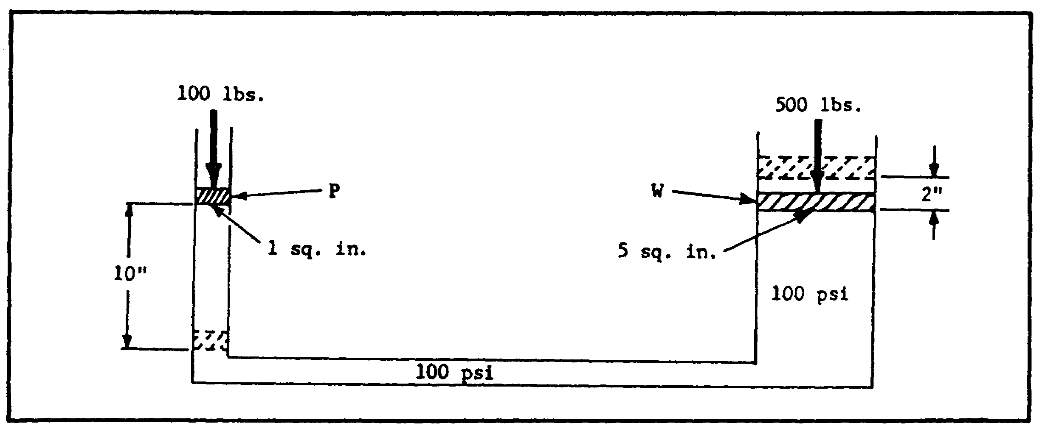
FIGURE 7. PASCAL'S LAW APPARATUS.

area of 5 square inches. The resulting force on the second piston is 500 pounds. Thus the force has been multiplied 5 times; in other words, a mechanical advantage of 5 to 1 has been obtained.

c. Mechanics of Liquids.

(1) Mechanical Advantage Provided by a Lever. Figure 8, on the following page, shows a simple machine, called a lever. There are 5 feet on one side of the fulcrum and 1 foot on the other; this allows a mechanical advantage of 5 to 1.

9

PRINC. OF M1 HYDRAULICS - OD0475 - LESSON 1/TASK 1

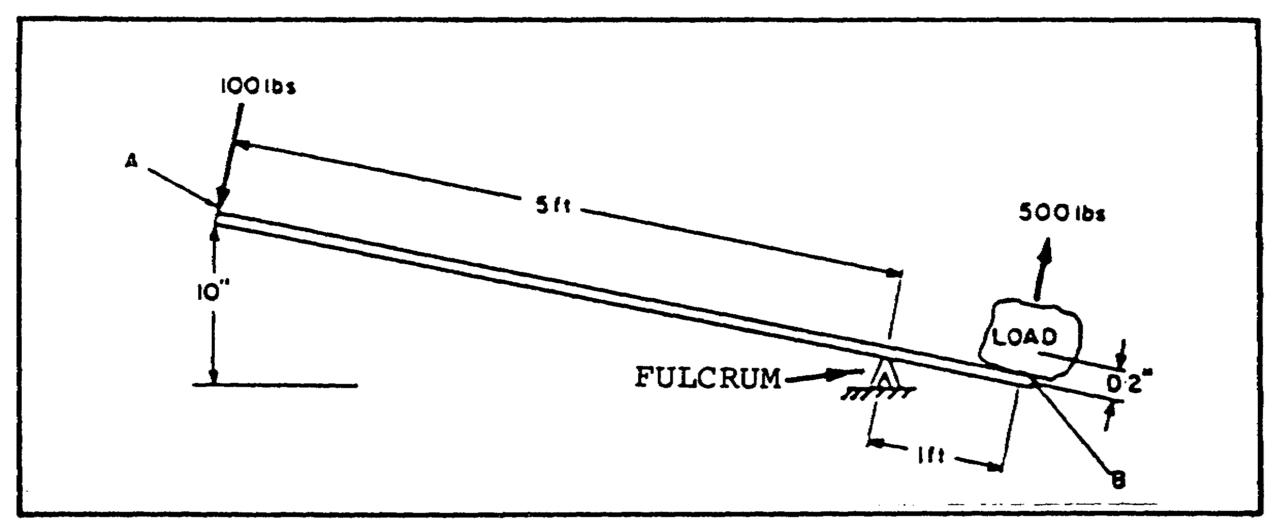
FIGURE 8. MECHANICAL ADVANTAGE.

The turning effort, or torque, produced by the 100 pound force acting on the 5 foot end must equal the turning effort on the 1 foot end. Therefore, 100 x 5 = F x 1 = 500 pounds. In this case, force has been multiplied but, because no more work can be gained from a machine than is put into it, distance must be sacrificed to pay for the increase in force. Recalling that work equals force times distance, if the 5 foot end is moved down 10 inches, the 1 foot end will raise the load only 2 inches:
500 x D = 100 x 10

500 x D 1000
------- ----
500 500

D = 1000
----
500

D = 2

(2) Mechanical Advantage Provided by Liquids. Applying the principles described to the hydraulic system in figure 7, on the previous page, there is a 100 pound force against a piston of 1 square inch area. Therefore, a pressure of 100 psi is transmitted throughout the liquid. This pressure, acting against the 5 square inch piston, will develop a force of 5 x 100 or 500 pounds exerted by the larger piston. Again, if the small piston is moved down 10 inches, the larger piston will move

10

PRINC. OF M1 HYDRAULICS - OD0475 - LESSON 1/TASK 1

up a distance of only 2 inches, which is illustrated in the simplified equation below:

500 x D = 10 x 100

1,000
D = ----- = 2 inches
500
d. Flow.

(1) Definition. Flow is the movement of the hydraulic fluid caused by a difference in pressure at two points. In a hydraulic system it is usually produced by the action of a hydraulic pump, a device used to continuously push on the hydraulic fluid.

(2) Measurement of Flow. There are two ways of measuring flow; velocity and flow rate.

(a) Velocity. Velocity of the fluid is the average speed of its particles past a given point. It is usually measured in feet per second (fps). Velocity is an important consideration in sizing the hydraulic lines that carry the fluid between components.

(b) Flow Rate. Flow rate is the measure of volume of the liquid passing a point in a given time. It is usually measured in gallons per minute (gpm). Flow rate determines the speed at which the load moves and, therefore, is important to the consideration of power.

(c) The difference between velocity and flow rate can be visualized by comparing them to the speedometer and odometer of a car. The velocity or rate of motion is similar to the speedometer; the needle indicates speed in miles per hour. The flow rate is similar to the odometer; the meter indicates total miles traveled.

Velocity measures how fast something is going by, flow rate measures how many of them are going by.

e. Characteristics of Flow.

(1) Static and Dynamic Factors.

11

PRINC. OF M1 HYDRAULICS - OD0475 - LESSON 1/TASK 1

(a) In addition to the characteristics of a static liquid, power hydraulics must consider the dynamic factors. Dynamic forces are present when the liquid is in motion.

(b) Energy is the ability to do work. It may be grouped into three forms: potential energy, kinetic energy, and heat energy.

(c) Potential Energy. Potential energy is energy due to position. An object has potential energy in proportion to its vertical distance above the earth's surface. Take the example of a body of water held back by a dam. The water in the dam represents potential energy because it is not doing work at the moment, but it is capable of doing work whenever it is released. In hydraulics, potential energy is a static factor.

(d) Kinetic Energy. Kinetic energy is the energy a body possesses because of its motion. The greater the speed, the greater the kinetic energy. In the above-mentioned example of the water held by the dam, if an opening in the dam is provided, the water will rush out in a high velocity jet, representing energy of motion, or kinetic energy.

(e) Heat Energy. Heat energy is the energy a body possesses because of its heat. Both kinetic energy and heat energy are dynamic factors.

(2) Static Pressure v. Heat Energy.

(a) Because it dealt with static pressures, Pascal's Law ignored the factor of friction. Friction is the resistance to relative motion between two bodies. When liquid flows in a hydraulic circuit, the friction present produces heat. This causes some of the kinetic energy to be lost in the form of heat energy.

(b) Although friction cannot be entirely eliminated, it can be controlled to some extent. The three main causes of excessive friction in hydraulic systems are:

1 Excessive length of lines.

2 Excessive number of bends and fittings, or improper bends.

12

PRINC. OF M1 HYDRAULICS - OD0475 - LESSON 1/TASK 1

3 Excessive velocity (lines undersized).

(c) In a liquid flowing through straight piping at a low speed, the particles of the liquid move in straight lines parallel to the direction of flow. Heat loss from friction is then minimized. This kind of flow is called "laminar" flow. An example of laminar flow is shown in A of figure 9, which illustrates an open stream flowing at a slow, uniform rate with logs floating on its surface. The logs represent particles of liquid.
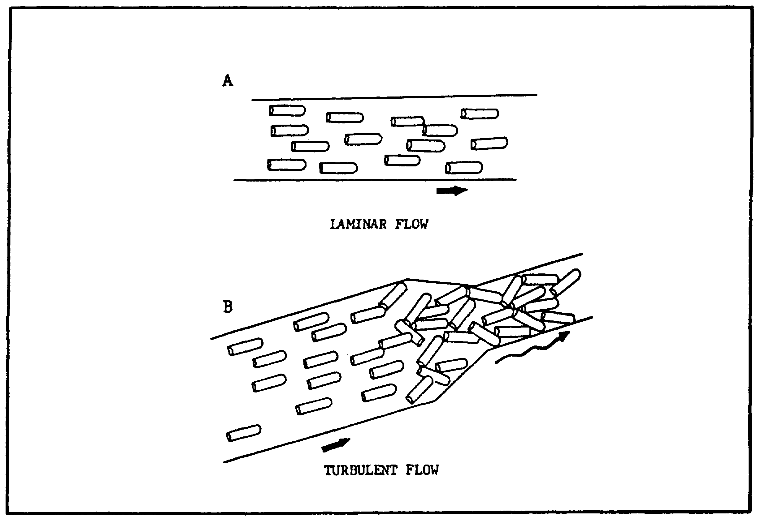

FIGURE 9. LAMINAR AND TURBULENT FLOW.

(d) If the speed is increased beyond a given point, "turbulent" flow develops. To illustrate this again in terms of the open stream, B of figure 9 shows the logs thrown against each other and against the banks of the stream.

(e) Pressure drop due to friction is shown as a difference in head in figure 10. Since there is no resistance to flow at point B (this is called "free flow" condition), the pressure there is zero. Pressure at point C is maximum because of the head at A. As the liquid flows from C to B, friction causes a pressure drop from maximum pressure to

13

PRINC. OF M1 HYDRAULICS - OD0475 - LESSON 1/TASK 1

zero pressure. This is reflected in a successively decreased head at D, E, and F.
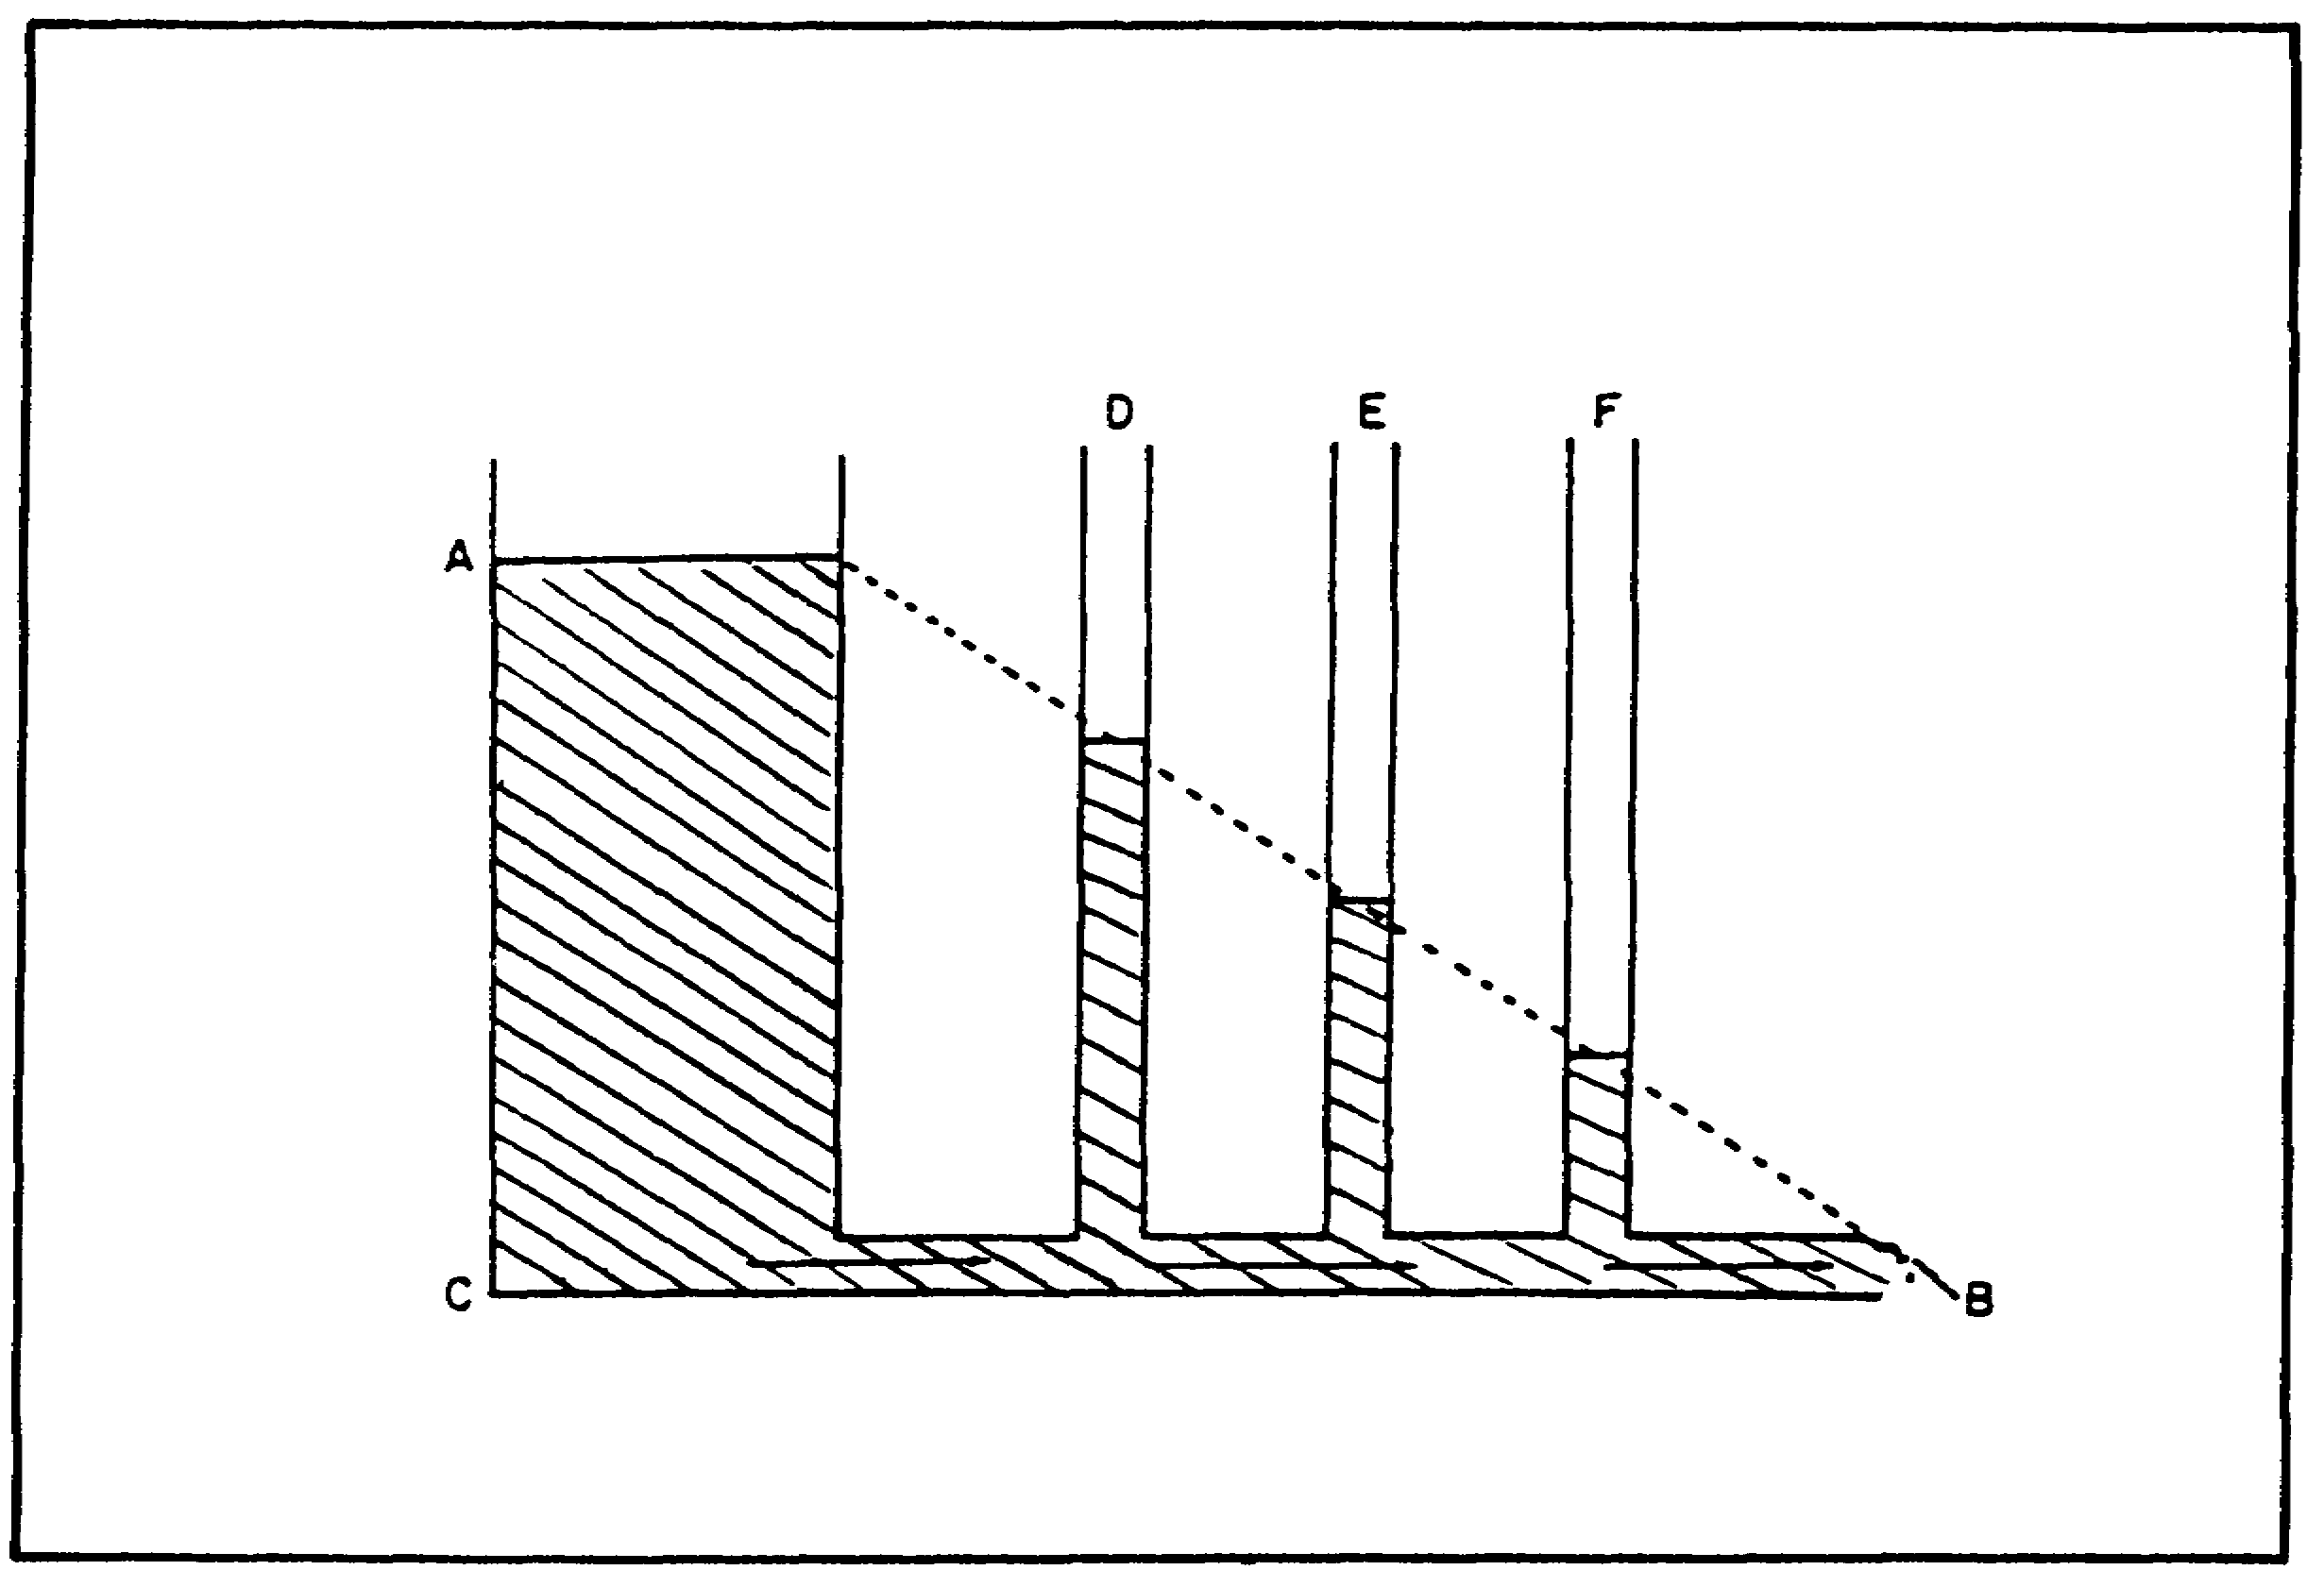

FIGURE 10. EFFECT OF FRICTION ON PRESSURE.

(3) Potential Energy v. Kinetic Energy.

(a) When force is applied to a confined liquid as shown in figure 4, on page 5, potential energy is present because of the static pressure of the liquid.

(b) It has been pointed out that the potential energy of a moving liquid can be reduced by the heat energy released. Potential energy may also be reduced in moving liquid by a transformation of this energy into kinetic energy. A moving liquid can, therefore, perform work as a result both of its static pressure and its momentum.

(c) The amount of kinetic energy in a moving liquid is directly proportional to the square of its velocity. Pressure caused by kinetic energy may be called "velocity pressure."

14

PRINC. OF M1 HYDRAULICS - OD0475 - LESSON 1/TASK 1

(4) Relationship Between Velocity and Pressure.

(a) Figure 11 is an illustration of the relationship between velocity and pressure. Assume that the force on piston X is sufficient to create a pressure of 100 psi on chamber A, and piston X is moving downward. All the liquid being forced out of chamber A must pass through passage C to reach chamber B. The velocity increases as it passes through C because the same quantity of liquid must pass through a narrower area in the same time period. Some of the 100 psi static pressure in chamber A is converted into velocity energy in passage C, so that a pressure gage at this point registers 90 psi.
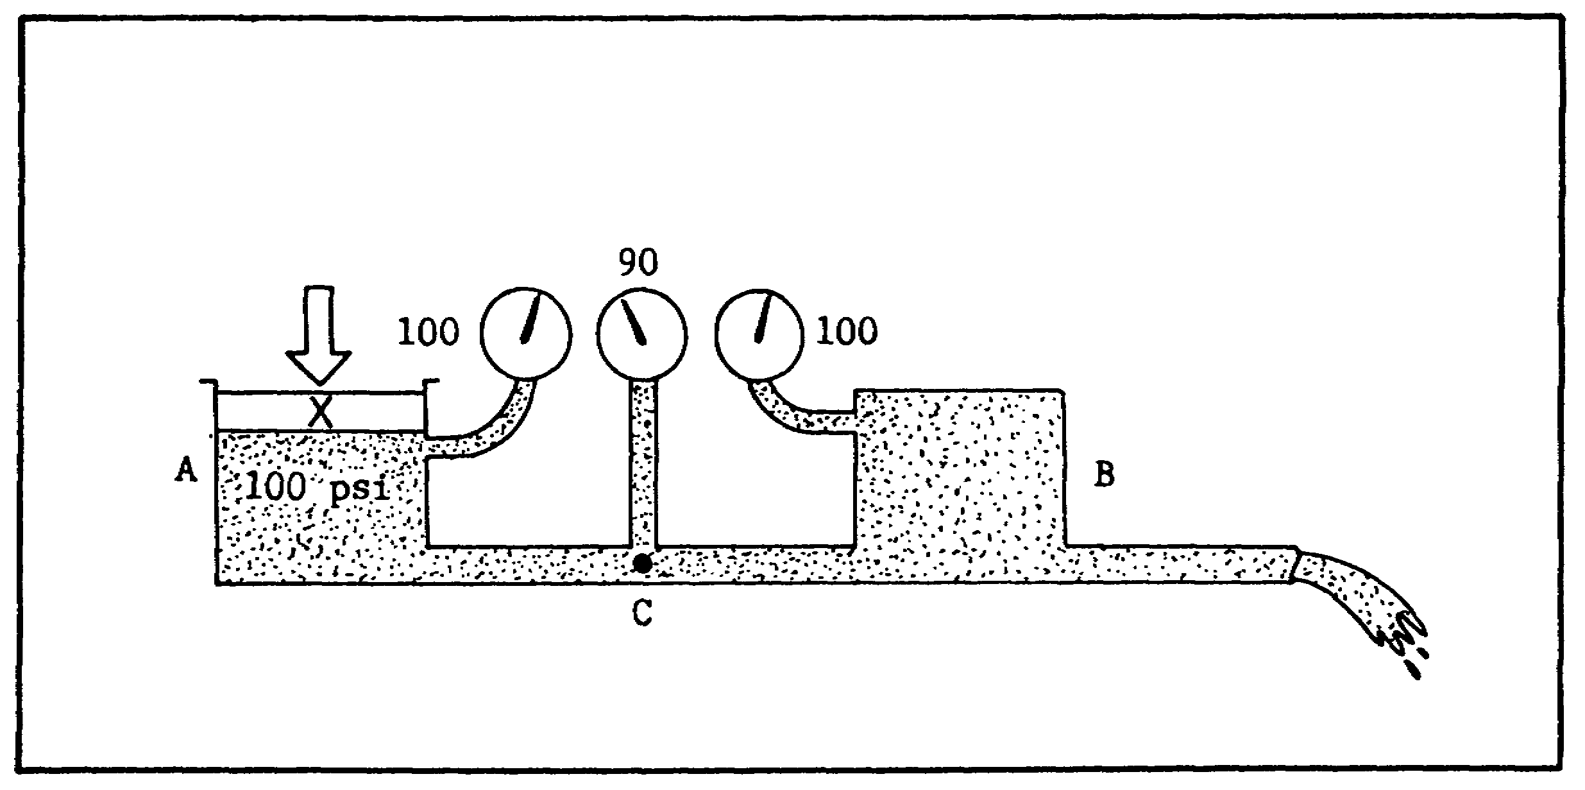

FIGURE 11. BERNOUILLI'S PRINCIPLE.

As the liquid passes through C and reaches chamber B, velocity decreases to its former rate and some of the kinetic energy is converted to potential energy. This is indicated by a static pressure reading of 100 psi on the gage. This action is summed up in Bernouilli's principle: the static pressure of a moving liquid varies inversely with its velocity; that is, as velocity increases, static pressure decreases.

(b) Figure 12, on the following page, shows the combined effects of friction and velocity changes. As in figure 10, pressure drops from maximum at C to zero at B. At D, velocity is increased, so the pressure head decreases. At E, the head increases as most of the kinetic energy is given up to

15

PRINC. OF M1 HYDRAULICS - OD0475 - LESSON 1/TASK 1

pressure energy, because velocity is decreased. Again, at F, the head drops as velocity increases.
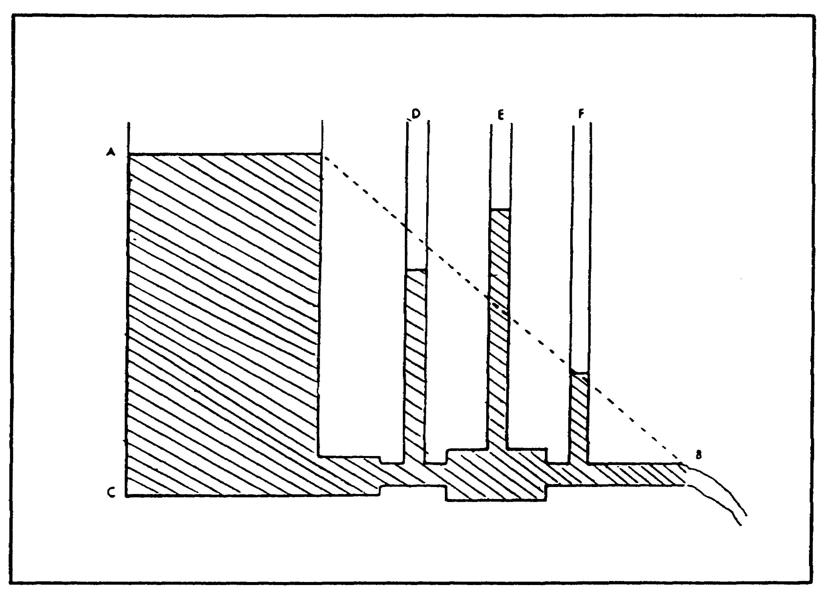

FIGURE 12. EFFECTS OF FRICTION AND VELOCITY
ON PRESSURE.

f. Work, Energy, and Power. Earlier in this task, the concepts of force, pressure, and flow were developed as a measure of effort. These fundamental conditions or phenomena will now be related to the principles of work, energy, and power.

(1) Work. Work is a measure of accomplishment. It requires motion to make a force do work. Therefore, to do work in a hydraulic system, there must be flow. Work is best defined as exerting a force over a definite distance; it is, therefore, a measure of force multiplied by distance. It is usually expressed in foot-pounds (ft-lbs).

(2) Energy. Energy is the capacity to do work, and is expressed in the same units as work.

(3) Power. Power is the rate of doing work, or the rate of energy transfer. The standard unit of power is horsepower. One horsepower (hp) is the

16

PRINC. OF M1 HYDRAULICS - OD0475 - LESSON 1/TASK 1

equivalent of doing 550 foot-pounds of work every second.

g. Typical Components.

(1) Reservoir. The purpose of a reservoir is to store the liquid while it is not actually being used ii. the system. The reservoir also affords an excellent place to expel gases and settle out foreign matter from the liquid.

(2) Filter. Filters are designed to remove foreign particles from the hydraulic fluid and are most effective as safeguards against contamination.

(3) Strainers. Strainers are used in hydraulic systems as a primary filtration system. While they do not provide so fine a screening action as do filters, strainers offer less resistance to flow.

(4) Pumps. Pumps are devices for converting mechanical energy into hydraulic energy.

(5) Relief Valves. Each system is provided with a relief valve, between the pump discharge and related components, to protect the hydraulic system from excessive pressure.

(6) Control Valves. Control valves are generally used to control the direction of fluid flow in hydraulic circuit.

(7) Cylinders. The purpose of cylinders is to apply force and motion to the load to be moved.

(8) Connectors. Connectors are used to direct the flow of liquid to the various components that make up a hydraulic circuit. They may be classified as piping, tubing, and flexible hosing.

3. Conclusion

In this task, we centered on the principles of hydraulics including a discussion that described the properties and characteristics of fluids. In the next task, we will discuss the types of pumps, motors, and valves that control hydraulic systems.

17

PRINC. OF M1 HYDRAULICS - OD0475 - LESSON 1/TASK 2

LESSON 1

BASIC HYDRAULIC PRINCIPLES
AND COMPONENTS

TASK 2. Identify typical components of a hydraulic system.

CONDITIONS

Within a self-study environment and given the subcourse text, without assistance.

STANDARDS

Within two hours

REFERENCES

No supplementary references are needed for this task.

1. Introduction

In the previous task, a hydraulic system was defined as a system designed to contain and confine a liquid in such a manner that it utilizes the laws governing liquids to transmit power and do work. Figures 13 and 14, on pages 20 and 21, show two common types of hydraulic power control systems. In this task, the typical components which comprise a hydraulic system will be discussed.

2. Simple Hydraulic Systems

a. Hydraulic Jack (figure 13). In this system, a reservoir and a system of valves has been added to Pascal's hydraulic lever (figure 7 on page 9) to permit stroking the small cylinder or pump continuously and raising the larger piston or actuator a notch with each stroke. The top view shows the intake stroke. The outlet check valve is closed by pressure under the load, and the inlet

18

PRINC. OF M1 HYDRAULICS - OD0475 - LESSON 1/TASK 2

check valve opens to allow liquid from the reservoir to fill the pumping chamber.
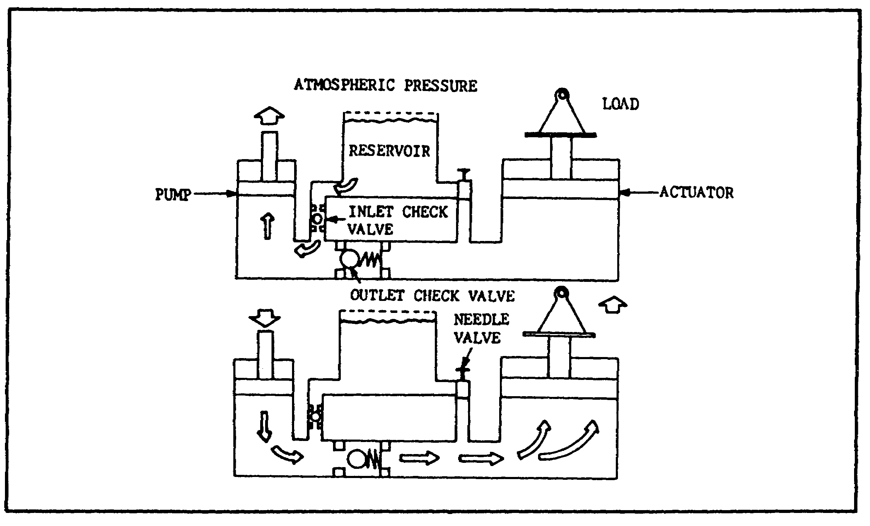
FIGURE 13. HYDRAULIC JACK.

In the bottom view, the pump is stroked downward. The inlet check valve is closed by pressure and the outlet valve opens. Another "slug" of liquid is pumped under the large piston to raise it. To lower the load, a third valve (needle valve) is opened, which opens the area under the large piston to the reservoir. The load then pushes the piston down and forces the liquid into the reservoir.

b. Motor Reversing System. In figure 14 on the following page, a power-driven pump operates a reversible rotary motor. A reversing valve directs fluid to either side of the motor and back to the reservoir. A relief valve protects the system against excess pressure, and can bypass pump output to the reservoir if pressure rises too high.

3. Hydraulic System Components

a. Reservoirs.

(1) Construction. A properly constructed reservoir is more than just a tank to hold the oil until the pump demands fluid. Whenever practical, it should also be capable of:

19

PRINC. OF M1 HYDRAULICS - OD0475 - LESSON 1/TASK 2

(a) Dissipating heat from the oil.

(b) Separating air from the oil.

(c) Settling out contamination in the oil.
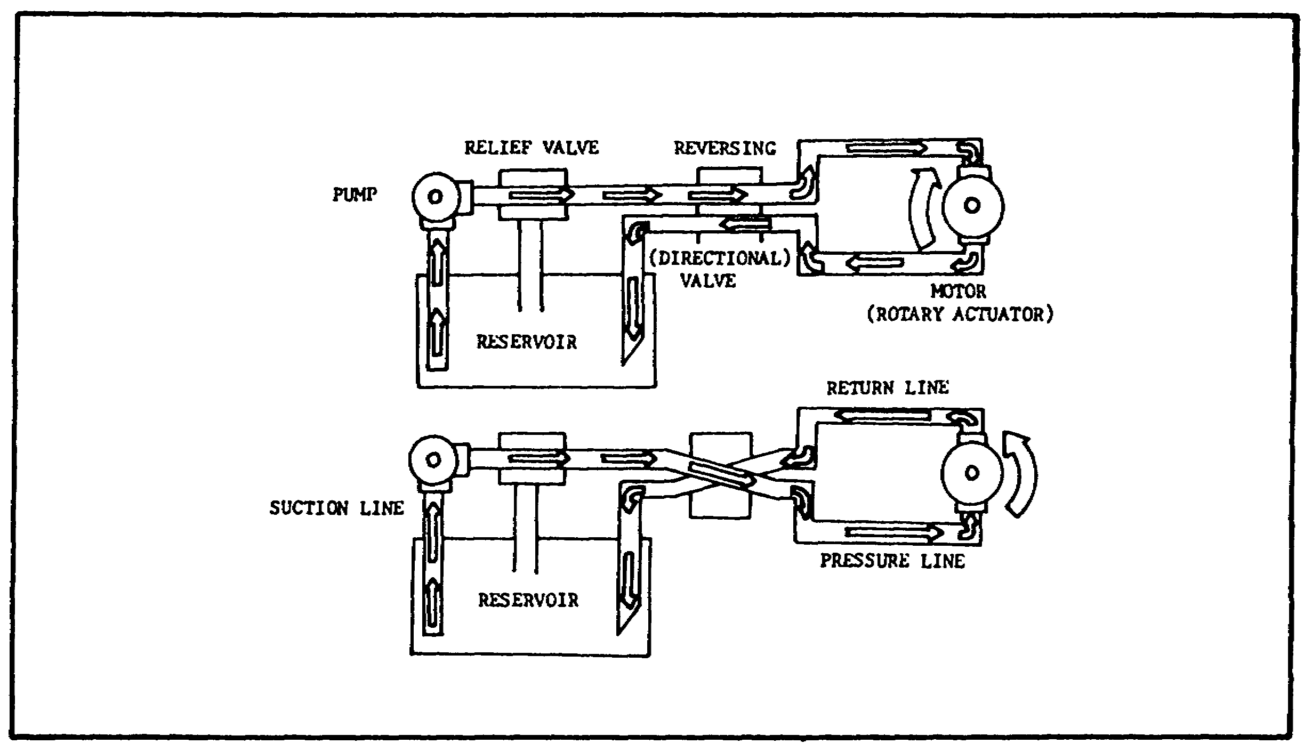

FIGURE 14. MOTOR REVERSING SYSTEM.

(2) Figure 15, on the following page, shows some of the design features of a reservoir. Ideally, it should be high and narrow, rather than shallow and broad. The oil level should be as high as possible above the opening to the pump suction line. This prevents the vacuum at the line opening from causing a vortex or whirlpool effect. Any time a whirlpool is seen at the suction line opening, the system is probably taking in air. Aerated oil can't do a proper job of transmitting power, because the air is compressible. Further, aerated oil has a tendency to break down and lose its lubricating ability.

(3) Size.

(a) For a long time, there has been a "rule of thumb" that reservoir capacity should be sized two to three times the pump output per minute. By this rule, which works well for stationary machinery, a 10 gallon per minute (gpm) system would call for a 20 or 30 gallon tank. This seldom happens on a

20

PRINC. OF M1 HYDRAULICS - OD0475 - LESSON 1/TASK 2
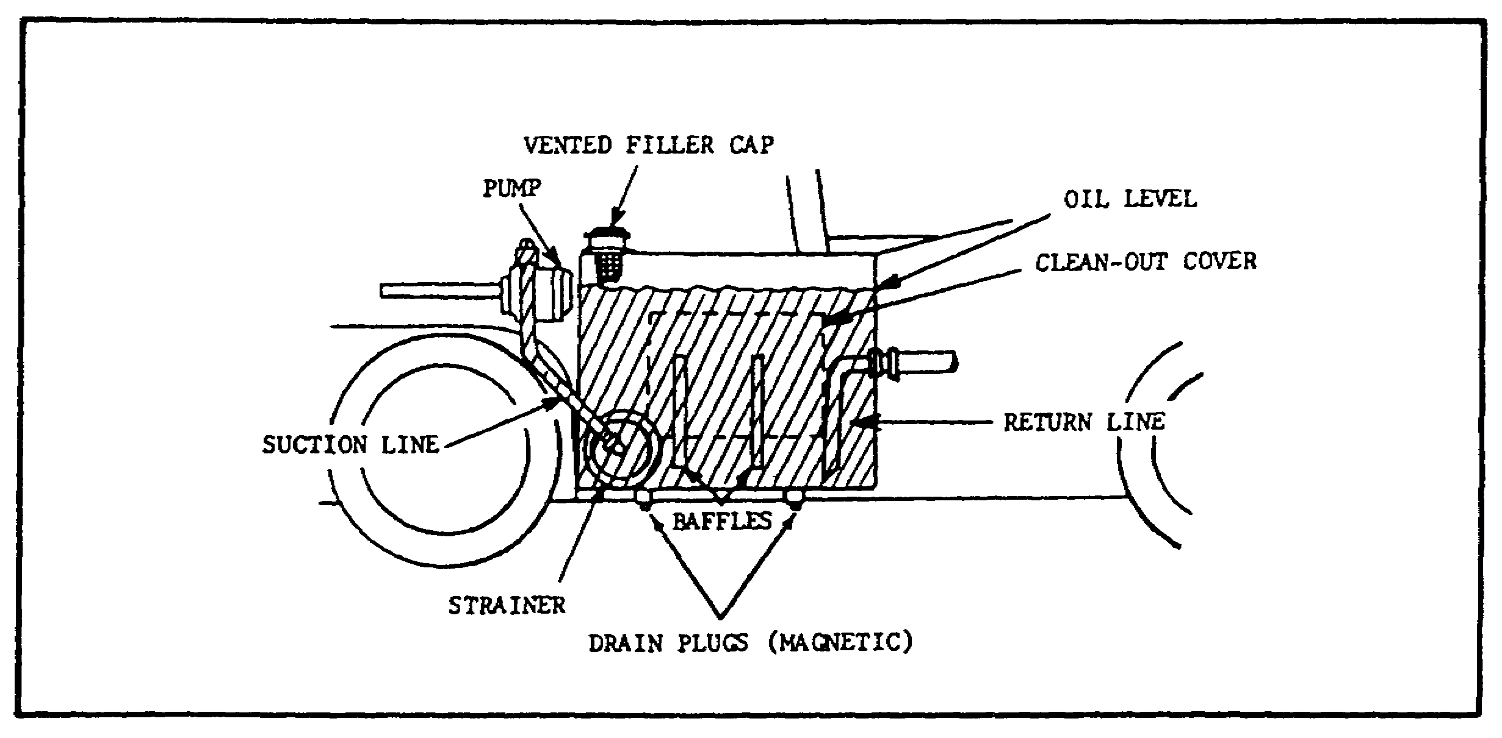

FIGURE 15. RESERVOIR.

mobile machine. It is more likely to find a 20 to 30 gallon tank used with a 100 gpm system. Many 10 gpm systems are operating with two or three gallon tanks. This is possible because mobile systems operate intermittently rather than constantly. The largest reservoirs on mobile equipment are found on road machinery. They may have 40 to 50 gallon capacity to handle more than 200 gpm.

(b) A large size tank is highly desirable for cooling. Large surface areas exposed to the outside air transfer heat from the oil. A large tank, by reducing recirculation, also helps to settle out contamination and separate air.

(c) The reservoir must be sized so that there is a reserve of oil with all the cylinders in the system fully extended. The reserve must be high enough to prevent a vortex at the suction line opening. Also, there must be enough space to hold all the oil when the cylinders are retracted, with some space to spare to allow for expansion when the oil is hot.

(4) Baffles. A baffle plate is desirable to separate the suction line from the return line. This will cause the return oil to circulate around the outer wall for cooling before it can get to the pump again. The baffle plate should be about 2/3 the height of the tank. The lower corners are diagonally cut to allow circulation. The cuts must be larger in area than the suction line cross-section, otherwise there might be an unequal level

21

PRINC. OF M1 HYDRAULICS - OD0475 - LESSON 1/TASK 2

of oil between the return and suction side. Baffling also prevents the oil from sloshing around when the machine is moving. Many large reservoirs are cross-baffled to prevent sloshing.

(5) Vented and Pressurized.

(a) Most reservoirs are vented to the atmosphere. A vent opening is provided to allow air to leave or enter the space above the oil as the level of the oil goes up or down. This maintains a constant atmospheric pressure above the oil. The reservoir filter cap is often used as the vent; it is protected with a filter element to keep dirt from entering with the air.

(b) Some reservoirs are pressurized rather than vented. A typical pressurized reservoir will use a simple pressure control valve in place of a vent. The valve automatically lets filtered air into the tank but prevents its release, unless the pressure reaches a preset level. Pressurization takes place when the oil and air in the tank expand from heat. Some reservoirs are pressurized by the air compressor on the vehicle.

b. Strainers and Filters.

(1) Keep Hydraulic Liquids Clean.

(a) To ensure long and trouble-free performance of hydraulic components, it is important to keep the hydraulic liquid clean. Although great care may be taken in servicing, maintaining, and operating hydraulic systems, it is impossible to prevent some foreign matter from entering the system. Also, tiny particles of metal are left in the liquid during normal wear of valves, pumps, and other components. Strainers, filters, and magnetic plugs are used to remove foreign particles from hydraulic liquid and are effective as safeguards against contamination.

(b) Magnetic plugs are used to remove iron or steel particles from the liquid. They are located in the reservoir to trap these particles by attraction.

(c) Because they share a common function, the terms "strainer" and "filter" are sometimes used as if they had the same meaning. However, devices used to remove large particles of foreign matter

22

PRINC. OF M1 HYDRAULICS - OD0475 - LESSON 1/TASK 2

from hydraulic liquids are normally referred to as strainers; those used to remove the smallest particles are called filters.

(2) Strainers.

(a) Strainers usually consist of a metal frame wrapped with a fine mesh wire screen, or a screening element made up of varying thickness of specially processed wire. While they do not provide so fine a screening action as do filters, strainers offer less resistance to flow. They are used at pump inlet lines (figure 15, on page 21), where pressure drop must be kept to a minimum.

(b) Figure 16 illustrates a type of strainer in three possible arrangements for use in a pump inlet line. If one strainer causes excessive friction of flow to the pump, two or more can be used in parallel, as shown in figure 16. Strainers and pipe fittings must always be below the liquid level in the tank.
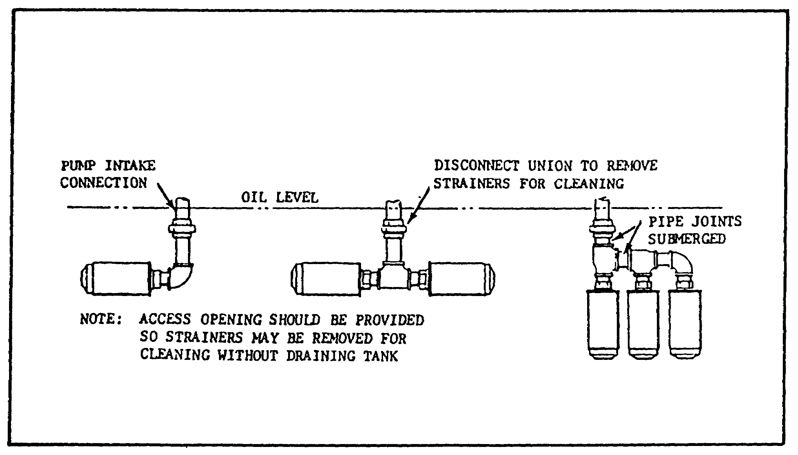

FIGURE 16. HYDRAULIC SYSTEM STRAINERS.

(3) Filters.

(a) The most common devices in hydraulic systems to prevent foreign particles and contaminating substances from remaining in the system are filters. They are located within the

23

PRINC. OF M1 HYDRAULICS - OD0475 - LESSON 1/TASK 2

reservoir, in the pressure line, in the return line, or in any other location where necessary.

(b) Filters are classified as full flow or proportional flow. In a full flow filter, all the fluid entering the unit passes through the filtering element. Although the full flow type provides a more positive filtering action, it offers greater resistance to flow, particularly when it becomes dirty.

c. Accumulators.

(1) Use.

(a) Like the familiar electrical storage battery, the hydraulic accumulator stores potential power, in this case liquid under pressure for future conversion into useful work. This work can include the operation of cylinders and fluid motors, maintenance of required system pressure in the event of pump or power failure, and the compensation for pressure loss due to leakage. Accumulators can also be employed as fluid dispensers, and provide shock absorbing action.

(b) The use of accumulators on military equipment is primarily on lift equipment to provide positive clamping action on heavy loads when pump flow is diverted to lifting or other operations.
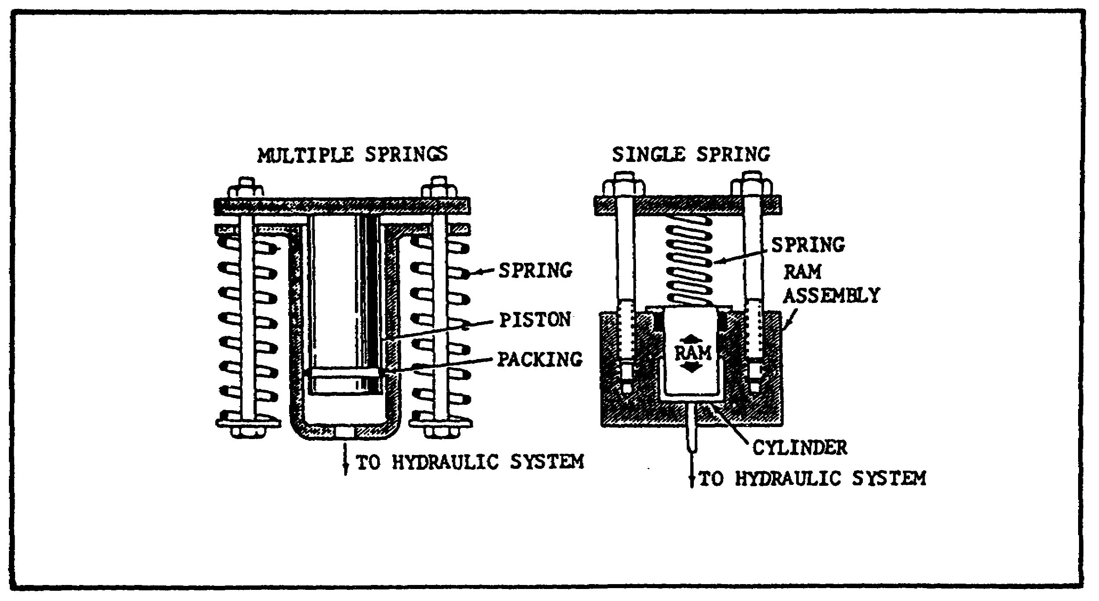

FIGURE 17. SPRING-LOADED ACCUMULATORS.

24

PRINC. OF M1 HYDRAULICS - OD0475 - LESSON 1/TASK 2

The accumulator also acts as a safety device to prevent the load from being dropped in case of an engine or pump failure or fluid leak. Also on lift and certain other equipment, accumulators absorb shock resulting from load starting, stopping or reversal.

(2) Spring-loaded Accumulator.

(a) The spring-loaded accumulator is used in some engineer equipment hydraulic systems. It uses the energy stored in springs to create a constant force on the liquid contained in the adjacent ram assembly. Figure 17, on the previous page, shows two examples of spring loaded accumulators.

(b) The load characteristics of: a spring are such that the energy stored depends on the force required to compress the spring. The free (uncompressed) length of the spring represents zero energy storage. As the spring is compressed to the maximum installed length, the minimum pressure valve of the liquid in the ram assembly is established. As liquid under pressure enters the ram cylinder, causing the spring to compress, the pressure on the liquid will rise because of the increased loading required to compress the spring.

(c) Bag-type Accumulator. Figure 18, on the following page, illustrates the bag-type accumulator. This accumulator derives its name from the shape of the synthetic rubber bag which separates the liquid and gas (usually nitrogen) within the accumulator. The accumulator consists of a seamless high-pressure shell, cylindrical in shape, with domed ends. The bag is fully enclosed in the shell and is molded to a gas stem in the upper end of the shell. The gas system contains a high-pressure gas valve. The bottom end of the shell is sealed with a special plug assembly containing the liquid port and usually a safety feature which makes it impossible to disassemble the accumulator with pressure in the system.

The bag is larger in diameter at the top and tapers to a smaller diameter at the bottom. The synthetic rubber is thinner at the top of the bag than at the bottom. The bag will stretch around the top at its largest diameter and thinnest wall-thickness, and will gradually stretch downward and push itself outward against the side walls of the shell. As liquid is forced into the accumulator

25

PRINC. OF M1 HYDRAULICS - OD0475 - LESSON 1/TASK 2

shell by the pump, it presses against the bag, thereby reducing the bag's volume and increasing the pressure. This pressure is then available to do work.
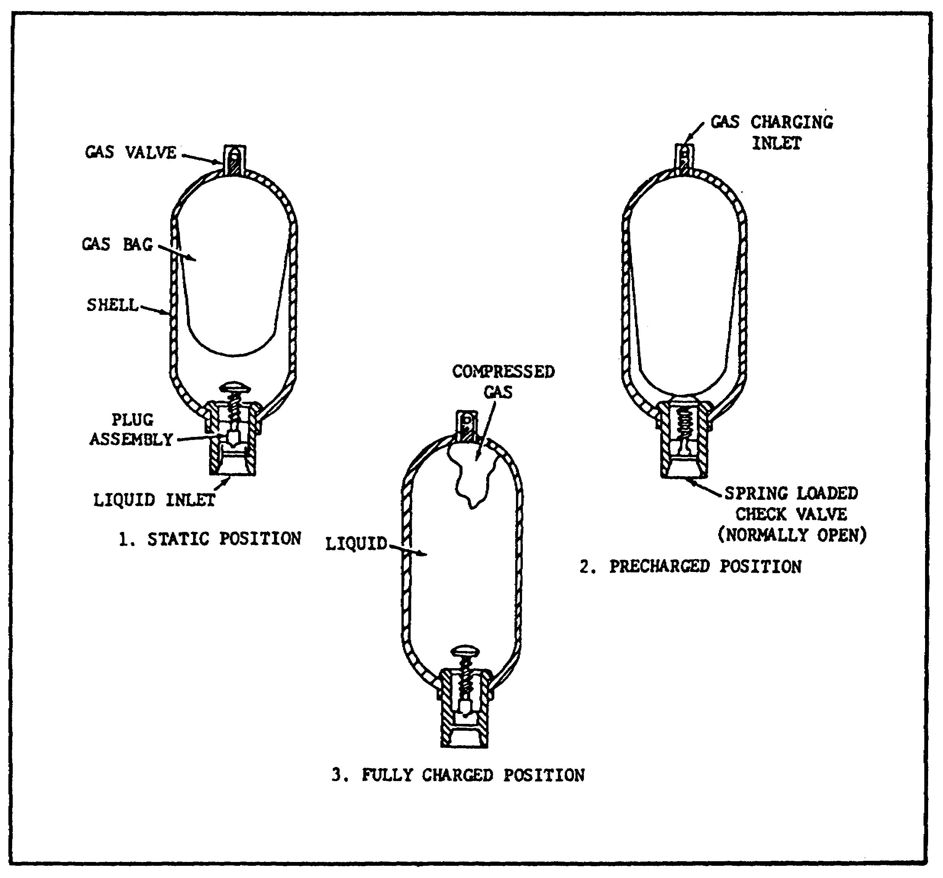

FIGURE 18. BAG-TYPE ACCUMULATOR.

(3) Piston-type Accumulator.

(a) The piston-type accumulator contains a free-floating piston, having liquid on one side of the piston and precharged air or nitrogen on the other (figure 19, on the following page). An increase of liquid volume decreases the gas volume and increases gas pressure, which provides a work potential when the liquid is allowed to discharge.

26

PRINC. OF M1 HYDRAULICS - OD0475 - LESSON 1/TASK 2
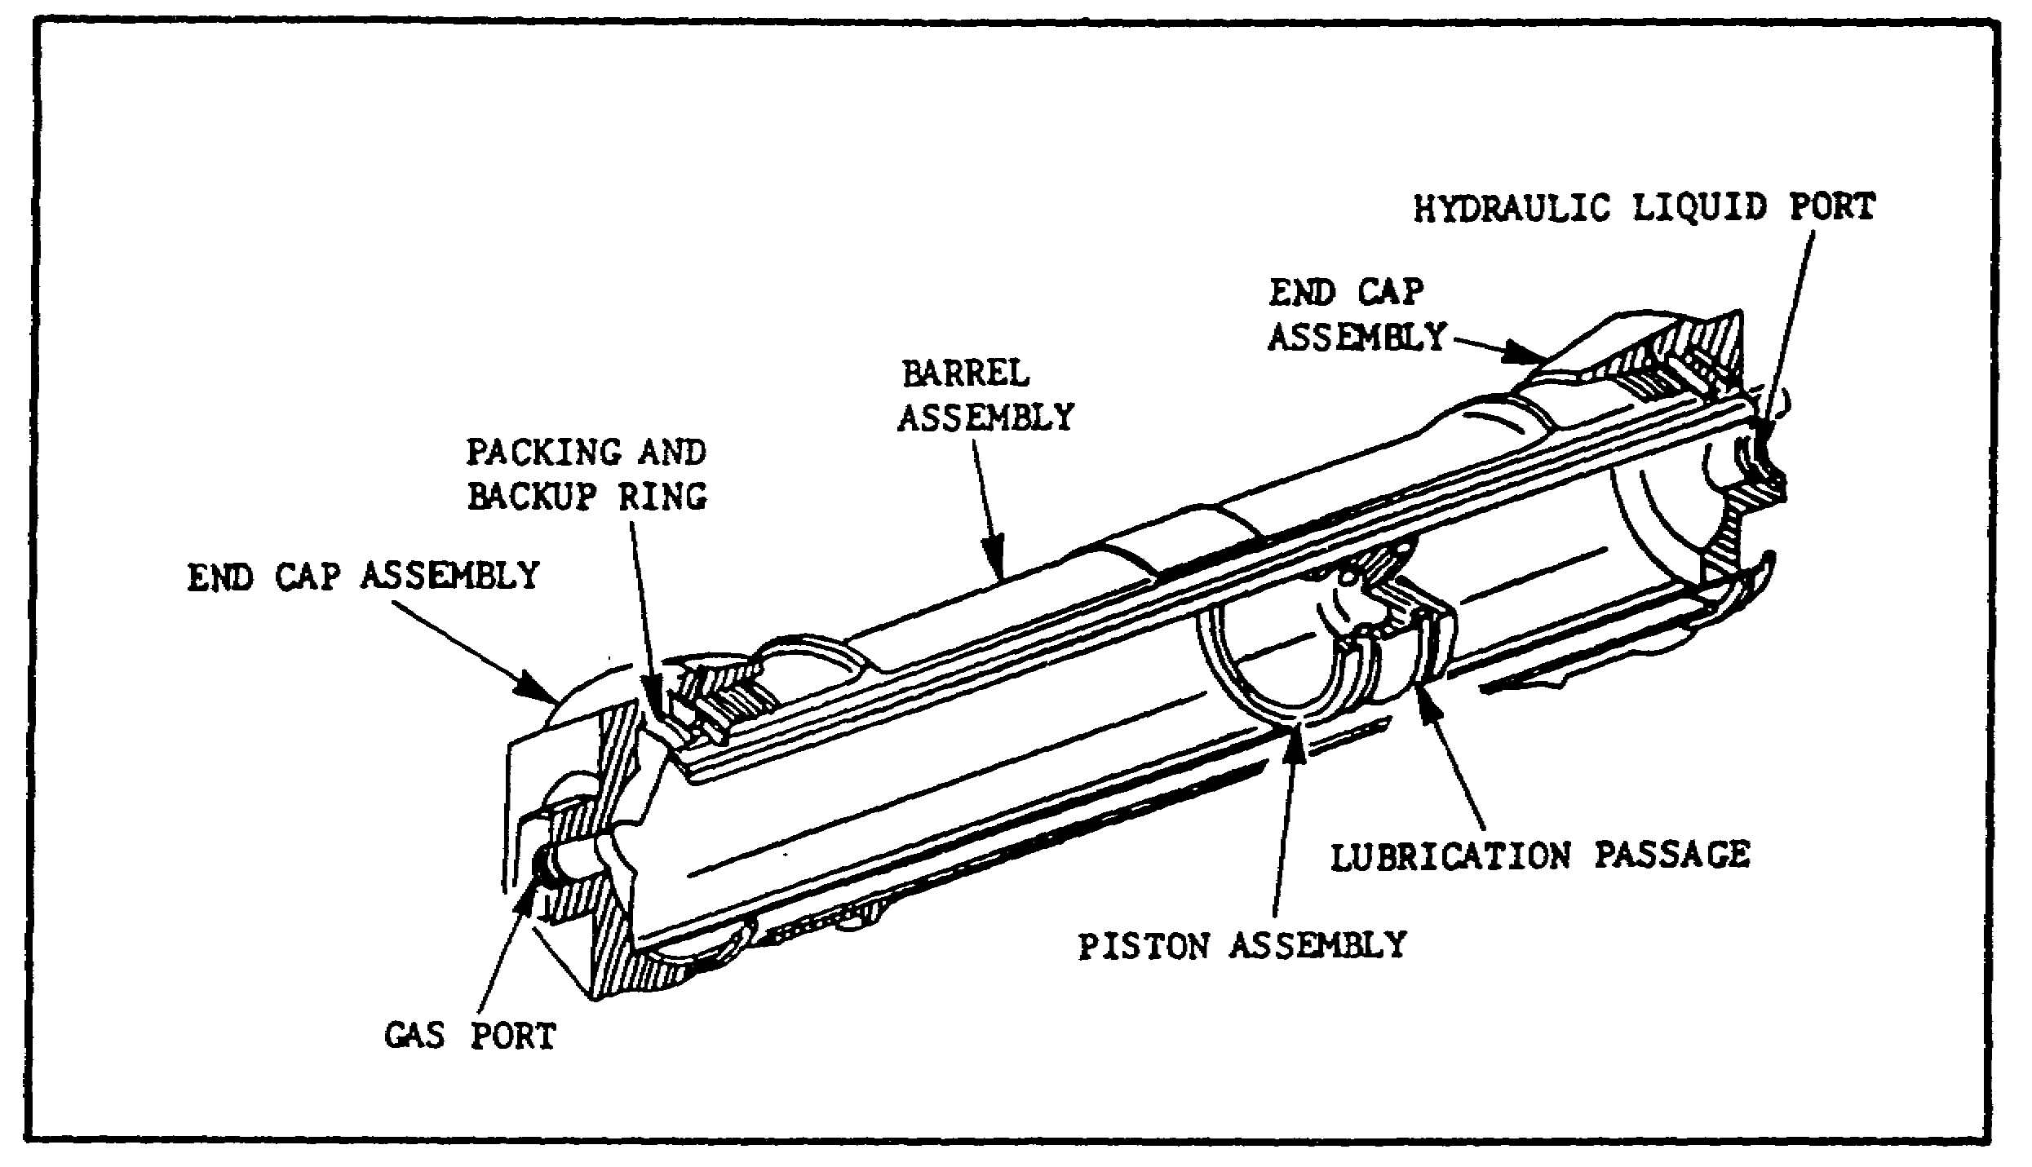

FIGURE 19. PISTON TYPE ACCUMULATOR.

(b) The piston accumulator consists of a cylinder assembly, a piston assembly, and two end-cap assemblies. The cylinder assembly houses the piston assembly and incorporates provisions for securing the end-cap assemblies.

d. Tubing, Piping, and Flexible Hosing.

(1) Tubing.

(a) There are two types of tubing used for hydraulic lines: seamless and electric welded. Both are suitable for hydraulic systems. Seamless tubing is made in larger sizes than tubing which is electric welded. The tubing is flared and fitted with threaded compression fittings. Tubing is highly desirable because it is easily bent, and so requires fewer pieces and fewer fittings. Unlike pipe, tubing can be cut, flared and fitted in the field. In general, tubing makes a neater, less costly, lower maintenance system with fewer flow restrictions and less chance of leakage. Figure 20, on the following page, shows the proper method of installing tubing.

(b) The type of tubing is determined by the flow, type of fluid, and fluid velocity, and system pressure. Nominal dimensions of tubing are given as fractions in inches or as "dash numbers." The

27

PRINC. OF M1 HYDRAULICS - OD0475 - LESSON 1/TASK 2

dash number represents the O.D. (outside diameter) of the tube, in sixteenths of an inch.
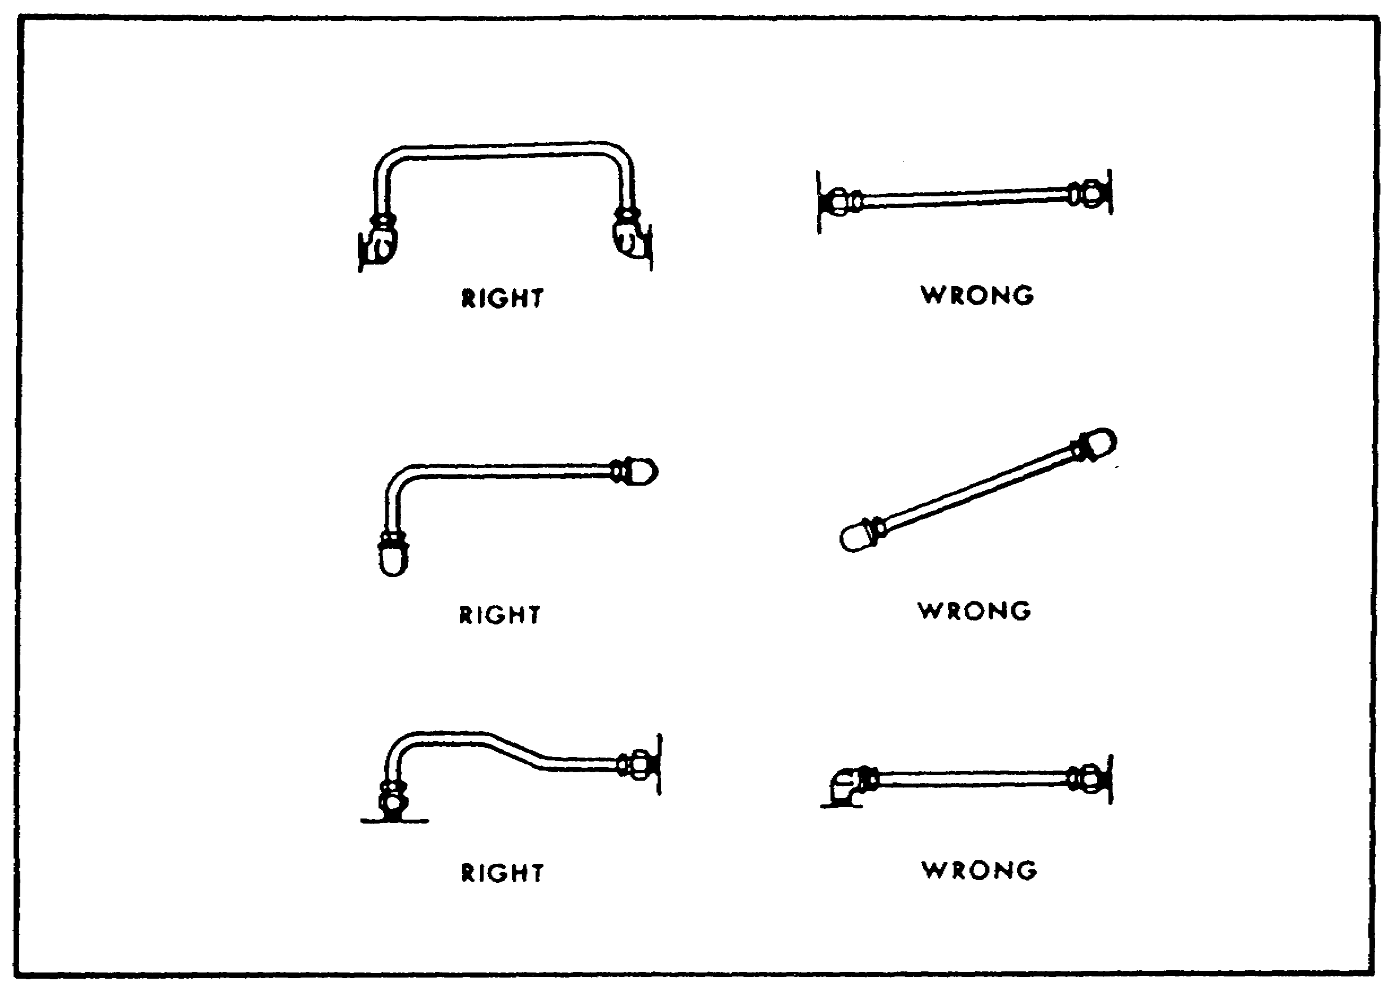

FIGURE 20. METHOD OF INSTALLING TUBING.

(c) The system pressure determines the thickness of the various tubing walls. Tubing above 1/2 inch O.D. is usually installed with either flange fittings, with metal or pressure seals, or with welded joints. If joints are welded, they should be stress relieved.

(2) Piping. Piping threaded with screwed fittings can be used with diameters up to 1 and 1/4 inches, and pressures of up to 1,000 psi. In instances where pressure will exceed 1,000 psi and required diameters are over 1 and 1/4 inches, piping with welded, flanged connections and socket welded size is specified by nominal I.D. (inside diameter) dimensions. The thread remains the same for any given pipe size, regardless of wall thickness. Pipe is used economically in larger size hydraulic systems where large flow is carried. It is particularly suited for long, permanent straight lines. Pipe is taper-threaded on its O.D. into a tapped hole or fitting. However, it cannot

28

PRINC. OF M1 HYDRAULICS - OD0475 - LESSON 1/TASK 2

be bent. Instead, fittings are used wherever a joint is required. This results in additional cost and increased chance for leakage.

(3) Flexible Hosing. Hose is used in fluid power systems where there is a necessity for flexibility, such as connections to units that move while in operation, or to units attached to a hinged portion of the equipment. It is also used in locations that are subjected to severe vibration. Flexible hose is usually used to connect the pump to the system; the vibration set up by an operating pump would ultimately cause rigid tubing to fail.

e. Pumps.

(1) Definition. Hydraulic pumps convert mechanical energy into hydraulic energy. The pump is probably the most important component in hydraulics, and can be among the most complex. Yet with proper selection and operation, and with good maintenance practices, the pump can become the most reliable component.

(2) Purpose. Fundamentally, the pump's purpose is to push on the hydraulic fluid and create flow. The pump converts mechanical energy from the prime mover (engine or electric motor) into pressure energy in the fluid. The pressure energy is then used to operate an actuator, often with very precise control.

(a) Essentials. The essentials of any hydraulic pump (figure 21) are:
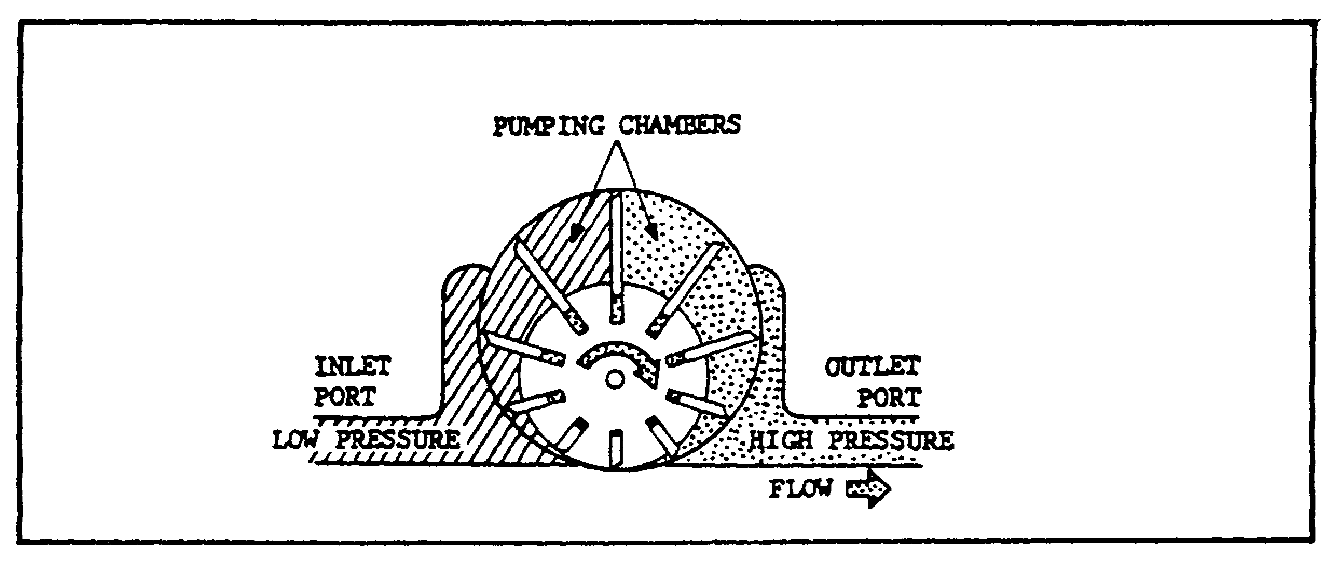

FIGURE 21. HYDRAULIC PUMP.

29

PRINC. OF M1 HYDRAULICS - OD0475 - LESSON 1/TASK 2

1 A low pressure inlet port which is supplied with fluid from the reservoir.

2 A high pressure outlet port, connected to the pressure line.

3 Pumping chamber(s) to carry the fluid from the inlet to the outlet port.

4 A mechanical means for activating the pumping chambers.

In most rotary hydraulic pumps, the design is such that the pumping chambers increase in size at the inlet, thereby creating a vacuum. The chambers then decrease in size at the outlet to push the fluid into the system. The vacuum at the inlet is used to create a pressure difference so that fluid will flow from the reservoir to the pump. However, in many systems, the inlet is charged or supercharged; that is, a positive pressure rather than a vacuum is created by a pressurized reservoir, a head of fluid above the inlet, or even a low pressure charging pump.

(3) Positive and Non-positive Displacement.

(a) Division. A fundamental division of pumps can be made according to displacement type. Pumps which discharge liquid in a continuous flow are the non-positive displacement type. Those which discharge volumes of liquid separated by periods of no discharge are the positive displacement type.

1 If the inlet and outlet are connected hydraulically, so that the fluid can recirculate in the pump when pressure builds up, the pump is nonpositive displacement.

2 If the inlet is sealed from the outlet, the pump will deliver fluid anytime the inlet is kept supplied and the pump is driven. Such a pump is classified as positive delivery or positive displacement, and requires a relief valve to protect it from pressure overloads.

(b) Non-positive Displacement Pumps. A nonpositive displacement pump is one in which the volume of liquid delivered for each cycle is dependent upon the resistance offered to flow. This type pump produces a force on the liquid that is constant for each particular speed of the pump.

30

PRINC. OF M1 HYDRAULICS - OD0475 - LESSON 1/TASK 2

Resistance in the discharge line produces a force in the opposite direction. When these forces are equal, the liquid is in a state of equilibrium and does not flow.

If the outlet of a non-positive displacement pump is completely closed, the discharge pressure will rise to the maximum for that type pump operating at that speed. Nothing more will happen, except that the pump will churn the liquid and produce heat.

Figure 22 shows a propeller type of non-positive displacement pump.
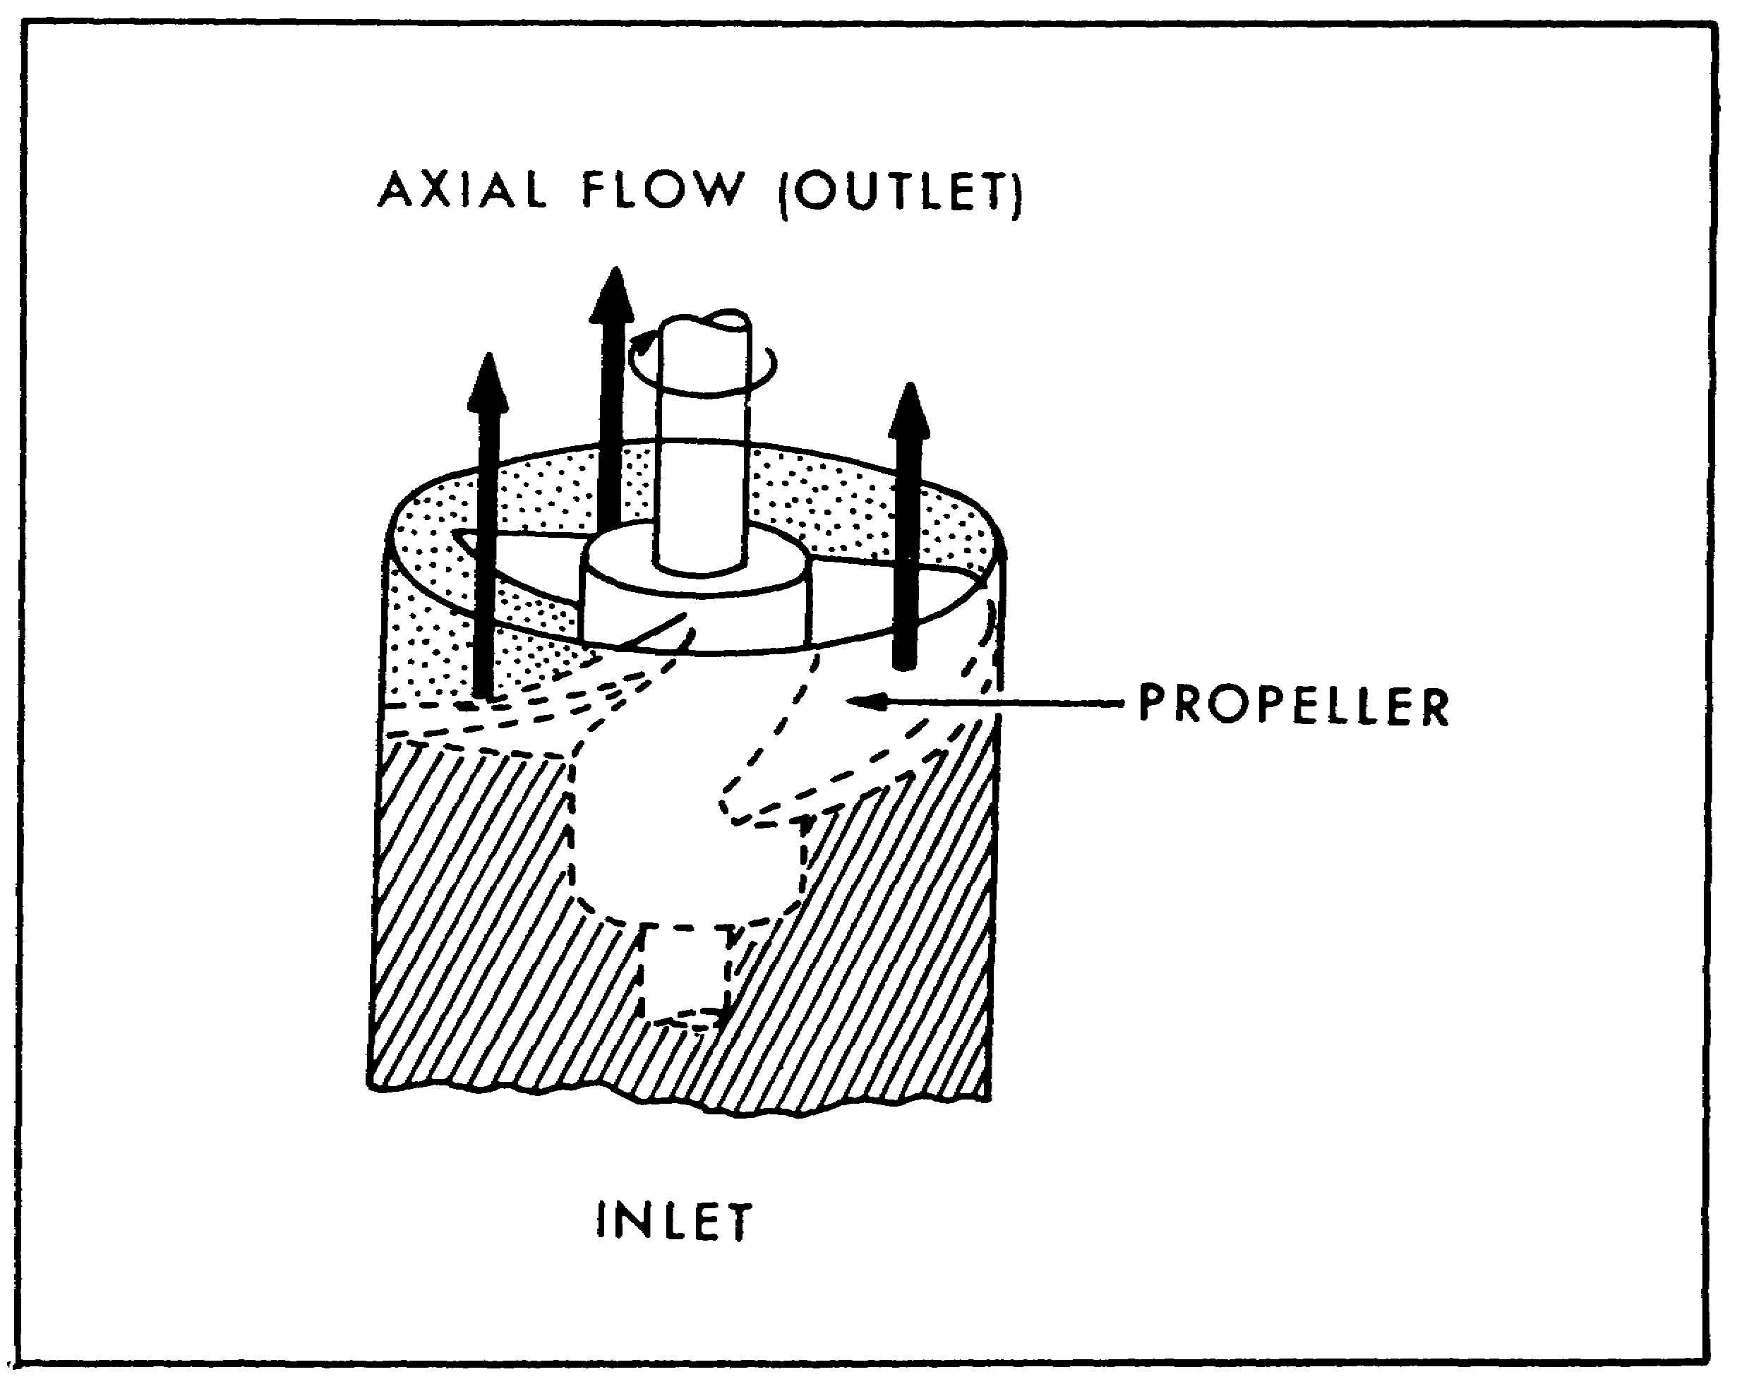

FIGURE 22. PROPELLER PUMP.

(c) Positive Displacement Pumps. A positive displacement pump is one in which a definite volume of liquid is delivered for each cycle of pump operation, regardless of the resistance offered, provided the capacity of the power unit driving the pump is not exceeded. If the outlet of a

31

PRINC. OF M1 HYDRAULICS - OD0475 - LESSON 1/TASK 2

positive displacement pump is completely closed, either the unit driving the pump will stall or something will break. For this reason, when the positive displacement type pump is used in a system, a pressure regulator, or unloading valve must also be incorporated into the system.

Figure 23 shows a reciprocating type positive displacement pump.
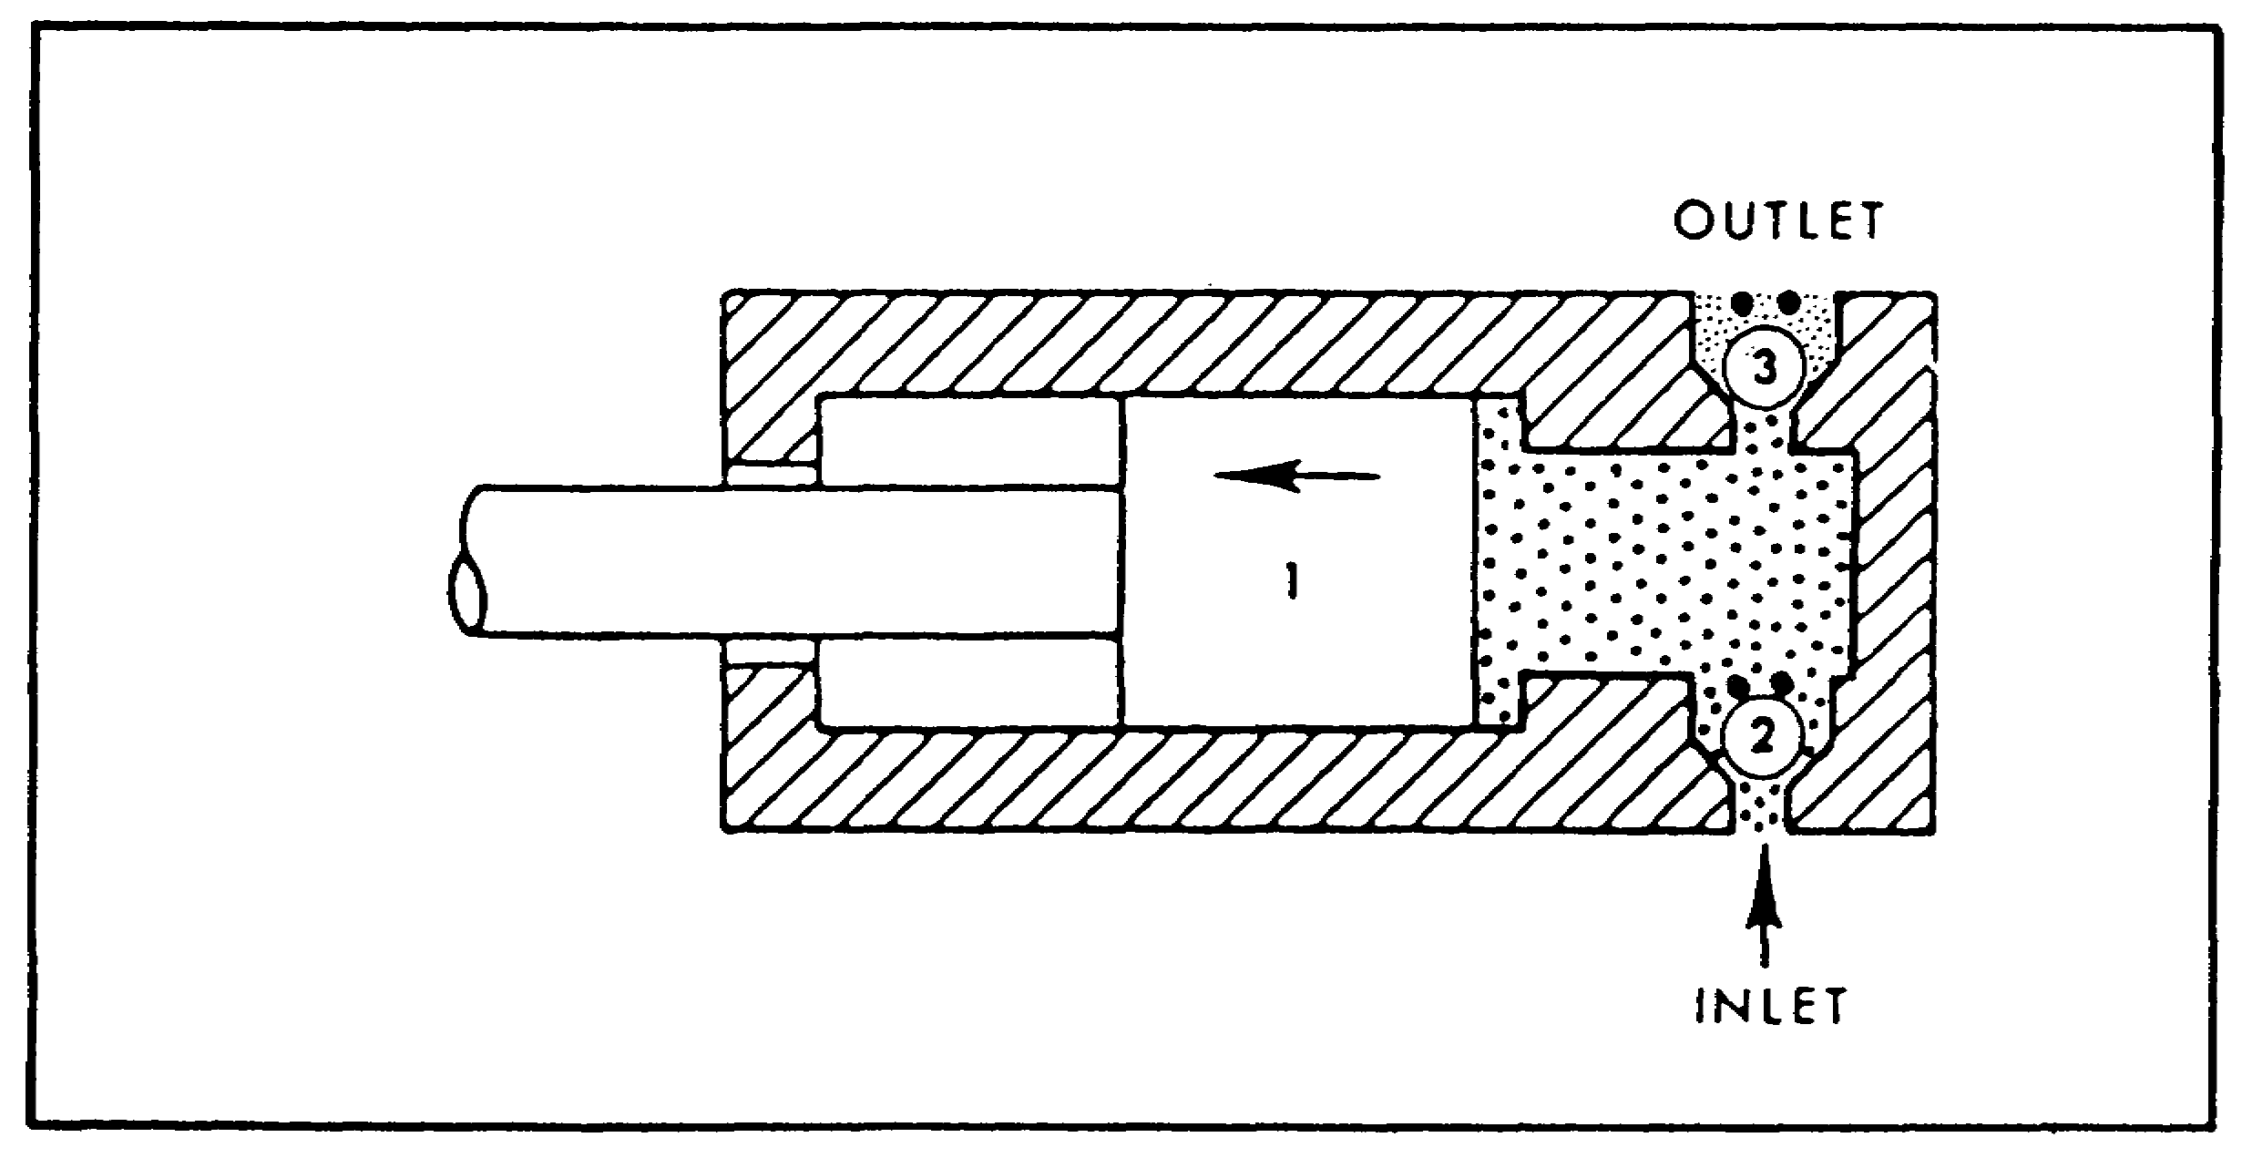

FIGURE 23. SIMPLIFIED RECIPROCATING PUMP.

(d) Characteristics. There are three contrasting characteristics in the operation of positive and non-positive displacement pumps:

1 A non-positive displacement pump provides a smooth, continuous flow. A positive displacement pump has a pulse with each stroke, or each time a pumping chamber opens to the outlet port.

2 The delivery of a non-positive pump is reduced by pressure. A high enough outlet pressure can actually stop any output--the liquid simply recirculates inside the pump. In a positive displacement pump, pressure affects the output only to the extent that it increases internal leakage.

3 A non-positive displacement pump, with its inlets and outlets connected hydraulically, can not create a vacuum sufficient for self-priming; it must be started with the inlet line full of liquid

32

PRINC. OF M1 HYDRAULICS - OD0475 - LESSON 1/TASK 2

and free of air. Positive displacement pumps are often self-priming when started properly.

(4) Performance.

(a) Rating Terms. Pumps are usually rated according to their volumetric output and pressure. Volumetric output (often called "delivery rate" or "capacity") is the amount of liquid the pump can deliver at its outlet port per unit of time, at a given drive speed. It is usually expressed in gallons per minute (gpm) or cubic inches per minute (cipm). Because changes in pump drive speed affect volumetric output, pumps are sometimes rated according to displacement; that is, by the amount of liquid the pump can deliver per cycle or cubic inches per revolution (cipr).

(b) Pressure. Because some confusion often arises over the significance of a pump's pressure rating, it is necessary to review the essential characteristics of pressure. Pressure is the force per unit area of a liquid; it is usually expressed in terms of pounds per square inch (psi), meaning gage pressure, not absolute pressure. Most of the pressure in the hydraulic systems covered in this lesson is created by resistance to flow. This resistance is usually caused by a restriction or obstruction in the path of flow. The pressure developed in a system has an effect on the volumetric output of the pump supplying flow to the system. As pressure increases, volumetric output decreases. This drop in output is caused by an increase in internal leakage from the pump's outlet side to its inlet side. For this reason, pumps have greater internal slippage than others. This is a factor in all pumps, some types of pumps are often rated in terms of their volumetric output at a given pressure. Although slippage is a measure of pump efficiency and is expressed in percent.

(5) Fixed and Variable Displacement.

(a) Definition. Displacement is the amount of liquid transferred from the pump inlet to the outlet in one revolution or cycle. For a rotary pump, displacement is expressed in cubic inches per revolution; for a reciprocating pump in cubic inches per cycle. If the pump has more than one pumping chamber, the pump displacement is equal to the displacement of one chamber multiplied by the number of chambers (figure 21 on page 29).

33

PRINC. OF M1 HYDRAULICS - OD0475 - LESSON 1/TASK 2

(b) Fixed Displacement. In a fixed displacement pump, the gpm output can be changed only by varying the drive speed.

(c) Variable Displacement. In a variable displacement pump, there is provision for changing the size of the pumping chamber(s). The gpm delivery can be changed by moving the displacement control, or changing the drive speed, or both.

(6) Design Classifications. Pumps may be classified according to the specific design used to create the flow of liquid. Practically all hydraulic pumps fall within three classifications of design: centrifugal, rotary, and reciprocating.

(a) Centrifugal Pumps. The two most common centrifugal pumps are the volute type and the diffuser type.

1 The volute pump (figure 24) has a circular pumping chamber with a central inlet port (suction pipe) and an outlet port. A rotating impeller is located in the pumping chamber. The chamber between the casing and the center hub is the volute. Liquid enters the pumping chamber through
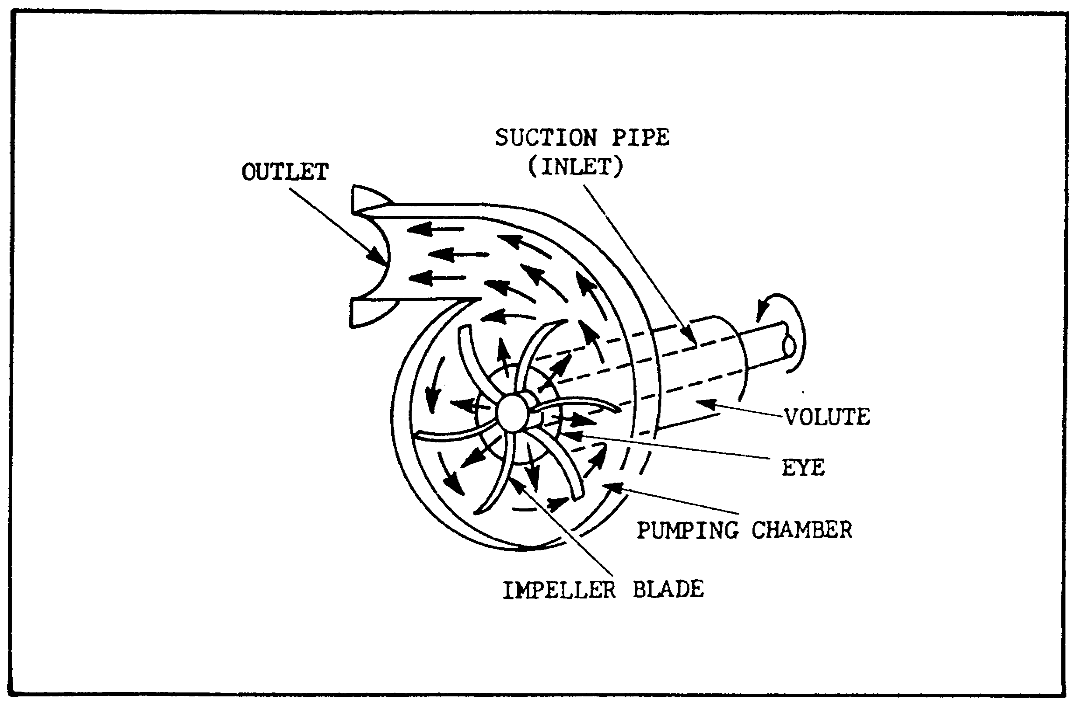

FIGURE 24. VOLUTE PUMP.

34

PRINC. OF M1 HYDRAULICS - OD0475 - LESSON 1/TASK 2

the central inlet (or eye) and is trapped between the whirling impeller blades. Centrifugal force throws the liquid outward at high velocity and the contour of the casing then directs the moving liquid through the outlet port.

2 Figure 25 shows a diffuser type centrifugal pump. Similar to the volute type, this pump has, in addition, a series of stationary blades (the diffuser). These blades curve in the opposite direction to the whirling impeller blades. The diffuser reduces the velocity of the liquid, decreases slippage, and increases the pump's ability to develop flow against resistance.
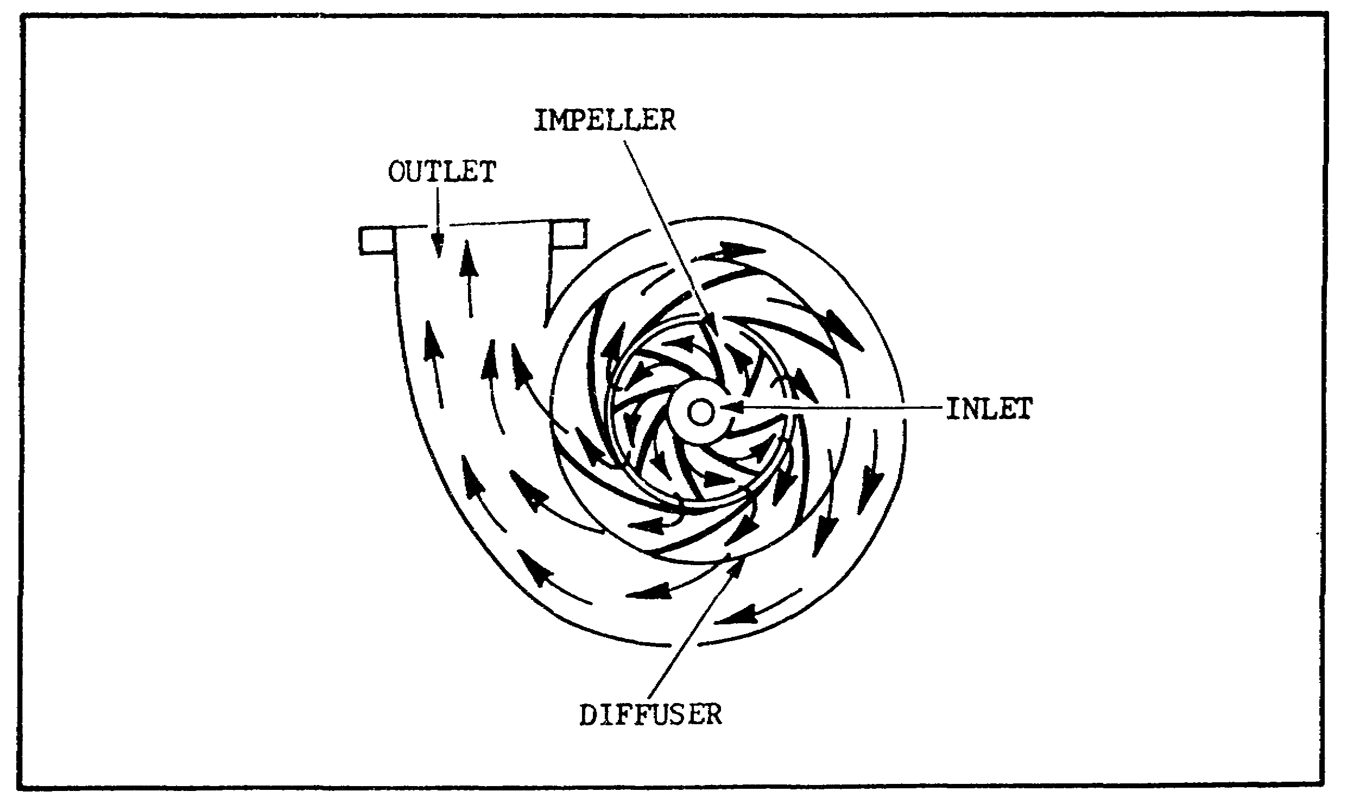

FIGURE 25. DIFFUSER PUMP.

3 Centrifugal pumps generally are used where a large volume of flow is required at relatively low pressures. However, several of these pumps can be connected in series by feeding the outlet of one into the inlet of the next. This arrangement enables the pumps to develop flow against high pressures. Centrifugal pumps are non-positive displacement pumps.

(b) Rotary Pumps. In a rotary or positive displacement pump, a rotary motion carries the liquid from the pump inlet to the pump outlet. Rotary pumps are usually classified according to

35

PRINC. OF M1 HYDRAULICS - OD0475 - LESSON 1/TASK 2

the type of element that actually transmits the liquid, so that we speak of a gear, vane, or piston type rotary pump.

(c) Reciprocating Pump. A reciprocating pump depends upon a reciprocating motion to transmit liquid from its inlet side to its outlet side. Figure 23 on page 32, illustrates a simplified reciprocating pump. The pump consists basically of a cylinder which houses a reciprocating piston or plunger and an inlet and outlet valve which direct fluid to and from the cylinder. When piston (1) moves to the left, the partial vacuum created draws ball (2) off its seat, allowing the liquid to be drawn through the inlet valve into the cylinder. When piston (1) moves to the right, ball (2) reseats, closing the inlet valve, but the force of the flow unseats ball (3), allowing the fluid to be forced out of the cylinder through the outlet valve.

f. Hydraulic Actuators.

(1) Definition. A hydraulic actuator is the device which receives pressure energy and converts it to mechanical force and motion.

(2) Purpose. Hydraulic actuators can be either linear or rotary. A linear actuator gives force and motion outputs in a straight line. A rotary actuator produces torque and rotating motion.

(a) Linear Actuators. There are many names for linear actuators in the hydraulics industry. They are commonly referred to as cylinders, but are also known as rams, reciprocating motors, and linear motors.

(b) Rotary Actuators. Rotary actuators are commonly referred to as hydraulic motors, or just motors. They very closely resemble pumps in construction. In fact, many hydraulic motors can be operated as pumps with little change, or no change at all.

(3) Basic Parts. The basic parts of an actuator, specifically a ram type cylinder actuator, are illustrated in figure 26 on the following page. The cylinder, or barrel, or housing, is a tube in which the plunger or piston operates. In the ram type cylinder, the plunger or

36

PRINC. OF M1 HYDRAULICS - OD0475 - LESSON 1/TASK 2

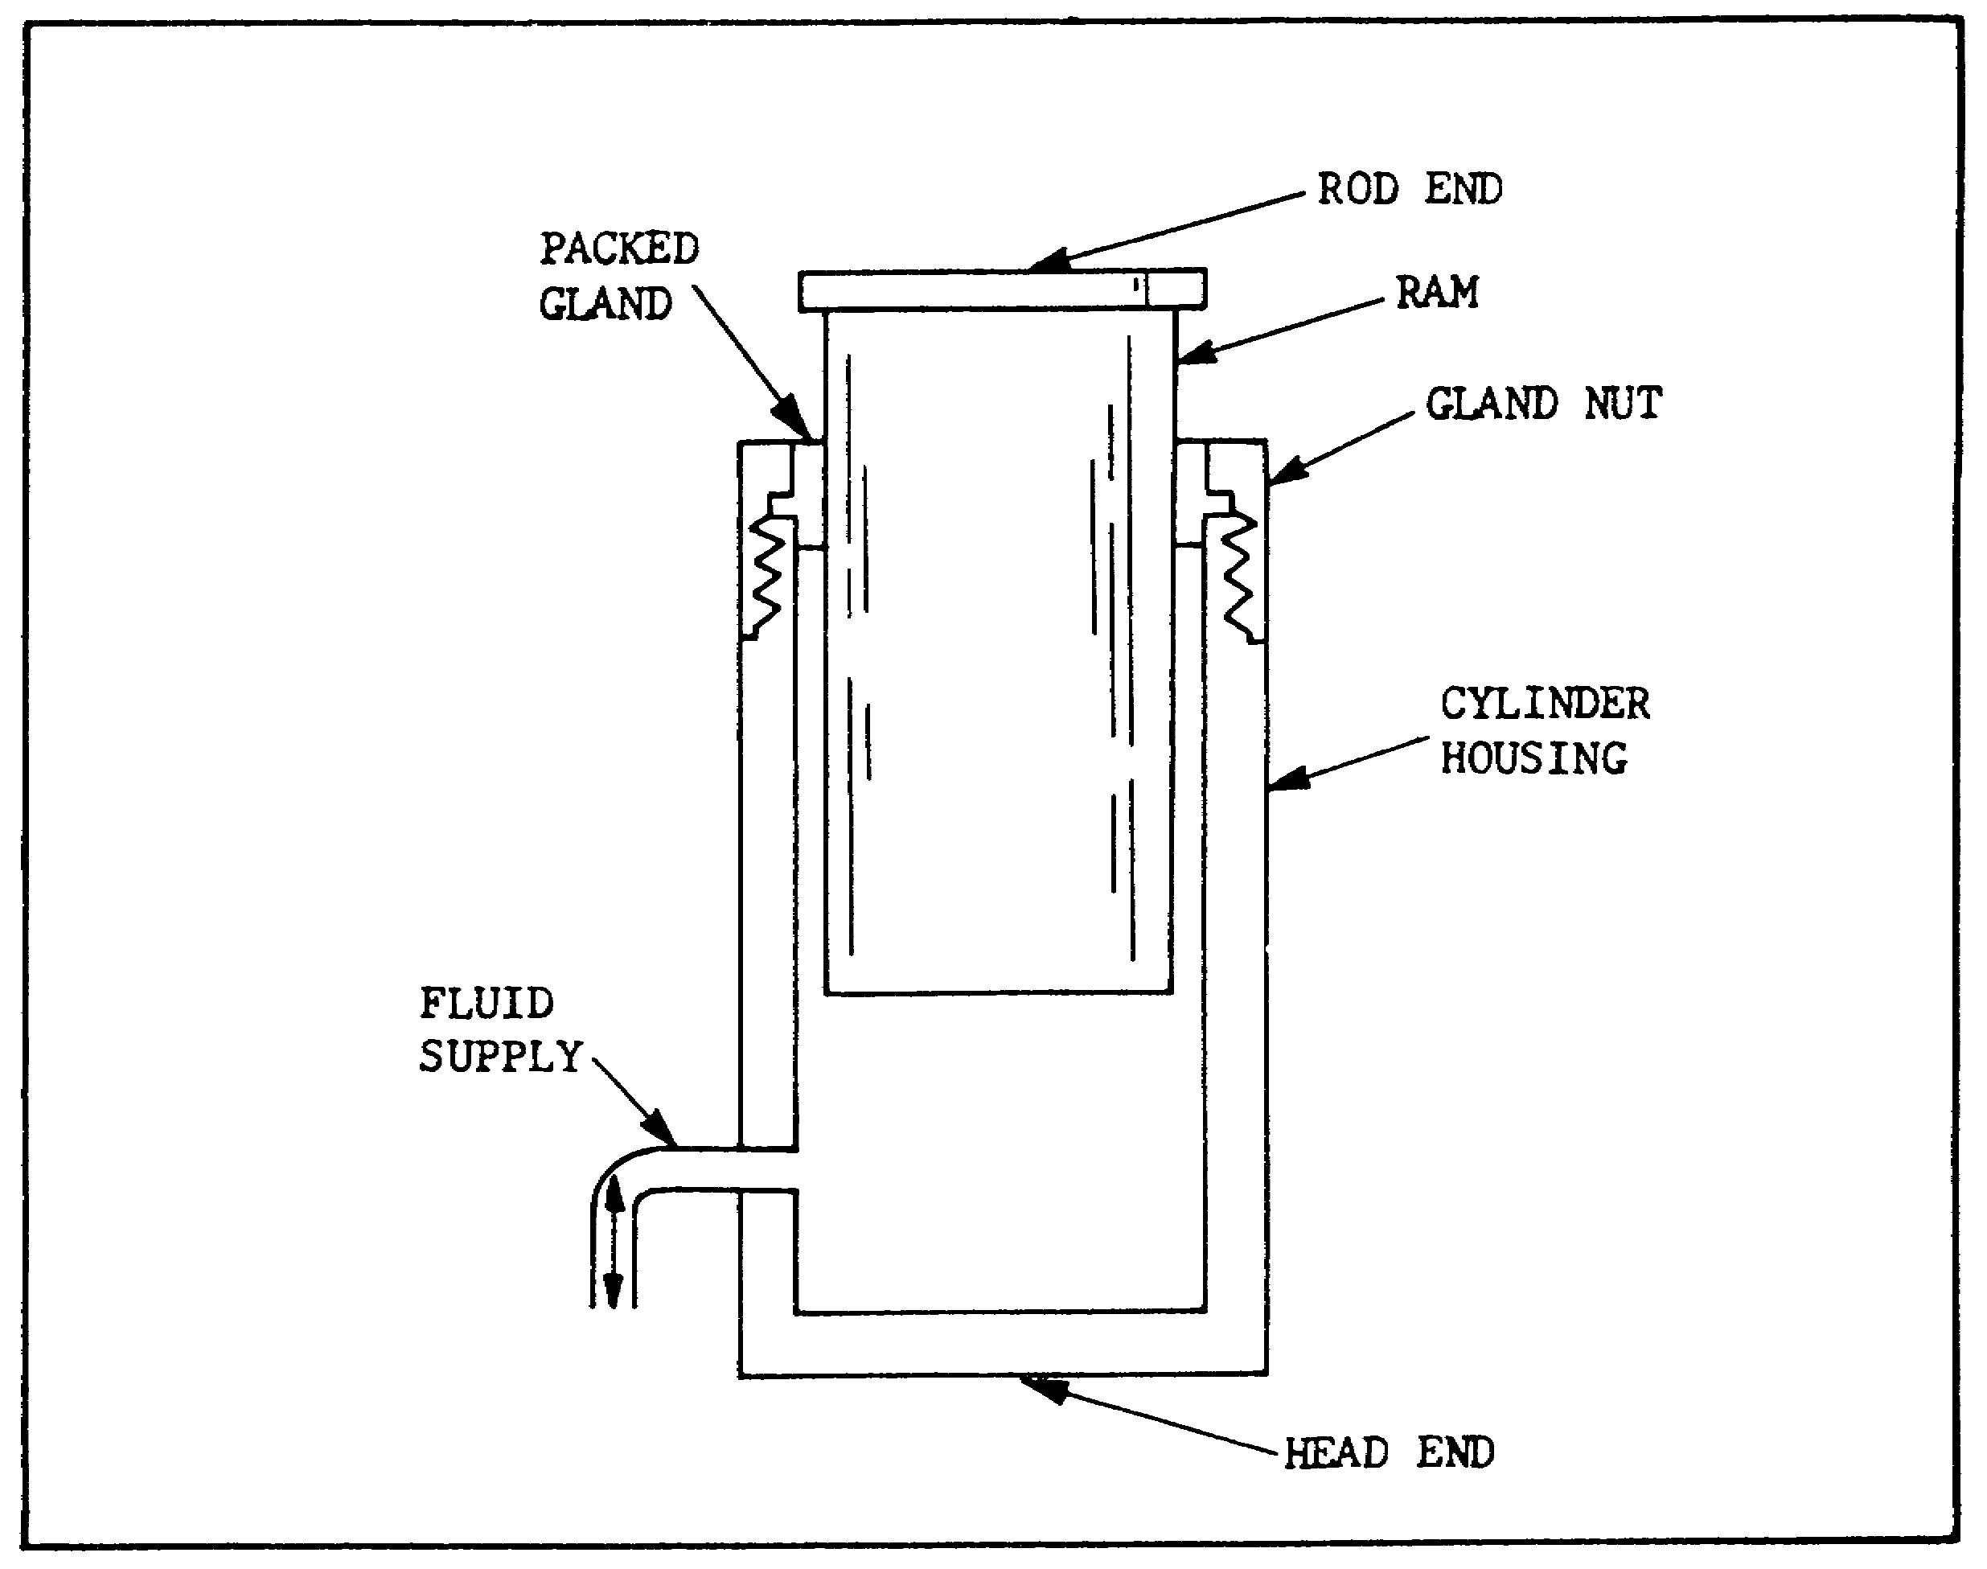
FIGURE 26. RAM TYPE CYLINDER.

ram actuates the load directly. In the piston cylinder, a piston rod is connected to the piston to actuate the load. The end of the cylinder from which the rod or plunger protrudes is called, appropriately, the rod end. The end opposite is called the head end. The hydraulic connections are called the head end port and the rod end port (fluid supply).

(4) Classifications.

(a) Single and Double Acting Cylinders.

1 A single acting cylinder (figure 26) has only a head end port and is operated hydraulically in only one direction. When oil is pumped into the port, it pushes on the plunger or piston, and the plunger or rod extends. To return or retract the cylinder, the oil must be released to the reservoir. The rod or plunger returns because of the weight of the load, or from some mechanical force such as a spring. In mobile equipment, flow

37

PRINC. OF M1 HYDRAULICS - OD0475 - LESSON 1/TASK 2

to and from a single-acting cylinder is controlled by a reversing directional valve of the single-acting type.

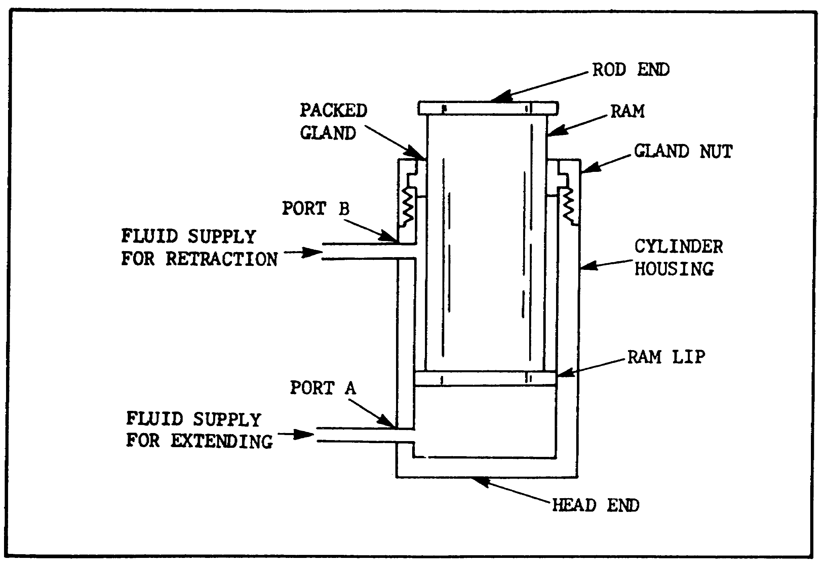
FIGURE 27. DOUBLE ACTING CYLINDER.

2 In a double acting cylinder, the pump does the job in both directions. The cylinder must have ports at both the head end and rod end (figure 27). Dumping oil into the head end moves the piston, to extend the rod. At the same time, any oil in the rod end is pushed out and must be returned to the reservoir. To retract the rod, flow is reversed. Oil from the pump is connected to allow return flow. The direction of flow to and from a double acting cylinder can be controlled by a double acting directional valve, or by actuating the control of a reversible pump.

(b) Differential and Non-differential Cylinders.

1 The double acting cylinder in figure 27 is called a differential cylinder, because the pressure apply areas on the piston are not equal. On the head end, the full piston area is available for applying pressure. At the rod end, the area of

38

PRINC. OF M1 HYDRAULICS - OD0475 - LESSON 1/TASK 2

the rod must be subtracted, so that only the annular area is available for applying pressure. The space that the rod takes up also reduces the volume of oil the rod end will hold. Thus, we can make two general rules about a differential cylinder:

a With an equal gpm delivery to either end, the cylinder will move faster when retracting because of the reduced volume capacity.

b With equal pressure at either end, the cylinder can exert more force when extending, because of the greater piston area. In fact, if we apply an equal pressure to both ports at the same time, the cylinder will extend because of the higher resulting force on the head end.
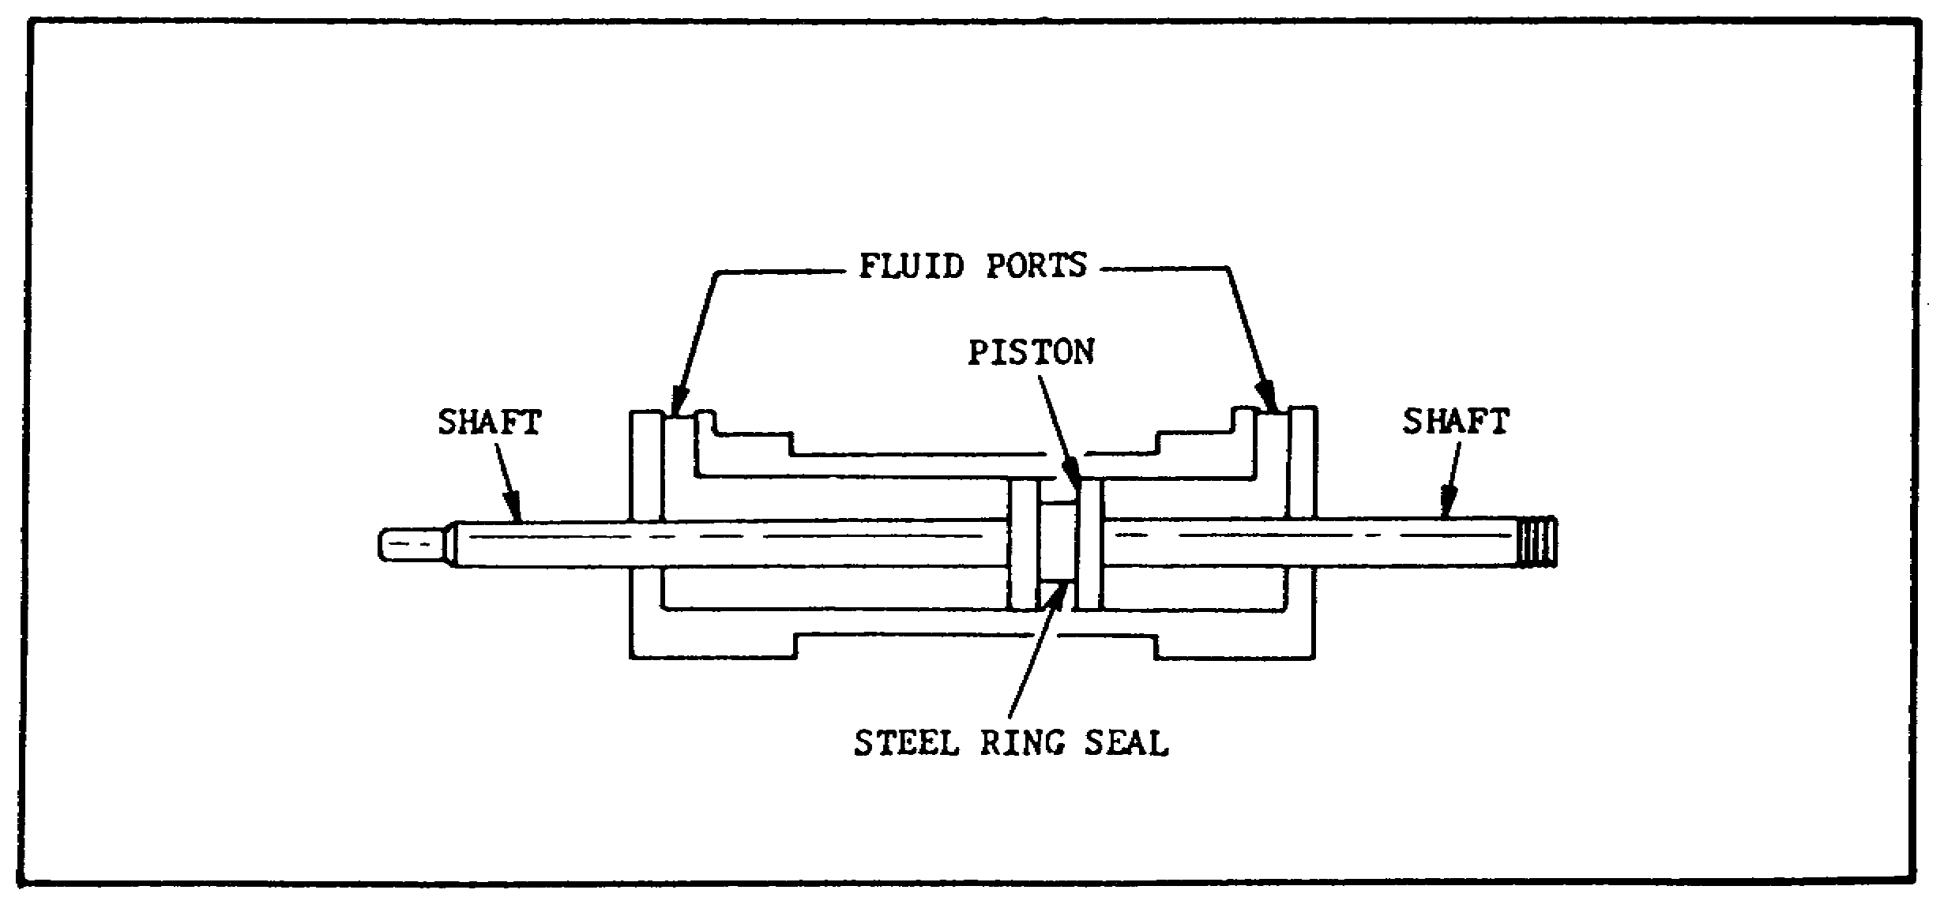

FIGURE 28. NON-DIFFERENTIAL CYLINDER.

2 A non-differential cylinder (figure 28), has a piston rod extending from each end. It has equal thrust and speed either way, provided that pressure and flow are unchanged. Few, if any, non-differential cylinders are used on mobile equipment.

(5) Types.

(a) Introduction. Although the terms "ram" and "piston" are often used interchangeably, a ram-type cylinder is usually considered one in which the cross-sectional area of the piston rod is more than one half the cross-sectional area of the piston head. In many cylinders of this type, the rod and

39

PRINC. OF M1 HYDRAULICS - OD0475 - LESSON 1/TASK 2

piston head have equal areas. The ram type actuating cylinder is used primarily for push functions rather than for pull. A cylinder in which the cross-sectional area of the piston rod is less than one-half the cross-sectional area of the piston head is referred to as a piston type cylinder. The piston type cylinder is normally used for application which require both push and pull functions. Thus, the piston type serves many more requirements than the ram type and, therefore, is the most common type used in fluid power systems.

(b) Ram-type Cylinder.

1 The single acting ram applies force in only one direction. Figure 26, on page 37, is an example of a single-acting ram-type cylinder. The operation of a single-acting cylinder is often used in the hydraulic jack.

2 In a double acting, ram-type cylinder, both strokes of the ram are produced by pressurized fluid. Figure 27, on page 38, is an example of a double acting ram-type cylinder.

3 Figure 29, on the following page, shows a telescoping ram-type actuating cylinder. A series of rams are nested in the telescoping assembly. With the exception of the smallest ram, each ram is hollow and serves as the cylinder housing for the next smaller ram. The ram assembly is contained in the main cylinder housing, which also provides the fluid ports.

Although the assembly requires a small space with all of the rams retracted, the telescoping action of the assembly provides a relatively long stroke when the rams are extended.

40

PRINC. OF M1 HYDRAULICS - OD0475 - LESSON 1/TASK 2

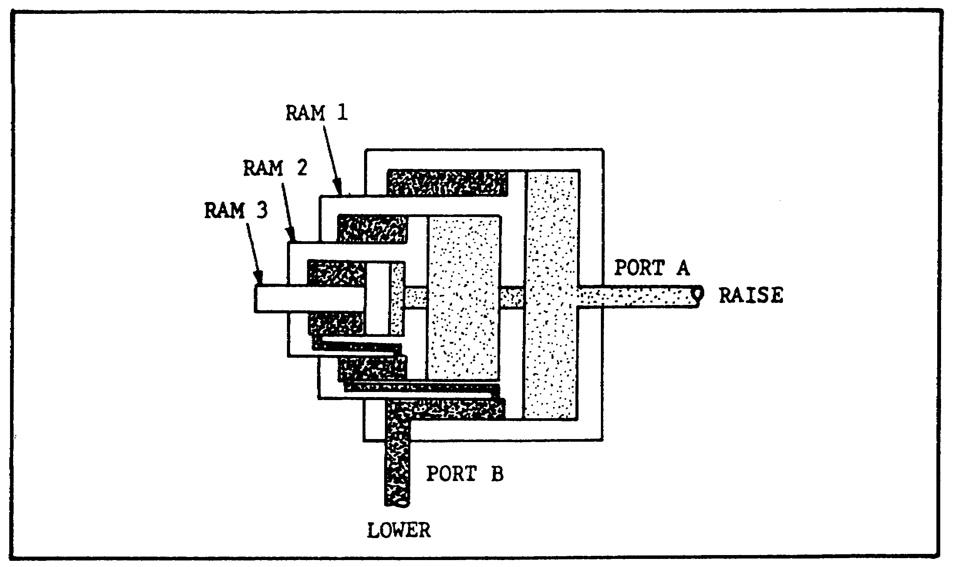
FIGURE 29. TELESCOPING, RAM-TYPE ACTUATING
CYLINDER.

(c) Piston-type Cylinder.

1 The single-acting piston-type cylinder uses fluid pressure to apply force in only one direction. In some designs of this type, the force of gravity moves the piston in the opposite direction. However, most cylinders of this type apply force in both directions. Fluid pressure provides the force in one direction and spring tension provides the force in the opposite direction. Figure 30, on the following page, illustrates a single-acting, spring-loaded, piston-type cylinder. In this cylinder, the spring is located on the rod side of the piston. In some spring-loaded cylinders, the spring is located on the blank side and the fluid port is on the rod end of the cylinder.

2 The piston-type cylinders are double-acting, which means that fluid under pressure can be applied to either side of the piston, to provide movement and apply force in the corresponding direction.

(d) Cushioned Cylinders. In order to slow the action and prevent shock at the end of the piston stroke, some actuating cylinders are constructed with a cushioning device at either or both ends of the cylinder. This cushion is usually a metering

41

PRINC. OF M1 HYDRAULICS - OD0475 - LESSON 1/TASK 2

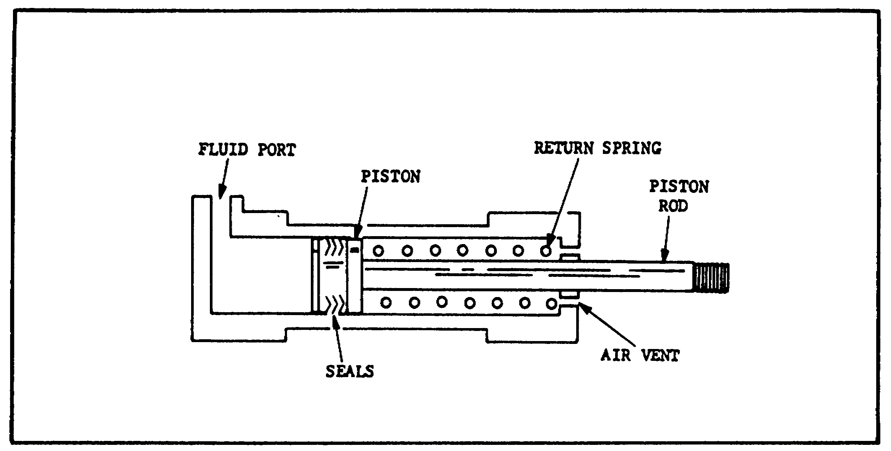
FIGURE 30. SINGLE ACTING, SPRING-LOADED, PISTON
TYPE CYLINDER.

device built into the cylinder to restrict flow at the outlet port, thereby slowing down the motion of the piston. There are various designs used to provide this cushioning effect. One such design is shown in the actuating cylinder illustrated in figure 31.
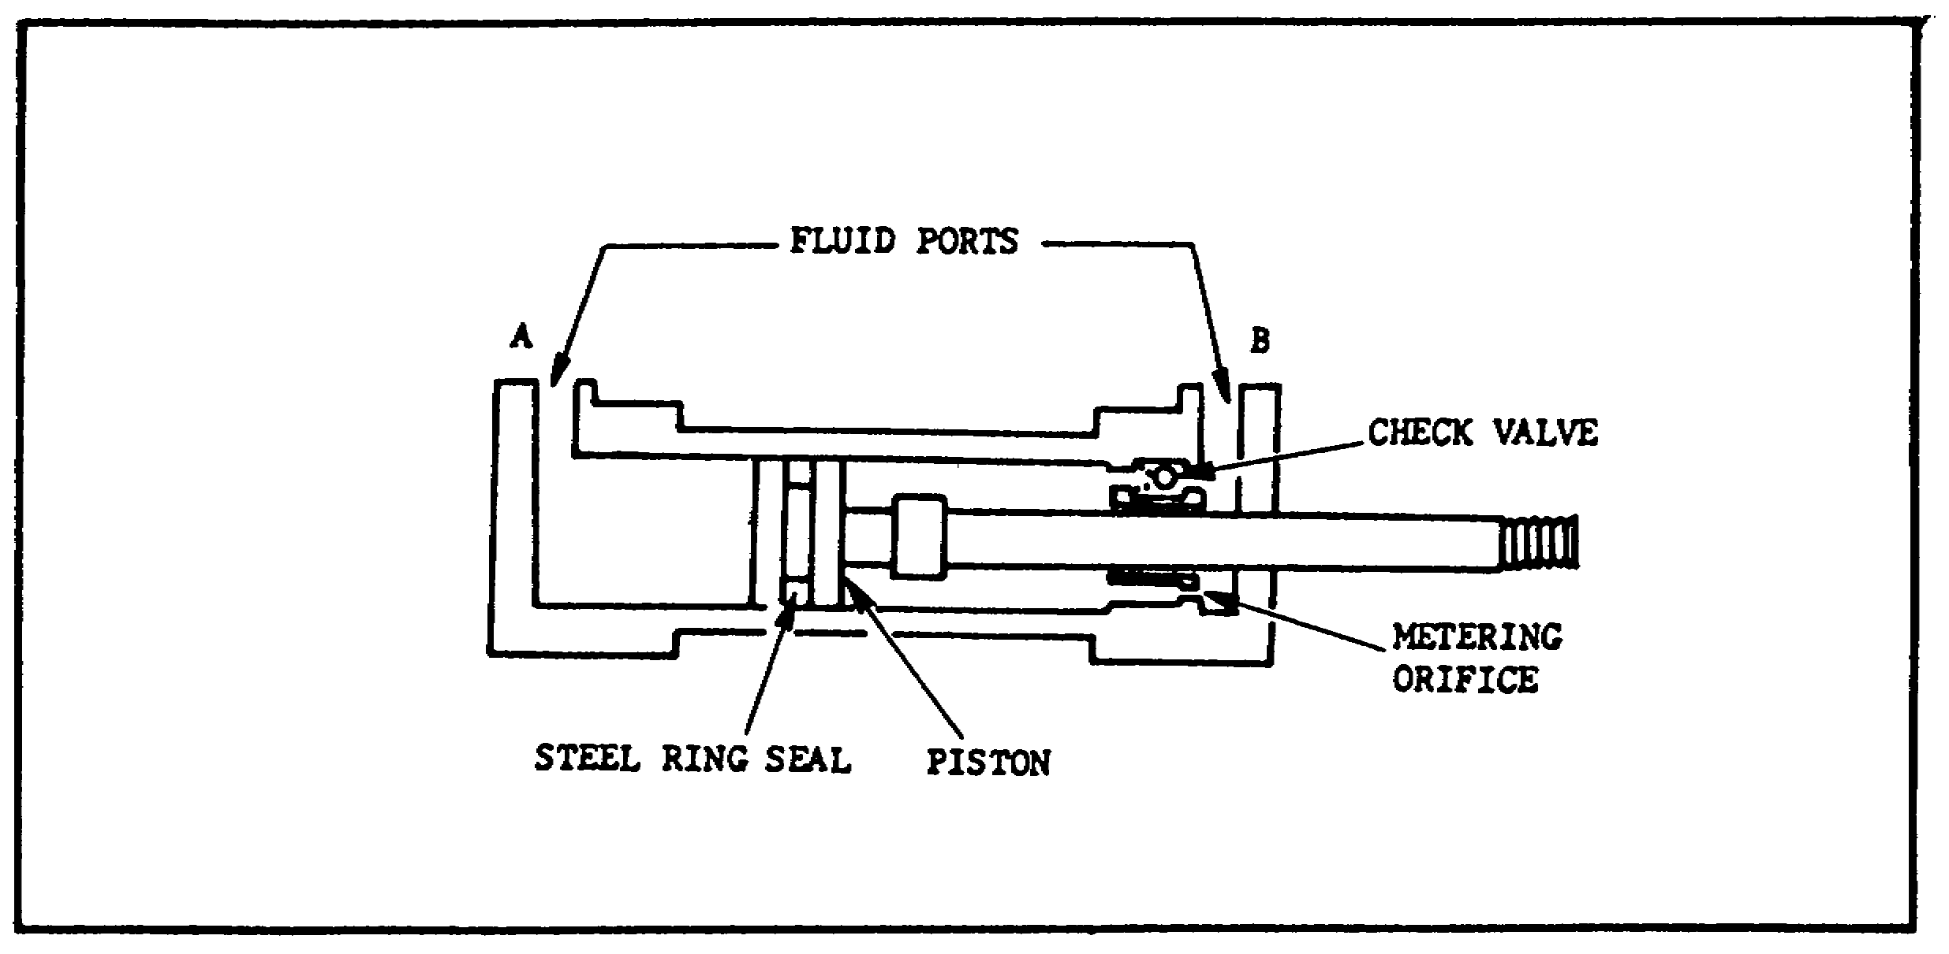

FIGURE 31. CUSHIONED ACTUATING CYLINDER.

(e) Lockout Cylinders. These cylinders are used to lock the suspension mechanism of a tracked vehicle when it is desired to use the vehicle as a stable platform. They also serve as shock absorbers when the vehicle is moving. Each lockout

42

PRINC. OF M1 HYDRAULICS - OD0475 - LESSON 1/TASK 2

cylinder is connected to a road arm by a control lever. When each road wheel moves up, the control lever forces the respective cylinder to compress. Hydraulic fluid is forced around the piston head through restrictor ports, causing the cylinder to act as a shock absorber. When hydraulic pressure is applied to the inlet port on each cylinder connecting eye, an inner control valve piston is forced against a spring in each cylinder. This action closes the restrictor ports, blocks the main piston motion in each cylinder, and locks the suspension system.

g. Hydraulic Motors.

(1) Purpose. Hydraulic motors perform a function opposite to that of hydraulic pumps, that is, they convert hydraulic energy into mechanical energy. In industrial hydraulic circuits, pumps and motors are normally combined with the proper valving and piping to form a hydraulic power transmission. The pump, which is mechanically linked to the prime mover, draws fluid from the reservoir and forces it to the motor. The motor, which is mechanically linked to the work load, is actuated by this flow, so that motion or torque, or both, are conveyed to the work.

(2) Operation. A motor is simply a pump that is being pushed instead of doing the pushing. Oil is pumped into one port and causes the shaft to turn. The same hydraulic chambers carry the oil to the other port and discharge it to return to the tank or the pump inlet.

(a) Ratings. The principal ratings of a motor are pressure, displacement and torque. Displacement tells us how much flow is required for a specified drive speed. Torque and pressure ratings tell us how much load the motor can handle.

(b) Displacement. Displacement of a hydraulic motor is expressed in cubic inches per revolutions, the same as pump displacement. A motor's displacement is the amount of oil we must pump into it to turn it one revolution. Most motors are fixed displacement, but there are variable displacement piston motors in use, particularly in hydrostatic drives.

43

PRINC. OF M1 HYDRAULICS - OD0475 - LESSON 1/TASK 2

(c) Types. The principal types of motors, then are the same as pumps: vane, piston, and gear. They can be unidirectional or reversible. Most motors designed for mobile equipment are reversible.

(3) Gear-type Motors. Figure 32 schematically illustrates the operation of a gear-type motor. Since this is a motor, both gears are driven gears, but only one is connected to the output shaft. Operation is essentially the reverse of that of a gear pump. Flow from the pump enters chamber (A) (figure 32), and flows in either direction around the inside surface of the casing, forcing the gears to rotate as indicated. This rotary motion is then available for work at the output shaft,.
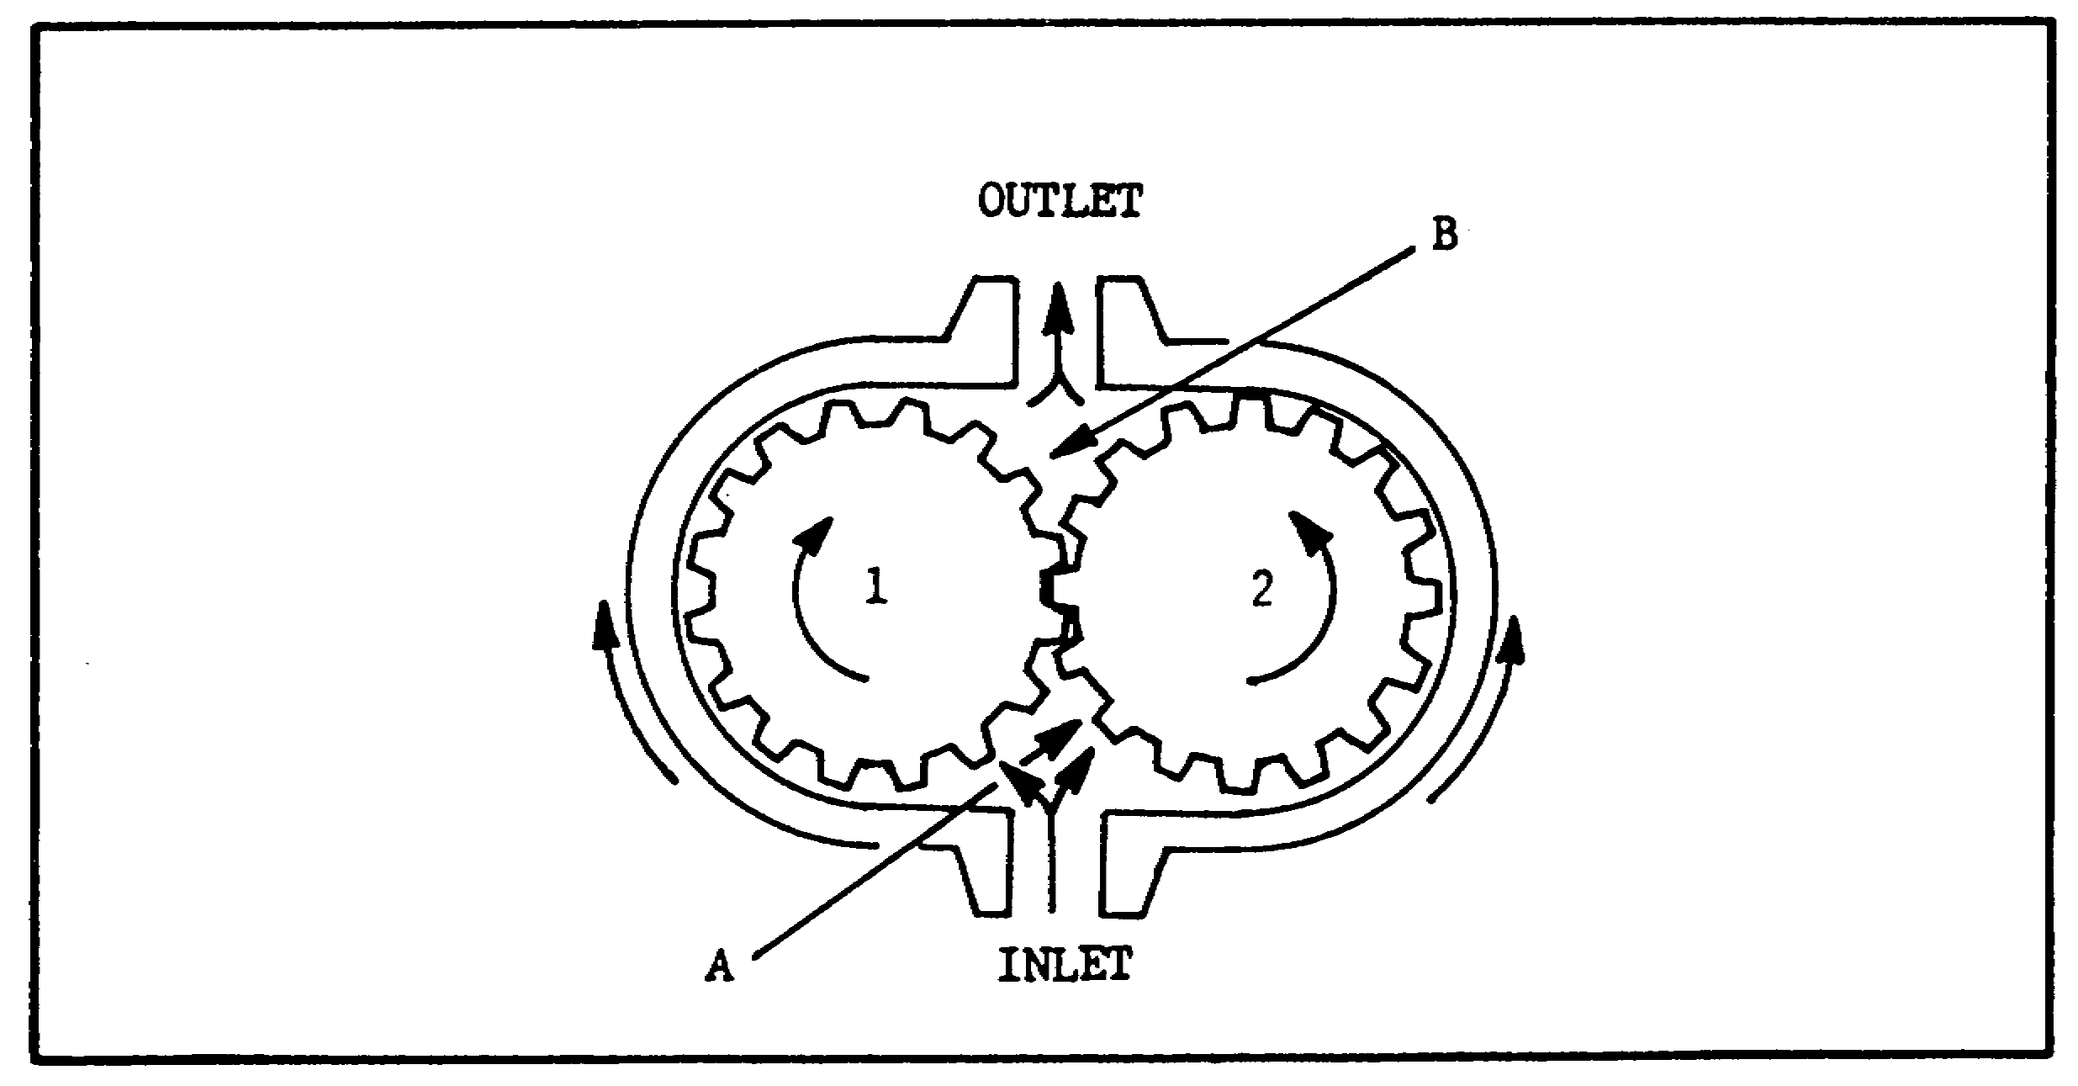

FIGURE 32. GEAR-TYPE MOTOR--SCHEMATIC.

(4) Vane-type Motors. Figure 33, on the following page, schematically illustrates operation of a vane type motor. Flow from the pump enters the inlet, forces the rotor and vanes to rotate, and passes out through the outlet. Rotation of the motor causes the output shaft to rotate. Since no centrifugal force exists until the motor begins to rotate, some method must be provided to initially hold the vanes against the casing contour.

44

PRINC. OF M1 HYDRAULICS - OD0475 - LESSON 1/TASK 2

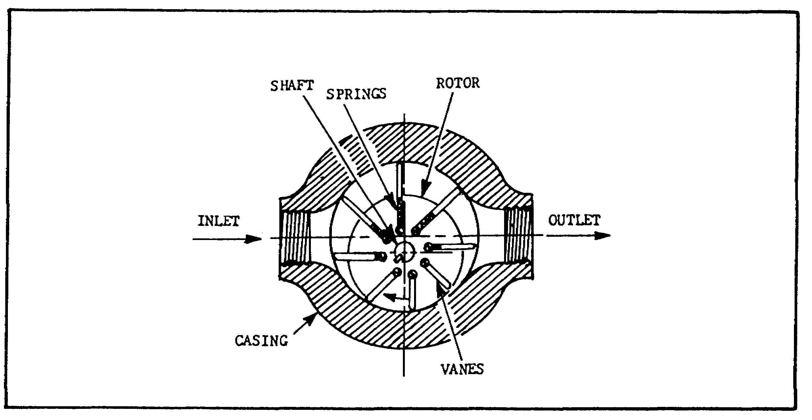
FIGURE 33. VANE-TYPE MOTOR--SCHEMATIC.

(5) Piston-type Motors.

(a) Introduction. the most common designs of piston-type motors are the bent axis and the inline axial piston type. They may be further classified as fixed displacement and variable displacement.

(b) Inline Axial Piston Motors.

1 The inline design piston motors are virtually identical to the pumps. They are built in both fixed and variable displacement models, in several sizes. Torque is developed by the pressure drop through the motor; that is, the pressure exerting a force on the ends of the pistons which is translated into shaft rotation. Shaft rotation of most models can be reversed at will by reversing the direction of flow.

2 Oil from the pump is forced into the cylinder bores through the motor inlet port (figure 34 on the following page). The force on the pistons at this point pushes them against the swash plate. They can move only by sliding along the swash plate to a point further away from the cylinder barrel. In so doing, they cause the cylinder barrel to rotate. The cylinder barrel is splined to the shaft, so the shaft must turn, too.

45

PRINC. OF M1 HYDRAULICS - OD0475 - LESSON 1/TASK 2

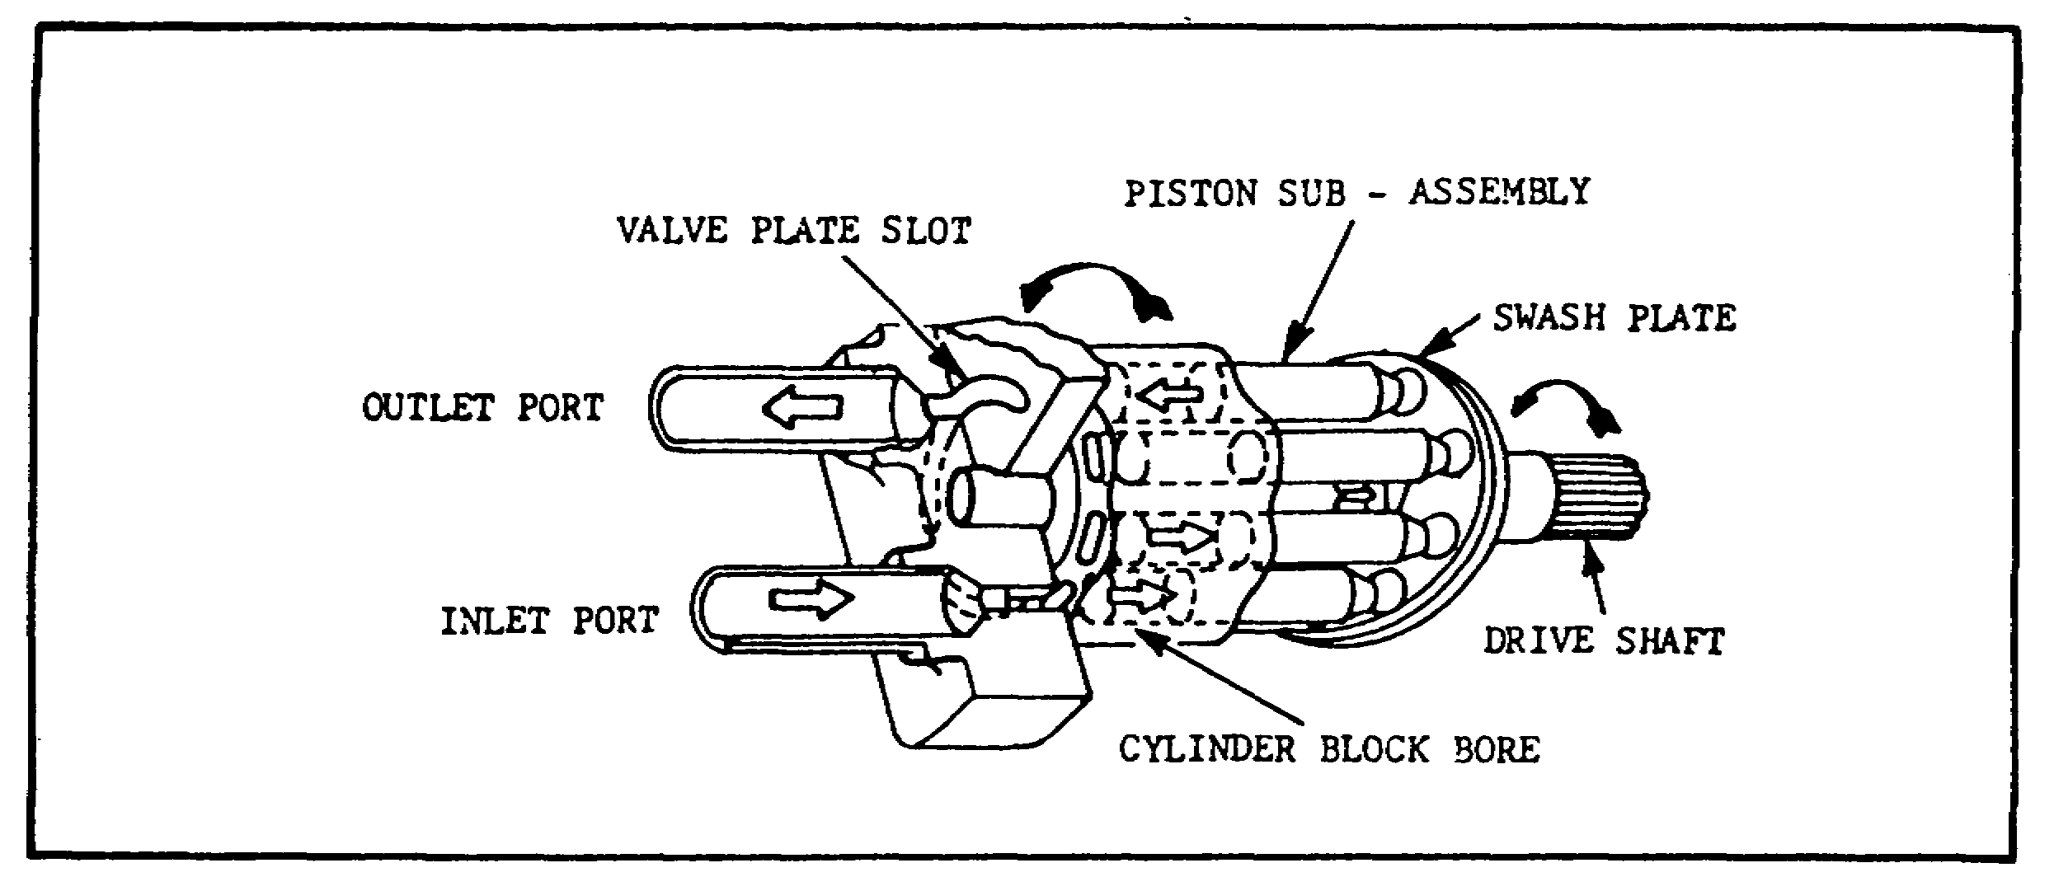
FIGURE 34. INLINE AXIAL PISTON MOTOR.

3 The motor's displacement depends on the angle of the swash plate (figure 35). At maximum angle, the displacement is maximum, because the pistons travel maximum length. When the angle is reduced, piston travel shortens, reducing displacement. If the flow remains constant, the motor then runs faster, but torque is decreased. Torque is greatest at maximum displacement because the component of piston force parallel to the swash plate is greatest.
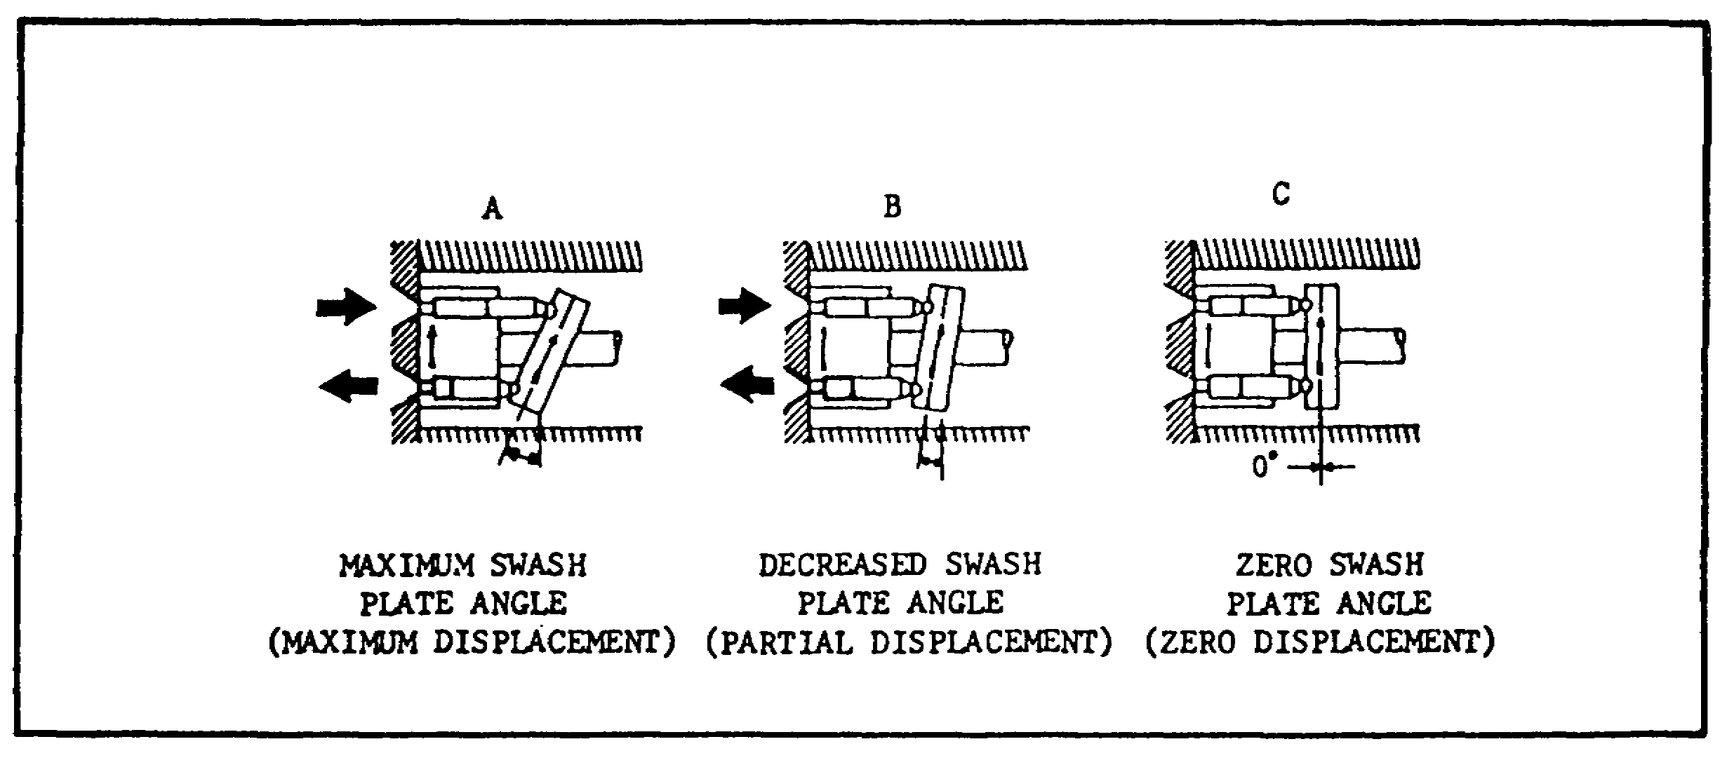

FIGURE 35. SWASH PLATE.

(c) Bent-axis Piston Motors.

1 Angle-type or bent-axis piston motors are also nearly identical to the pumps. They are built in both fixed displacement and variable displacement versions and in several sizes.

46

PRINC. OF M1 HYDRAULICS - OD0475 - LESSON 1/TASK 2

Variable displacement motors can be controlled mechanically, or by pressure compensation.

2 Operation of the motor is nearly identical to inline motors, except that the thrust of the pistons is against the driveshaft flange. The parallel component of the thrust causes the flange to turn. Torque is maximum at maximum displacement; speed is minimum. This design piston motor is very heavy and bulky, particularly the variable displacement motor. Its use on mobile equipment is limited.

h. Valves - Operation.

(1) Introduction. It is impossible to develop a useful fluid power system without using valves. It is also difficult to manage a fluid power system without knowing how to control its valves and ensure their efficient operation. There follows a brief introduction to the uses of valves found in fluid power systems.

(2) Valve Groupings. Hydraulic valves can be grouped into three general categories: pressure controls, flow controls, and directional controls. Some valves, however, have multiple functions that fall into more than one of these categories.

(3) Ratings. Valves are rated by their size, pressure capabilities, and pressure drop vs. flow. They are usually named for their functions, but may be named for their construction as well.

(4) Pressure Control Valves.

(a) Operation. A pressure control valve may have the job of (1) limiting or otherwise regulating pressure; (2) creating a particular pressure condition required for control; or (3) causing actuators to operate in a specific order. All pure pressure control valves operate in a condition approaching hydraulic balance. Usually the balance is very simple: pressure is effective on one side or end of a ball, poppet or spool; and is opposed by a spring. In operation, the valve takes a position where the hydraulic pressure exactly balances the spring force.

(b) Infinite Positioning. Since spring force varies with compression distance, and since pressure also can vary, a pressure control valve is
47
PRINC. OF M1 HYDRAULICS - OD0475 - LESSON 1/TASK 2

said to have infinite positioning. In other words, it can take a position anywhere between two finite flow conditions, changing a large volume of flow to a small volume, or passing no flow at all.

(c) Classifications. Most pressure control valves are classified as normally-closed. This means that flow to the valve inlet port is blocked from the outlet port until pressure becomes high enough to cause "unbalanced" operation. In a normally-open valve, there is free flow through the valve until it begins to operate in balance. Then, flow is partially restricted or cut off.

(5) Relief Valves.

(a) Purpose. The most common type of pressure control valve is the relief valve. The function of a relief valve may be varied to meet the needs of the system. A relief valve can be used to provide overload protection for circuit components, or to limit the force or torque exerted by a linear actuator or rotary motor.
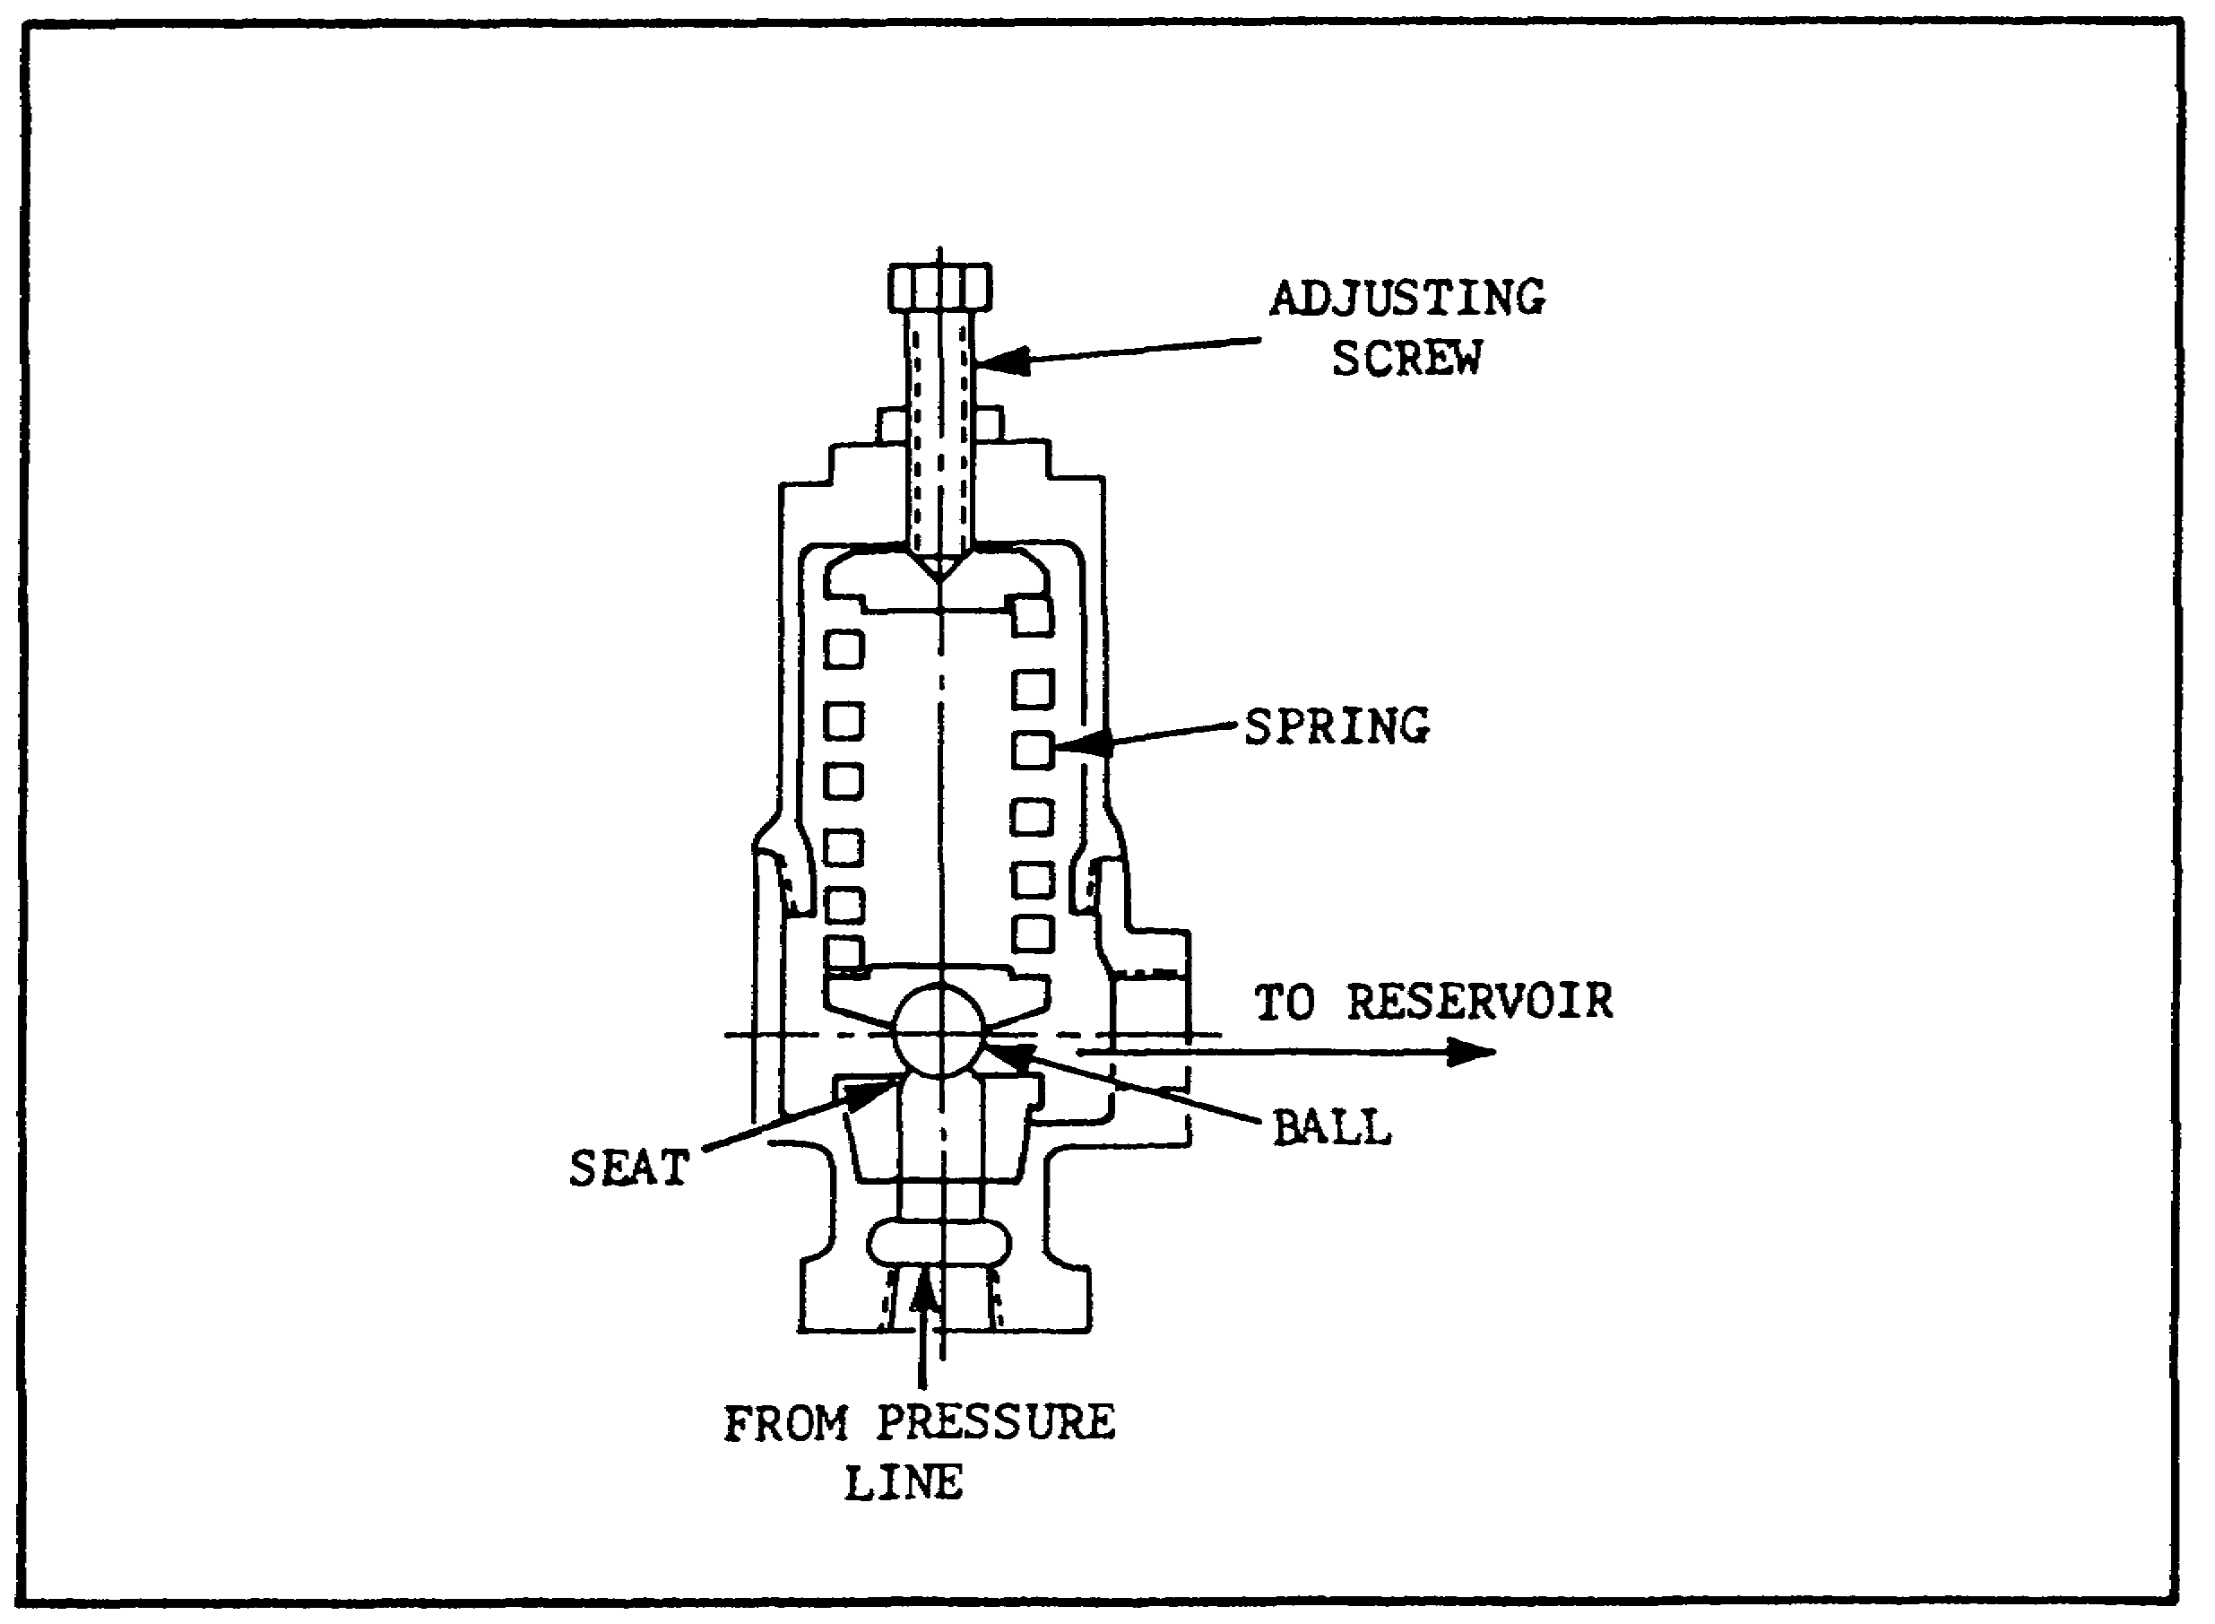

FIGURE 36. SIMPLE RELIEF VALVE.

48

PRINC. OF M1 HYDRAULICS - OD0475 - LESSON 1/TASK 2

(b) Operation.

1 A relief valve of the simple type is shown in figure 36 on the previous page. The valve is installed so that one port is connected to the pressure line or inlet, and the other to the reservoir. The ball is held on its seat by thrust of the spring. Spring thrust can be changed by turning the adjusting screw. When pressure at the valve inlet is insufficient to overcome spring force, the ball remains on its seat and the valve is closed, as shown. Position of the ball prevents flow through the valve. When pressure at the valve inlet exceeds the adjusted spring force, the ball is forced off its seat and the valve is opened. Liquid flows from the pressure line, through the valve, to the reservoir. This diversion of flow prevents further pressure increase in the pressure line. When pressure decreases below the valve setting, the spring reseats the ball and the valve is again closed.

2 The pressure at which the valve first begins to pass flow is termed the "cracking pressure" of the valve. The pressure at which the valve passes its full rated capacity is termed the "full flow pressure" of the valve. Because of the spring rate, the full flow pressure is higher than the cracking pressure. This condition is referred to as "pressure override", and one disadvantage of a simple type of relief valve is its relatively high pressure override at its rated capacity.
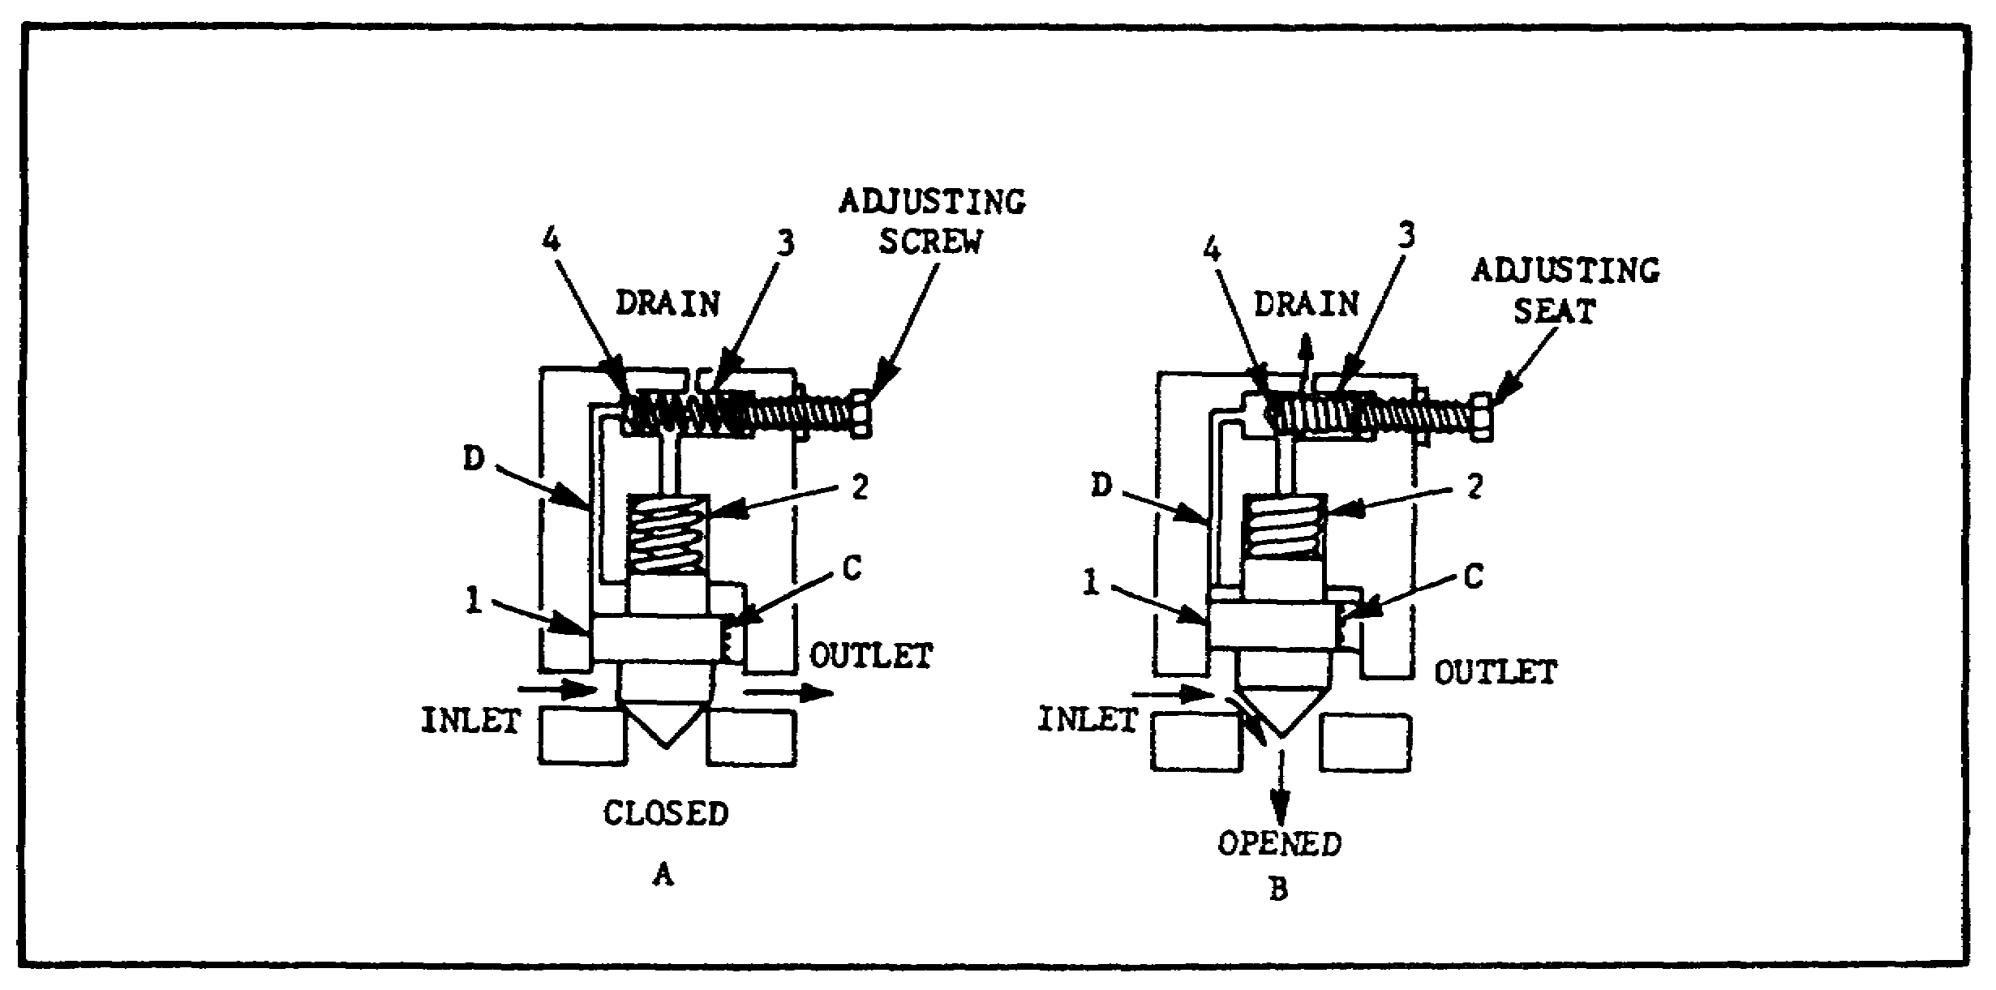

FIGURE 37. COMPOUND RELIEF VALVE.

49

PRINC. OF M1 HYDRAULICS - OD0475 - LESSON 1/TASK 2

3 A relief valve of the compound type is shown in figure 37, on the previous page. Passage (C) is used to keep the piston in hydraulic balance when the valve inlet pressure is less than the valve setting (A). The valve setting is determined by the adjusted thrust of spring (3) against poppet (4). When pressure at the valve inlet reaches the valve setting, the pressure in passage (D) also rises, to overcome the thrust of spring (3). When the flow through passage (C) creates sufficient pressure drop to overcome the thrust of spring (2), the piston is raised off its seat, as shown in (B). This allows flow to pass through the discharge port to the reservoir and prevents further rise in pressure.

(6) Pressure Reducing Valves.

(a) Purpose. Pressure reducing valves limit pressure on a branch circuit to something less than that required in the main circuit.

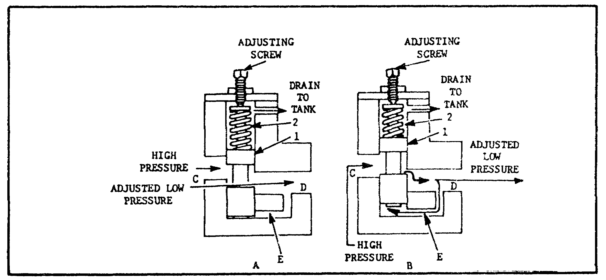
FIGURE 38. PRESSURE REDUCING VALVE.

(b) Function. As an example of the function of a pressure reducing valve, assume a circuit in which it is necessary to limit branch circuit pressure to 300 psi, but in which the main circuit operating pressure must be 800 psi to fulfill the work requirements. A relief valve, adjusted to a setting above 800 psi, installed in the main circuit would allow main circuit pressure to rise to the necessary 800 psi. However, this relief valve would not limit branch circuit. pressure to 300 psi. Therefore, a circuit such as this would

60

PRINC. OF M1 HYDRAULICS - OD0475 - LESSON 1/TASK 2

require a relief valve adjusted to a setting of 800 psi installed in the main circuit and a pressure reducing valve adjusted to a setting of 300 psi installed in the branch circuit.

(c) Operation.

1 Figure 38, on the previous page, schematically illustrates a pressure reducing valve.

2 The desired maximum branch circuit pressure is determined by adjustment of the compression of the spring, which acts to hold spool (1) in the open position. Liquid from the main circuit enters the valve at inlet port (C), flows past the valve spool, and enters the branch circuit through outlet port D. Pressure at outlet port D acts through passage E to the bottom of spool (1). When this pressure is insufficient to overcome the thrust of spring (2), the valve remains open, as shown in A, figure 38.

3 When pressure at outlet port (D), and beneath spool (1), exceeds the equivalent thrust of spring (2), the spool is raised and the valve is partially closed, as shown in (B)(figure 38). This increases the valve's resistance to flow, thereby creating a greater pressure drop through the valve and reducing the pressure at outlet port (D). The spool will position itself to limit maximum pressure at outlet port (D) irrespective of pressure fluctuations at inlet port (C), as long as work load does not cause back flow at the outlet port. Back flow would close the valve and pressure would increase.

(7) Sequence Valves.

(a) Purpose. Sequence valves control the sequence of operation between two branches of a circuit. They are commonly used to regulate the operating sequence of two separate work cylinders, so that one cylinder begins its stroke when the other completes its stroke. A sequence valve used in this manner also ensures minimum pressure equal to its setting on the first cylinder, during the subsequent operation at lower pressure.

(b) Operation.

1 Figure 39, on the following page, schematically illustrates the operation of a sequence valve.
51

PRINC. OF M1 HYDRAULICS - OD0475 - LESSON 1/TASK 2

2 The desired sequencing pressure is obtained by adjusting the compression of the spring which acts to hold piston (1) in the closed position. Liquid enters the valve at inlet port (C), flows
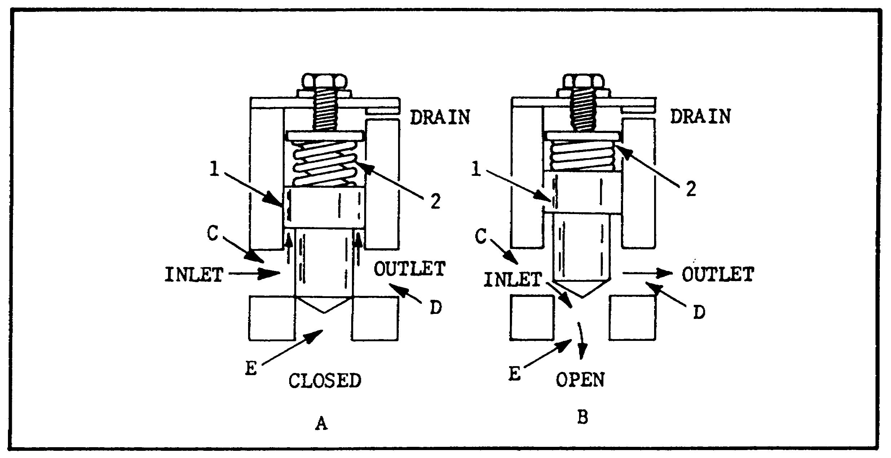
FIGURE 39. SEQUENCE VALVE.

freely past piston (1) and enters the primary circuit through port (D). When pressure of the liquid flowing through the valve is below the valve setting, the force acting upward on piston (1) is less than the downward force of the spring (2), so that the piston is held down and the valve is in the closed position, as shown in (A)(figure 39).

3 When resistance in the primary circuit causes the pressure to rise sufficiently to overcome the force of spring (2), piston (1) rises. The valve is then open, as shown in (B)(figure 39). Liquid entering the valve can now flow through port (E) to the secondary circuit.

(8) Counterbalance Valves.

(a) Purpose. The purpose of a counterbalance valve is to permit free flow of fluid in one direction and to maintain a resistance to flow in the other direction, until a certain pressure is reached. The valve is normally located in the line between the directional control valve and the outlet of a vertically mounted actuating cylinder which supports weight, or must be held in position for a period of time. The counterbalance valve

52

PRINC. OF M1 HYDRAULICS - OD0475 - LESSON 1/TASK 2

serves as a hydraulic resistance to the actuating cylinder. For example, counterbalance valves are used in some hydraulically operated fork lifts. The valve offers a resistance to the flow from the actuating cylinder when the fork is lowered. It also helps to support the fork in the up position.

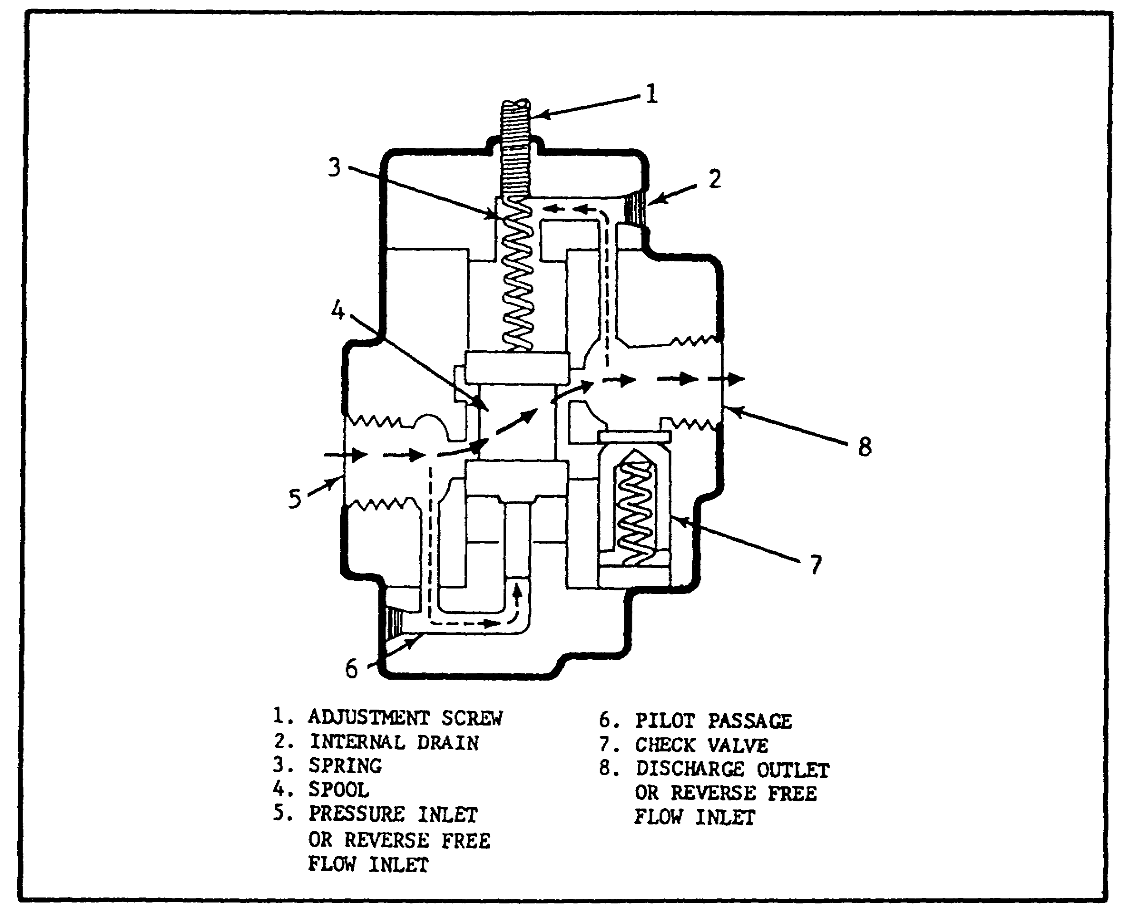
FIGURE 40. COUNTERBALANCE VALVE.

(b) Operation.

1 A counterbalance valve is shown in figure 40.

2 The valve element is a balance spool valve (4). The spool valve consists of two pistons permanently fixed on either end of a shaft. The inner piston areas of the pistons are equal; therefore, pressure acts equally on both areas regardless of the position of the valve, and has no effect on the movement of the valve; hence the

53

PRINC. OF M1 HYDRAULICS - OD0475 - LESSON 1/TASK 2

term "balanced." A small pilot piston is attached to the bottom of the spool valve.

3 When the valve is in the closed position, the top piston of the spool valve blocks the discharge port (8). With the valve in this position, fluid, flowing from the actuating unit, enters the inlet port (5). The fluid cannot flow through the valve because the discharge port (8) is blocked. However, fluid will flow through the pilot passage (6) to the small pilot piston. As the pressure increases, it acts on the pilot piston until it overcomes the preset pressure of spring (3). This forces the spool up and allows the fluid to flow around the shaft of the spool valve and out the discharge port (8). Figure 40, on the previous page, shows the valve in this position.

4 During reverse flow, the fluid enters port (8). The spring (3) forces the spool valve (4) to the closed position. The fluid pressure overcomes the spring tension of check valve (7). The check valve opens and allows free flow around the shaft of the spool valve and out port (5).

5 The operating pressure of the valve can be adjust by turning the adjustment screw (1), which increases or decreases the tension of the spring. The adjustment depends on the weight that the valves must support.

6 It is normal for small amounts of fluid to leak around the top piston of the spool valve and into the area around the spring (3). An accumulation would cause a hydraulic lock on the top of the spool valve (since a liquid cannot be compressed). The drain (2) provides a passage for this fluid to flow to port (8).

(9) Directional Control Valves. Although all directional control valves share the common purpose of controlling the direction of flow, they vary considerably in physical characteristics and operation.

(a) Types. The valving element of these units may be of the poppet type, in which a piston or ball moves on and off a seat, the rotary spool type, in which the spool rotates about its axis, or the sliding spool type, in which the spool slides axially in a bore. In the sliding spool type, the spool is often classified according to the flow

54

PRINC. OF M1 HYDRAULICS - OD0475 - LESSON 1/TASK 2

conditions created when it is in its normal or neutral position. Thus, a "closed-center" spool blocks all valve ports from each other when in the normal, center position; while with the "open-center" spool, all valve ports are open to each other when the spool is in this position. The closed-center and open-center types of sliding spool are only two of the many spool designs used in the various sliding spool-type directional control valves.

(b) Classifications.

1 Directional control valves may also be classified according to the method used to actuate the valving element. A poppet-type valve is usually hydraulically operated. A rotary spool type may be manually operated (lever or plunger action), mechanically operated (cam or trip action), or electrically operated (solenoid action). The sliding spool-type may be manually, mechanically, electrically, or hydraulically operated, or may require a combination thereof.

2 Directional control valves may also be classified according to the number of positions of the valving element, or the total number of flow paths provided in the extreme position. For example, a three-position, four-way valve has two extreme positions and a center or neutral position. In each of the two extreme positions, there are two paths of flow providing a total of four flow paths.

(10) Poppet Valves.
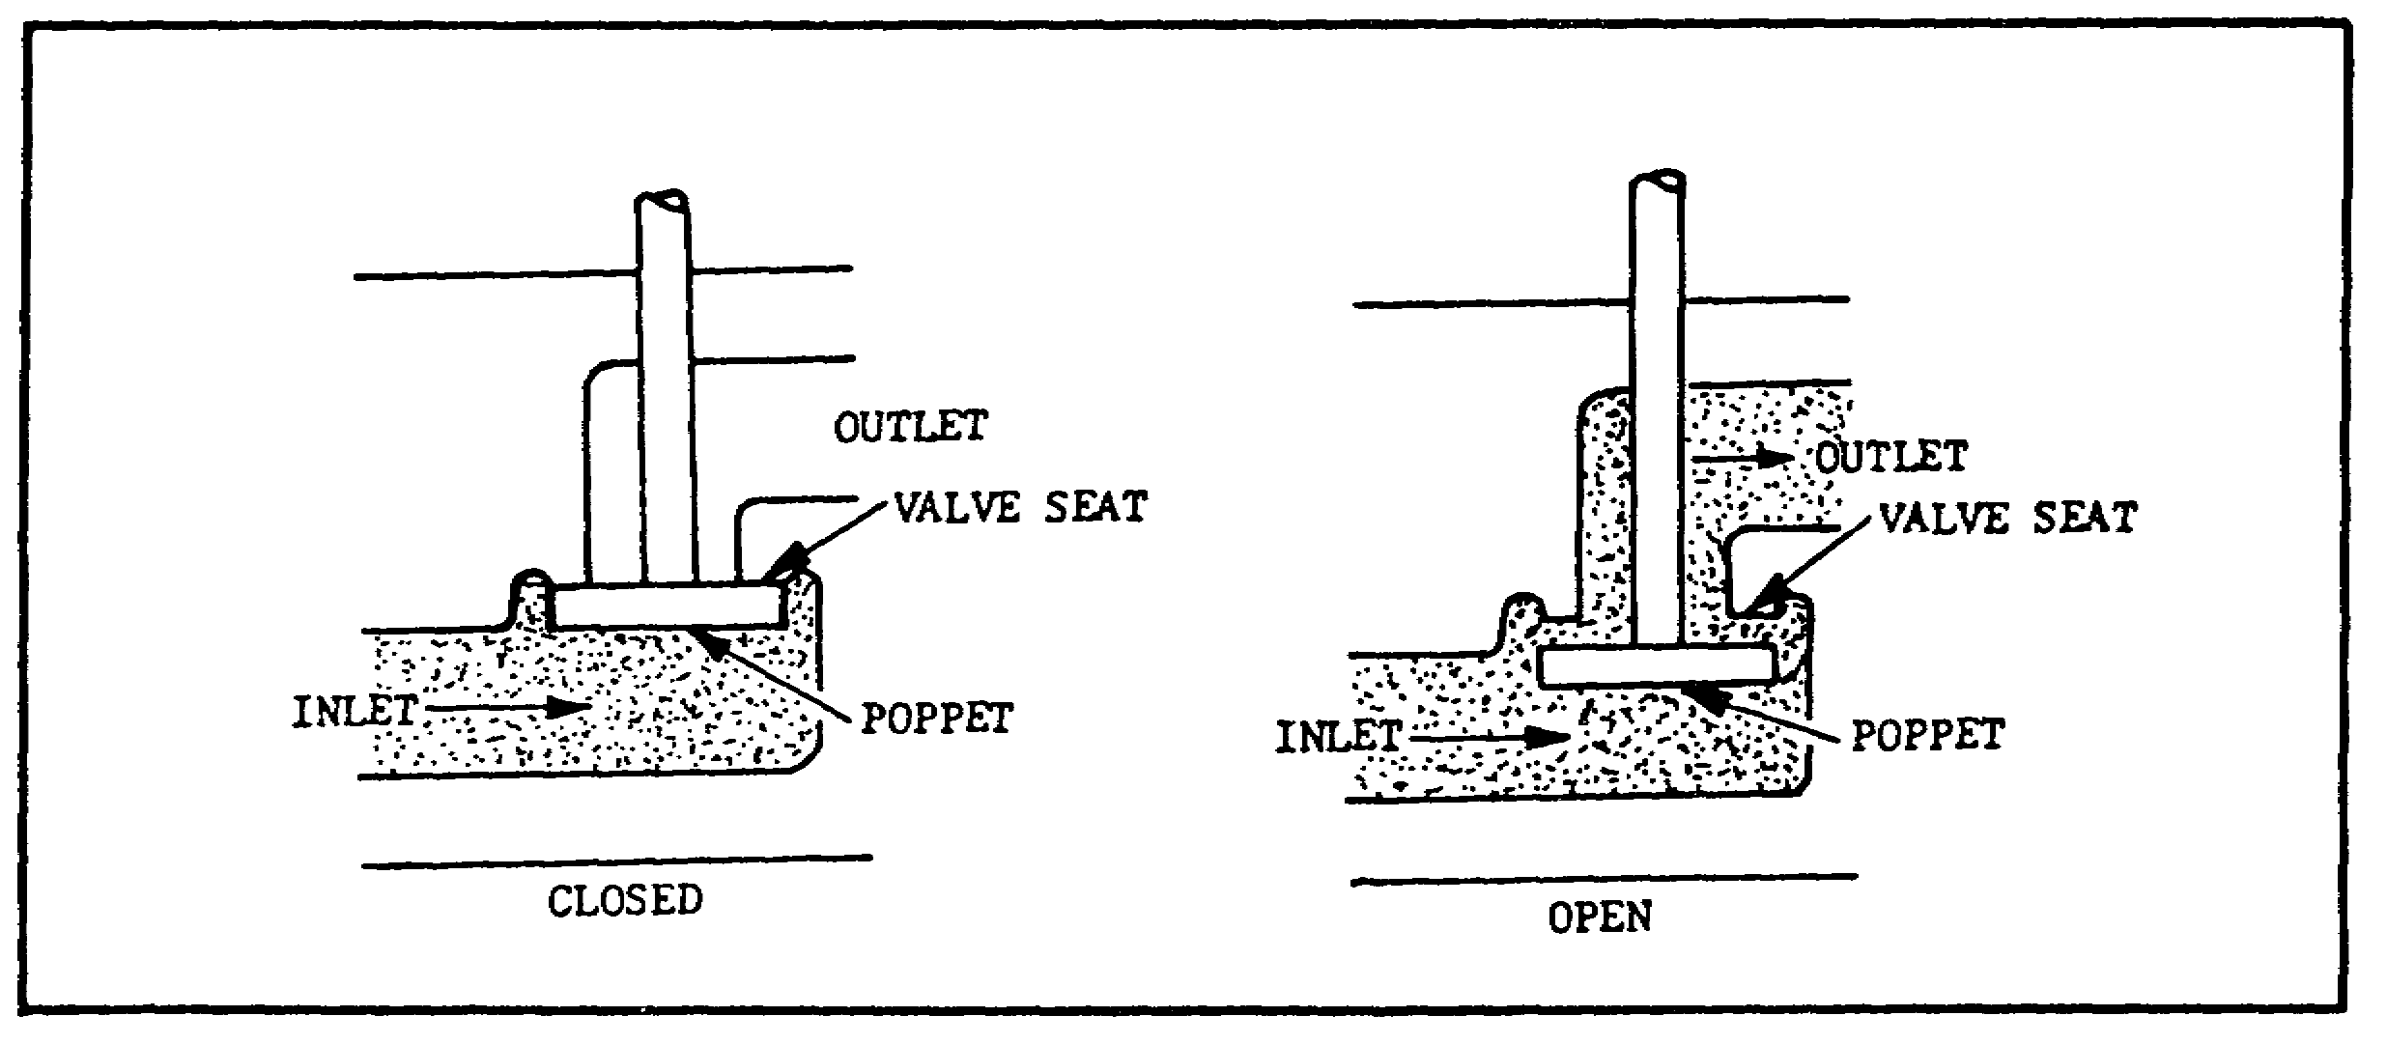

FIGURE 41. OPERATION OF A SIMPLE POPPET VALVE.

55

PRINC. OF M1 HYDRAULICS - OD0475 - LESSON 1/TASK 2

Figure 41 illustrates the operation of a simple poppet valve. It consists primarily of a movable poppet which closes against a valve seat. Pressure from the inlet tends to hold the valve tightly closed. A slight force applied to the poppet stem opens the poppet. The action is similar to the valves of an automobile engine. The poppet stem usually has an O-ring seal to prevent leakage. In some valves, the poppets are held in the seated position by springs. The number of poppets in a valve depends on the purpose of the valve.

(11) Sliding Spool Valves.

Figure 42 shows a sliding spool valve. The valve element slides back and forth, blocking and uncovering ports in the housing. Sometimes called the piston type, the valve has a piston of which

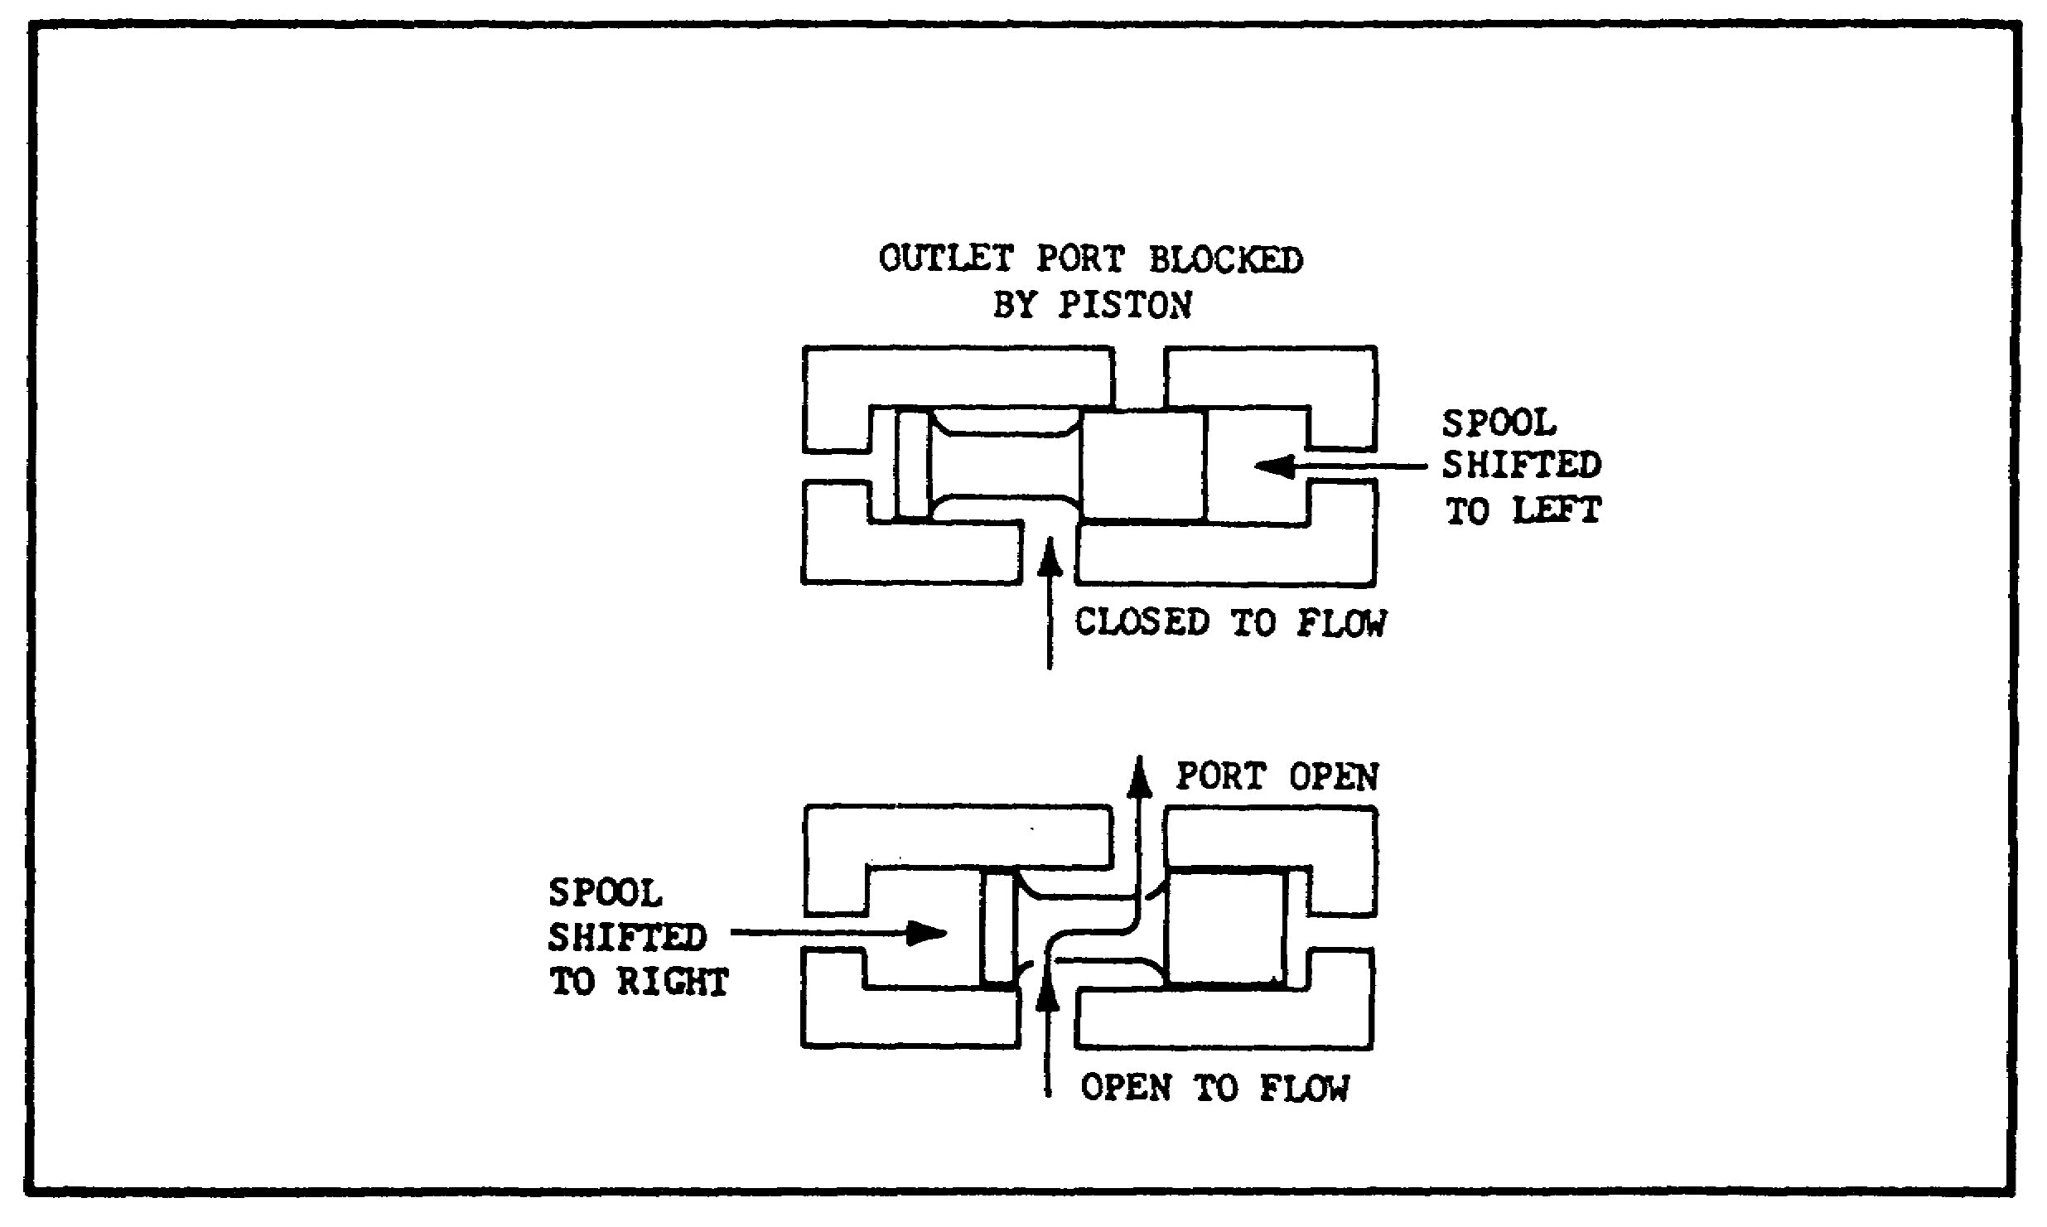
FIGURE 42. OPERATION OF THE SLIDING SPOOL
DIRECTIONAL CONTROL VALVE.

the inner areas are equal. Pressure from inlet ports acts equally on both inner piston areas, regardless of the position of the spool. Sealing is done by a machined fit between the spool and valve body or sleeve.

(12) Check Valves.

(a) Purpose. Check valves are the most

56

PRINC. OF M1 HYDRAULICS - OD0475 - LESSON 1/TASK 2 - 05/86

commonly used valves in fluid power systems. They permit flow in one direction and prevent flow in the other. They may be installed independently in a line, or may be incorporated as an integral part of a sequence, counterbalance, or pressure-reducing valve.

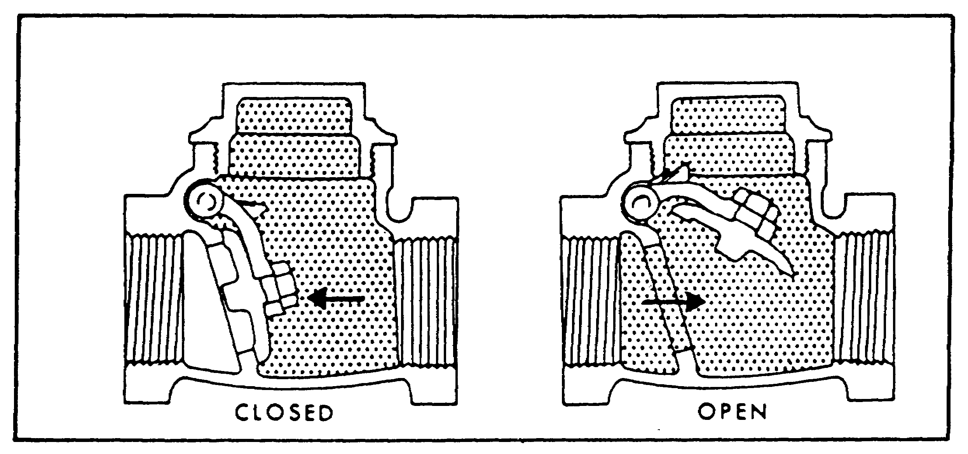
FIGURE 43. SWING-TYPE CHECK VALVE.

In check valves, the valving element may be a sleeve, cone, ball, poppet, piston, spool, or disc. Force of the moving fluid opens a check valve, which is closed by back flow, a spring, or gravity. Figures 43 through 45 show the various types.

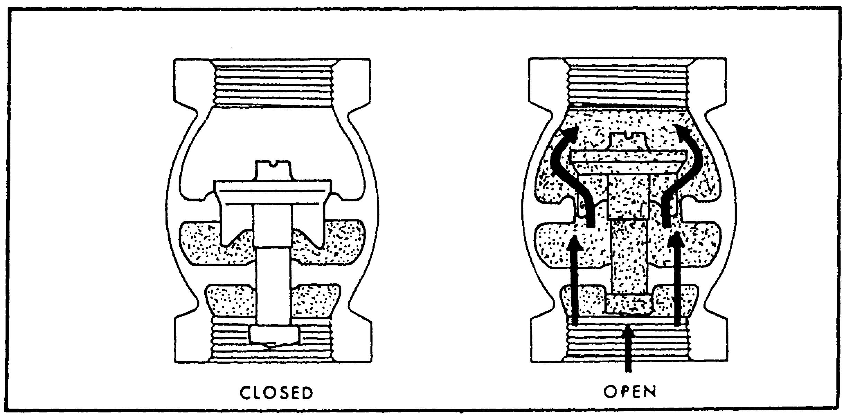
FIGURE 44. VERTICAL CHECK VALVE.

57

PRINC. OF M1 HYDRAULICS - OD0475 - LESSON 1/TASK 2 - 05/86
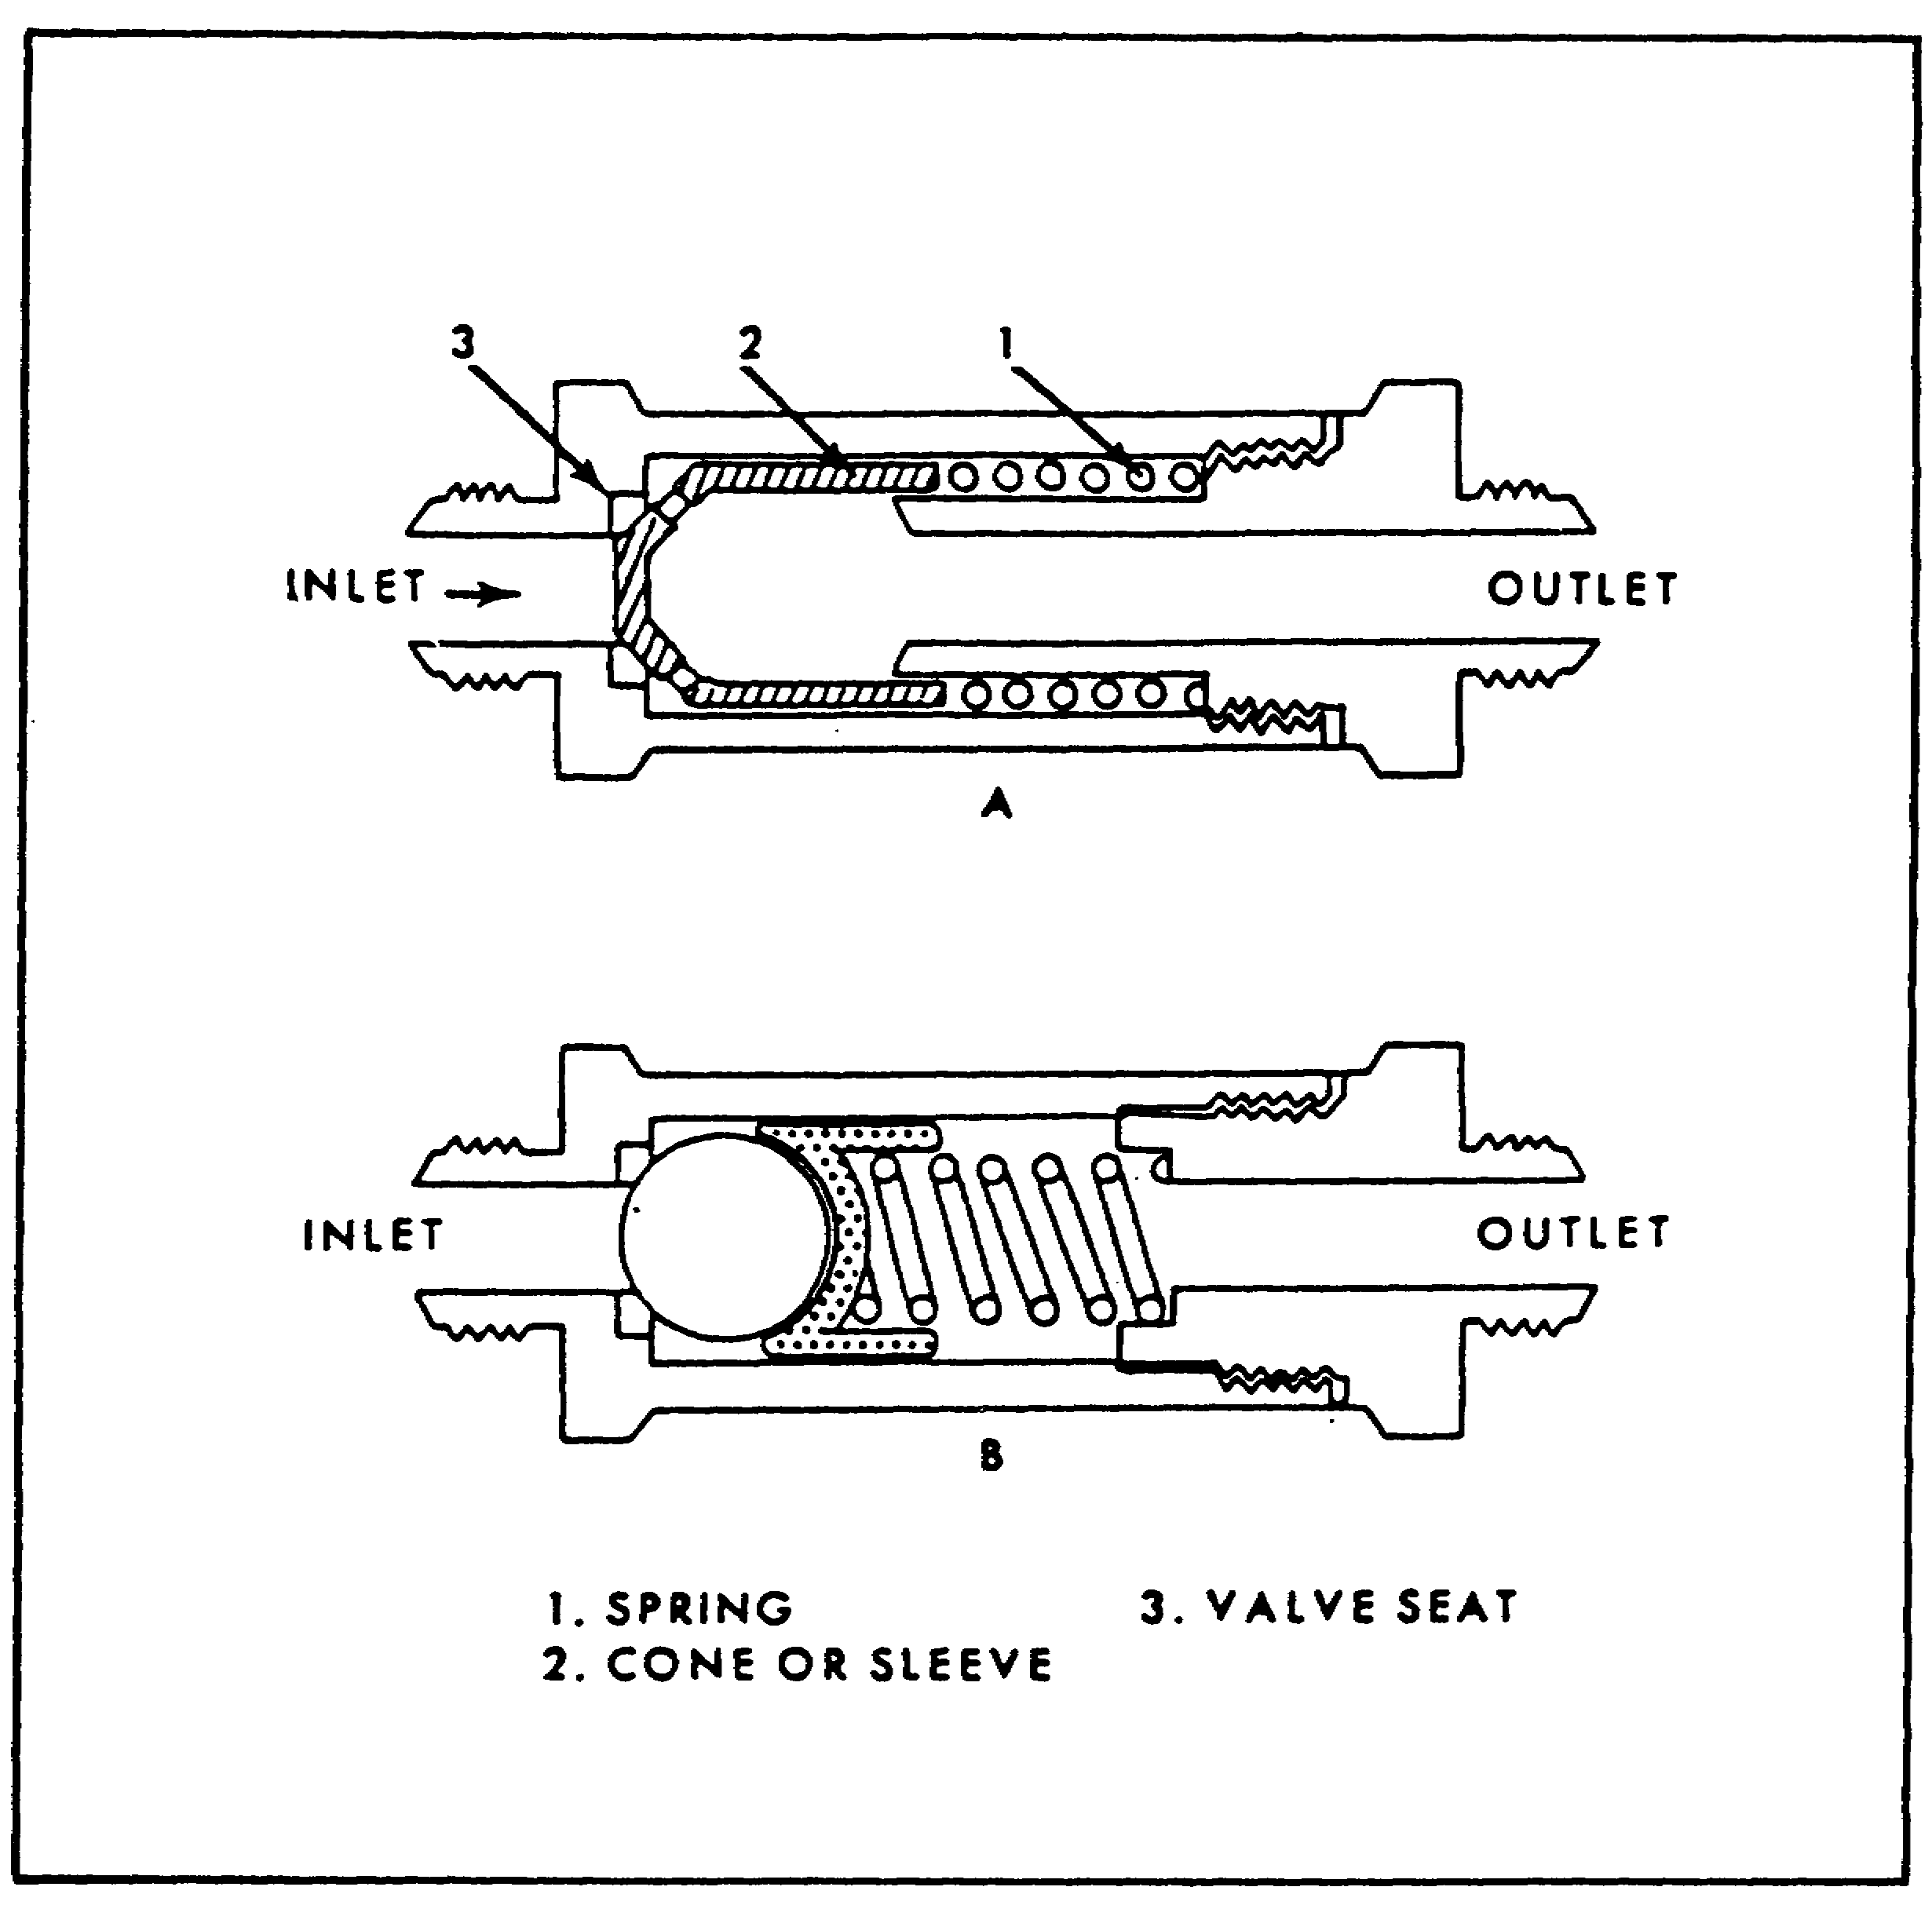

FIGURE 45. SPRING-LOADED CHECK VALVE.

(b) Operation. The standard check valve has two commonly used modifications; the restriction check valve, and the pilot operated check valve. A restriction check valve permits free flow in one direction and restricted flow in the opposite direction. A pilot operated check valve operates as a standard check valve but can be opened, by remote pilot pressure, to permit reverse flow.

(c) Standard Check Valves.

1 These check valves may be of the right-angle type or the in-line type, according to the relative locations of their ports. Both types operate on the same principle (figure 46).

58

PRINC. OF M1 HYDRAULICS - OD0475 - LESSON 1/TASK 2 - 05/86
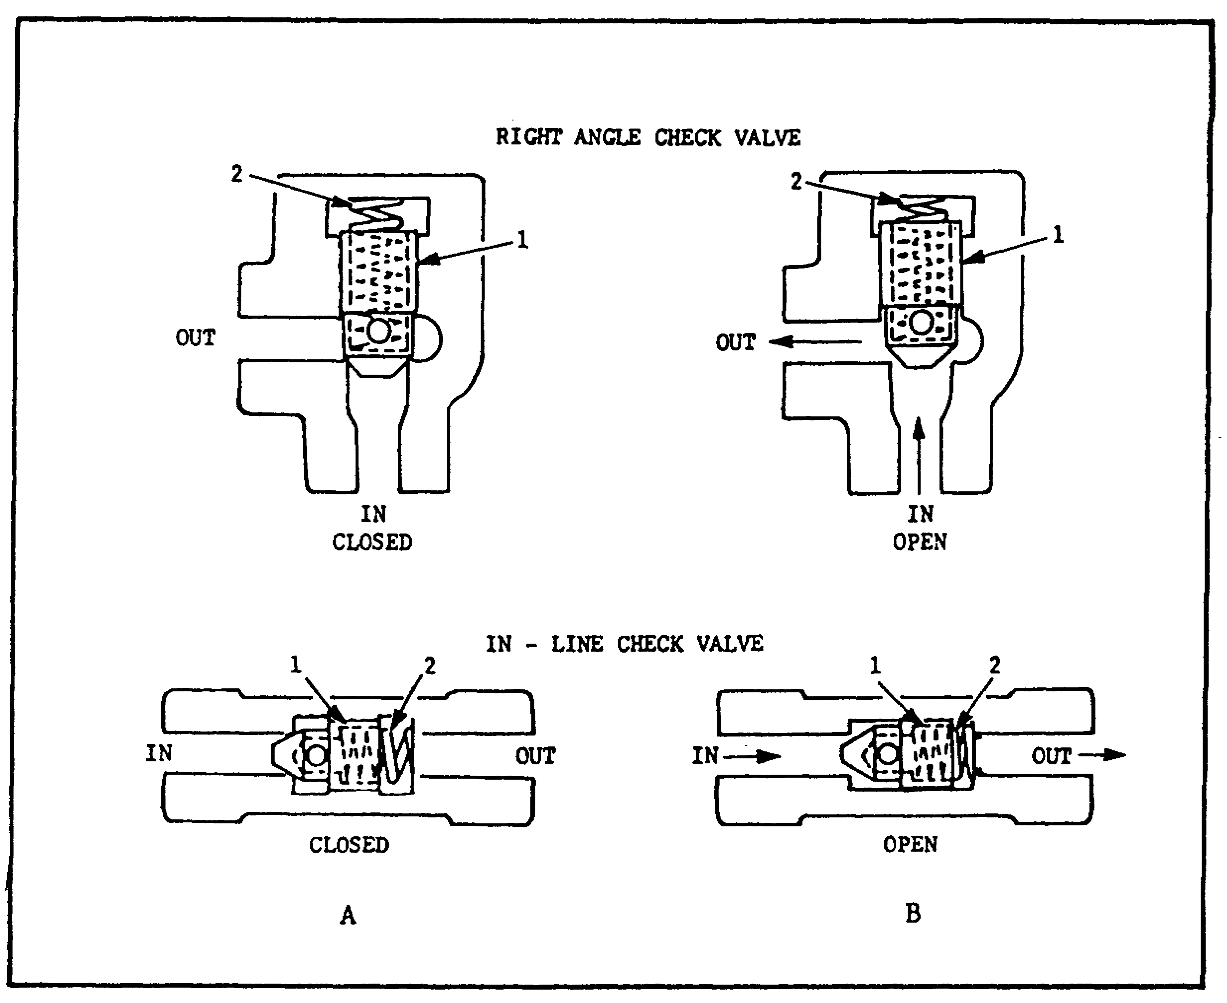

FIGURE 46. CHECK VALVE OPERATION.

The valves consist essentially of a poppet or ball (1)(figure 46), held on a seat by the force of a spring (2). Flow directed to the inlet port acts against the spring (2) to unseat the poppet (1) and open the valve for through flow (B)(figure 46). Flow entering the valve through the outlet port combines with spring action to hold the poppet (!) on its seat to check reverse flow.

2 Check valves are available with various cracking pressures. Conventional applications usually incorporate the light spring which assures reseating of the poppet regardless of mounting position of the valve. "Heavy spring" units are used to ensure the availability of at least the minimum pressure required for pilot operations.

59

PRINC. OF M1 HYDRAULICS - OD0475 - LESSON 1/TASK 2 - 05/86

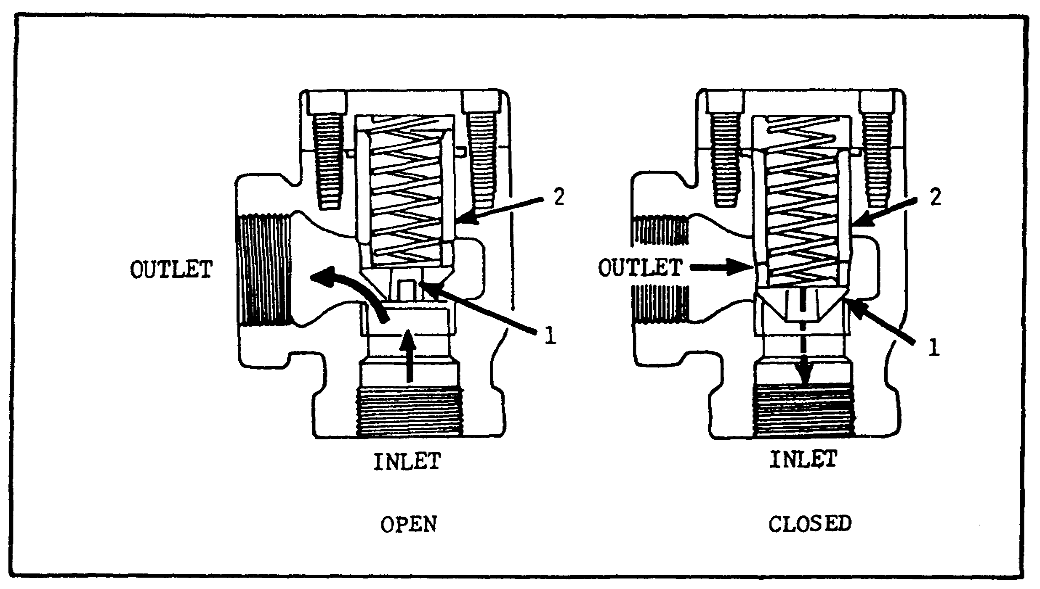
FIGURE 47. CONSTRUCTION OF RESTRICTION VALVE.

(d) Restriction Check Valves. Figure 47 shows that the construction of a restriction check valve differs from a conventional right-angle check valve only in the incorporation of an orifice plug (1) (figure 47) in the nose of poppet (2). Flow directed to the inlet port will open the valve, to permit free flow through the valve. Reverse flow, directed in through the outlet port, seats poppet (2). This flow is restricted to the amount of oil which will pass through the orifice, the size of which can be altered to allow a suitable bleed when the poppet is closed. This valve is sometimes used to control the lowering speed of a down-moving piston. Another use is to control the rate of decompression in large presses.

(13) Two-way Valves.

(a) Purpose. Two-way valves are generally used to control the direction of fluid flow in a hydraulic circuit. These valves are generally of the sliding spool type.

(b) Operation. A two-way, sliding spool directional control valve is shown, in the open and closed positions, in figure 48 on the following page. As the spool moves back and forth it either allows or prevents the flow of fluid through the valve. In either shifted position in a two-way

60

PRINC. OF M1 HYDRAULICS - OD0475 - LESSON 1/TASK 2 - 05/86

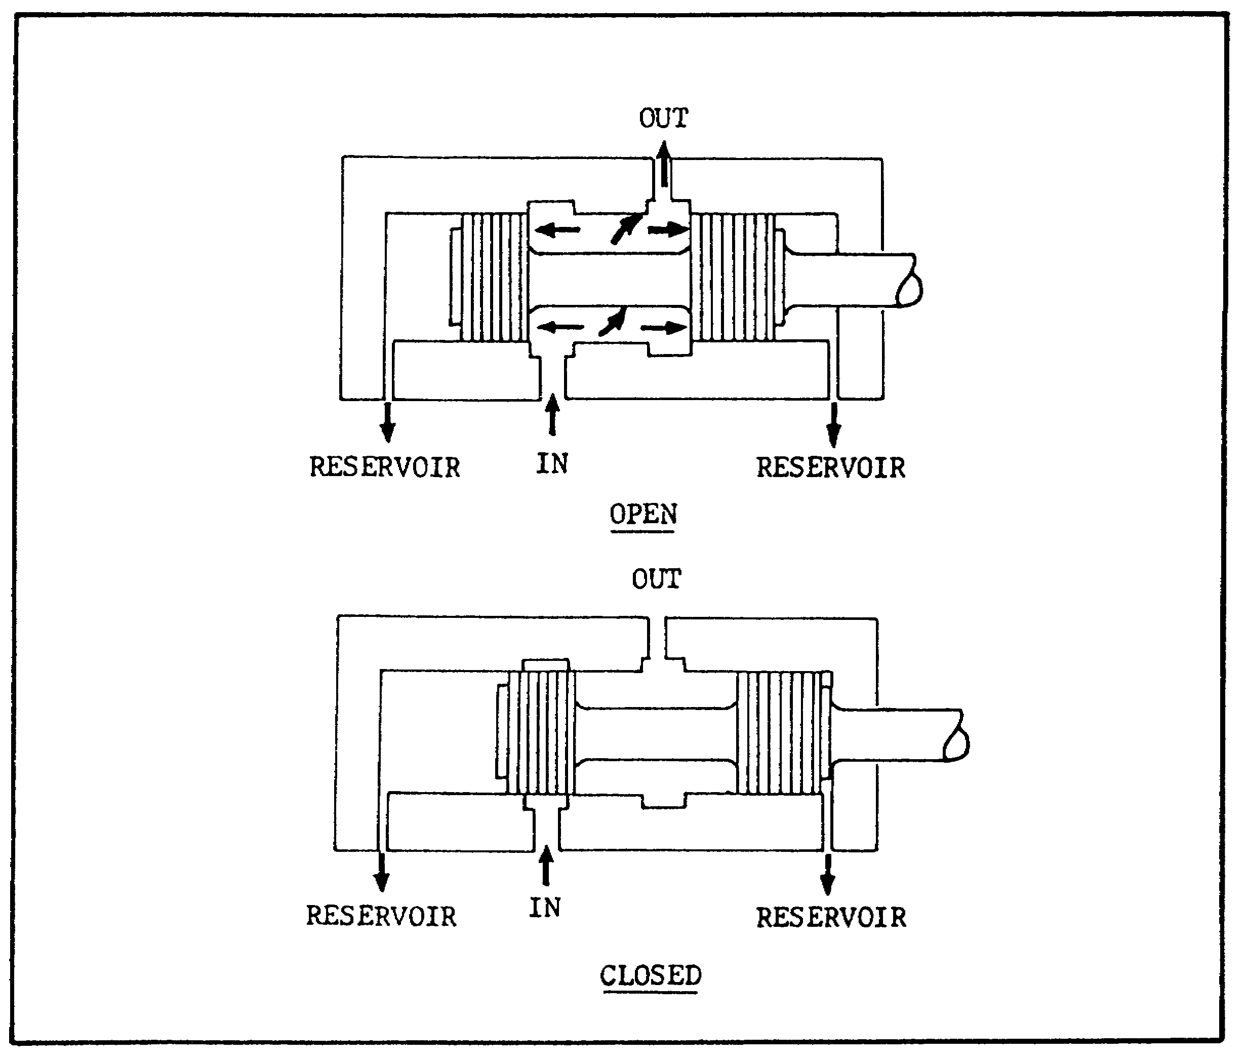
FIGURE 48. TWO-WAY VALVE.

valve, the pressure port is open to one cylinder port, but the opposite cylinder port is not open to the tank. The tank port on these valves is used primarily for drain purposes.

(14) Four-way Valves.

(a) Purpose. Four-way directional control valves are, as the name implies, generally used to control the direction of fluid flow in a hydraulic circuit. This, in turn, would control the direction of movement of a work cylinder or the rotation of a fluid motor.

(b) Function.

1 These valves are usually of the sliding spool type. The typical four-way directional control valve has four ports; a pressure port, a return or exhaust port, and two working ports. The pressure
61

PRINC. OF M1 HYDRAULICS - OD0475 - LESSON 1/TASK 2 - 05/86

port is connected to the pressure line, the return or exhaust port to the reservoir; the two working ports are connected, by lines, to the actuating unit.

2 Four-way valves consist primarily of a rectangular cast body, a sliding spool, and a means for positioning the spool. The spool is precision fitted to a bore through the longitudinal axis of the valve body. The lands of the spool divide this bore into a series of separate chambers. Ports in the valve body lead into these chambers, so that position of the spool determines which of the ports are open to each other, and which are sealed off. Ports which are sealed off from each other in one position may be interconnected in another. Spool positioning is accomplished manually, mechanically, electrically, hydraulically, or by combinations thereof.

(15) Flow Control Valves.

(a) Purpose. A flow control valve is used to control the actuator speed by metering the flow. Metering means "measuring", or regulating, the flow rate to or from the actuator.

(b) Example. A typical example of a valve used to control flow is the ordinary water faucet. It is normally in the closed position, preventing any flow. The rate of flow is varied by turning the faucet handle, clockwise or counterclockwise, changing the size of the faucet opening. Many of the flow control valves used in fluid power systems are similar in design and operation to a water faucet.

(c) Function.

1 These valves are designed to provide an accurate and adjustable control of flow rates in hydraulic circuits, or portions thereof. They are generally used for controlling the speed of hydraulic motors, work spindles, and the rates of travel of tool heads or slides. Flow control valves incorporate an integral pressure compensator which causes flow rate to remain substantially uniform, irrespective of changes in work load. A non-pressure compensated flow control, such as a needle valve or fixed restriction, permits changes in flow rate when pressure-drop through it changes.

62

PRINC. OF M1 HYDRAULICS - OD0475 - LESSON 1/TASK 2 - 05/86

2 Variations of the basic flow control valves are flow control and check valves, and flow control and overload relief valves. Models in the flow control and check valve series incorporate an integral check valve to permit reverse free flow. Models in the flow control and overload relief valve series incorporate an integral relief valve to limit system pressure. Some of these valves are gasket-mounted and some are panel-mounted.

(16) Gate Valves.

In this type of valve, flow is controlled by means of a wedge, or gate, which can be moved up and down across the line of flow by a handwheel, to open and close the passage. The principal elements of this type valve are shown in cross section in figure 49.
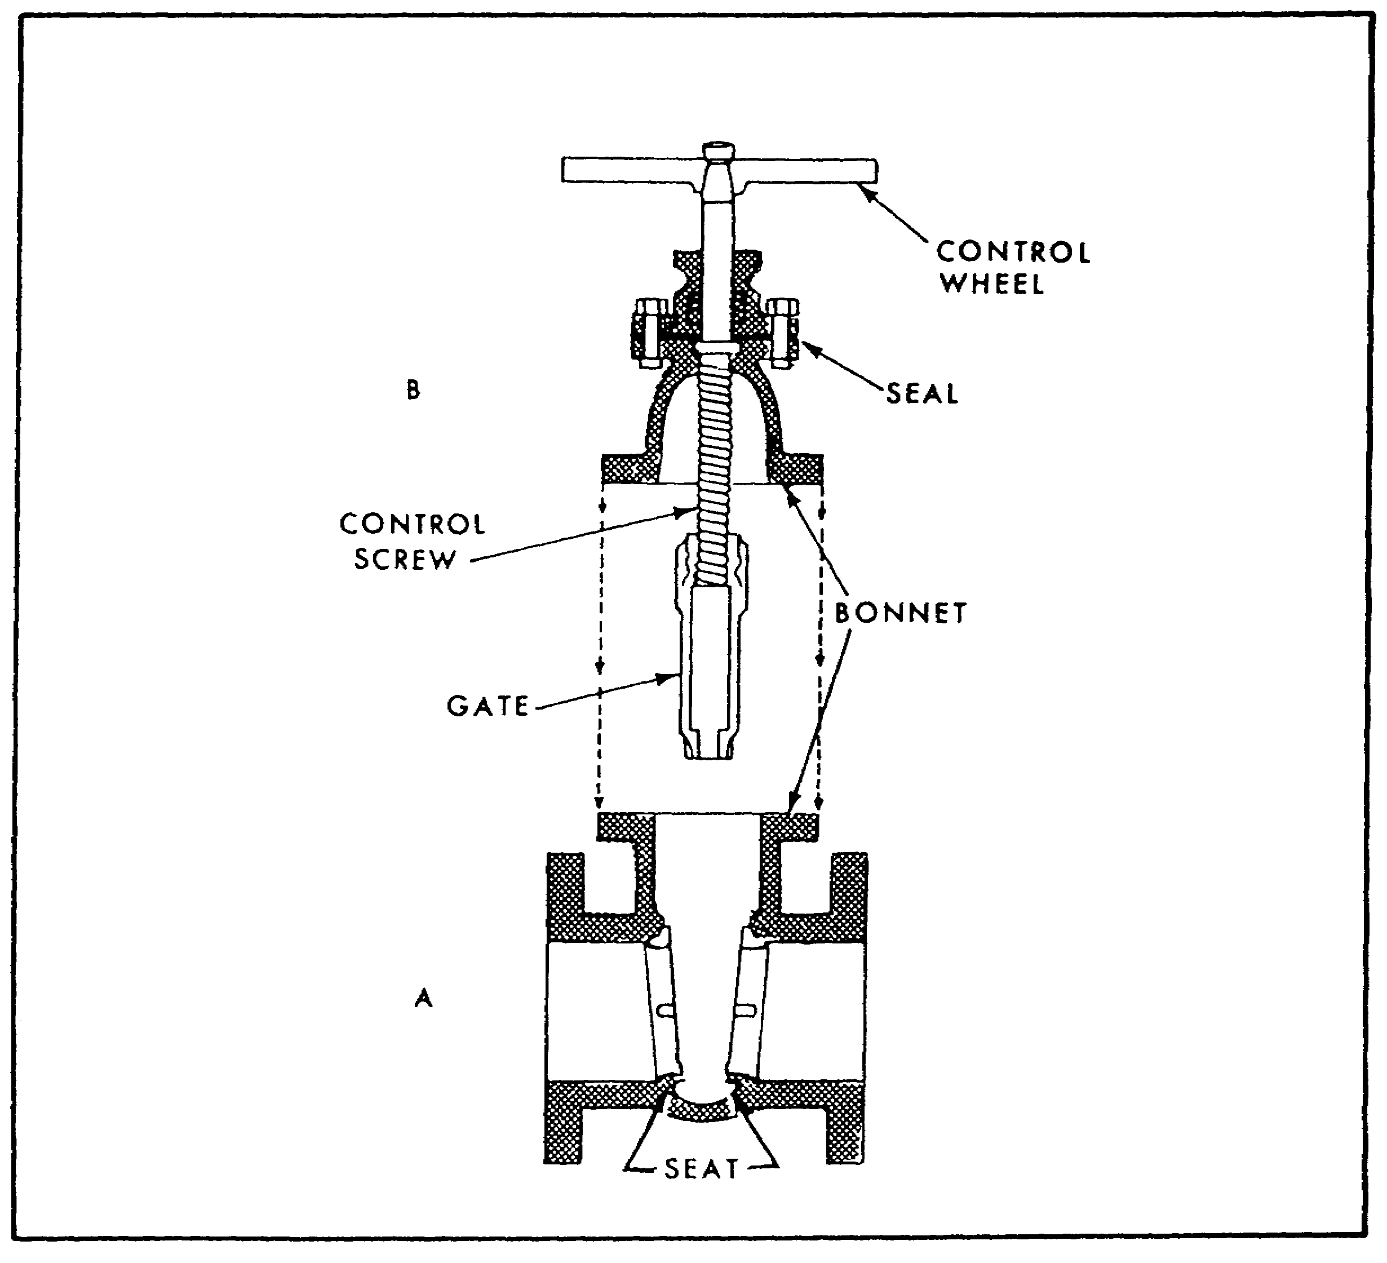
FIGURE 49. CROSS SECTION OF GATE VALVE.

63

PRINC. OF M1 HYDRAULICS - OD0475 - LESSON 1/TASK 2 05/86

The line connection and the outside structure of the valve are shown at A, while B locates the wedge or gate inside the valve and the stem to which the gate and the handwheel are attached. When the valve is open, the gate stands up inside the bonnet, its bottom flush with the wall of the line. While the valve is closed the gate blocks flow by standing straight across the line, resting firmly against two seats extending completely around the line. Gate valves permit straight flow and offer little or no resistance to the flow of fluid when the valve is completely open. Although sometimes placed in the partly open position to restrict the rate of flow, gate valves are intended for use as fully open or fully closed valves. If the valve is left partly open, the face of the valve stands in the flow of fluid. This flow of fluid will act on the face of the valve, causing it to erode.

(17) Globe Valve.

Globe valves derive their name from their body shape. (It should be noted, however, that other types of valves may also have globular bodies; hence, the name may tend to be misleading.) The controlling member of the globe valve, called the disc, is screwed directly on the end of the stem. The valve is closed by lowering the disc into the valve seat. Since the fluid flows equally on all sides of the center of support when the valve is open, there is no unbalanced pressure on the disc to cause uneven wear. The globe valve is illustrated in figure 50.
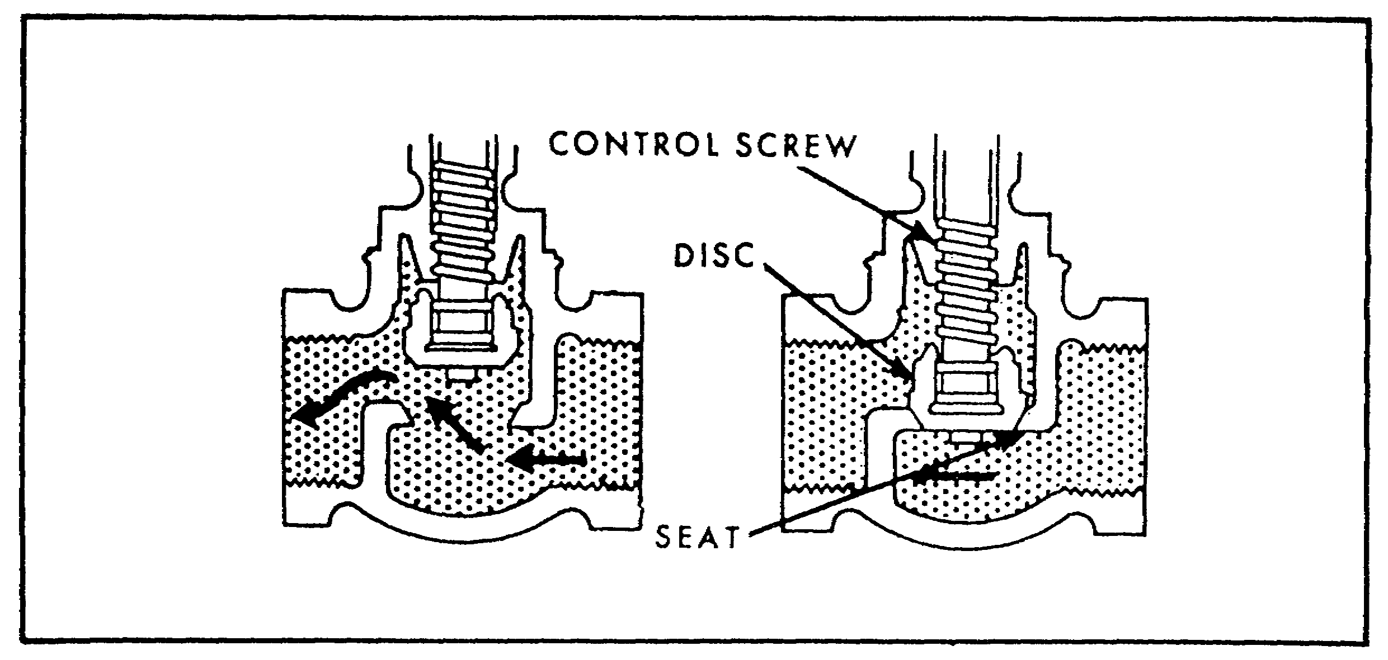

FIGURE 50. GLOBE VALVE.

64

PRINC. OF M1 HYDRAULICS - OD0475 - LESSON 1/TASK 2 - 05/86

(18) Needle Valves.

Needle valves are similar in design and operation to globe valves. Instead of a disc, a needle valve has a long tapered point at the end of the valve stem. Figure 51, is a sectional view of a needle valve. The long taper permits the needle valve to be opened or closed gradually. Needle valves are used to control flow into delicate gages which might be damaged if fluid under pressure were suddenly delivered to them. Needle valves are also used to control end operation of a work cycle, where it is desirable that a work motion be brought slowly to a halt; and at other points where a precise adjustment of flow is necessary, and where a small rate of flow is desired.
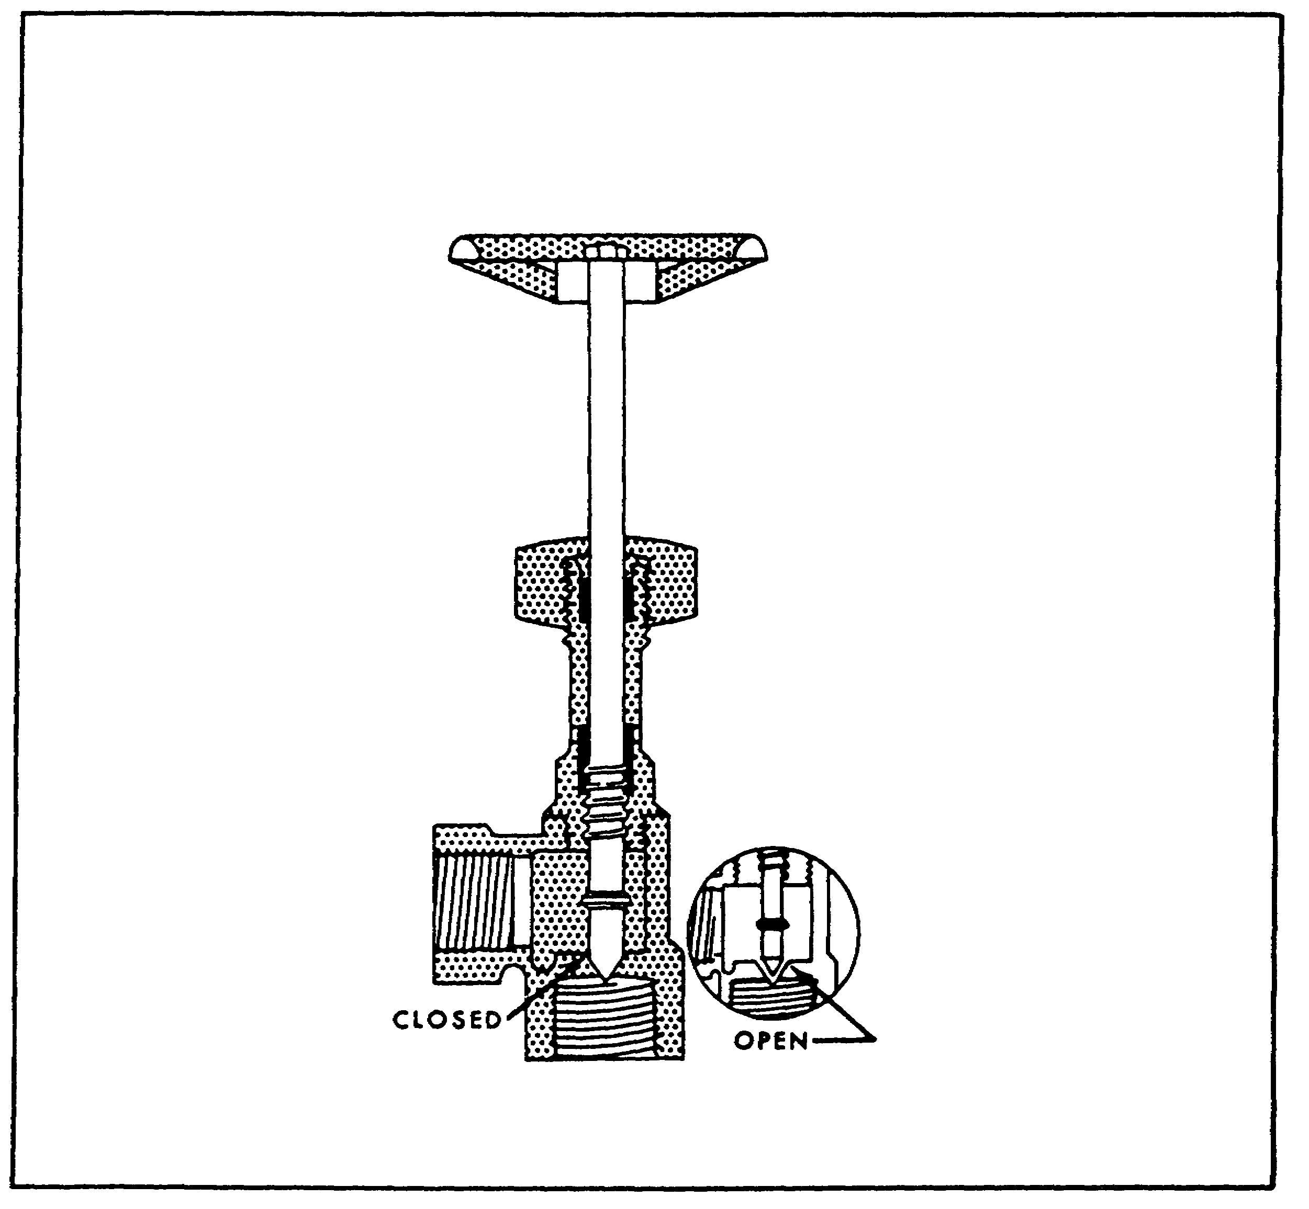

FIGURE 51. SECTIONAL VIEW OF NEEDLE VALVE.

65

PRINC. OF M1 HYDRAULICS - OD0475 - LESSON 1/TASK 2 - 05/86

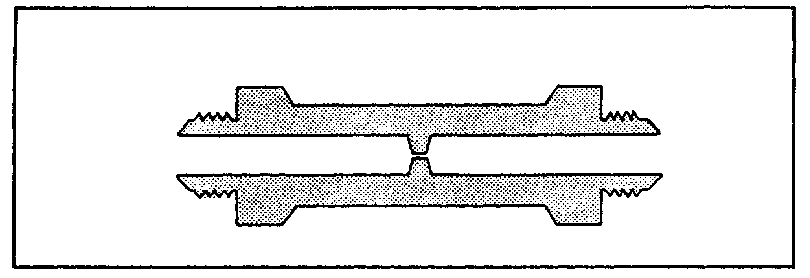
FIGURE 52. FIXED RESTRICTOR.

(19) Restrictors.

Restrictors, sometimes referred to as orifices, are used in fluid power systems to limit the speed of movement of certain actuating devices. They do so by serving as restrictions in the line, thereby limiting the rate of flow. Figure 52 shows an example of a typical restrictor. This type is referred to as a fixed restrictor.
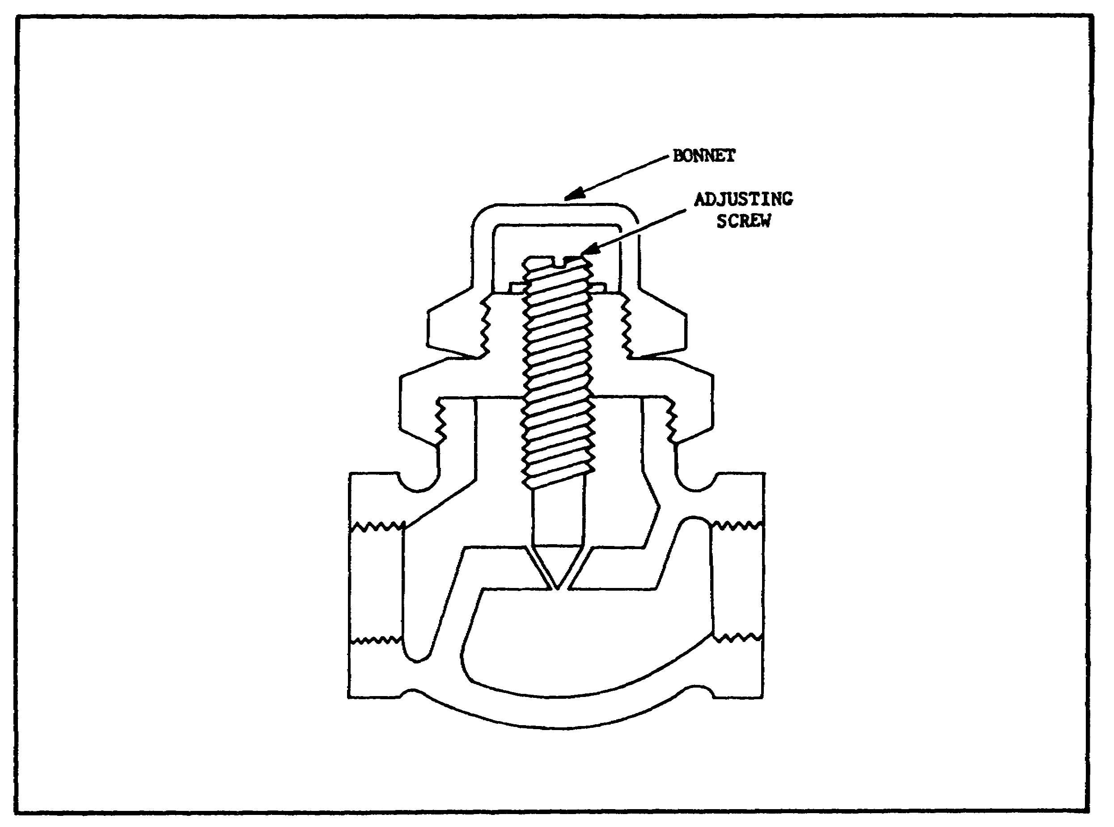

FIGURE 53. VARIABLE RESTRICTOR.

66

PRINC. OF M1 HYDRAULICS - OD0475 - LESSON 1/TASK 2 - 05/86

Some types of restrictors are constructed so that the amount of restriction can be varied. One type of variable restrictor is illustrated in figure 53, on the previous page. This type is simply a modification of the needle valve, previously described. Instead of a handwheel control, the valve is constructed so that it can be preadjusted to alter the time of operation of a particular subsystem. It can be adjusted to conform to the requirements of a particular system, permitting the same type valve to be used in different systems.

(20) Orifice Check Valves.

Check valves were described in more detail in paragraph 3h (12), on page 56, since their purpose is to control the direction of flow. However, they are used in conjunction with some types of flow control valves. The orifice check valve is an example, and is used in fluid power systems to allow normal speed of operation in one direction and a limited speed in the other. Some typical examples of orifice check valves are illustrated in figure 54.
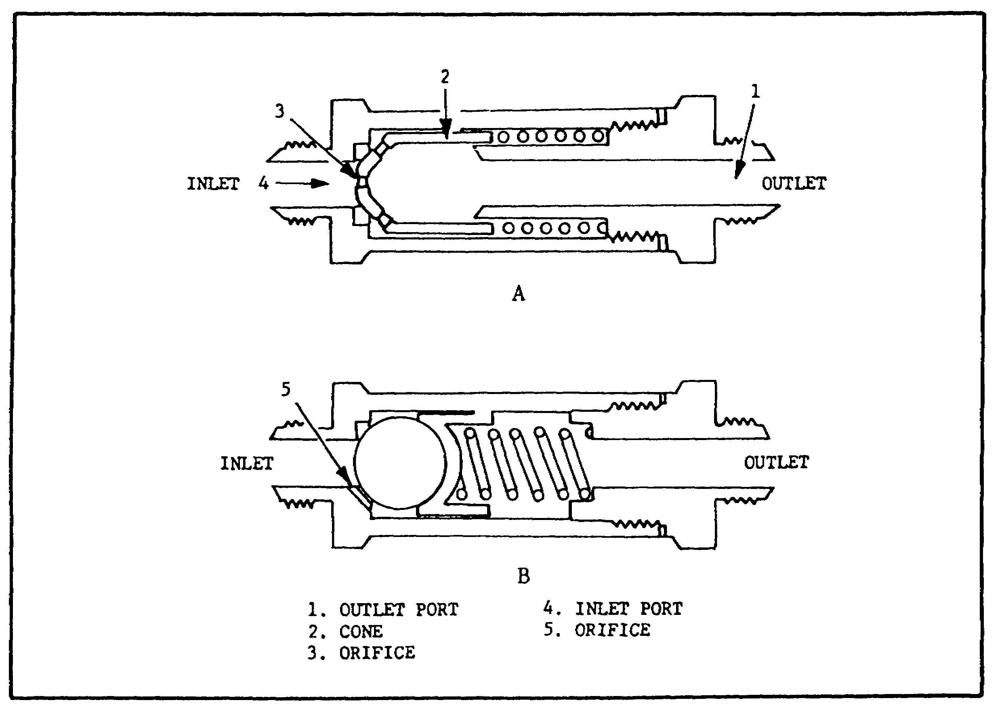

FIGURE 54. ORIFICE CHECK VALVES.

67

PRINC. OF M1 HYDRAULICS - OD0475 - LESSON 1/TASK 2 - 05/86

(21) Flow Equalizer.

(a) Purpose. A flow equalizer (flow divider) is used in some hydraulic systems to synchronize the operation of two actuating units by dividing a single stream of fluid from the directional control valve into two equal streams. Thus, each actuating unit receives the same rate of flow, and both move in unison. During operation in the opposite direction, the flow equalizer combines the two streams of return fluid at an equal rate. Therefore, the flow equalizer synchronizes the movement of the actuating units during both directions of operation. Since the unit equally divides the combined flow, it is said to be dual acting.
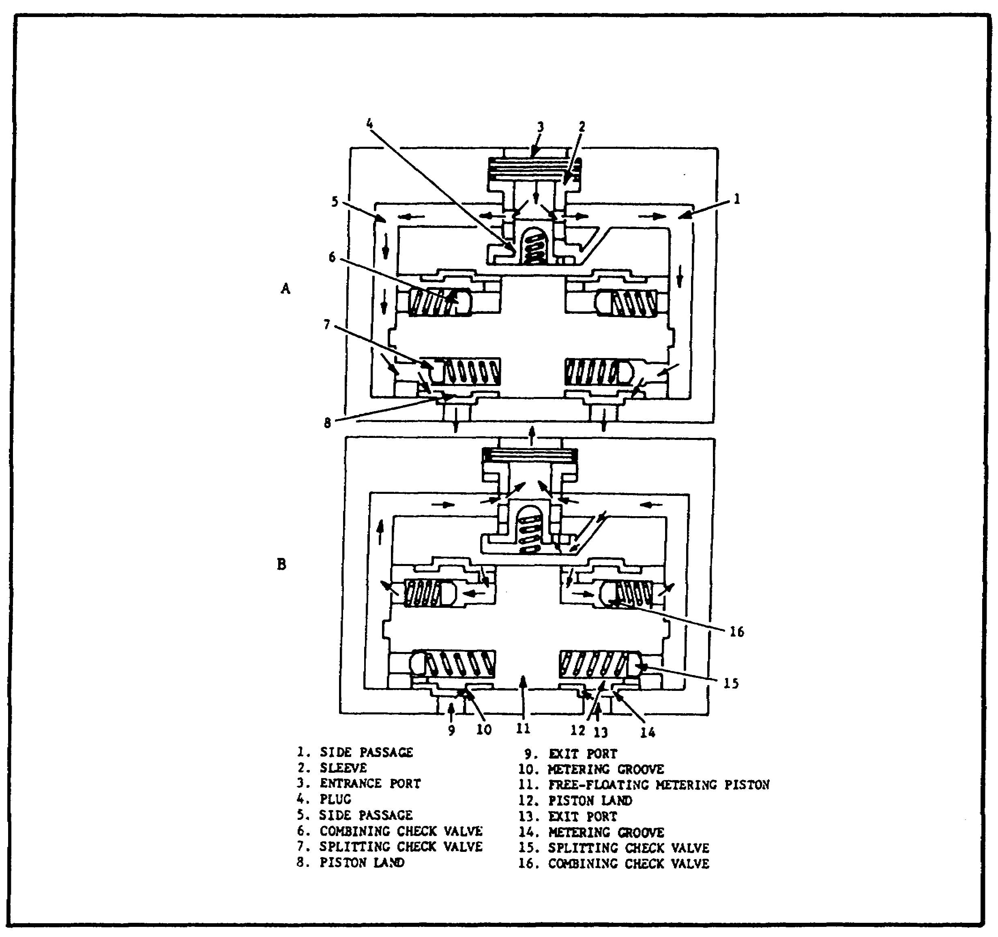

FIGURE 55. FLOW EQUALIZER.

68

PRINC. OF M1 HYDRAULICS - OD0475 - LESSON 1/TASK 2 - 05/86

(b) Operation. One type of flow equalizer is illustrated in figure 55 on the previous page. Figure 55 shows the valve in the splitting (divided flow) position.

Fluid under pressure from the directional control valve enters port (3). This pressure overcomes spring tension and forces the plug (4) down, uncovering the two orifices in the sleeve (2). The fluid then splits and tends to flow equally through the two side passages, (1) and (5). The fluid flows through the two splitting check valves (7) and (15), through the metering grooves (10) and (14), through ports (9) and (13), and through the connecting lines to the actuating cylinders. Any difference in the rate of flow between the two passages results in a pressure differential between these two passages. The free-floating metering piston (11) then shifts, to equalize the internal pressure, and the flow equalizes.

(22) Types of Flow Control.

(a) Connections of Ports. Since these valves meter flow in one direction only, the inlet and outlet ports must be correctly connected in the circuit, in relation to the direction of the flow to be metered. The valve drain connection must be piped to tank in such a manner that this part of the valve will not be subjected to possible pressure surges.

(b) Valve Installations. The location of a flow control valve, with respect to the work load, has an affect on the circuit operating characteristics. The three basic types of flow control valve installations are "meter-in," "meter-out," and "bleed-off."

(c) Meter-in Circuit.

1 Figure 56, on the following page, illustrates a typical meter-in circuit. The flow control valve is installed in the pressure line leading to the work cylinder. All flow entering the work cylinder is first metered through the flow control valve. Since this metering action involves a reduction in flow from the pump to the work cylinder, the pump must deliver more fluid than is required to actuate the cylinder at the desired speed. The excess fluid is returned to tank through the relief valve.

69

PRINC. OF M1 HYDRAULICS - OD0475 - LESSON 1/TASK 2 - 05/86

To conserve power and avoid undue stress on the pump, the relief valve setting should be only slightly higher than the working pressure required by the cylinder.
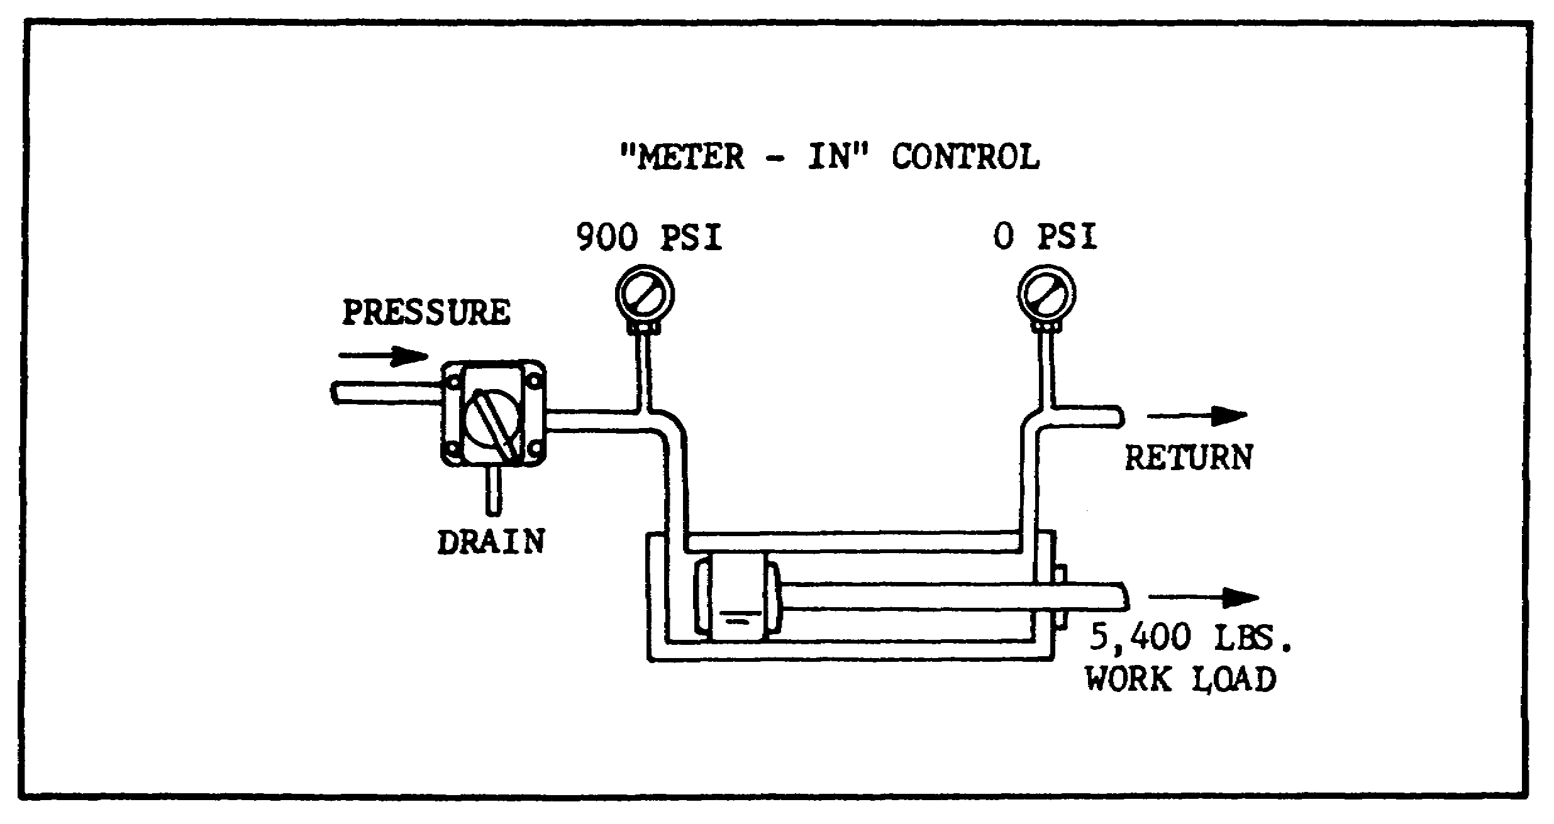

FIGURE 56. TYPICAL METER-IN CIRCUIT.

2 A meter-in circuit is recommended for applications in which the load always offers a positive resistance to flow during the controlled stroke. It is therefore suitable for feeding grinder tables, welding machines, milling machines, and rotary hydraulic motor drives.

A flow control and check valve used in this circuit would permit reverse free flow for the return stroke of the cylinder, but would not provide control of return stroke speed.

(d) Meter-out Circuit.

1 Figure 57, on the next page, illustrates a typical meter-out circuit. The flow control valve is installed on the return side of the cylinder, so that it controls cylinder actuation by metering the cylinder discharge flow. Again, the relief valve is set slightly above the operating pressure required by the work.

2 This type of circuit is ideally suited for "negative" or "overhauling" load applications in which the work load tends to pull the operating piston faster than the pump delivery would warrant.

70

PRINC. OF M1 HYDRAULICS - OD0475 - LESSON 1/TASK 2 - 05/86

Meter-out circuits are recommended for drilling, reaming, boring, turning, threading, tapping, cutoff, and cold sawing machines. A flow control and check valve used in this circuit would permit reverse free flow, but would not provide a control of return stroke speed.
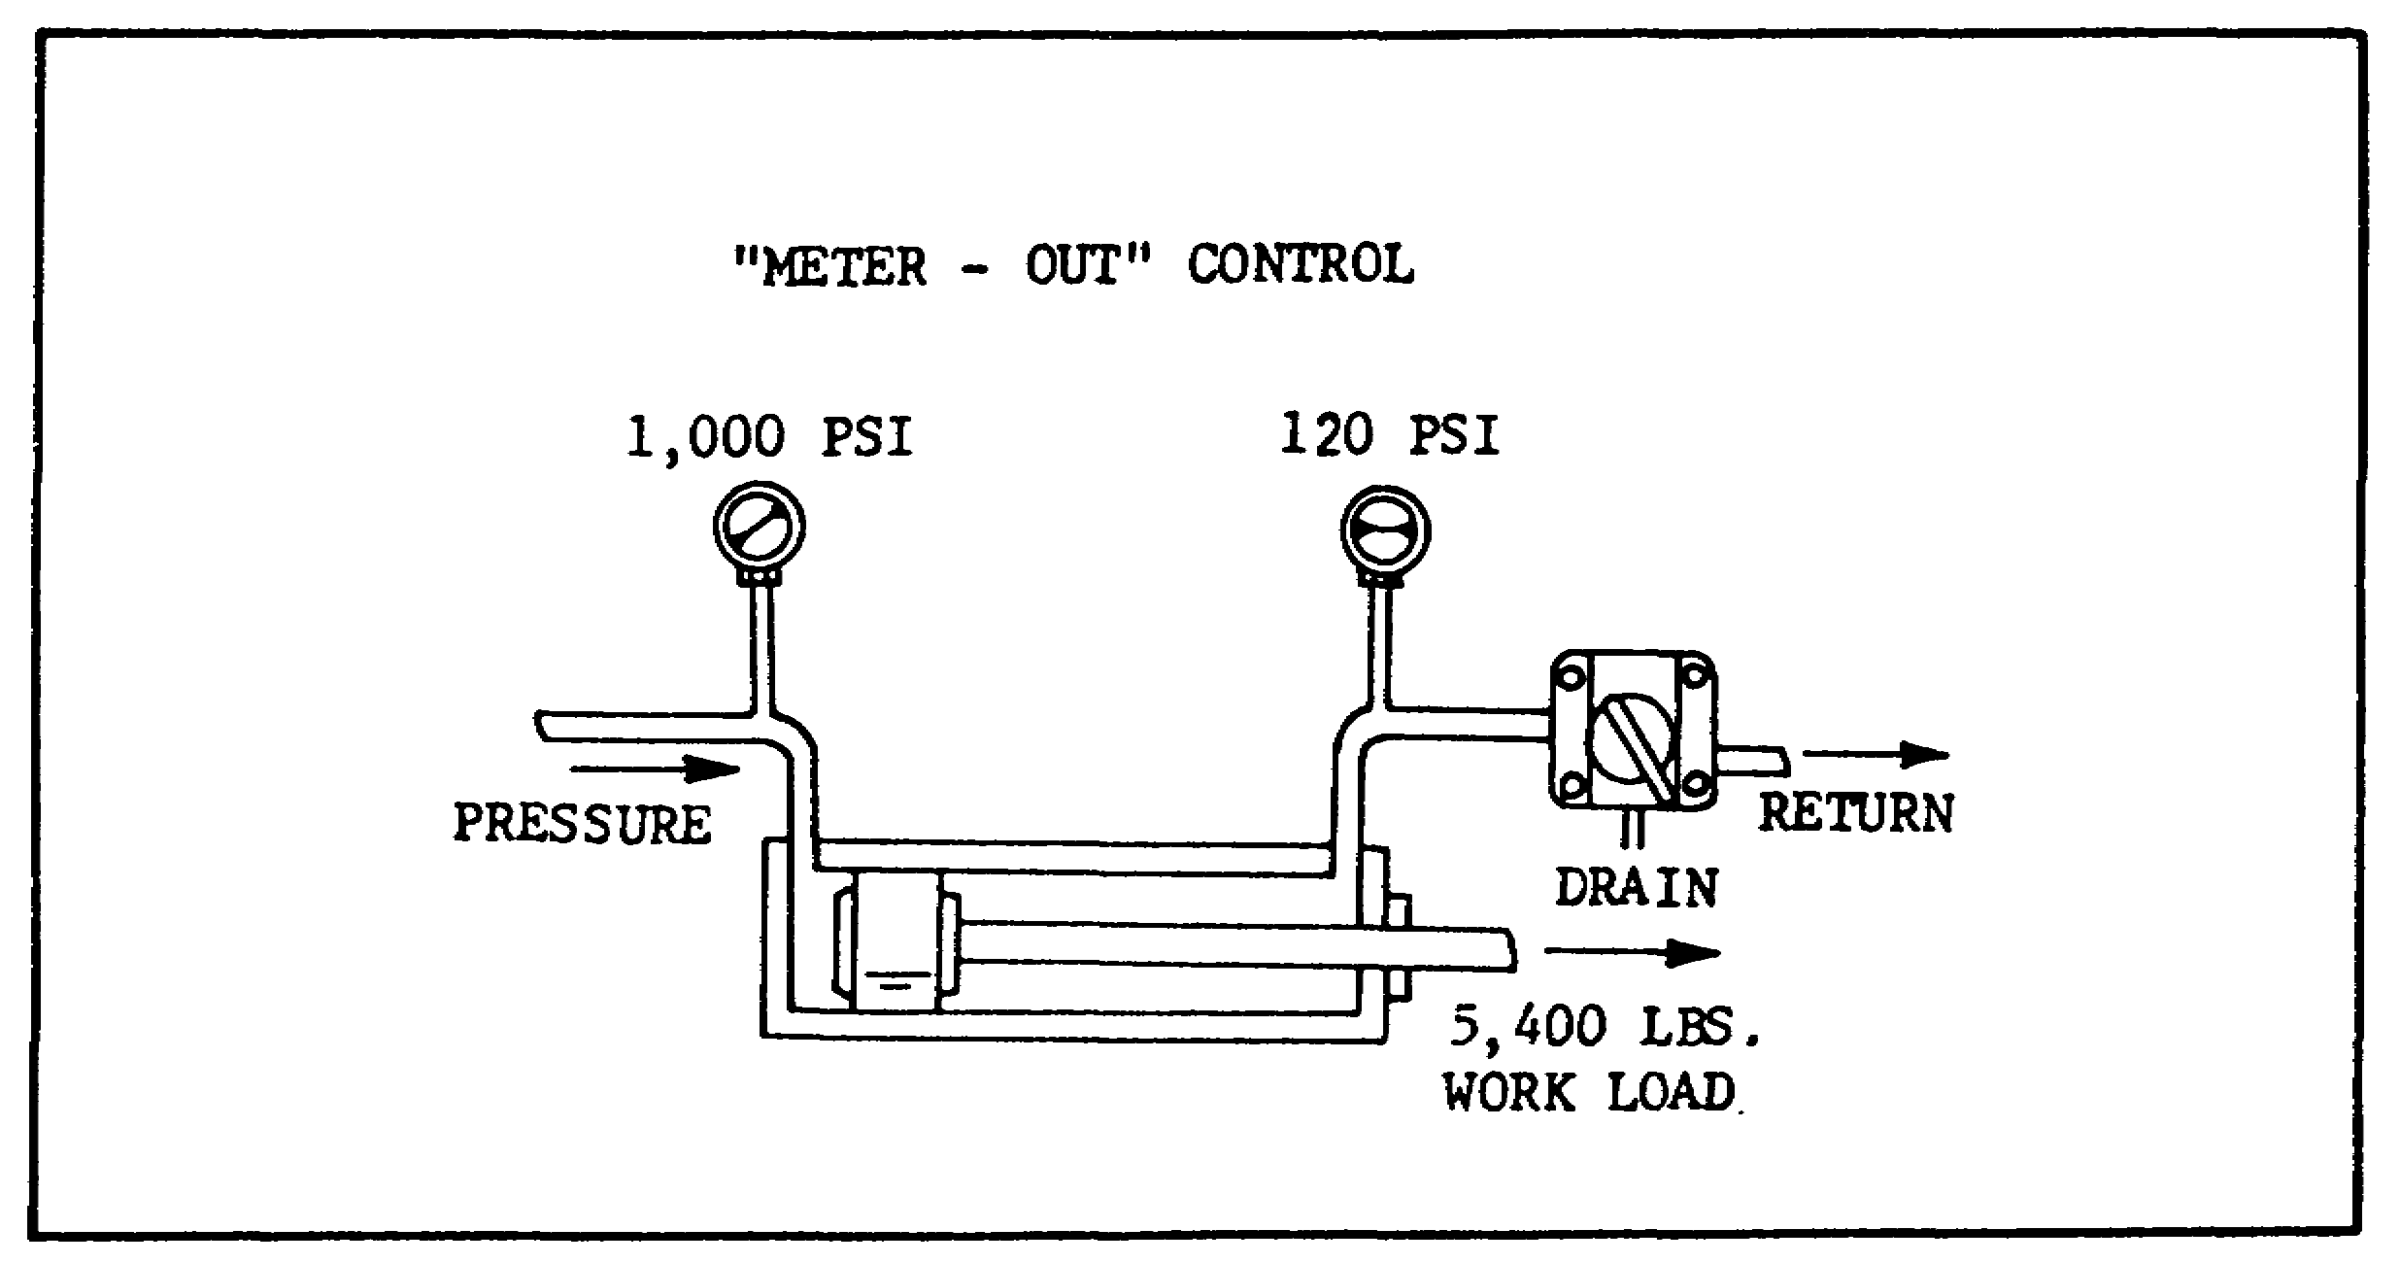

FIGURE 57. TYPICAL METER-OUT CIRCUIT.

(e) Bleed-off Circuit. A typical bleed-off circuit is not installed directly in the feed line, but is teed into this line with its outlet connected to a return line. The valve regulates flow to the cylinder by diverting an adjustable portion of pump flow to tank. Since fluid delivered to the work cylinder does not have to pass through the flow control valve, there is no need to dump excess fluid through a relief valve. This type of circuit usually involves less generation of heat, because pressure on the pump equals work resistance during feed operation.

4. Conclusion

Our discussion of hydraulics began with defining (in task 1) a hydraulic system as a system designed to contain and confine a liquid in such a manner that it uses the laws governing liquids to transmit power and do work. In this task we discussed the typical components (pumps, motors,

71

PRINC. OF M1 HYDRAULICS - OD0475 - LESSON 1/TASK 2 - 05/86

valves, etc.) which comprise a hydraulic system. With this newly acquired background in hydraulic systems the next task will introduce hydraulic circuit diagrams, and the symbols used in these diagrams to depict hydraulic systems.

72

PRINC. OF M1 HYDRAULICS - OD0475 - LESSON 1/TASK 3

LESSON 1

BASIC HYDRAULIC PRINCIPLES
AND COMPONENTS

TASK 3. Describe a hydraulic diagram and identify hydraulic symbols.

CONDITIONS

Within a self-study environment and given the subcourse text, without assistance.

STANDARDS

Within one hour

REFERENCES

No supplementary references are needed for this task.

1. Introduction

Accurate diagrams of hydraulic circuits are essential to the designer, to the people who build the machine, and to the men who repair it. The diagram shows how the components will interact. It shows the manufacturing engineer, and the assembler, how to connect the components. It shows the maintenance technician how the system works, what each component should be doing and where the oil should be going, so that he can diagnose and repair the system. This task will familiarize you with simple hydraulic diagrams and the symbols used in graphic diagrams of a hydraulic system.

2. Hydraulic Circuit Diagram

a. Definition. A hydraulic circuit diagram is a complete drawing of a hydraulic circuit, including description, sequence of operations, notes, and component lists.

73

PRINC. OF M1 HYDRAULICS - OD0475 - LESSON 1/TASK 3

b. Graphical Diagram. A graphical diagram is made up of simple geometric symbols for the components, their controls and connections. Figure 58 is a graphical diagram. Notice that the graphical diagram doesn't show anything about the construction or relative locations of the components. Its purpose is to show functions, port connections, and flow paths.
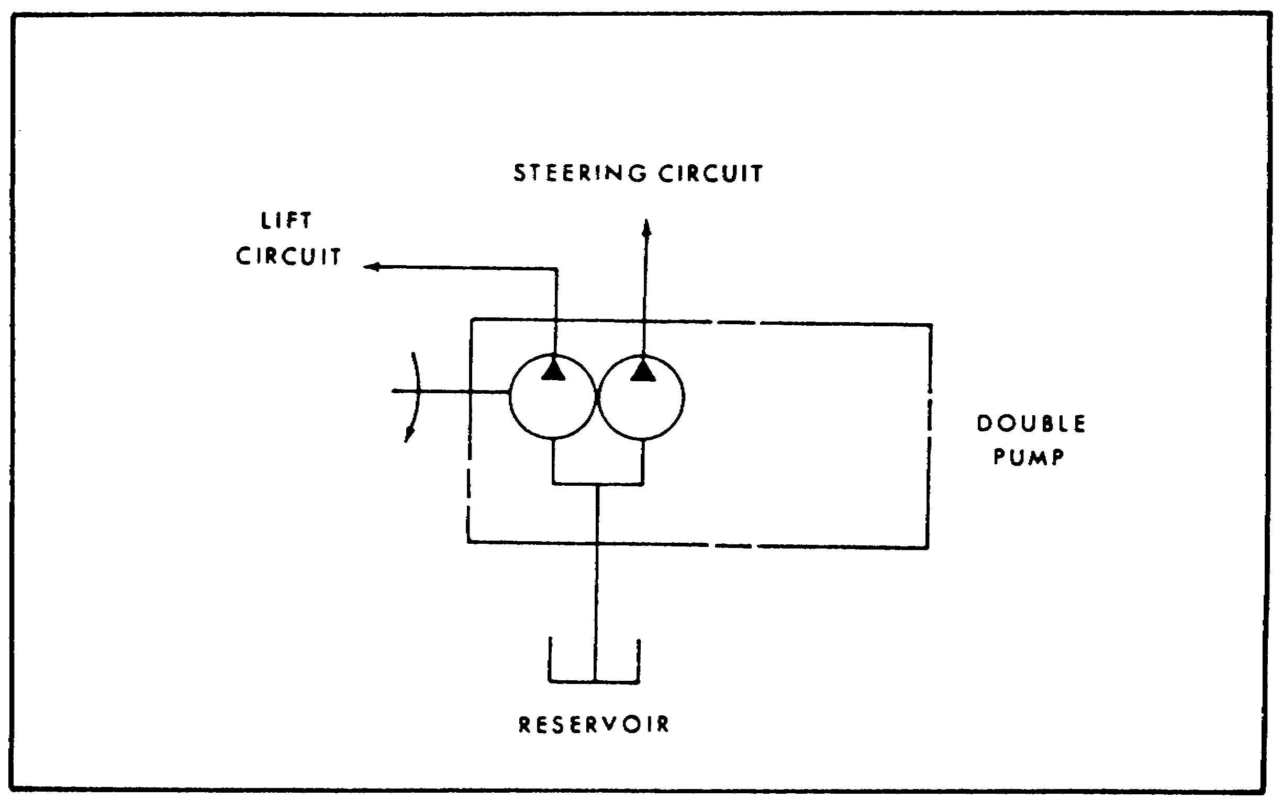

FIGURE 58. GRAPHICAL CIRCUIT DIAGRAM.

3. USASI Graphical Symbols

a. Introduction. There are three systems of hydraulic symbols. In this task, we will use the new set of USASI (United States of America Standards Institute) symbols, which are shown in figures 59 and 60, on pages 75 and 76. You may also encounter circuits which used the old ASA (American Standards Association) or JIC (Joint Industry Conference) symbols. There are many differences, but sufficient similarities between the systems; if you understand the USASI system, you will be able to interpret the others. The USASI symbols are designed to eliminate the use of letters; so they are capable of crossing language barriers and can promote a universal understanding of hydraulic (fluid power) systems.

74

PRINC. OF M1 HYDRAULICS - OD0475 - LESSON 1/TASK 3
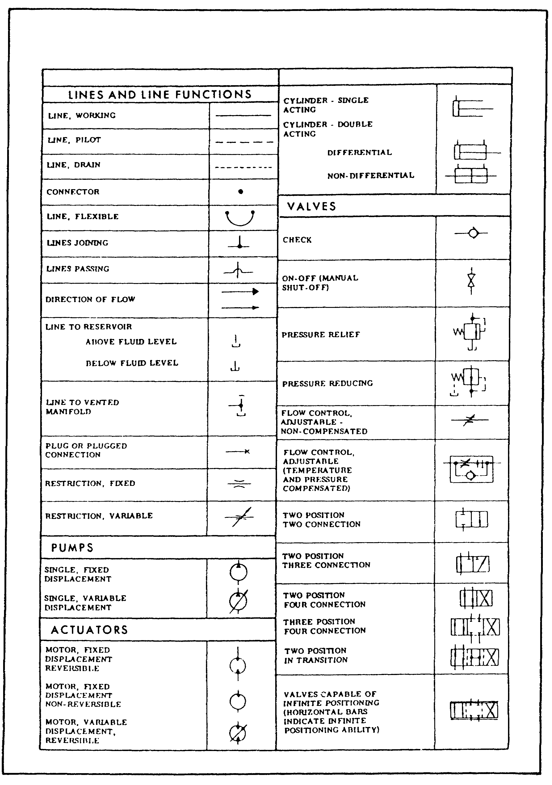

FIGURE 59. USASI GRAPHICAL SYMBOLS.

75

PRINC. OF M1 HYDRAULICS - OD0475 - LESSON 1/TASK 3
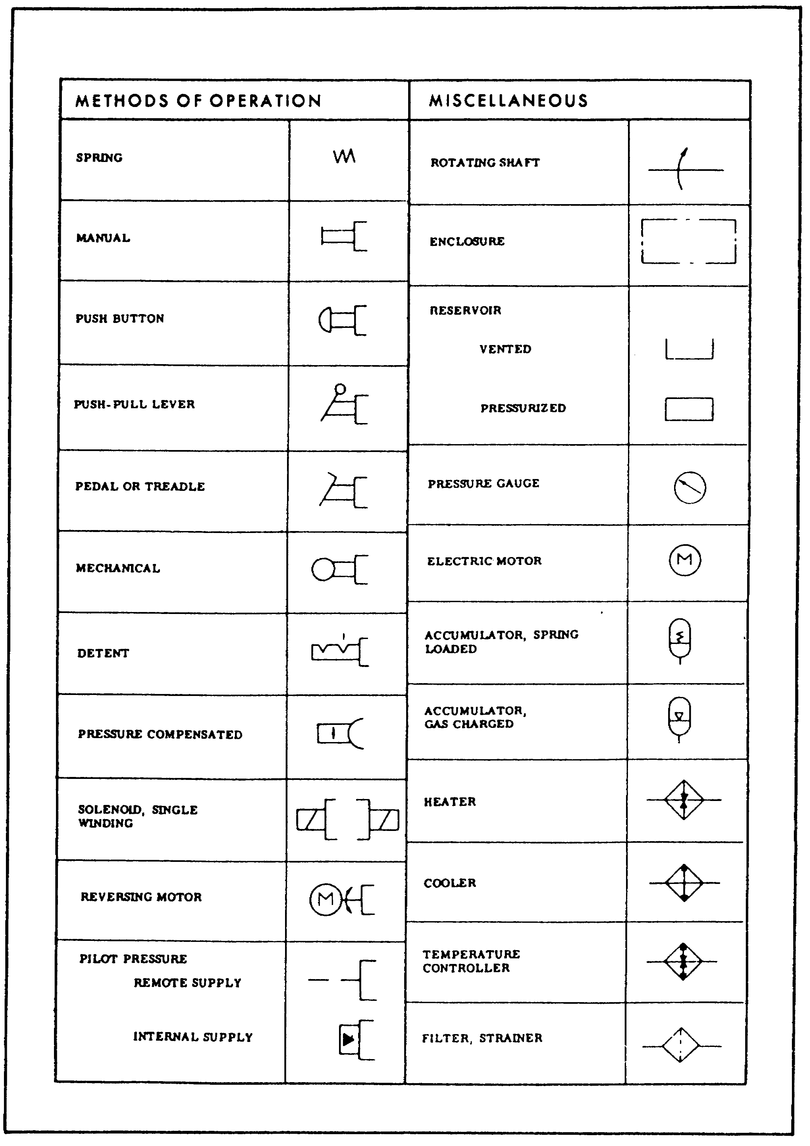

FIGURE 60. USASI GRAPHICAL SYMBOLS (CONT).

76

PRINC. OF M1 HYDRAULICS - OD0475 - LESSON 1/TASK 3

b. System Symbol.

(1) Reservoir.

(a) A rectangle (figure 61), with the long side horizontal, is the symbol for a reservoir. It is open at the top if the reservoir is vented to the atmosphere. If the reservoir is pressurized, the top is closed.
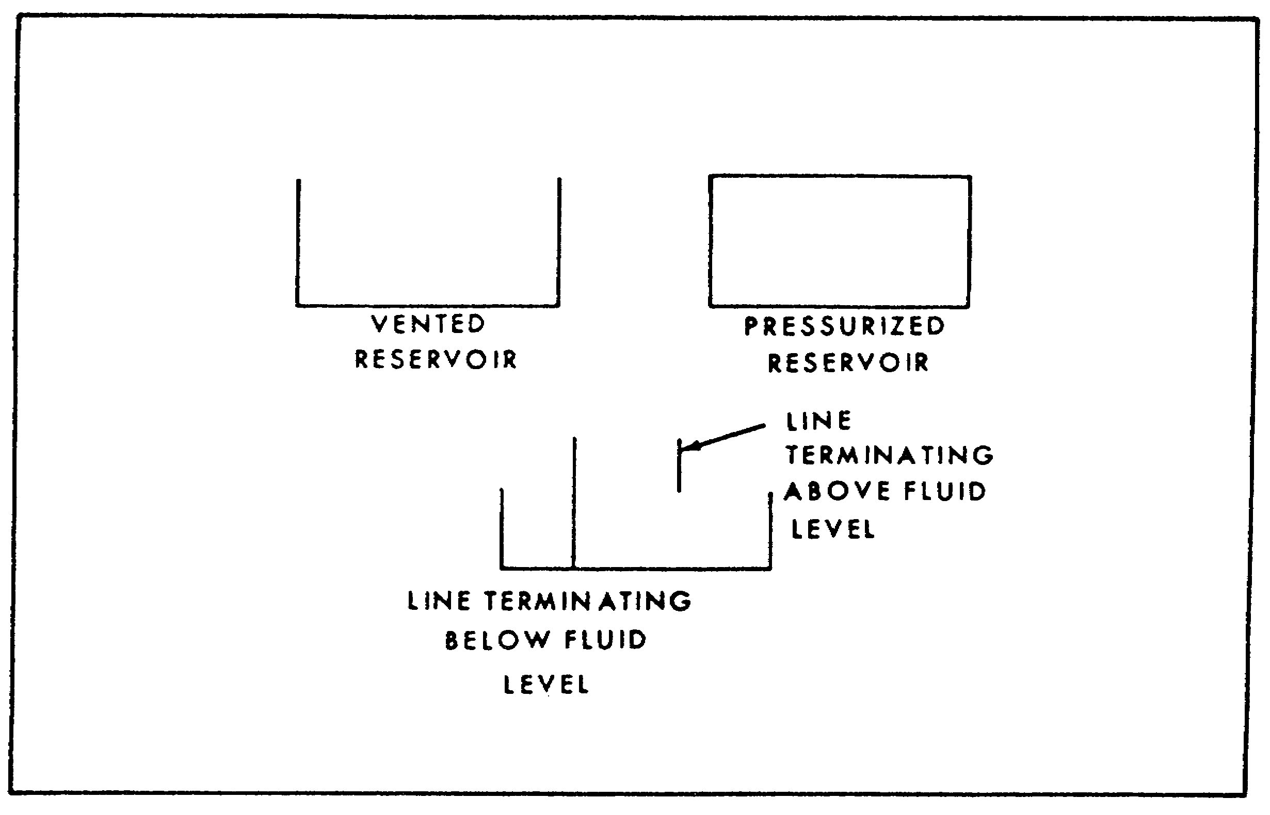

FIGURE 61. SYMBOL FOR RESERVOIR.

(b) Lines connected to the reservoir usually are drawn from the top, regardless of where the actual connection is. If the line terminates below the fluid level, it is drawn all the way to the bottom of the symbol. A line connected to the bottom of the reservoir may be drawn from the bottom of the symbol, if the bottom connection is essential to the system's operation. For instance, when the pump inlet must be charged or flooded by a positive head of oil above the inlet port, the reservoir symbol would be positioned above the pump symbol, and the suction line from the bottom of the symbol.

(c) Every reservoir has at least two hydraulic lines connected to it; some have many more. And often the components that are connected to the

77

PRINC. OF M1 HYDRAULICS - OD0475 - LESSON 1/TASK 3

reservoir are spread all over the diagram, making it inconvenient to draw all the return or drain lines to one symbol. It is customary then to draw individual reservoir symbols wherever convenience indicates it. The reservoir, however, is usually the only component pictured more than once.

(2) Lines.

(a) A hydraulic pipe, tube, hose, or other conductor that carries the liquid between components is drawn as a single line (figure 62).
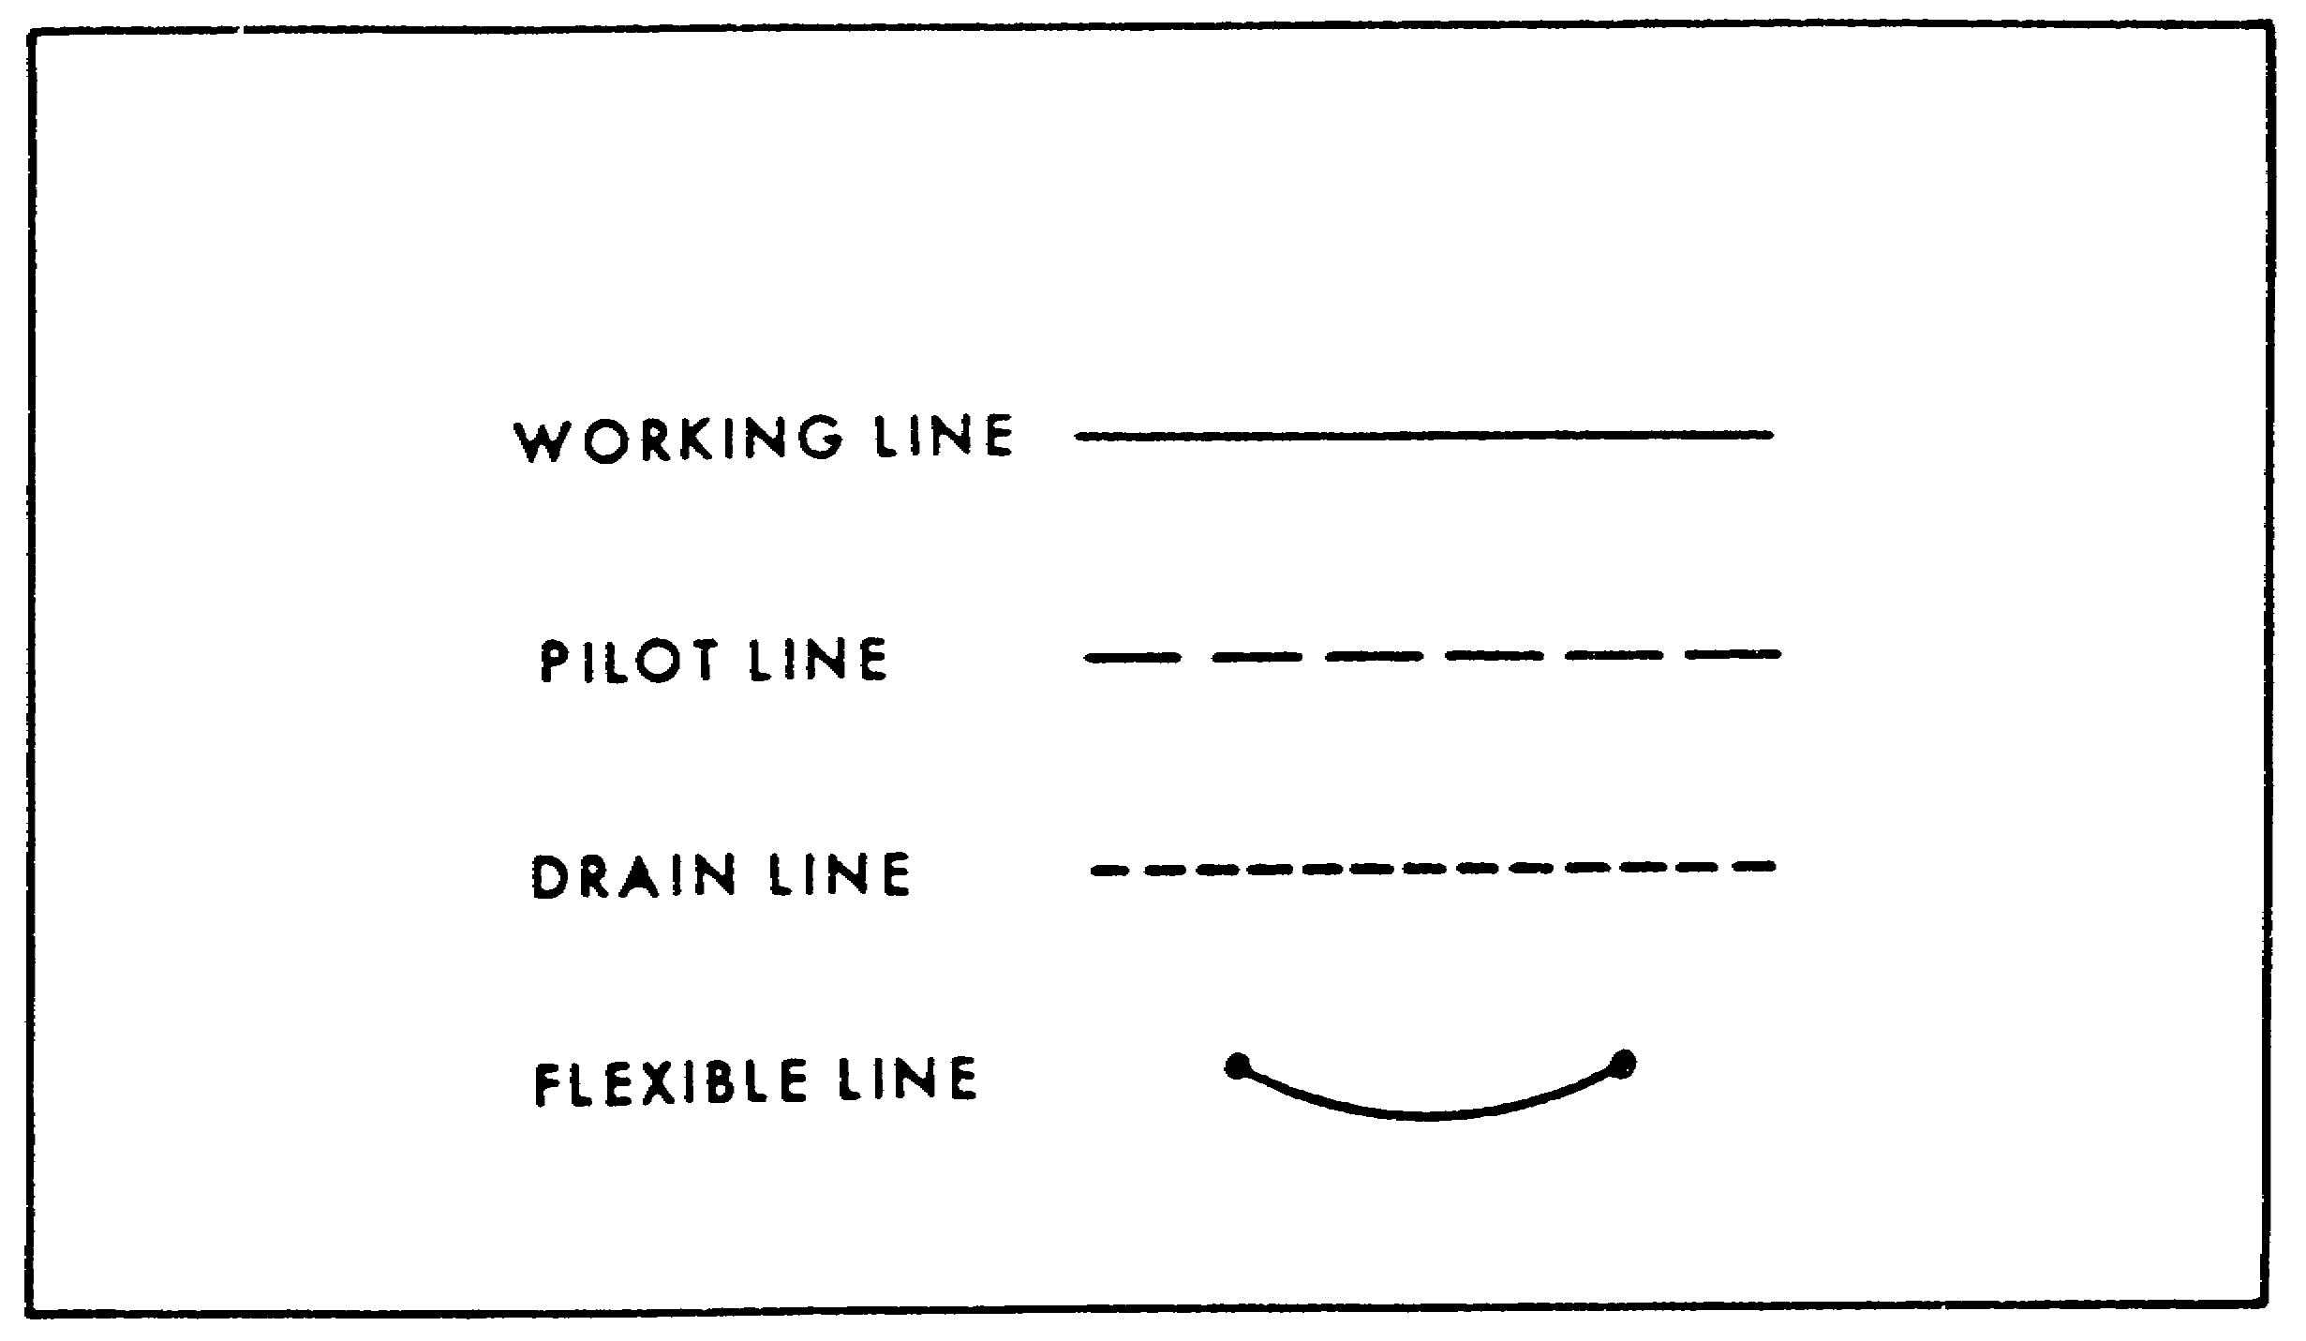

FIGURE 62. SYMBOLS FOR HYDRAULIC LINES.

A working line (suction, pressure, or return) is drawn as a solid line. Pilot or control lines are broken into long dashes; drain lines for leakage oil are broken into short dashes. A flexible line is drawn as an arc between two dots and is always represented by a solid line.

(b) The shortest distance between two connected components is a straight line. It is desirable to draw it that way to avoid following a line all over the diagram just to get back where you started. To avoid crossing lines that aren't connected to each other (when it is necessary) there are two accepted systems to the question "to loop and dot or not?" To show that two crossed lines are not connected,

78

PRINC. OF M1 HYDRAULICS - OD0475 - LESSON 1/TASK 3
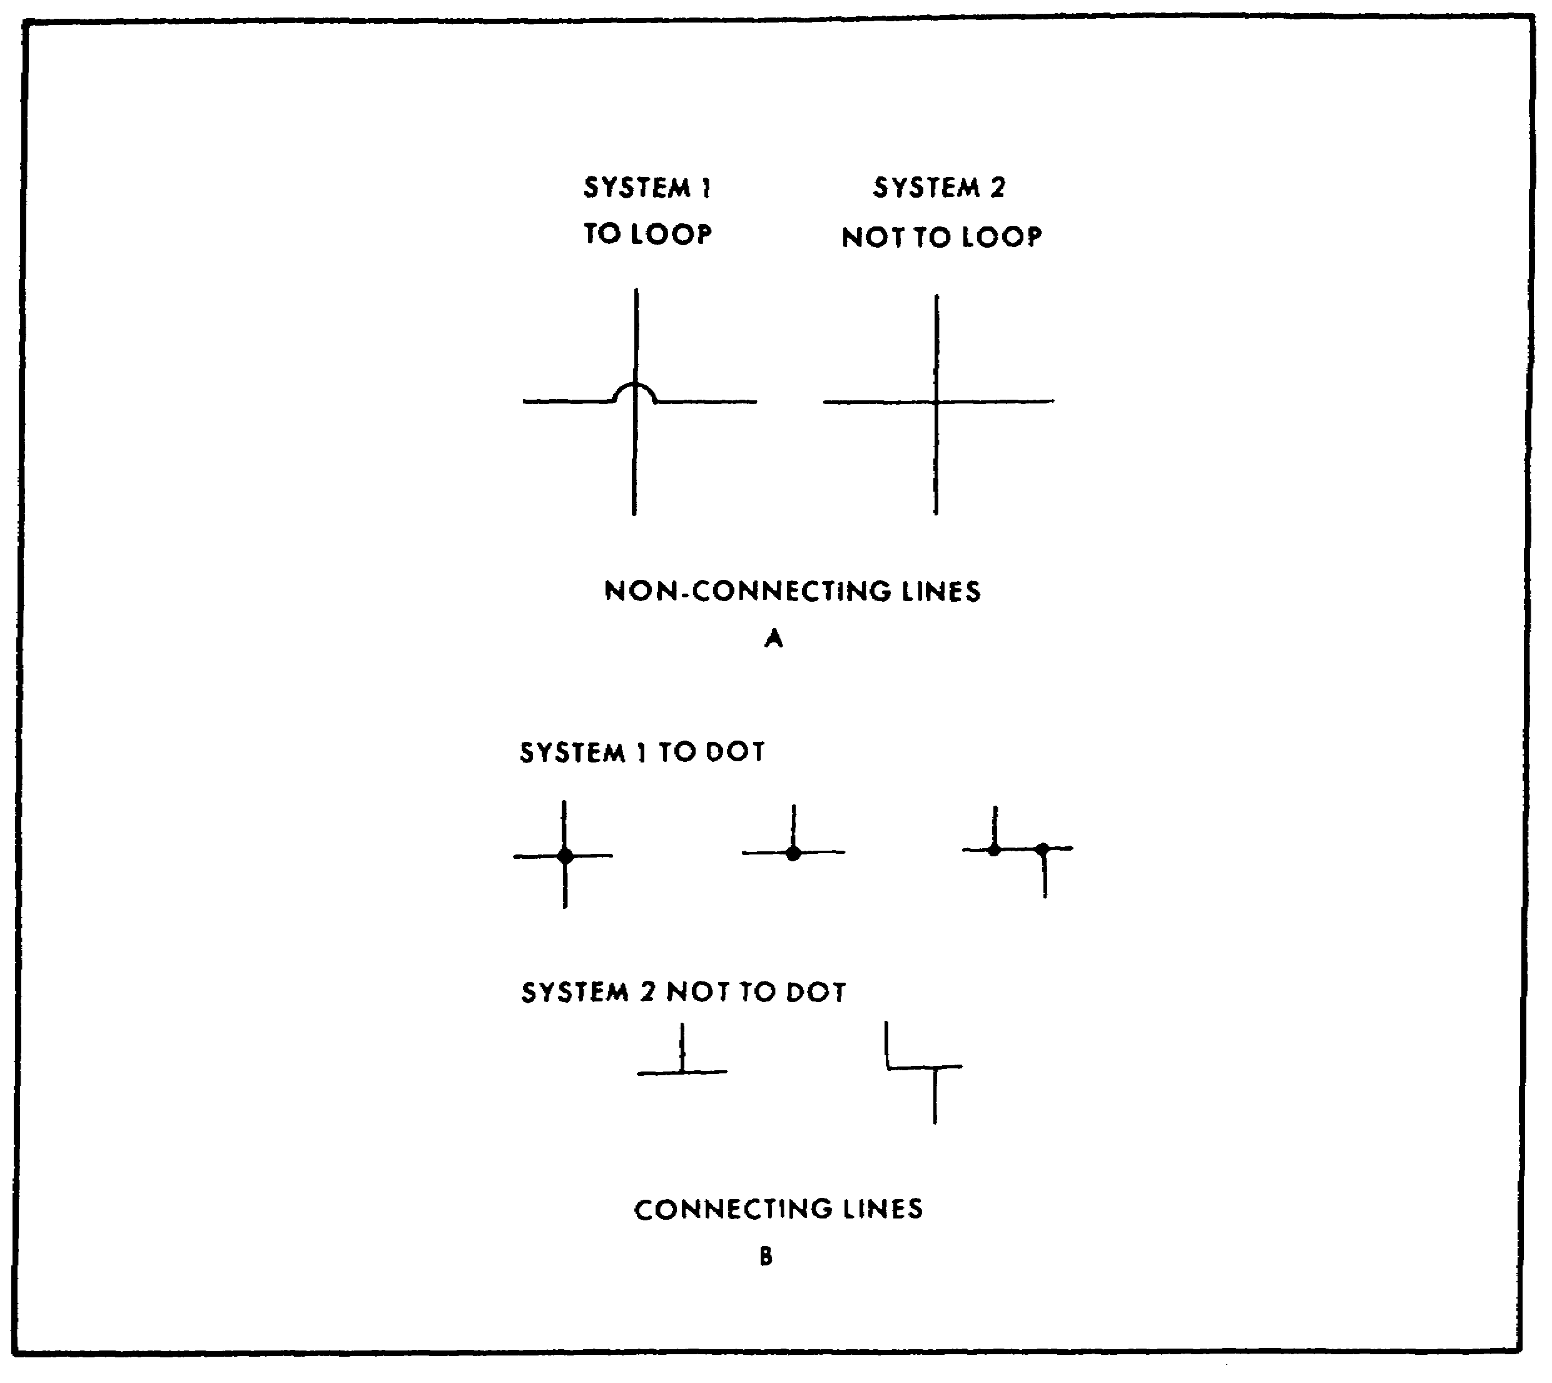

FIGURE 63. CROSSING LINES.

we put a short, loop (A)(figure 63) in one of the lines at the intersection. However, it is just as correct to let the lines cross. A connection between two crossing lines (B), (figure 63) must be designated by placing a dot at the crossing, if loops are used to designate crossings. The dot is omitted if no loops are used for crossings, but all joining lines must be shown as tees. Only one system must be used throughout a diagram. For maximum clarity of circuits, the "loop and dot" system is recommended.

(3) Pump. The basic symbol of a pump is a circle with a black triangle pointing outward (figure 64 on the next page). There are probably many more basic designs of pumps, but all have the same function, and one basic symbol is all we need to depict that function. The black triangle will

79

PRINC. OF M1 HYDRAULICS - OD0475 - LESSON 1/TASK 3

be used with many symbols to indicate that they are either receivers or sources of energy.
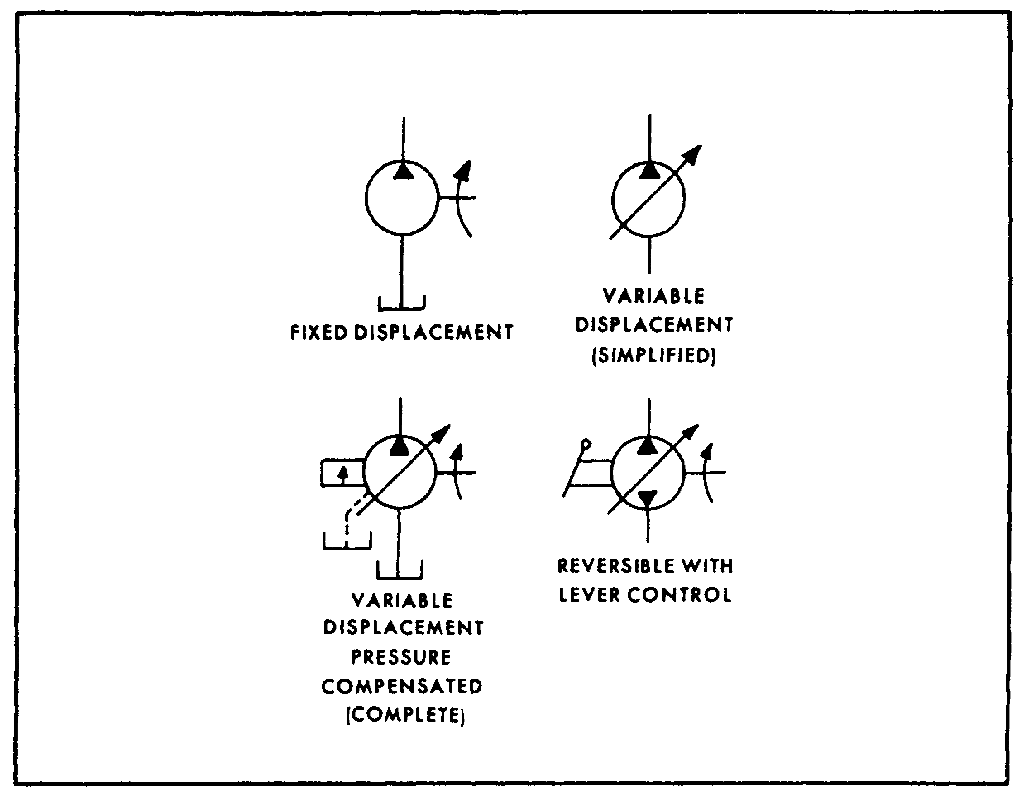

FIGURE 64. PUMP SYMBOLS.

The triangle will point out from a source, into a receiver. The pressure line from the pump is drawn from the tip of the triangle; the suction line is drawn opposite it. Thus, the triangle also indicates the direction of flow. If a pump is reversible, it will have two triangles, one pointing out of each port. Port connections to the pump (or any other component, with the exception of the reservoir) are at the points where the lines touch the symbols. A variable (or adjustable) component is designated by drawing an arrow through it, at 45 degrees.

(4) Motor. Motor symbols are also circles with black triangles (figure 65 on the next page), but the triangles point in, to show that the motor is a receiver of pressure energy. One triangle is used in a non-reversible motor symbol; two are used for a reversible motor. The direction of flow is easily

80

PRINC. OF M1 HYDRAULICS - OD0475 - LESSON 1/TASK 3

evident with a single triangle; it is the way the triangle points. In the reversible motor, we must refer to the pump and valve symbols to trace the flow direction. The arrows outside the lines show the flow direction, always away from the pump's pressure port and into the motor port that is connected to the pressure line. The opposite port then must be discharging back to the tank.
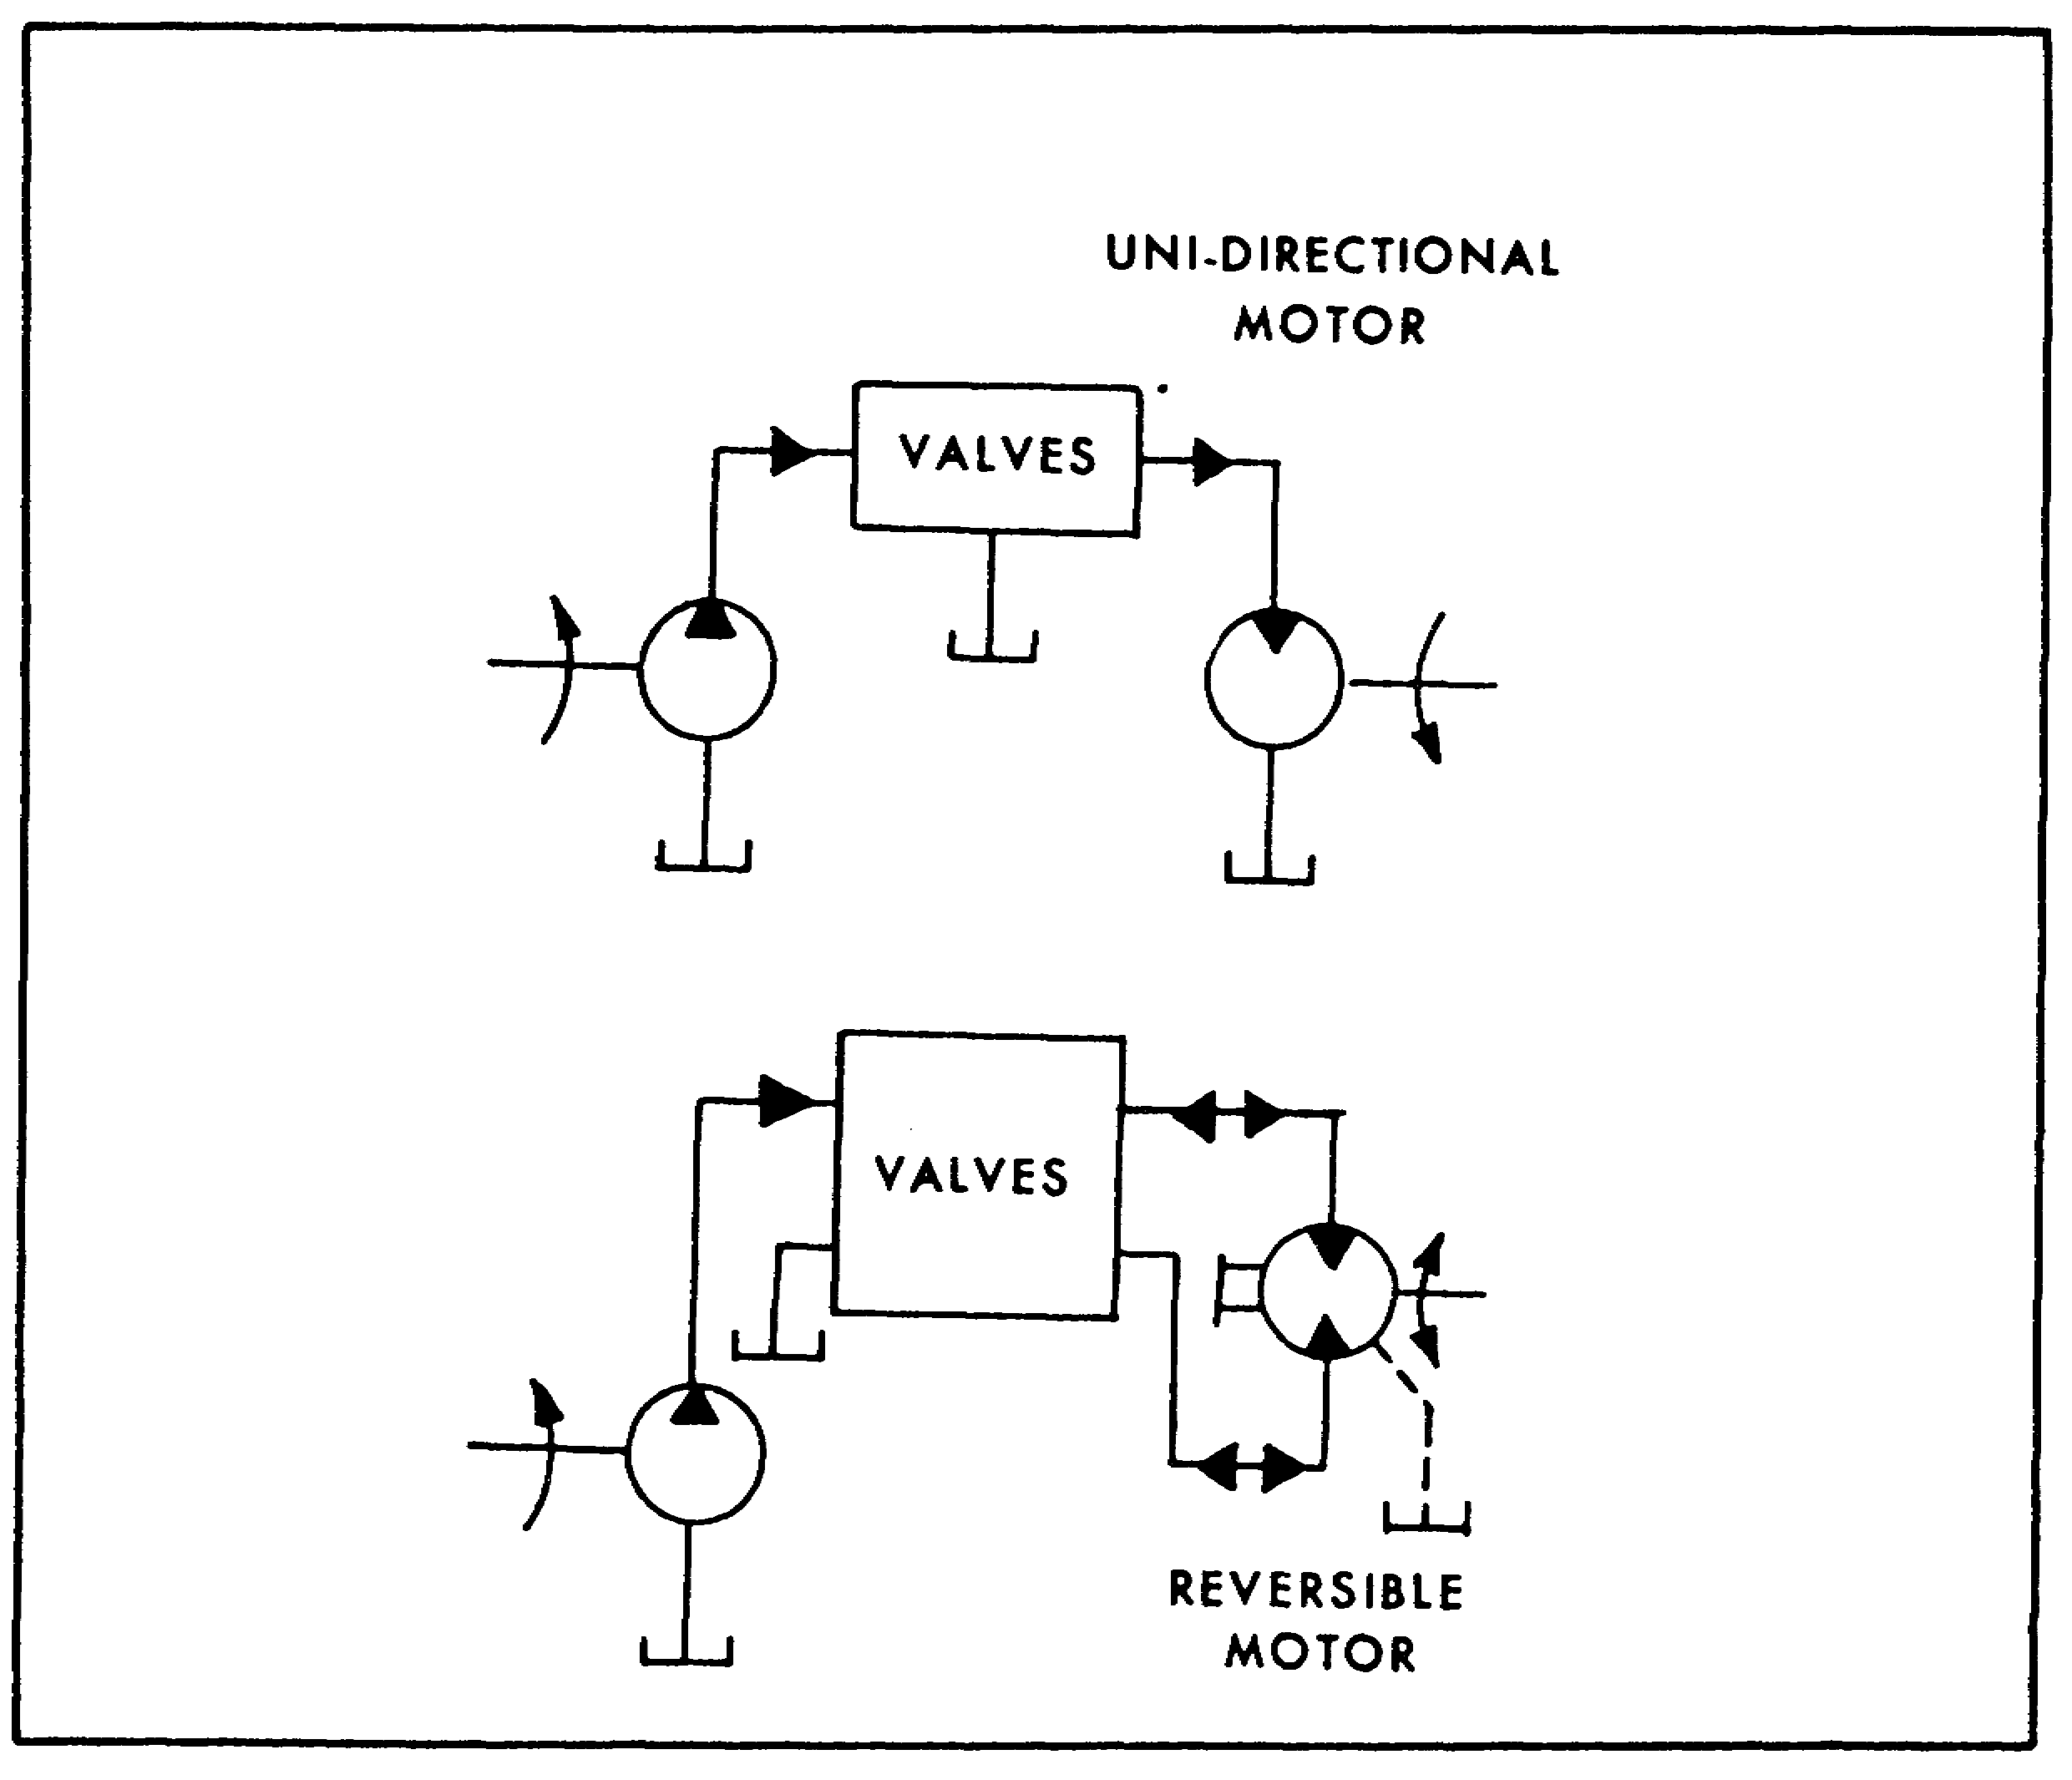

FIGURE 65. MOTOR SYMBOLS.

(5) Cylinder. A cylinder symbol (figure 66 on the next page) consists of a simple rectangle, representing the barrel, and a T-shaped figure, representing a piston and rod. The symbol can be drawn in any position. If the cylinder is single-acting, there is only one hydraulic line drawn to the symbol. Also, the end of the symbol opposite the port is left open. A double-acting cylinder symbol has both ends closed and two lines meeting the symbol at the port connections. A double end

81

PRINC. OF M1 HYDRAULICS - OD0475 - LESSON 1/TASK 3

rod cylinder has a "rod" line extending from each end. Cylinder cushions are drawn as smaller rectangles against the piston line. If the cushion has an adjustable orifice, the slanted arrow is drawn across the symbol.

Flow to and from a cylinder must be traced by observing which lines it is connected to. There is no provision in the symbol for flow direction. This is really not a problem, however, since valve symbols are decorated with many arrows indicating the direction of flow.
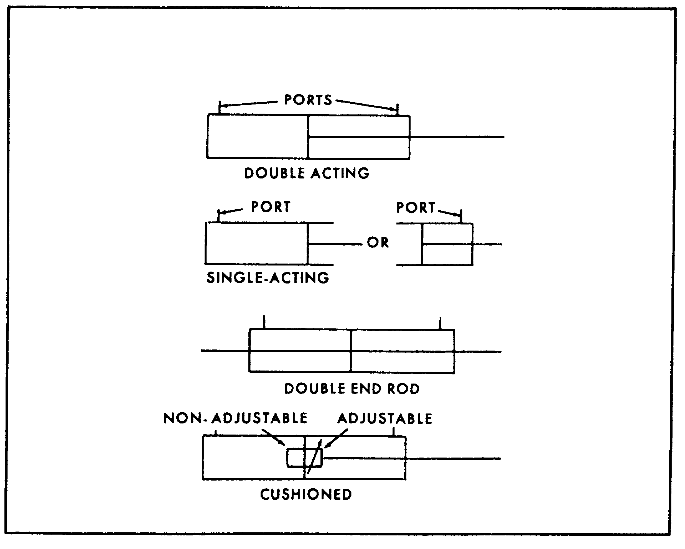

FIGURE 66. CYLINDER SYMBOLS.

(6) Pressure Control Valves. A pressure control valve is positioned between two flow conditions. Its basic symbol is a square (figure 67 on the next page) with external port connections and an arrow inside to show the direction of flow. Usually this type valve operates by balancing pressure against a spring, so a spring is shown at one side of the symbol and a pilot pressure line at the other.

82

PRINC. OF M1 HYDRAULICS - OD0475 - LESSON 1/TASK 3
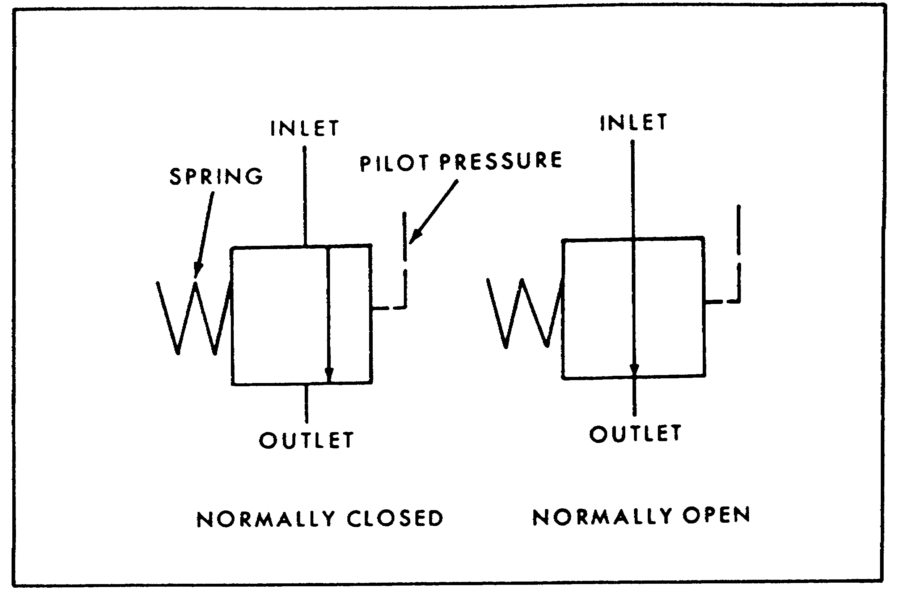

FIGURE 67. PRESSURE CONTROL VALVE SYMBOLS.

(a) A normally closed valve, such as a relief or sequence valve, is shown with the arrow offset from the ports toward the pilot pressure line. This indicates that the spring holds the valve closed until it is overcome by pressure. We mentally visualize the arrow moving over to complete the flow path from inlet to outlet when pressure rises to the valve setting. The actual function of the valve is shown by its connection into the circuit diagram.

(b) When the arrow connects the two ports, we know that the valve is normally open. It closes only when pressure overcomes the spring force.

(c) A relief valve (figure 68 on the next page) is diagrammed with a normally closed symbol connected between the pressure line and tank. The flow direction arrow points away from the pressure line port and toward the tank port. This shows how a relief valve operates. When pressure in the system overcomes the valve spring, flow is from the pressure port to the tank port. The symbol does not show whether this is a simple or compound relief valve. What is important is to show its function in the circuit.

83

PRINC. OF M1 HYDRAULICS - OD0475 - LESSON 1/TASK 3
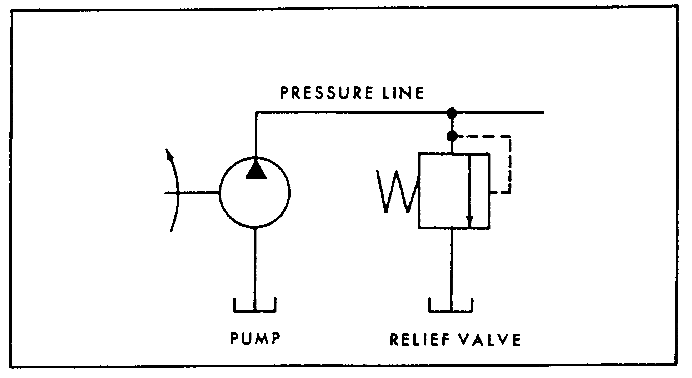

FIGURE 68. RELIEF VALVE SYMBOL.

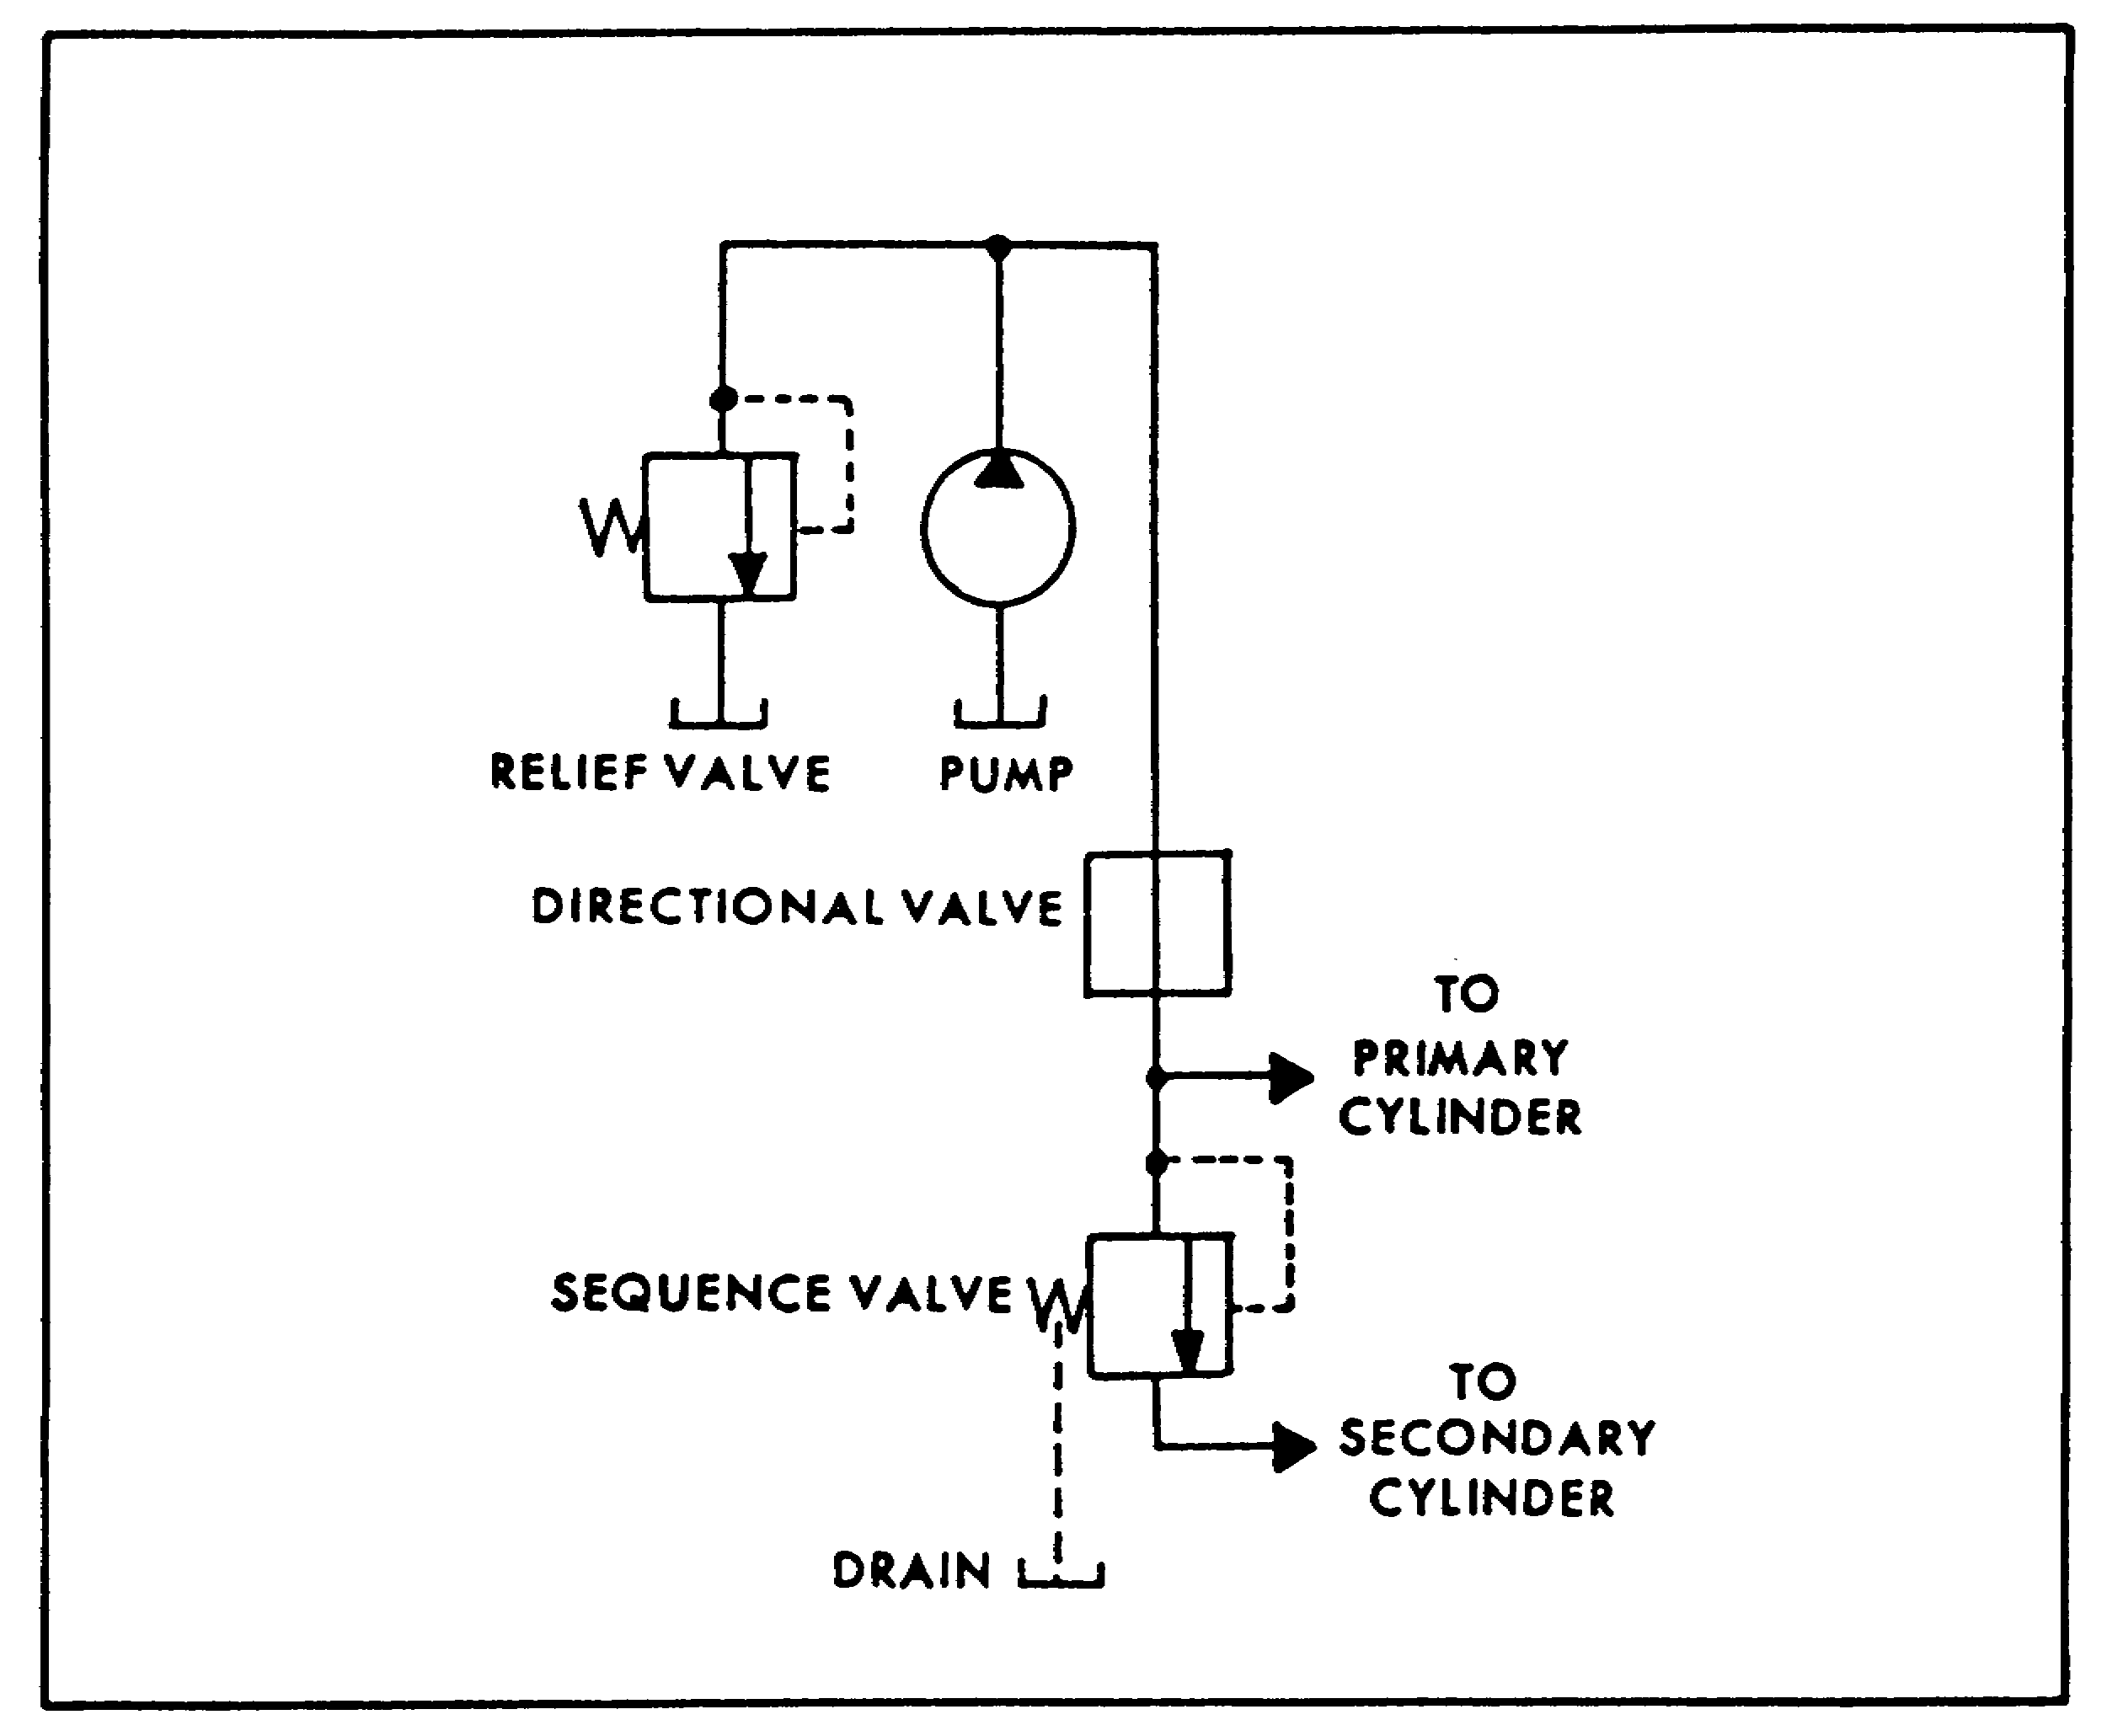

FIGURE 69. SEQUENCE VALVE SYMBOL.

84

PRINC. OF M1 HYDRAULICS - OD0475 - LESSON 1/TASK 3

(d) The same symbol is used for a sequence valve (figure 69, on the previous page). This time, though, the inlet port is connected to a primary cylinder line; the outlet port to the secondary cylinder line. Pilot pressure from the primary cylinder line sequences the flow to the outlet port when it reaches the setting of the valve. Since the sequence valve is externally drained, we have added a drain connection to the symbol, at the drain's location in the valve.

(e) A sequence valve must be used with a check valve for free return flow when the cylinders are reversed. Figure 70 shows the simplified check valve symbol and its parallel connection. As you are looking at it, free flow is up, away from the "V", which represents a seat. In the top view, we see the check valve as a separate unit. When the check valve is built into the sequence valve, we enclose both valves with a box, called an enclosure. An enclosure is used to show the limits of a component, or an assembly containing more than one component. It is an alternate long-and-short dash line. External ports are assumed to be on the enclosure line and indicate connections to components.
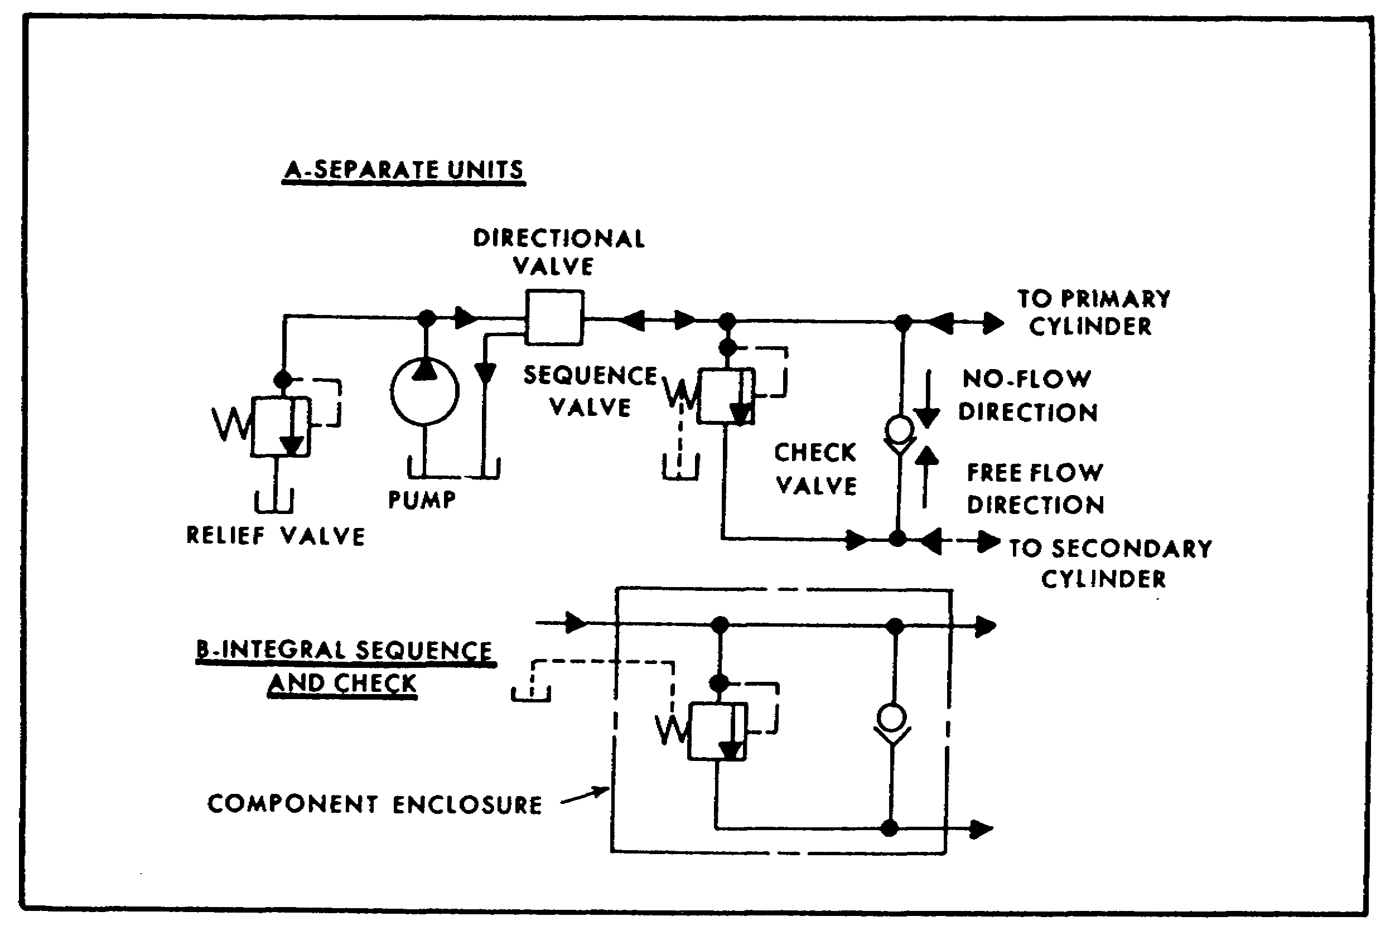

FIGURE 70. SIMPLIFIED CHECK VALVE SYMBOL.

85

PRINC. OF M1 HYDRAULICS - OD0475 - LESSON 1/TASK 3

(f) A counterbalance valve is a normally closed pressure control with an integral check valve. For a directly controlled valve, we use the same symbol (figure 71) with the primary port connected to the bottom port of the cylinder, and the secondary port to the directional valve. The drain connection isn't shown because the valve is internally drained. If the valve body has two primary ports, a complete symbol should show one of them plugged.
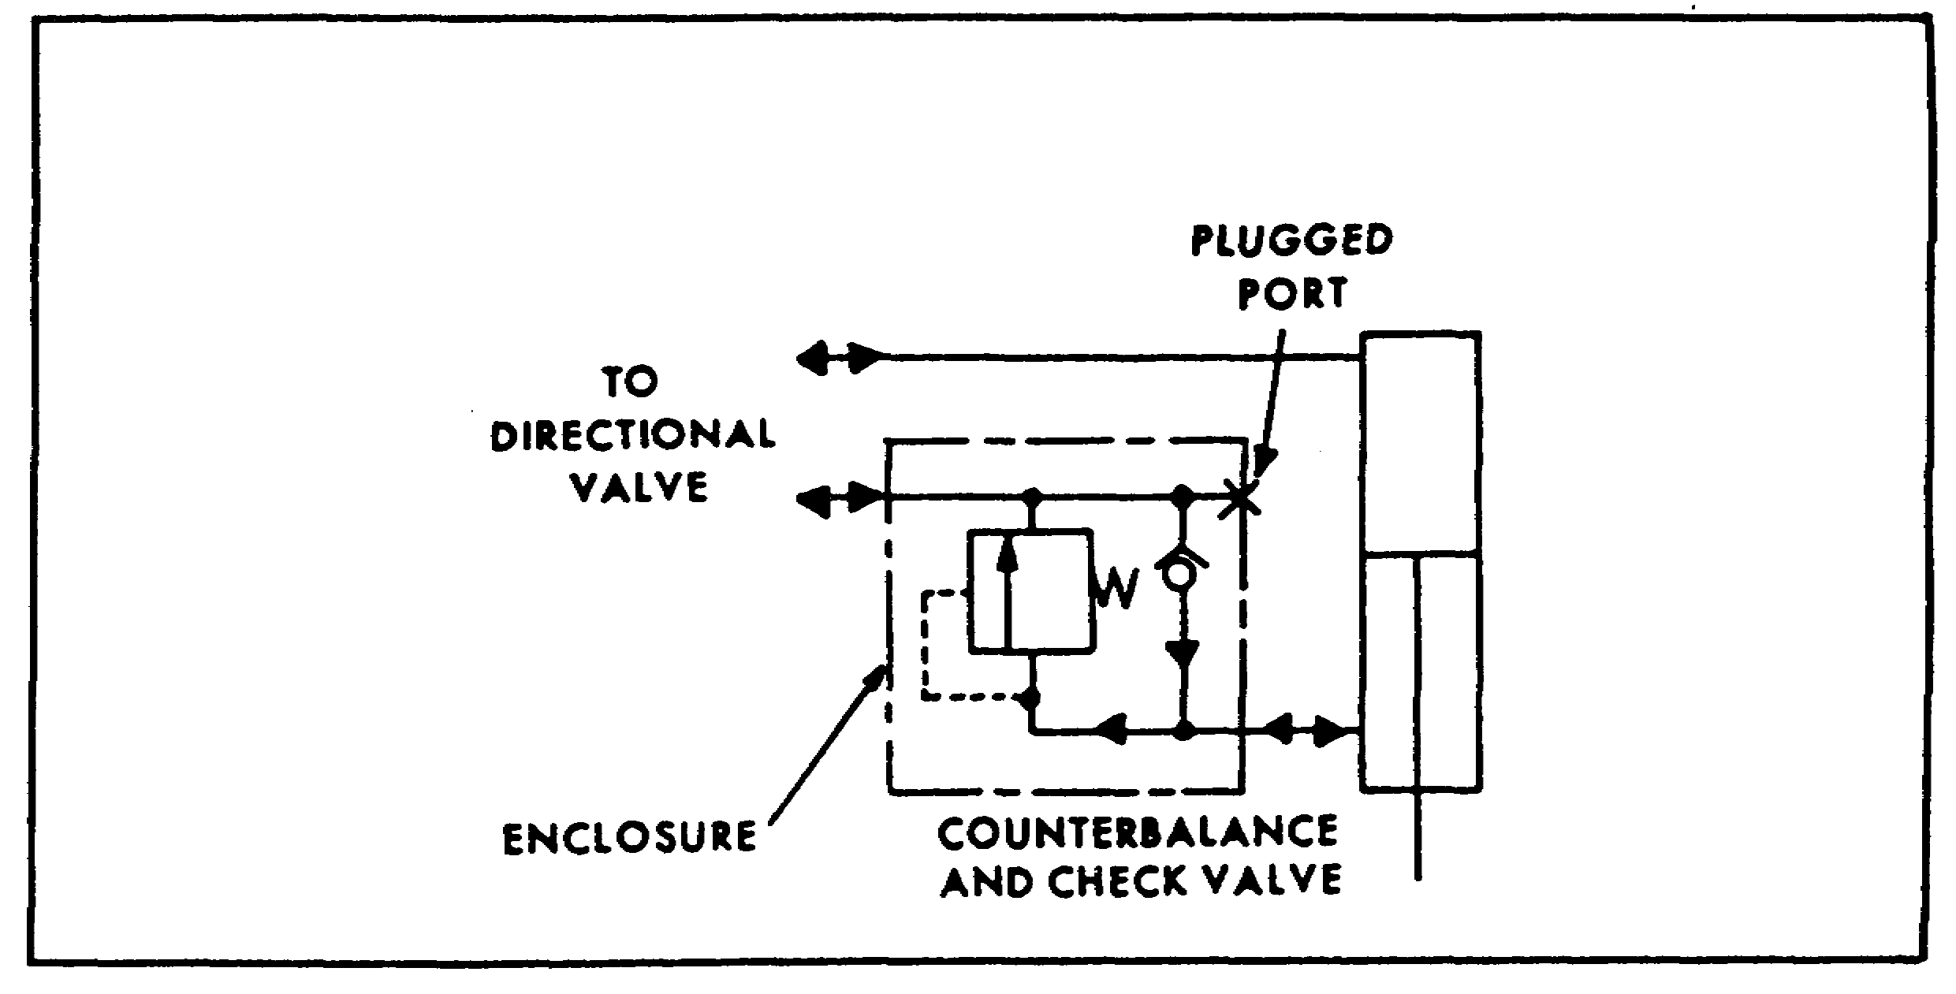

FIGURE 71. COUNTERBALANCE VALVE SYMBOL.

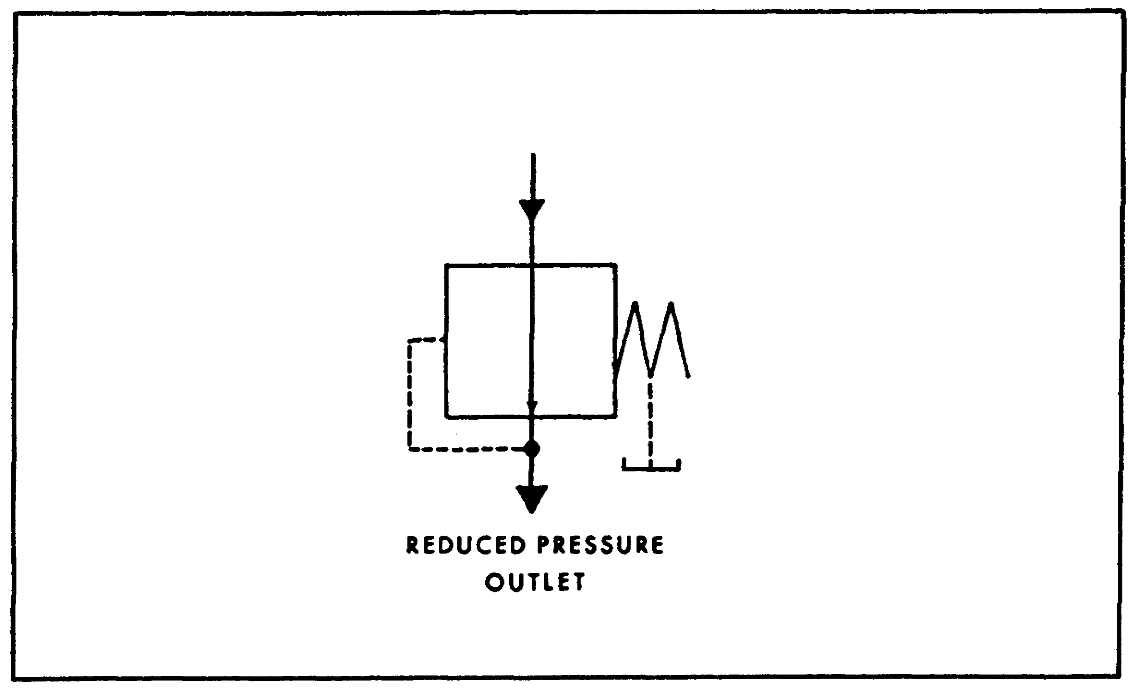

FIGURE 72. NORMALLY OPEN PRESSURE REDUCING VALVE.

86

PRINC. OF M1 HYDRAULICS - OD0475 - LESSON 1/TASK 3

(g) The normally open pressure reducing valve is diagrammed in figure 72 on the previous page. Outlet pressure is shown opposing the spring to modulate or shut off flow when the valve setting is reached.

(7) Flow Control Valves. The basic flow control valve symbol (figure 73) is a simple representation of a restriction. If the valve is adjustable, a slanted arrow is drawn across the symbol.
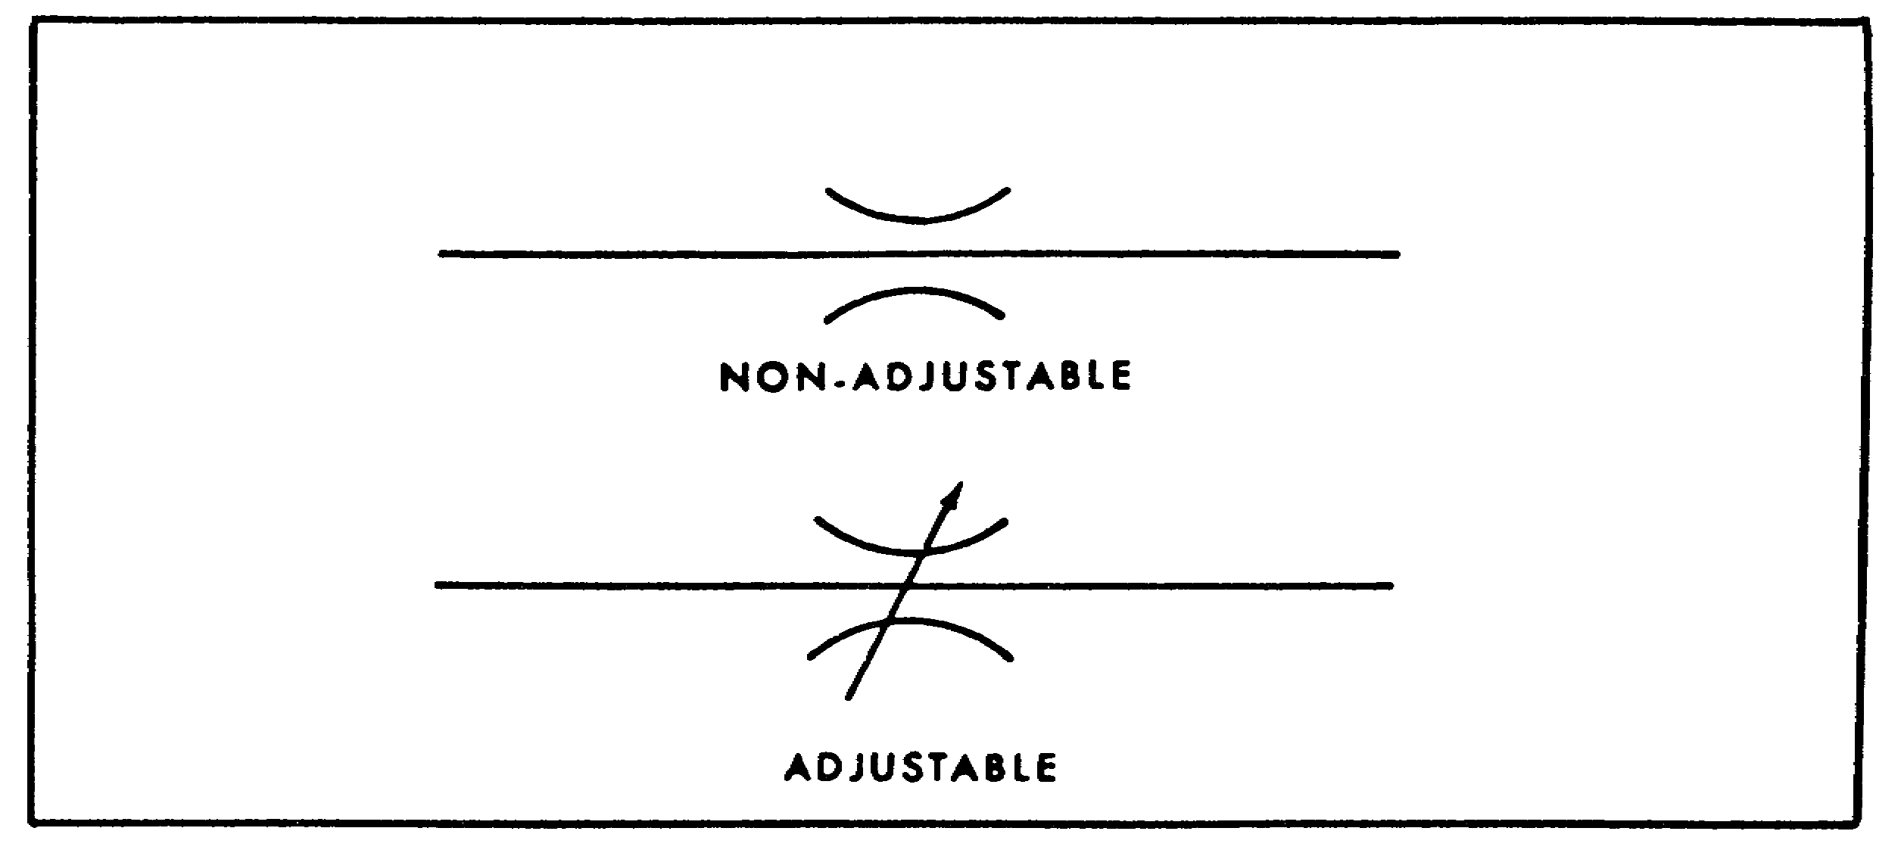

FIGURE 73. FLOW CONTROL VALVE SYMBOL.

A complete adjustable pressure compensated flow control, with built in by-pass, is diagrammed in figure 74. The short vertical arrow is the symbol for pressure compensation.
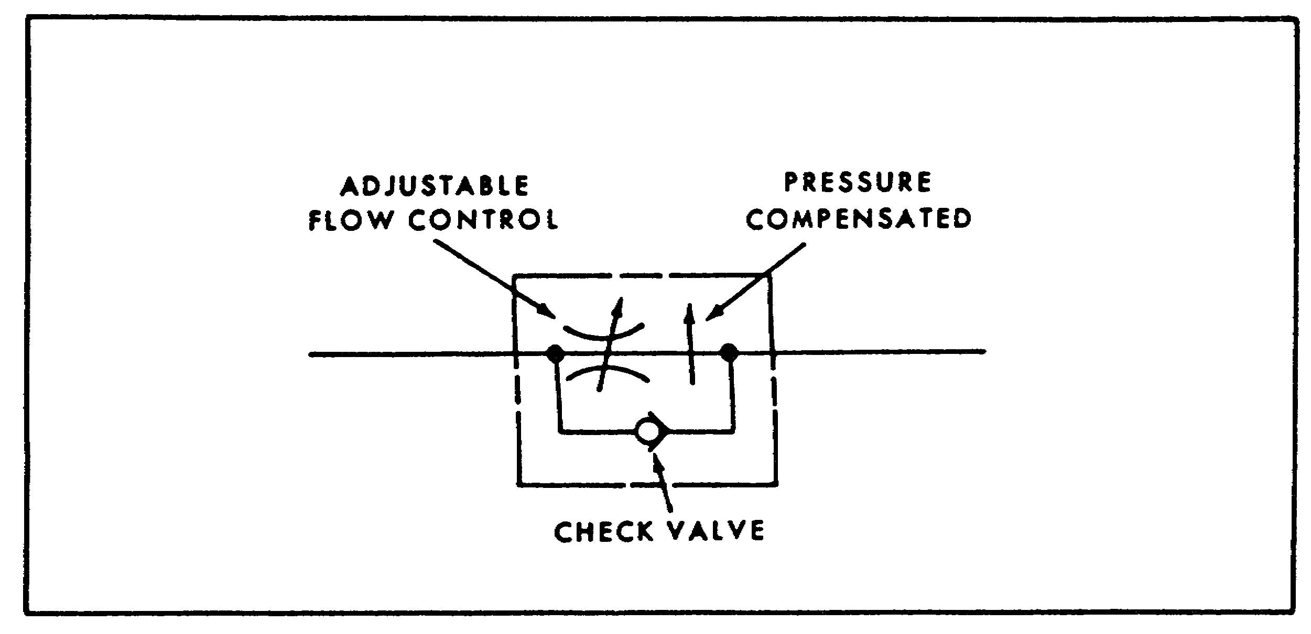

FIGURE 74. COMPENSATED FLOW CONTROL, SYMBOL.

87

PRINC. OF M1 HYDRAULICS - OD0475 - LESSON 1/TASK 3

(8) Directional Control Valves. A directional control valve symbol uses a multiple envelope system that has a separate rectangle for each position. All the port connections are made to the envelope that shows the neutral condition of the valve. Within each envelope are arrows showing the flow paths when the valve is shifted to that position.

(a) An unloading valve symbol (figure 75) has two envelopes. In the normal closed position, flow is shown blocked inside the valve. The spring control is placed adjacent to this envelope to show that the spring controls this position. External pilot pressure is indicated against the bottom envelope to show that this is the flow condition when the pilot pressure takes over. With the lower envelope superimposed on the other, the flow path arrow connects the pump outlet to the reservoir.
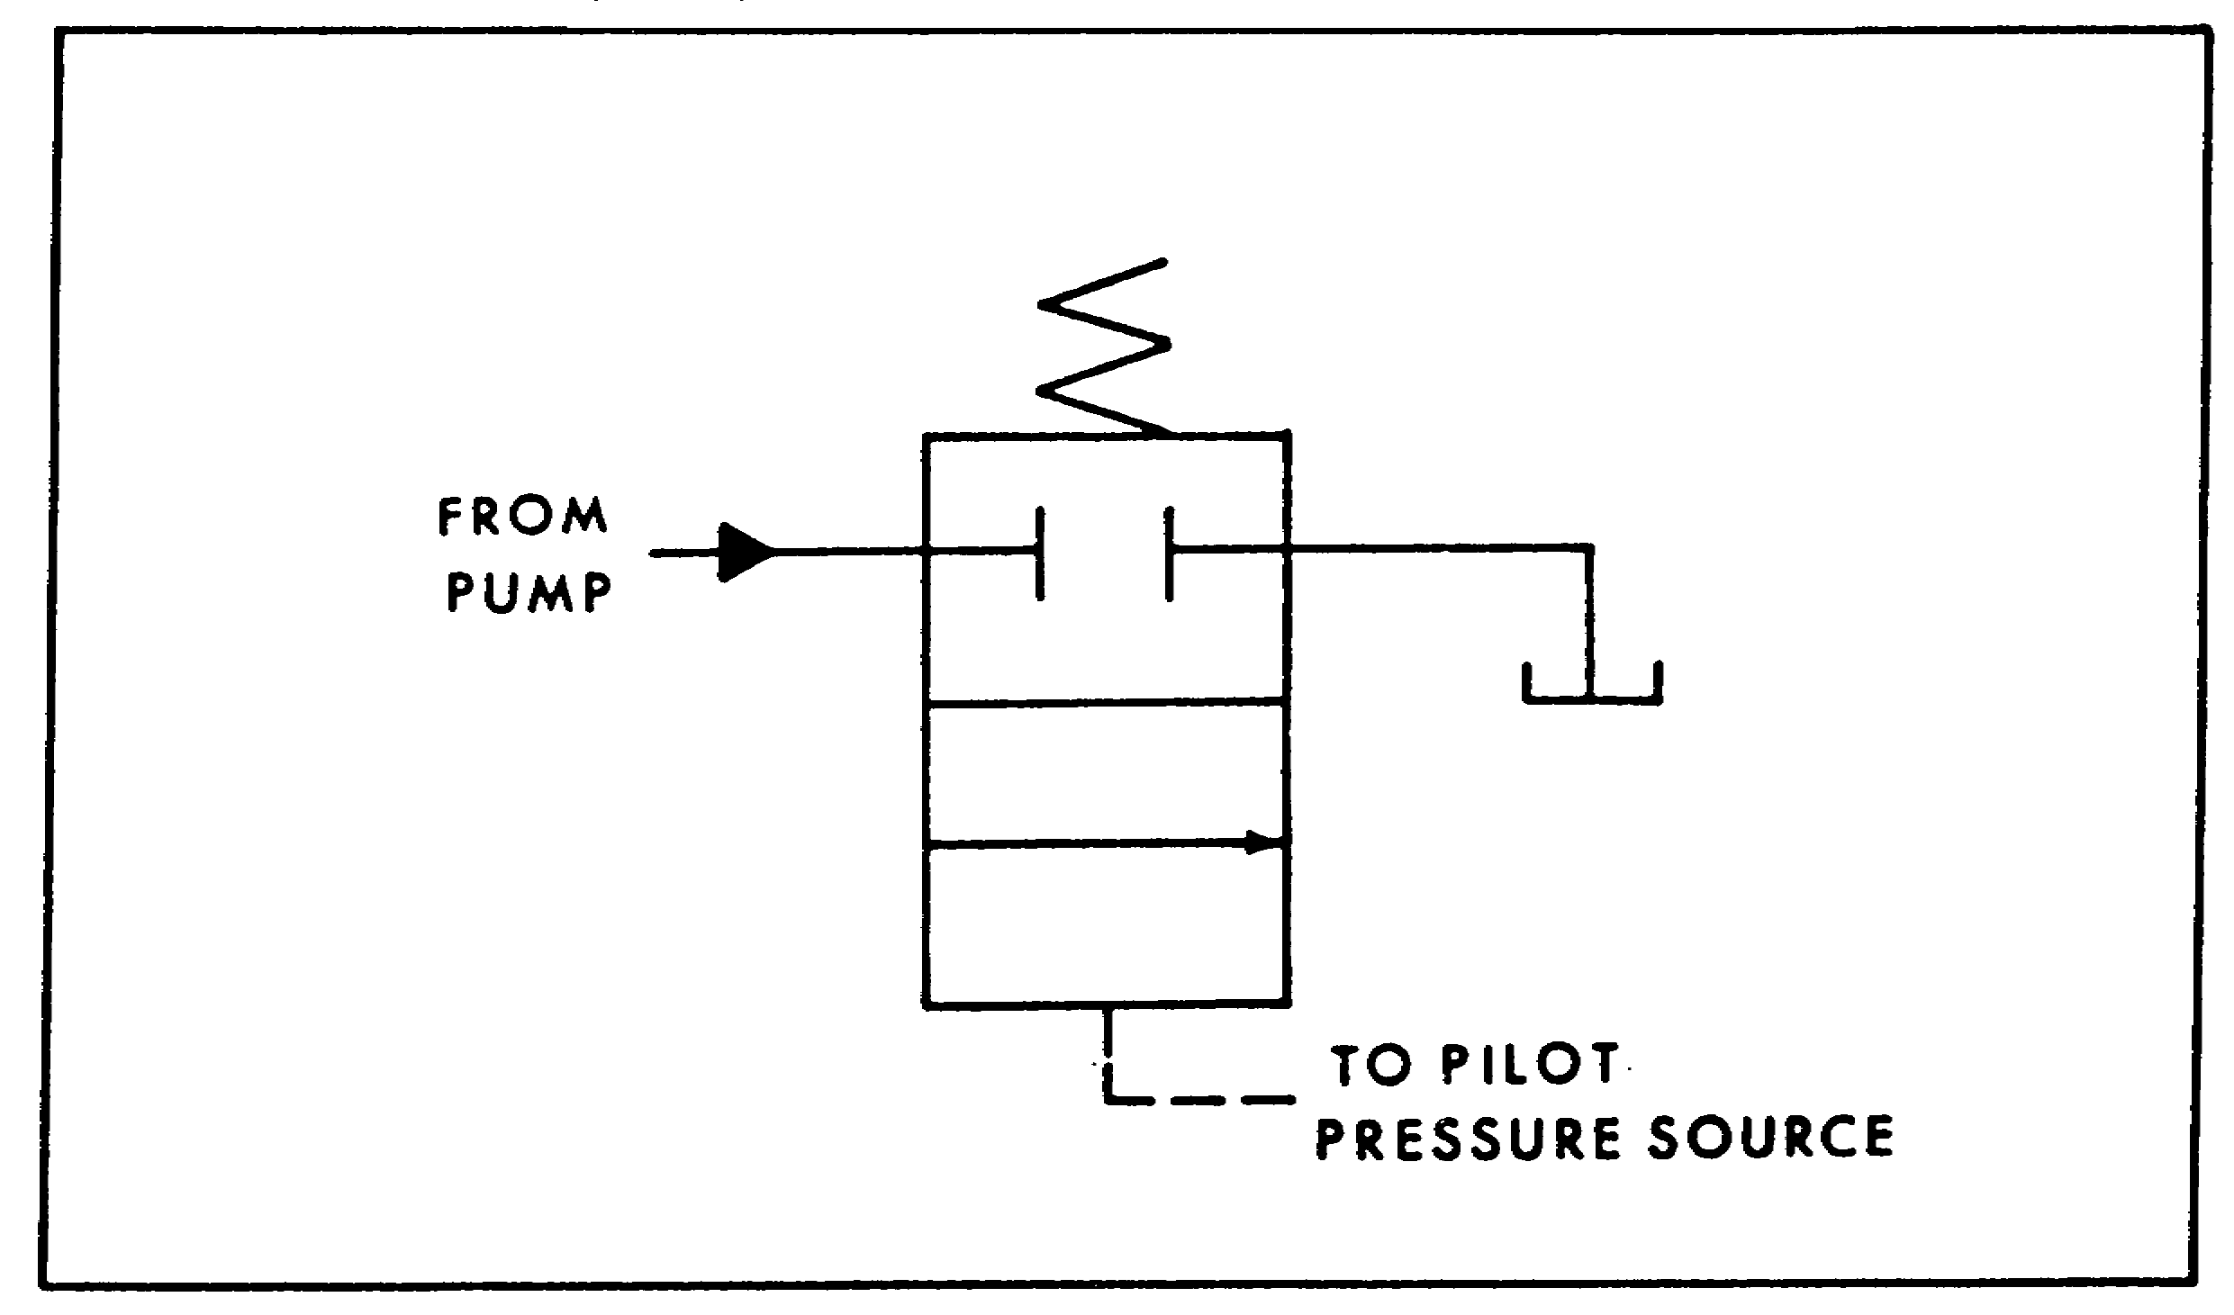

FIGURE 75. UNLOADING VALVE SYMBOL.

(b) An ordinary four-way valve has two envelopes if it is a two-position valve (figure 76 on the following page), or three envelopes if it has a center position. The actuating control symbols are placed at ends of the envelopes. The extreme envelopes show the flow conditions when their adjacent controls are actuated.

88

PRINC. OF M1 HYDRAULICS - OD0475 - LESSON 1/TASK 3
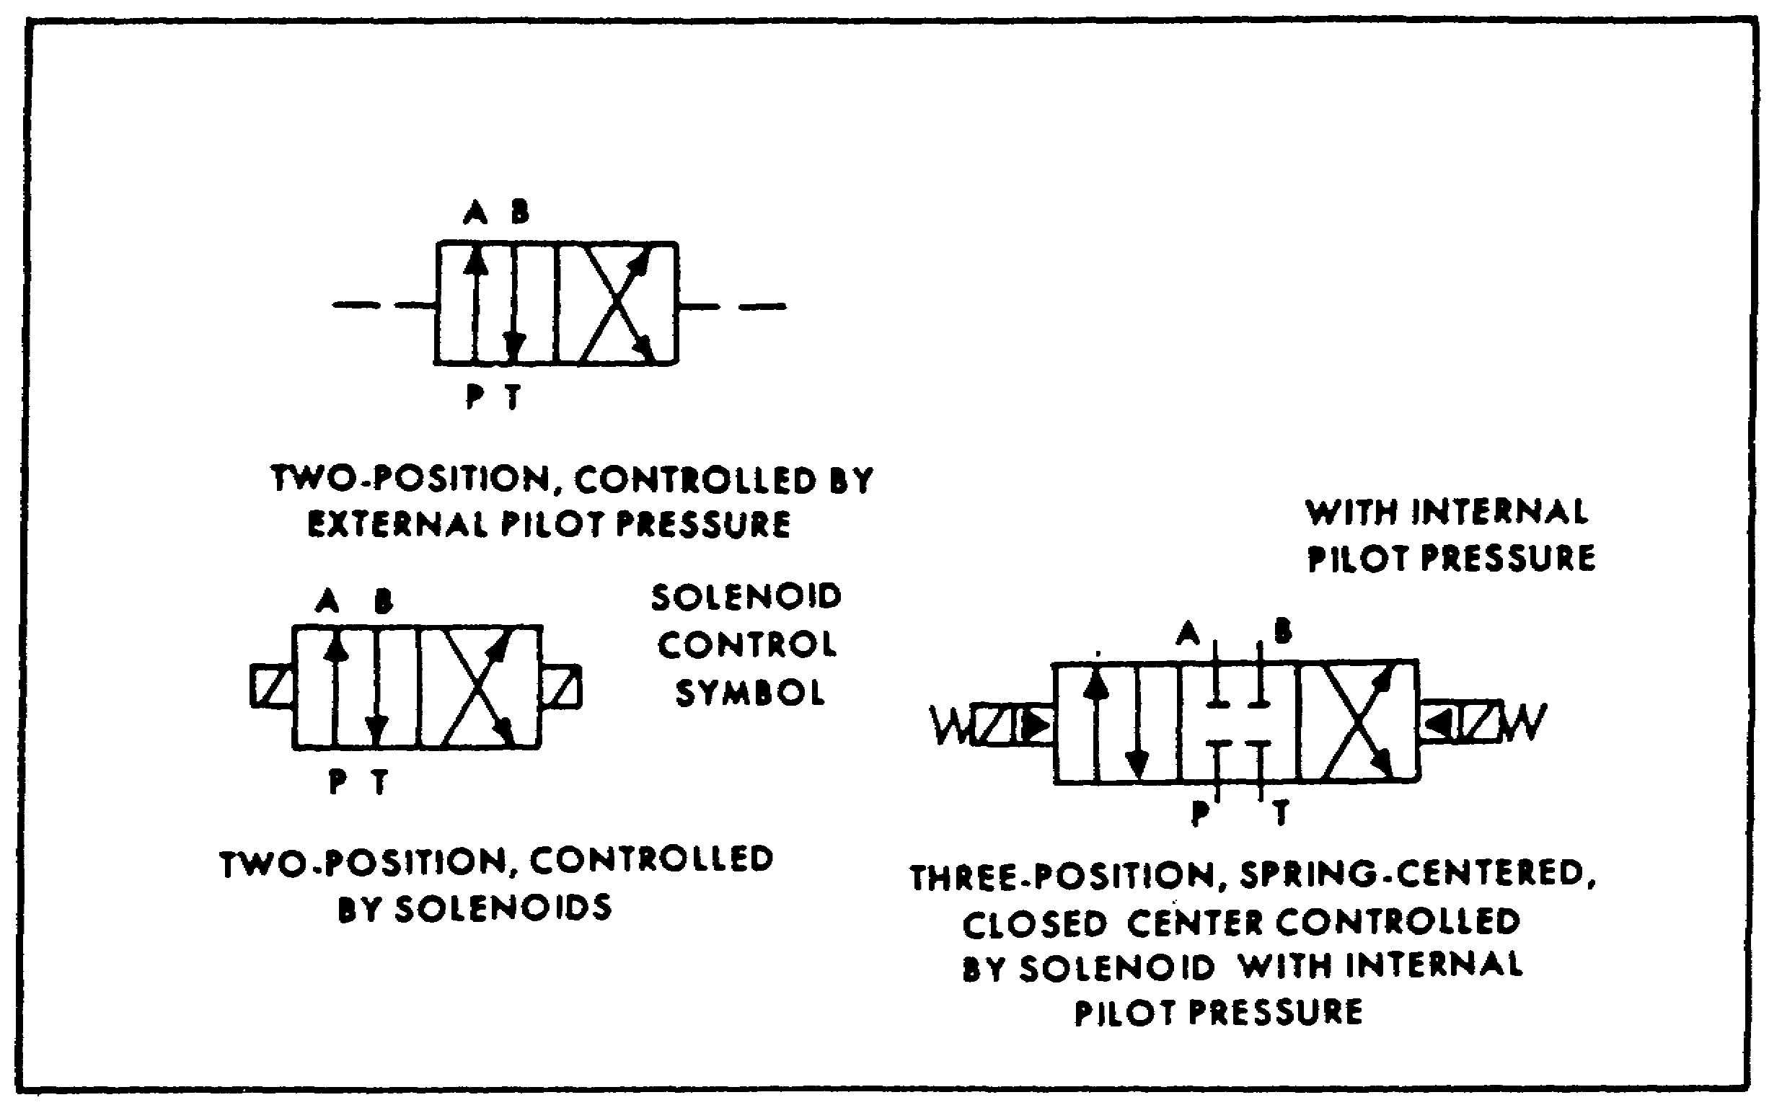

FIGURE 76. FOUR-WAY DIRECTIONAL CONTROL VALVE.

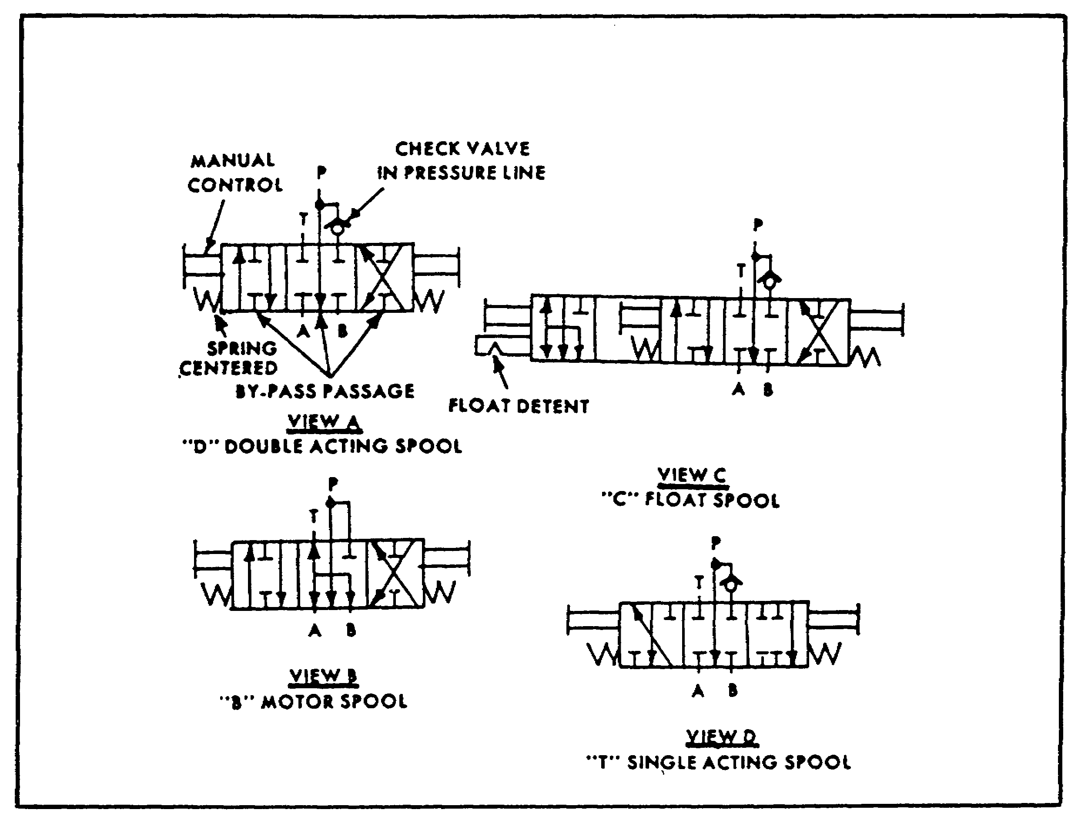

FIGURE 77. MOBILE DIRECTIONAL VALVE ACTION.

89

PRINC. OF M1 HYDRAULICS - OD0475 - LESSON 1/TASK 3

(c) The symbol for a mobile directional valve section (figure 77 on the previous page) resembles a four-way valve symbol, but it has added connections and flow paths to represent the by-pass passage. There is a separate envelope for each finite position and connections are shown to the center or neutral position. A manual lever control with centering springs is shown at each end. Complete symbols for B, C, and T spools are shown in figure 77, views B, C, and D.

These illustrations show only the spools. A complete mobile valve bank would also show relief valves and internal connections within an enclosure.

4. Conclusion

In this section, the major graphical symbols have been reviewed and their uses discussed. No attempt was made to cover every possible symbol and combinations; that would take several appendices the size of this subcourse. For reference, all the basic hydraulic symbols are tabulated in figures 59 and 60 on pages 75 and 76.

90

PRINC. OF M1 HYDRAULICS - OD0475 - LESSON 1/PE 1

PRACTICAL EXERCISE 1

1. Instructions

On a plain sheet of paper, write down the answers to the following questions. When you have answered them, turn the page and check your answers.

2. First Requirement

a. Hydraulics is the science of transmitting force and/or motion through the medium of a confined liquid. In a hydraulic system, how is power transmitted to a confined liquid?

b. Define "force", as used when describing hydraulic principles.

c. In the middle of the 17th century, Blaise Pascal discovered that pressure on a fluid acts equally in what direction?

d. Name the two ways of measuring flow?

e. Energy has been described as the ability to do work; it may be grouped into three forms. Name the three forms.

3. Second Requirement

a. A properly constructed reservoir is more than just a tank to hold oil. Whenever practical it should be capable of separating air from oil and settling out contamination in the oil. Name another feature of a well-designed reservoir.

b. A magnetic plug can be used to remove foreign particles from hydraulic liquid. In addition to this component, name two other components that can be used for this purpose.

c. Name the hydraulic component that stores potential power, in this case liquid under pressure for future conversion to useful work.

d. Name the type of accumulator which contains liquid on one side and air or nitrogen on the other.

91

PRINC. OF M1 HYDRAULICS - OD0475 - LESSON 1/PE 1

e. The type of tubing used for hydraulic lines is determined by the flow and type of fluid. Name two other factors which contribute to deciding which type of tubing will be used for a hydraulic line.

f. What is the primary purpose of a hydraulic pump?

g. A fundamental division of hydraulic pumps is that they can be made according to displacement type. Identify the type of pump that discharges liquid in a continuous flow.

h. Hydraulic actuators can be either linear or rotary. The purpose of a linear actuator is to produce force and motion outputs in a straight line. Describe what a rotary actuator produces.

i. Name the type of cylinder usually found in a hydraulic jack.

j. When a piston-type cylinder is identified as "double-acting", what is meant?

k. There are three principal ratings for hydraulic motors. Displacement is one rating, name the remaining two.

l. Hydraulic valves can be grouped into three general categories: pressure control, flow control and directional control. The purpose of a pressure control valve may be limiting or regulating pressure. It may also cause the operation of actuators to occur in a specific order. What other job could a pressure control valve perform?

m. Name the most common type of pressure control valve.

n. Describe the purpose of a counterbalance valve.

o. Two-way valves are generally used to control the direction of fluid flow in a hydraulic circuit. They are generally referred to as a certain type of valve. Name the type.

92

PRINC. OF M1 HYDRAULICS - OD0475 - LESSON 1/PE 1

4. Third Requirement

a. In the definition of a hydraulic circuit diagram, there are four types of information which are generally included. Two types are: (1) a description of the hydraulic circuit, and (2) notes regarding the hydraulic circuit. Name the remaining two types of information.

b. Describe the hydraulic system symbol for a reservoir.

c. What is the minimum number of hydraulic lines drawn to a reservoir?

d. The basic symbol of a pump is a circle with a black triangle pointing outward. What does the triangle point out from?

e. Motor symbols also are circles with black triangles. What is signified when two triangles are used?

f. A pressure control valve symbol is a square with external port connections and an arrow inside to show the direction of flow. Describe how a normally closed valve, such as a relief or sequence valve, is shown.

93

PRINC. OF M1 HYDRAULICS - OD0475 - LESSON 1/PE 1

LESSON 1. PRACTICAL EXERCISE - ANSWERS

1. First Requirement

a. Force is transmitted by "pushing" on a confined liquid.

b. Force, is anything which tends to produce or modify motion. It is a push or pull, and is usually expressed in pounds.

c. Pressure, exerted on a fluid, acts "equally" in all directions.

d. (1) Velocity.
(2) Flow Rate.

e. (1) Potential energy.
(2) Kinetic energy.
(3) Heat energy.

2. Second Requirement

a. Dissipating heat from the oil.

b. (1) Strainers.
(2) Filters.

c. The accumulator.

d. Piston-type accumulator.

e. (1) Fluid velocity.
(2) System pressure.

f. The primary purpose of a hydraulic pump is to push on the hydraulic fluid and create flow.

g. Non-positive displacement type.

h. A rotary actuator produces torque and rotating motion.

i. A ram type cylinder.

j. When a piston-type cylinder is defined as double acting, this means that fluid under pressure can be applied to either side of the piston, to provide movement and apply force in the corresponding direction.

94
PRINC. OF M1 HYDRAULICS - OD0475 - LESSON 1/PE 1

k. (1) Pressure.
(2) Torque.

l. Creating a particular pressure condition
required for control.

m. The relief valve.

n. The purpose of a counterbalance valve is to permit the free flow of fluid in one direction and to maintain resistance to flow in the other direction, until a certain pressure is reached.

o. Sliding spool type.

3. Third Requirement

a. (1) The sequence of operation of the hydraulic circuit.

(2) A list of components which comprise the hydraulic circuit.

b. A rectangle, with the long side horizontal.

c. Two.

d. A source.

e. A reversible motor.

f. A normally closed valve is shown with the arrow offset from the ports toward the pilot pressure line.

95

PRINC. OF M1 HYDRAULICS - OD0475 - LESSON 2/TASK 1

LESSON 2

M1 SERIES TANK HYDRAULICS

TASK 1. Identify the major M1 series tank hydraulic system components.

CONDITIONS

Within a self-study environment and given the subcourse text, without assistance.

STANDARDS

Within two hours

REFERENCES

No supplementary references are needed for this task.

1. Introduction

The M1 Abrams tank uses hydraulic pressure to move the main gun in elevation and the turret in azimuth. To accomplish these tasks, several sophisticated hydraulic components are incorporated into the M1's hydraulic system. Before actually naming and identifying the location and purpose of the components that make up the M1's hydraulics, we shall begin with a simple overview of the operation of the M1 hydraulic system.

2. Basic Operation

In addition to elevating the main gun and moving the turret in azimuth, hydraulic pressure also opens and closes the ammo door. A hydraulic pump on the powerpack provides this power when the engine is running.

An electrically-driven auxiliary pump provides hull hydraulic pressure when the main pump is not operating and the vehicle master power is on. The auxiliary hydraulic power (AUX HYDR POWER)

96

PRINC. OF M1 HYDRAULICS - OD0475 - LESSON 2/TASK 1

switch on the commander's control panel is used to turn on or shut off the auxiliary pump.

A pressure gage, located to the left of the gunner's primary sight, is used to indicate the M1's hydraulic system pressure.

A parking brake for the tank is hydraulically applied, and mechanically held or released. There is a pressure gage to indicate hydraulic system pressure for the driver. Also, there is a HYDRAULIC SYSTEM MALFUNCTION light on the driver's instrument panel, to alert the driver to possible main hydraulic system failure.

The following paragraphs will name and identify the specific components that comprise the M1's hydraulic system.

3. M1 Hydraulic Components
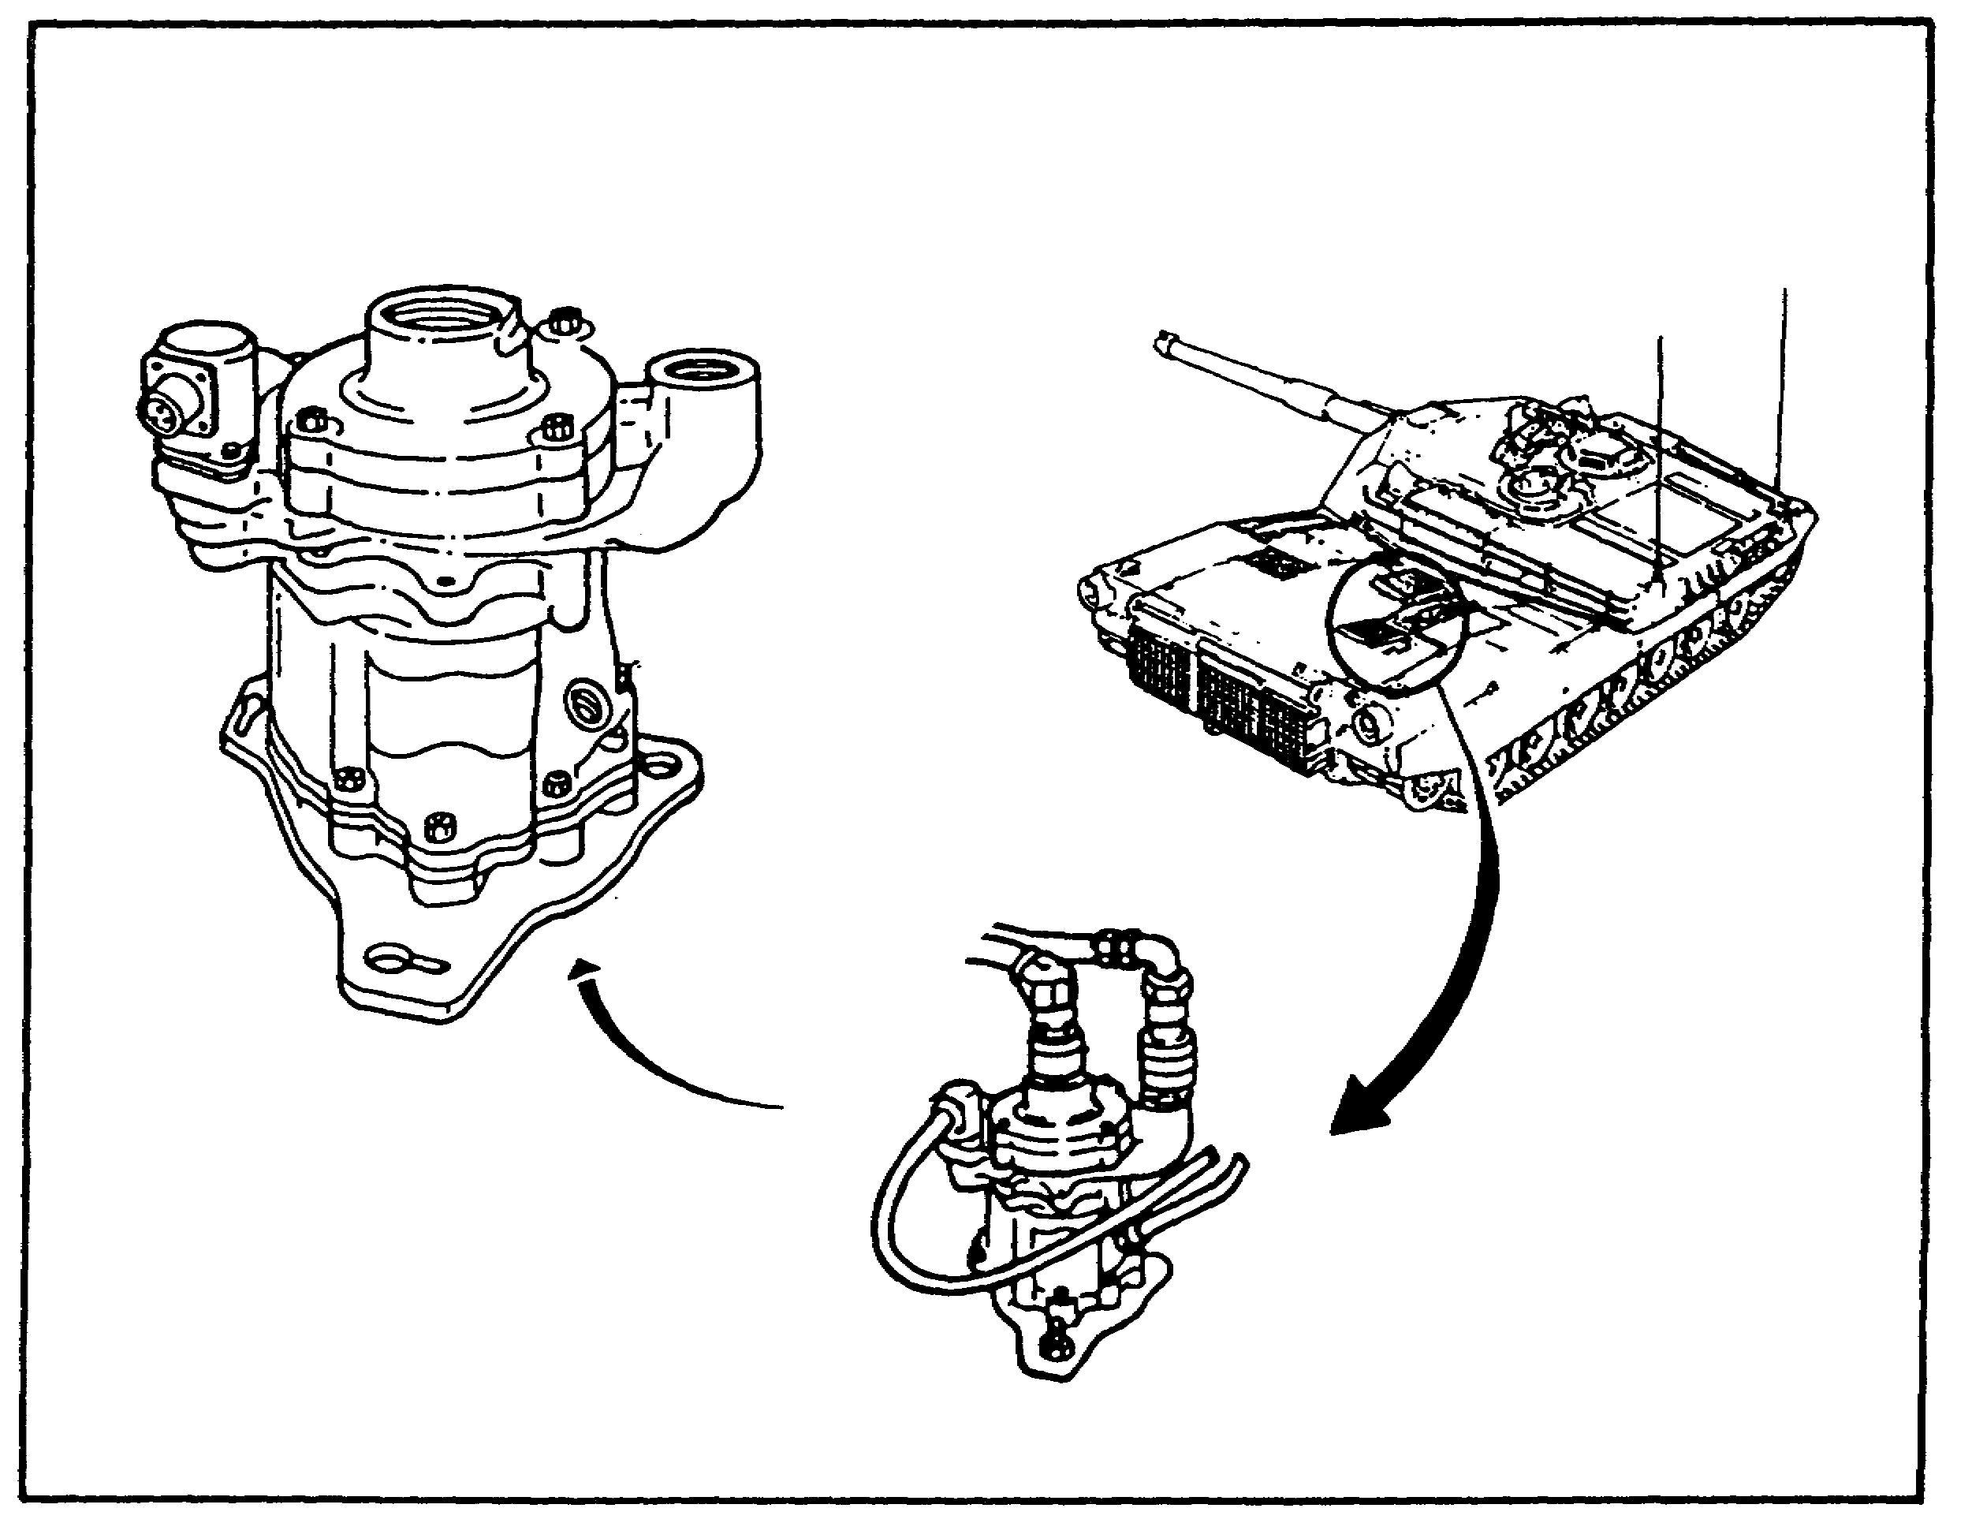

FIGURE 78. MAIN HYDRAULIC PUMP.

97

PRINC. OF M1 HYDRAULICS - OD0475 - LESSON 2/TASK 1

a. Main Hydraulic Pump.

The main hydraulic pump is a variable displacement, pressure compensated, pump (figure 78 on the previous page). It is driven by the turbine engine and is located on the powerpack. It is capable of delivering a maximum of 47 gpm into a hydraulic system requiring a system pressure of 1600 psi (plus or minus 50 psi).

Whenever the pump is turning an inlet pump on top of the housing draws hydraulic fluid from the reservoir, ensuring a positive supply of fluid to the pump. The fluid is then drawn into the pumping chamber, due to the low pressure area created by the pistons being drawn out of their cylinders. As the pistons are forced up into the cylinders the pump displaces fluid.

The pump is hydraulically deactivated during engine start and until either the TURRET POWER switch on the commander's control panel, or BILGE PUMP switch on the driver's MASTER PANEL, is turned to the ON position.

b. Reservoir.

The reservoir (figure 79), serves as a storage tank for 18 gallons of hydraulic fluid, it is mounted on the hull wall, on the left side of the vehicle.
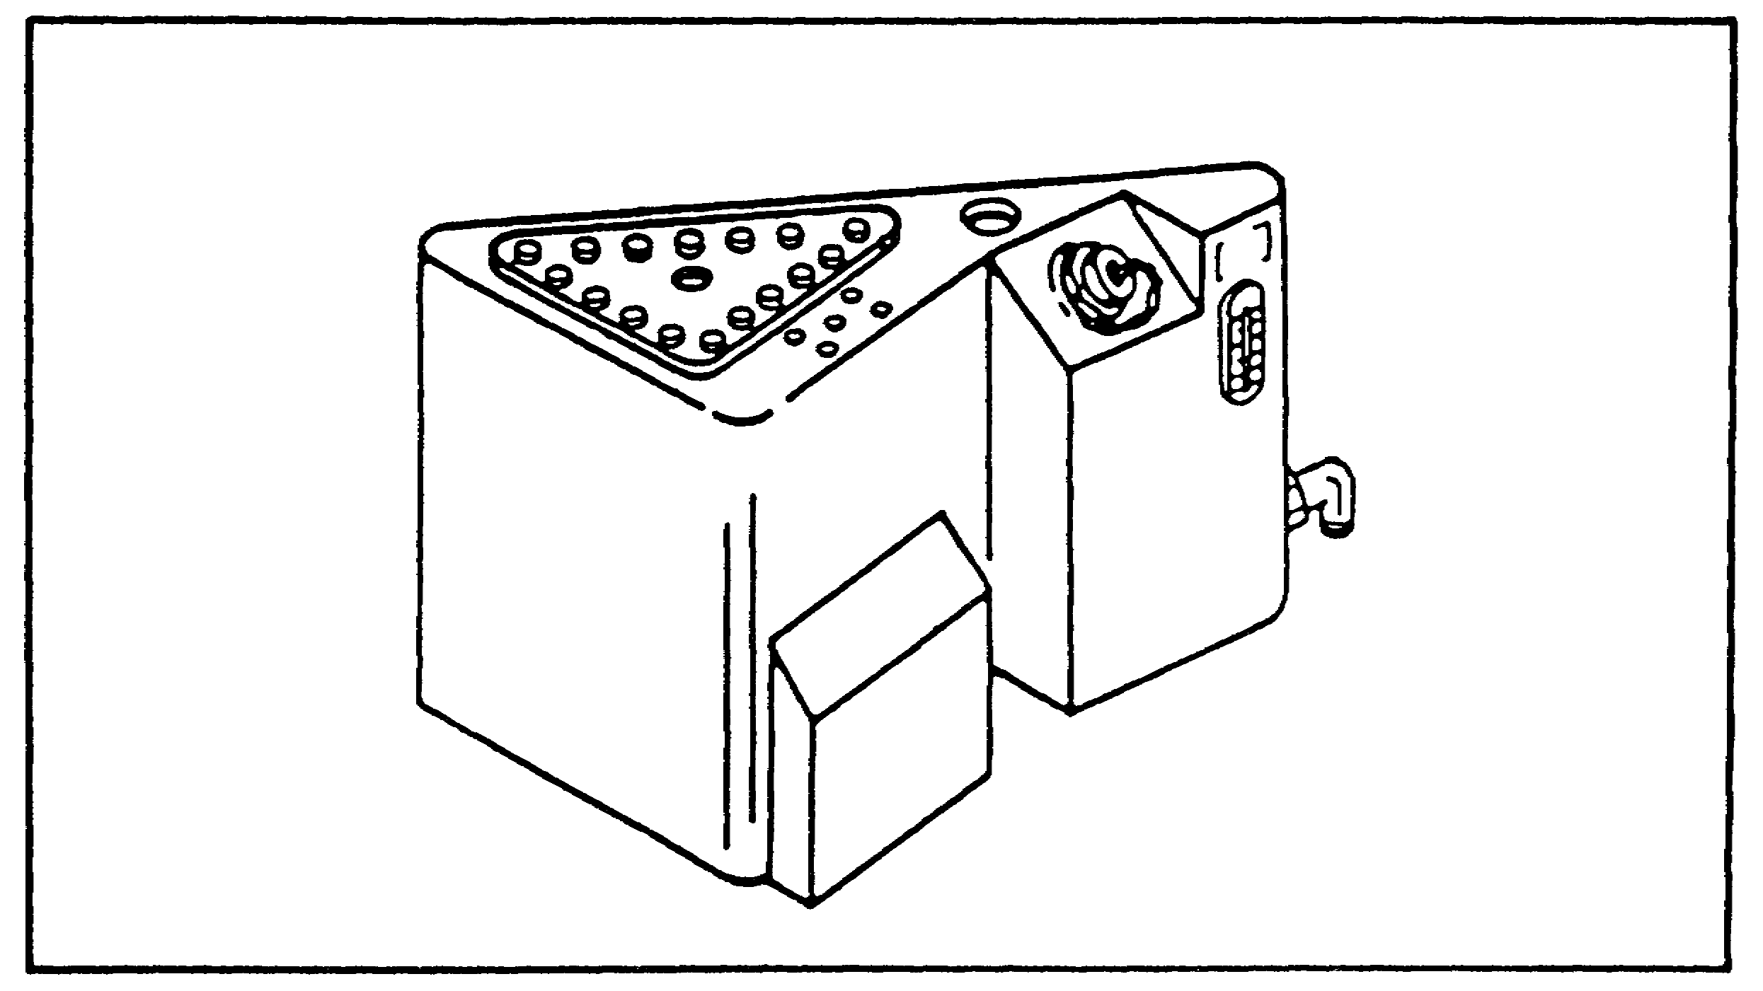

FIGURE 79. RESERVOIR.

98

PRINC. OF M1 HYDRAULICS - OD0475 - LESSON 2/TASK 1

c. Reservoir Manifold.

The reservoir manifold (figure 80), sits on top of the reservoir. Its function is to distribute fluid to hydraulic components in the hull and up to the slipring for use in the turret.
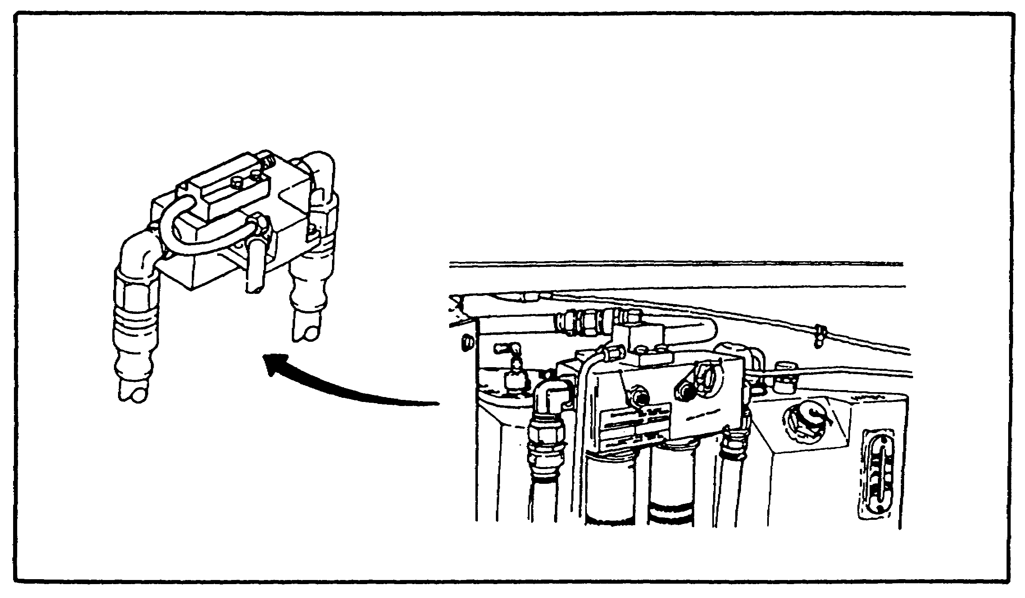

FIGURE 80. RESERVOIR MANIFOLD.

d. Heat Exchanger.

The heat exchanger (figure 81 on the following page), is used to dissipate heat in the hydraulic system. Normal operating temperature is between 165-185 degrees F. The heat exchanger is mounted to the rear of the fuel/water separator, cooled by air circulating in the engine compartment. All fluid leaving the hull distribution manifold must flow through the heat exchanger.

e. Slipring.

The hull/turret slipring (figure 82 on the following page), is the interconnection point between the hull and turret for both electrical and hydraulic power, it is located on the turret floor.

99

PRINC. OF M1 HYDRAULICS - OD0475 - LESSON 2/TASK 1
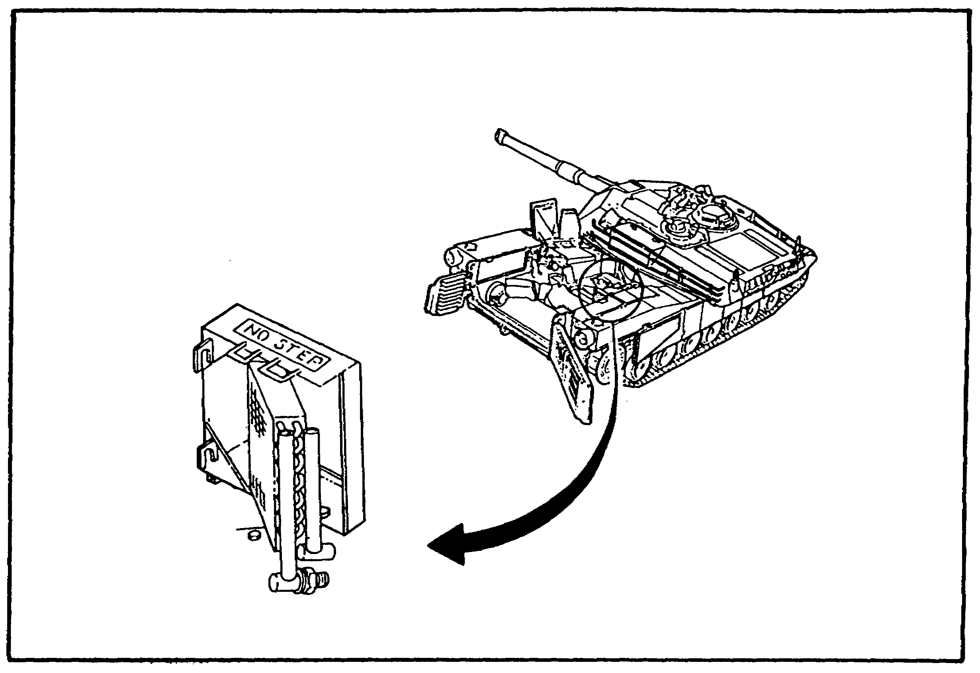

FIGURE 81. HEAT EXCHANGER.

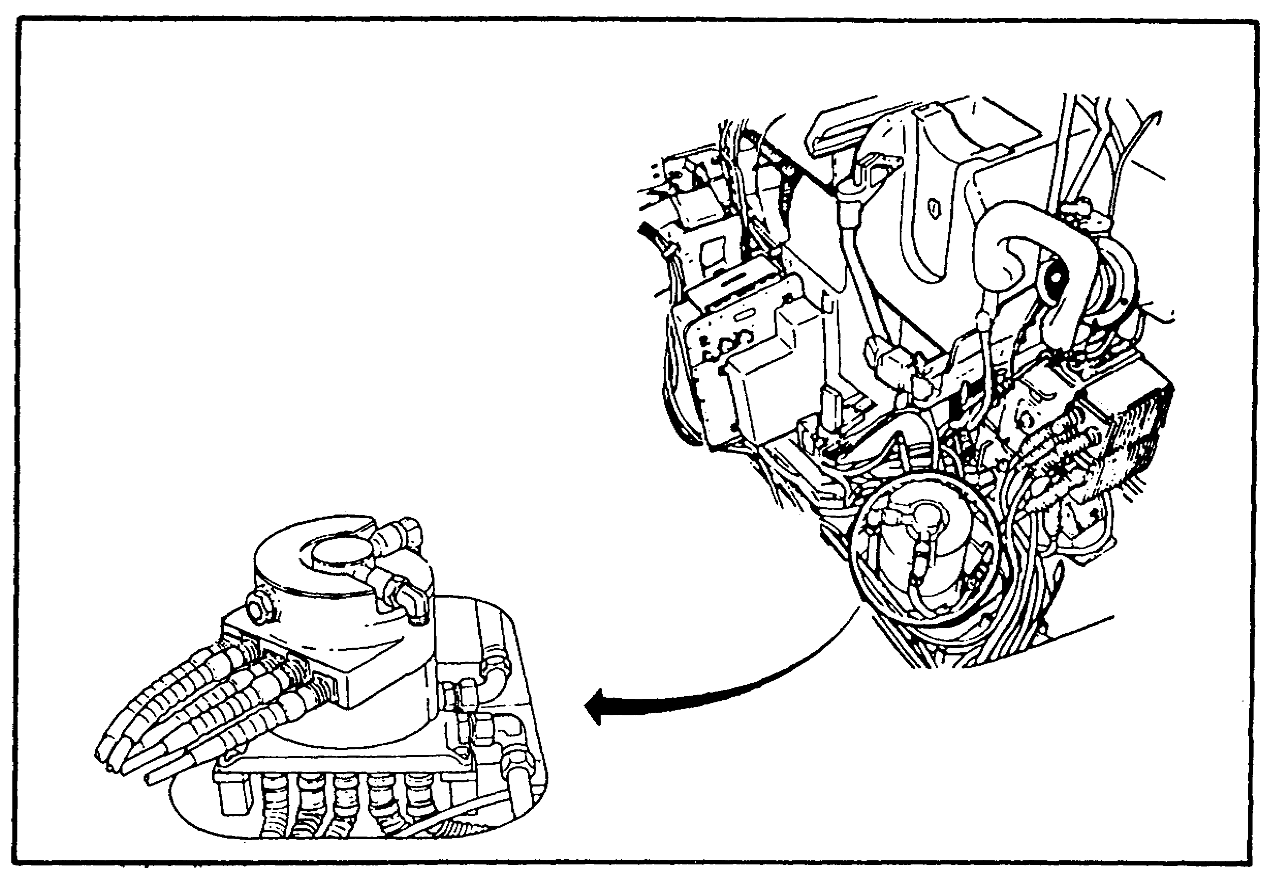
FIGURE 82. SLIPRING.

100

PRINC. OF M1 HYDRAULICS - OD0475 - LESSON 2/TASK 1

f. Turret Power Distribution Valve.

The turret power distribution valve (figure 83) is located on the turret basket floor. It operates on electrical control signals to control hydraulic power to all hydraulic components in the turret: the ammo door hydraulic actuator, the elevation servomechanism, and the traverse servomechanism.
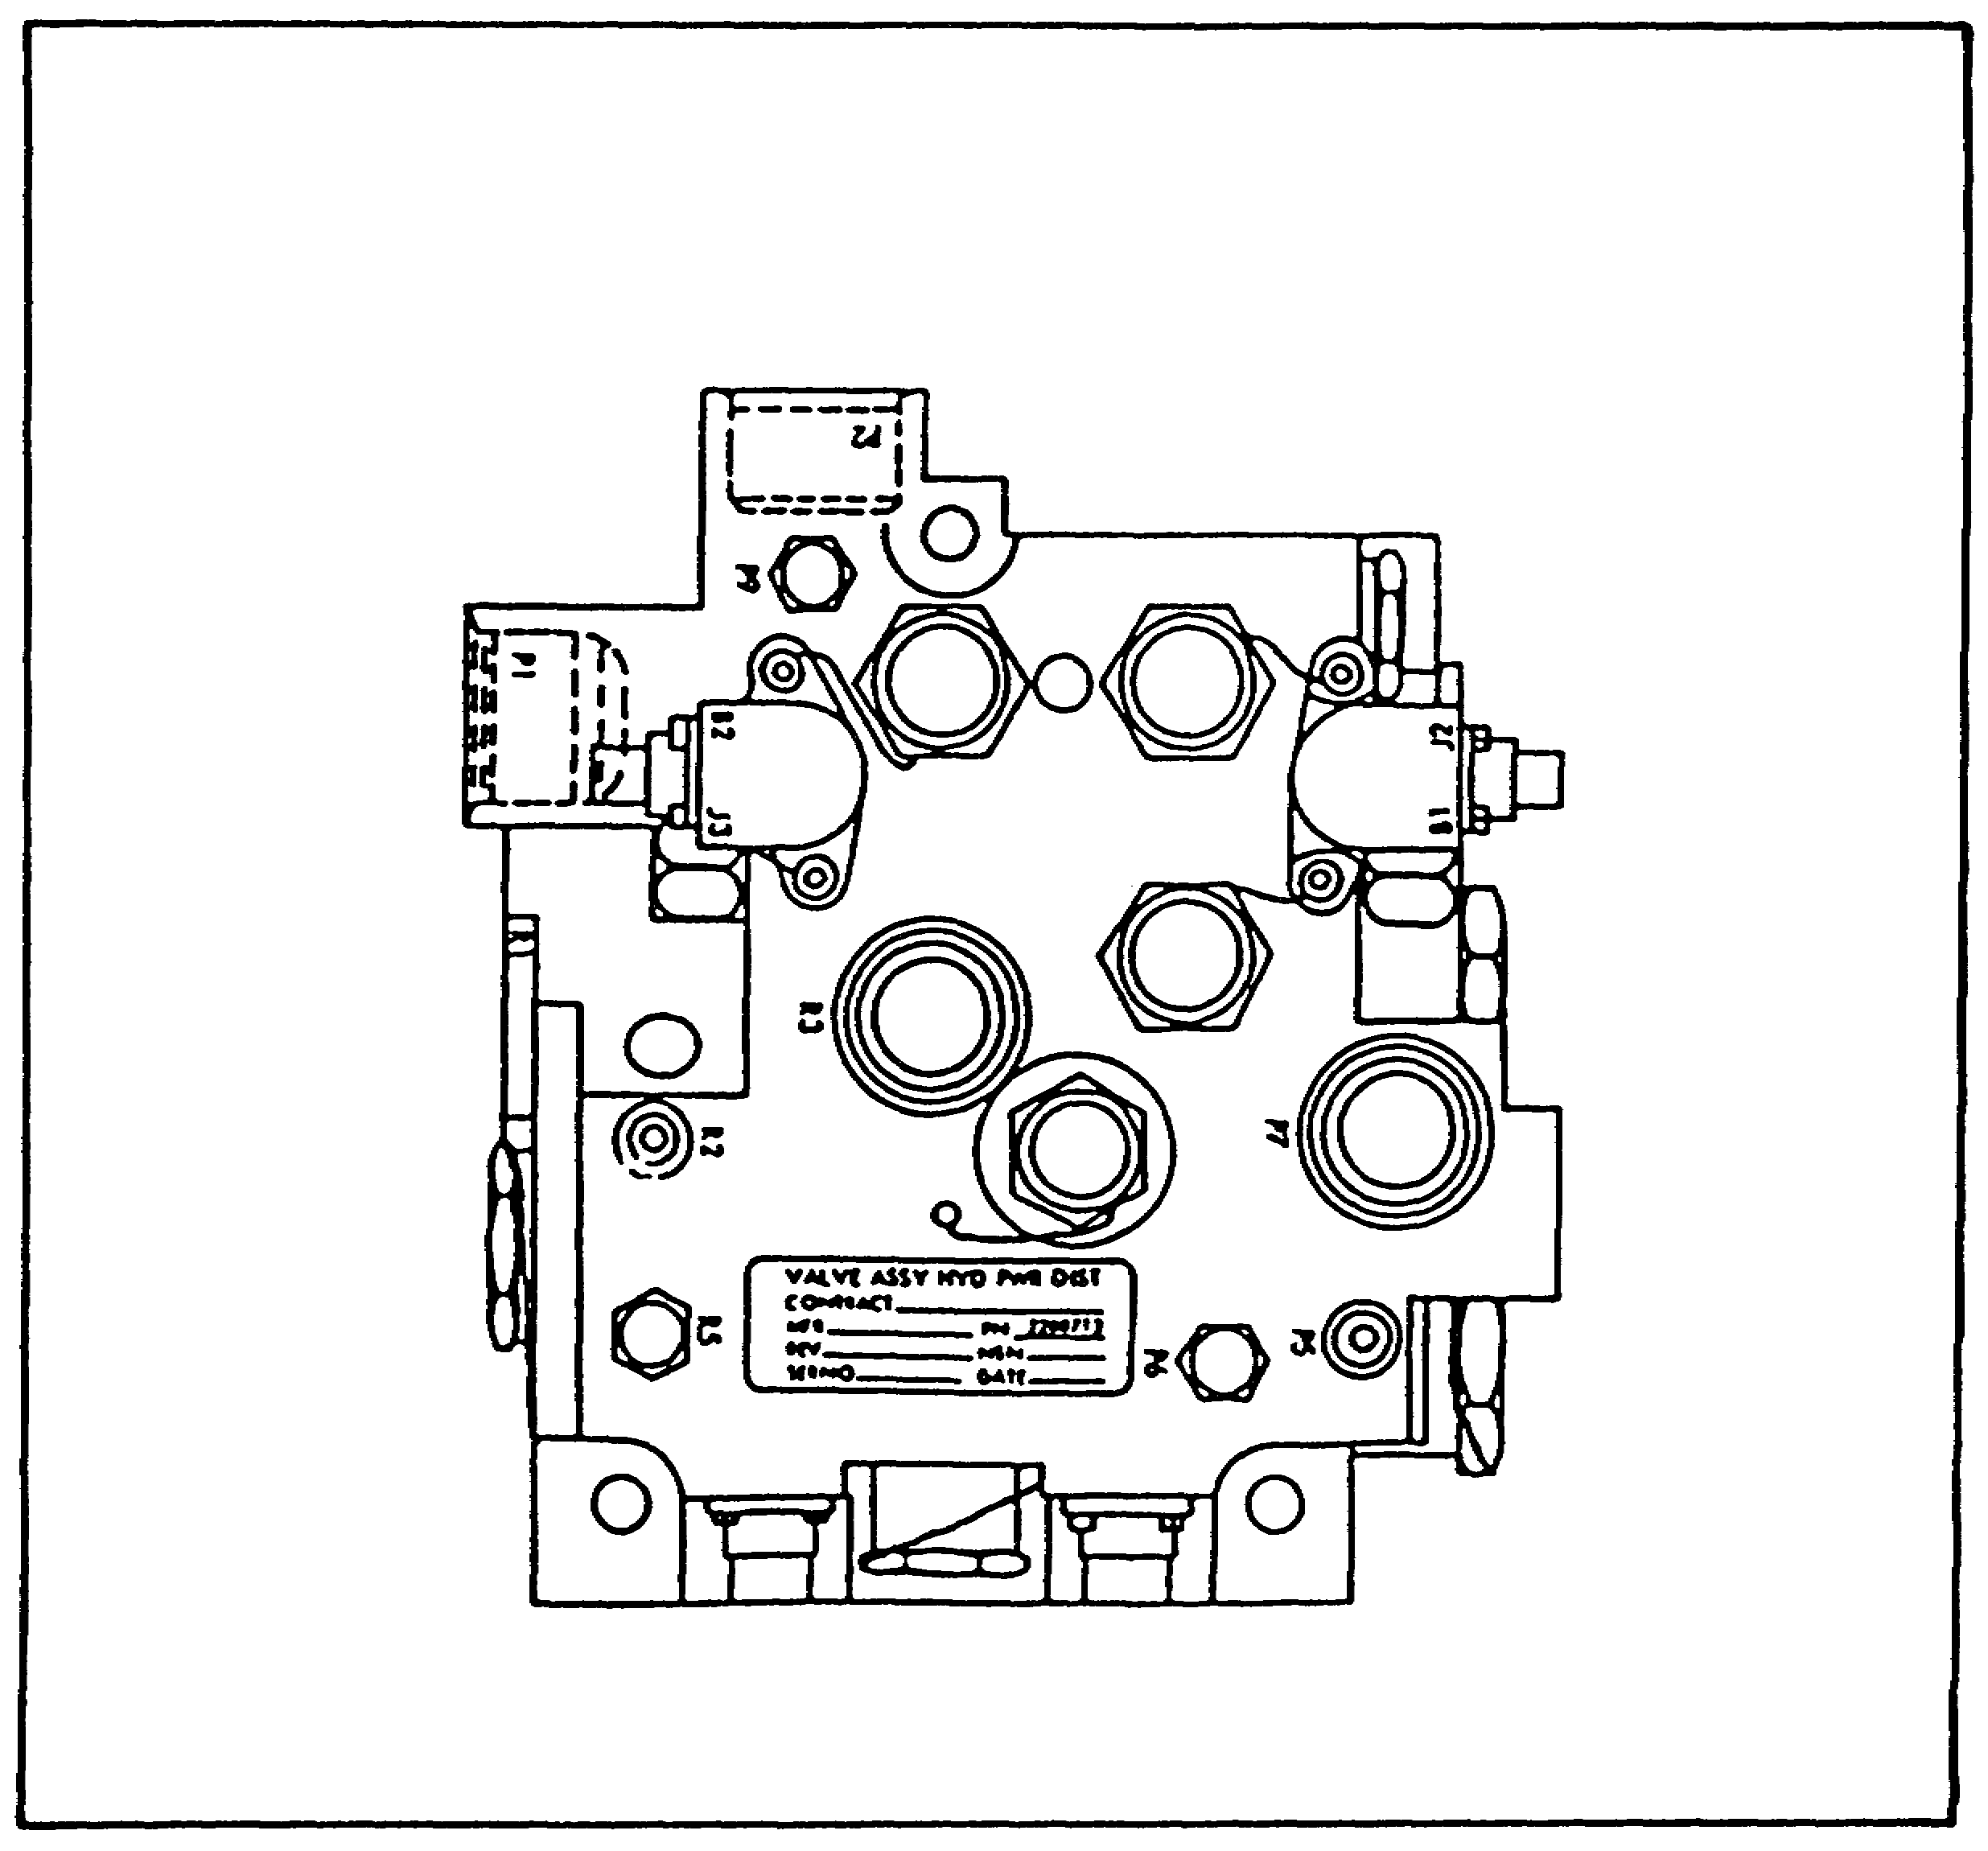

FIGURE 83. TURRET POWER DISTRIBUTION VALVE.

g. Elevation Servo.

The elevation servo package (figure 84 on the next page) contains three valves (stages), feedback transducers, and a filter for the elevation hydraulic circuitry. This component is located in the turret, to the right of the gunner's station.

101

PRINC. OF M1 HYDRAULICS - OD0475 - LESSON 2/TASK 1

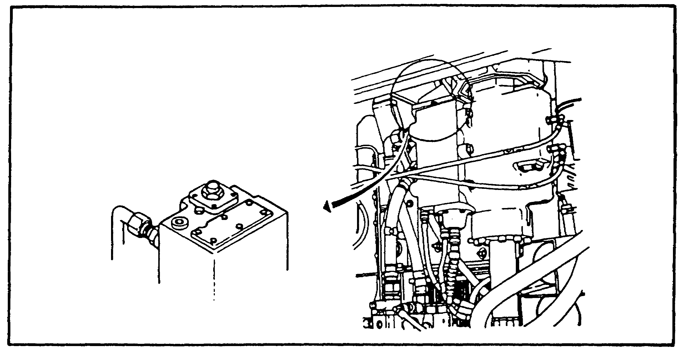
FIGURE 84. ELEVATION SERVO.

h. Azimuth Servo.

The azimuth servo package (figure 85), contains the three valves (stages), the feedback transducers, and a filter for the azimuth hydraulic circuitry. It is located in the turret, right of the gunner.
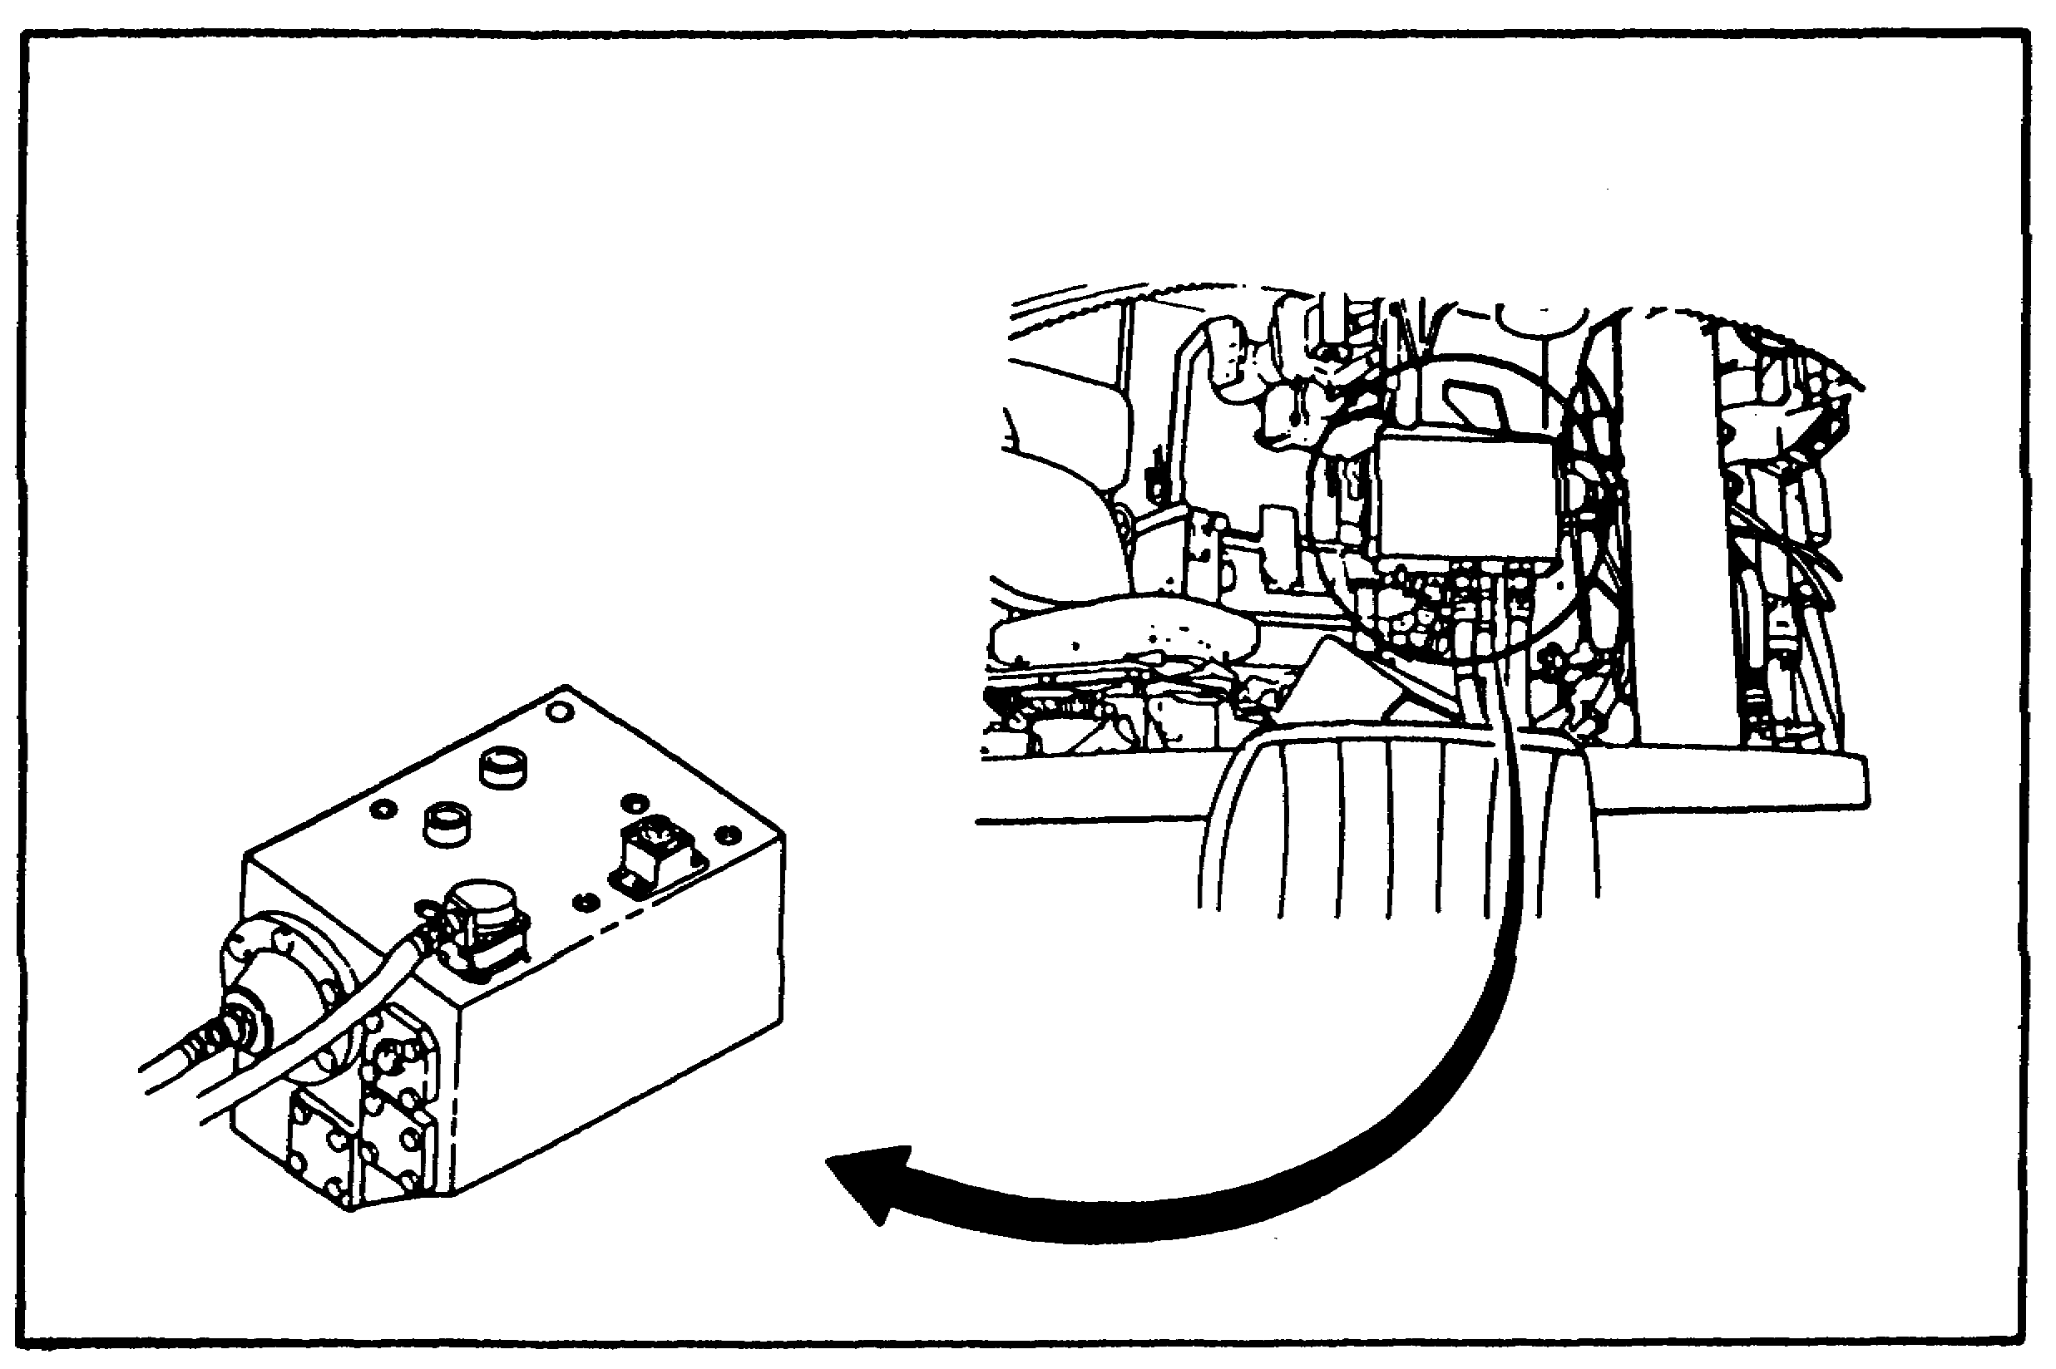

FIGURE 85. AZIMUTH SERVO.

102

PRINC. OF M1 HYDRAULICS - OD0475 - LESSON 2/TASK 1

i. Manual Elevation Accumulator.

The manual elevation accumulator (figure 86) located at the gunner's station, assists in the manual elevation and depression of the main gun.
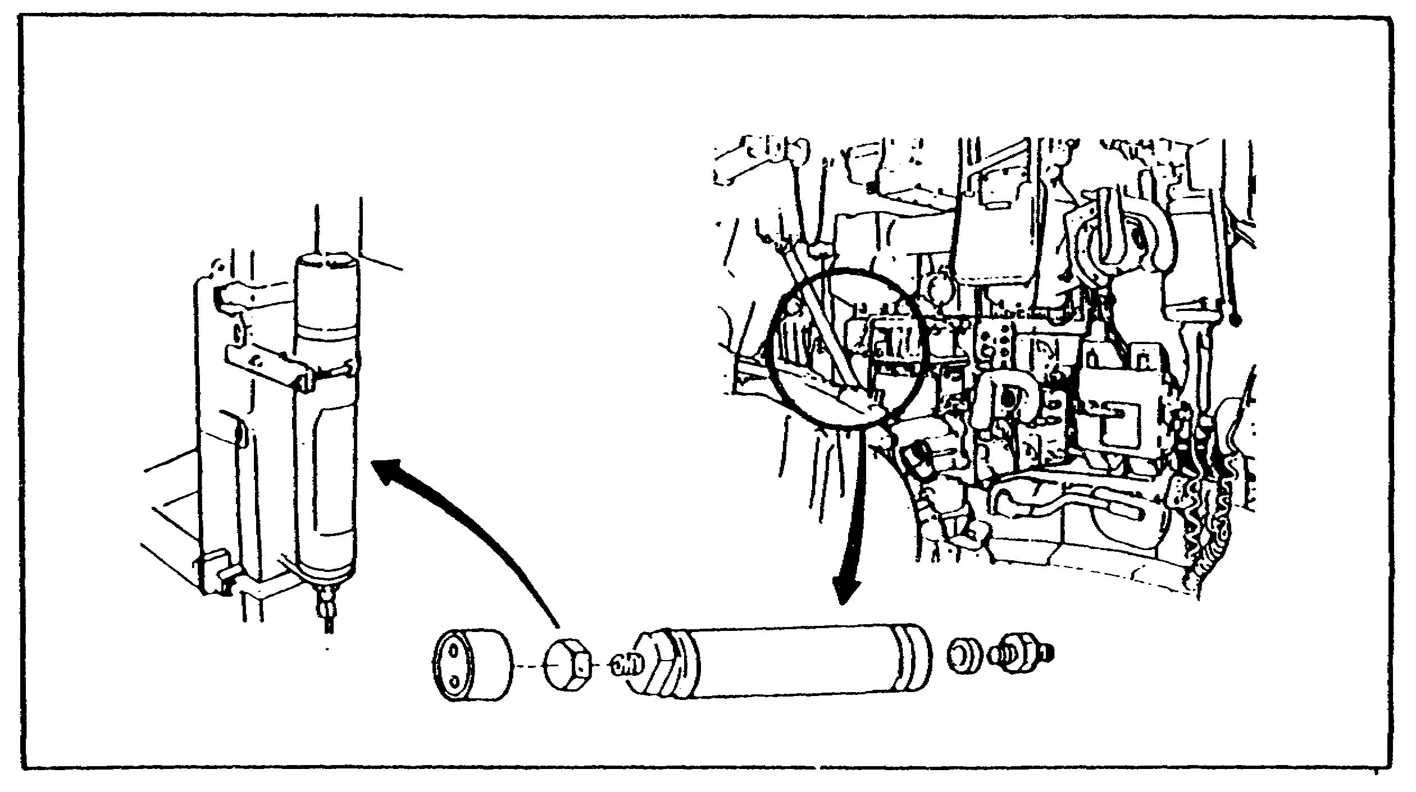

FIGURE 86. MANUAL ELEVATION ACCUMULATOR.

j . Ammo Door Actuator.

Tile ammo door actuator (figure 87) causes the ammo door to open and close hydraulically. It is located in the turret, on the door frame.
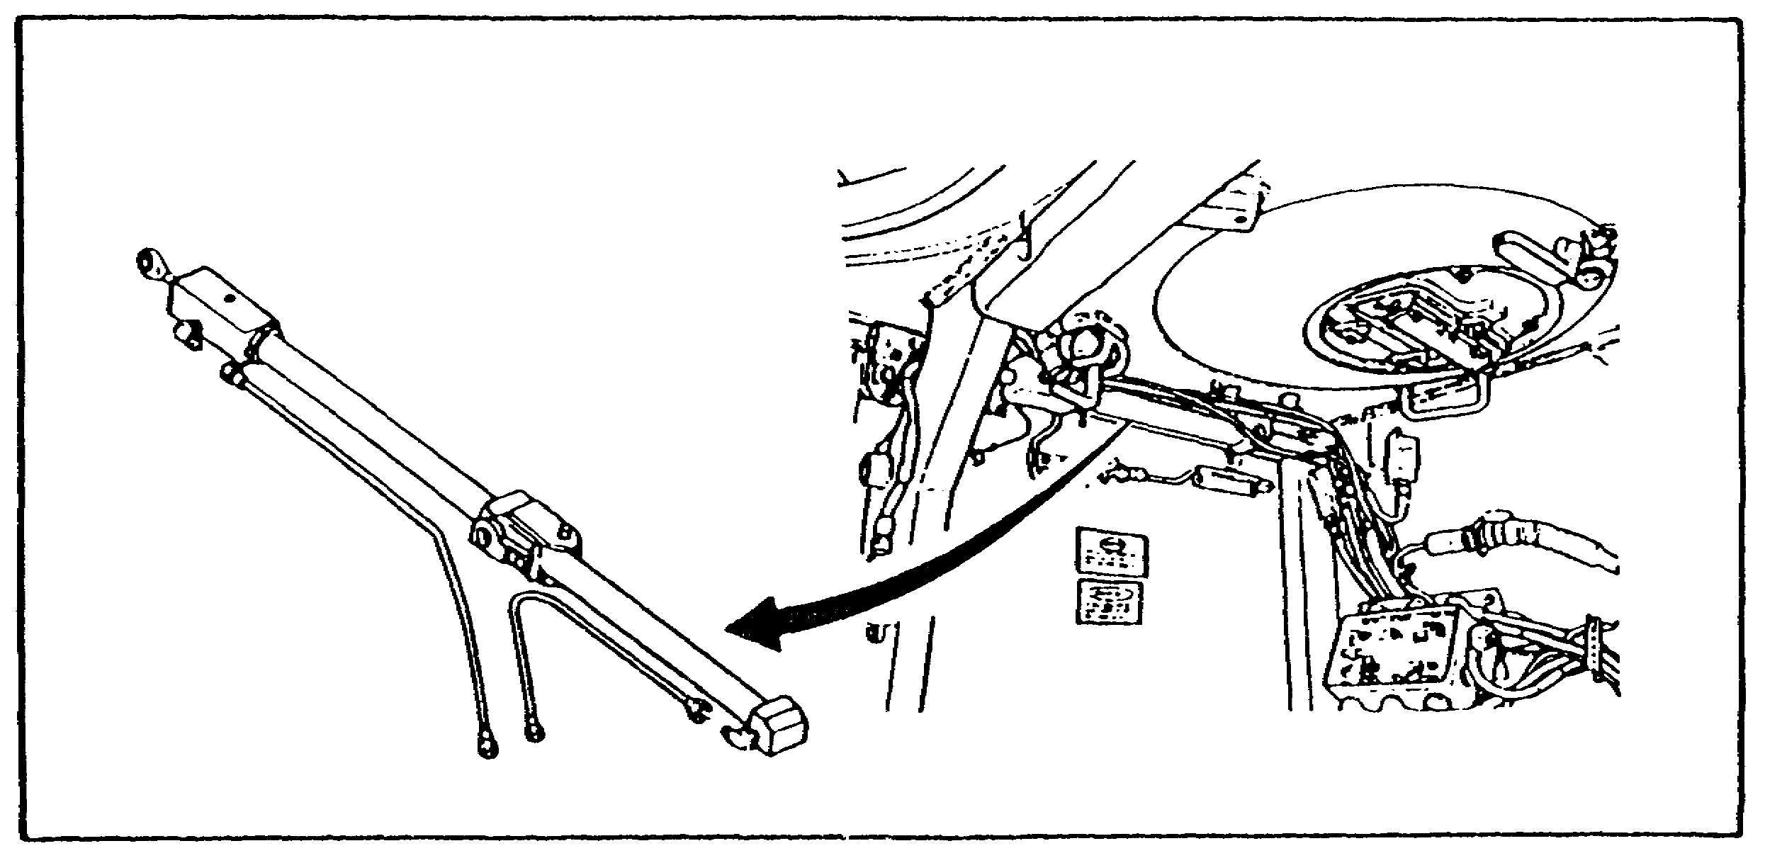
FIGURE 87. AMMO DOOR ACTUATOR.

103

PRINC. OF M1 HYDRAULICS - OD0475 - LESSON 2/TASK 1

k. Main Accumulator.

The main accumulator (figure 88) is located on the turret basket floor.

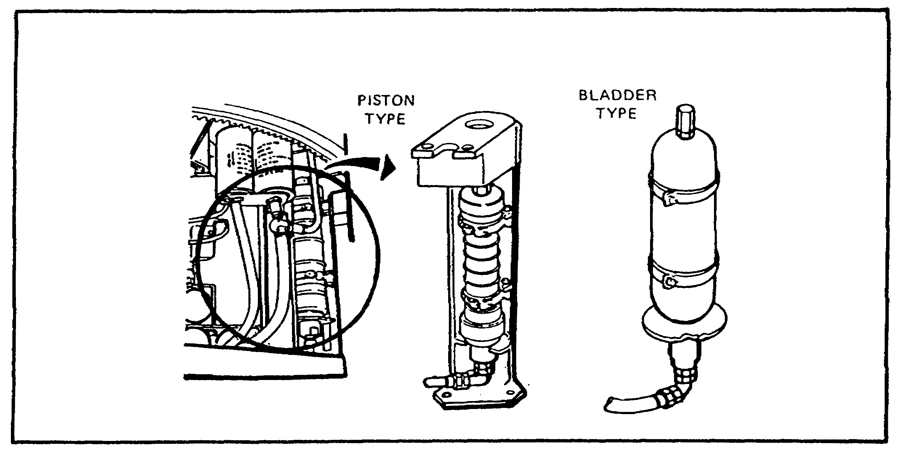
FIGURE 88. MAIN ACCUMULATOR.

l. Hull Distribution Manifold.

The hull distribution manifold (figure 89), is located on the hull floor. It contains two electrically controlled solenoid valves: the bilge pump valve and a dump valve.
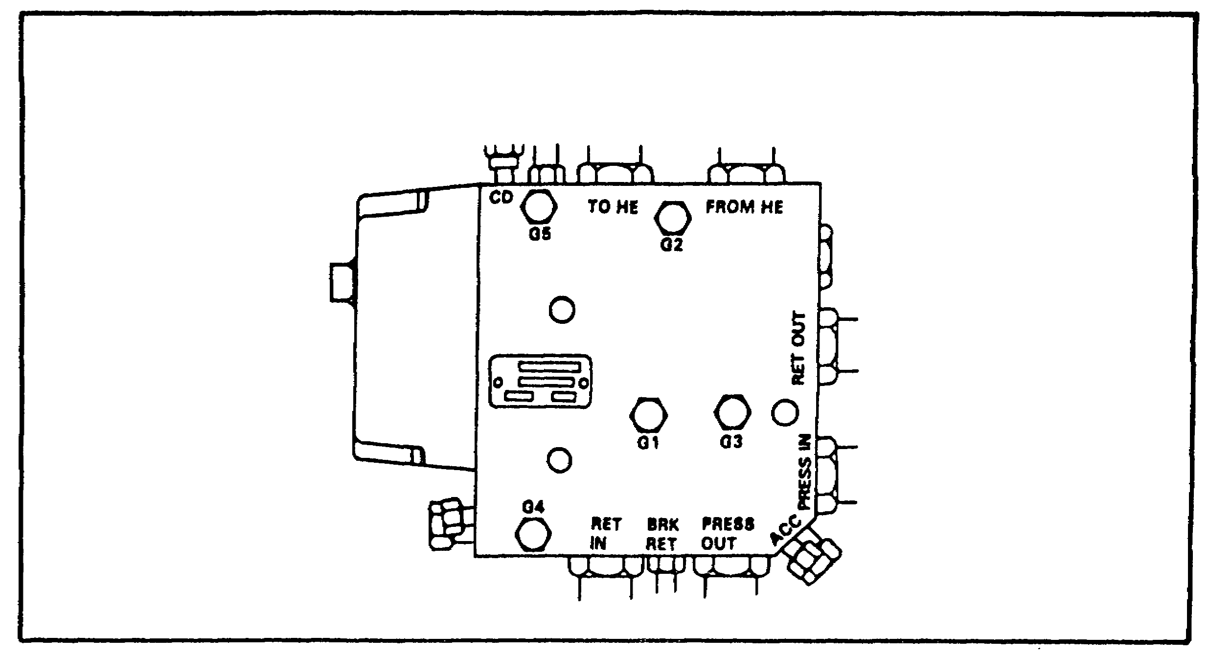

FIGURE 89. HULL DISTRIBUTION MANIFOLD.

104

PRINC. OF M1 HYDRAULICS - OD0475 - LESSON 2/TASK 1

m. Auxiliary Hydraulic Pump.

The auxiliary hydraulic pump (figure 90), is driven by an electrical motor and enabled by the switch on the tank commander's panel. It is located on the hull floor, under the turret.
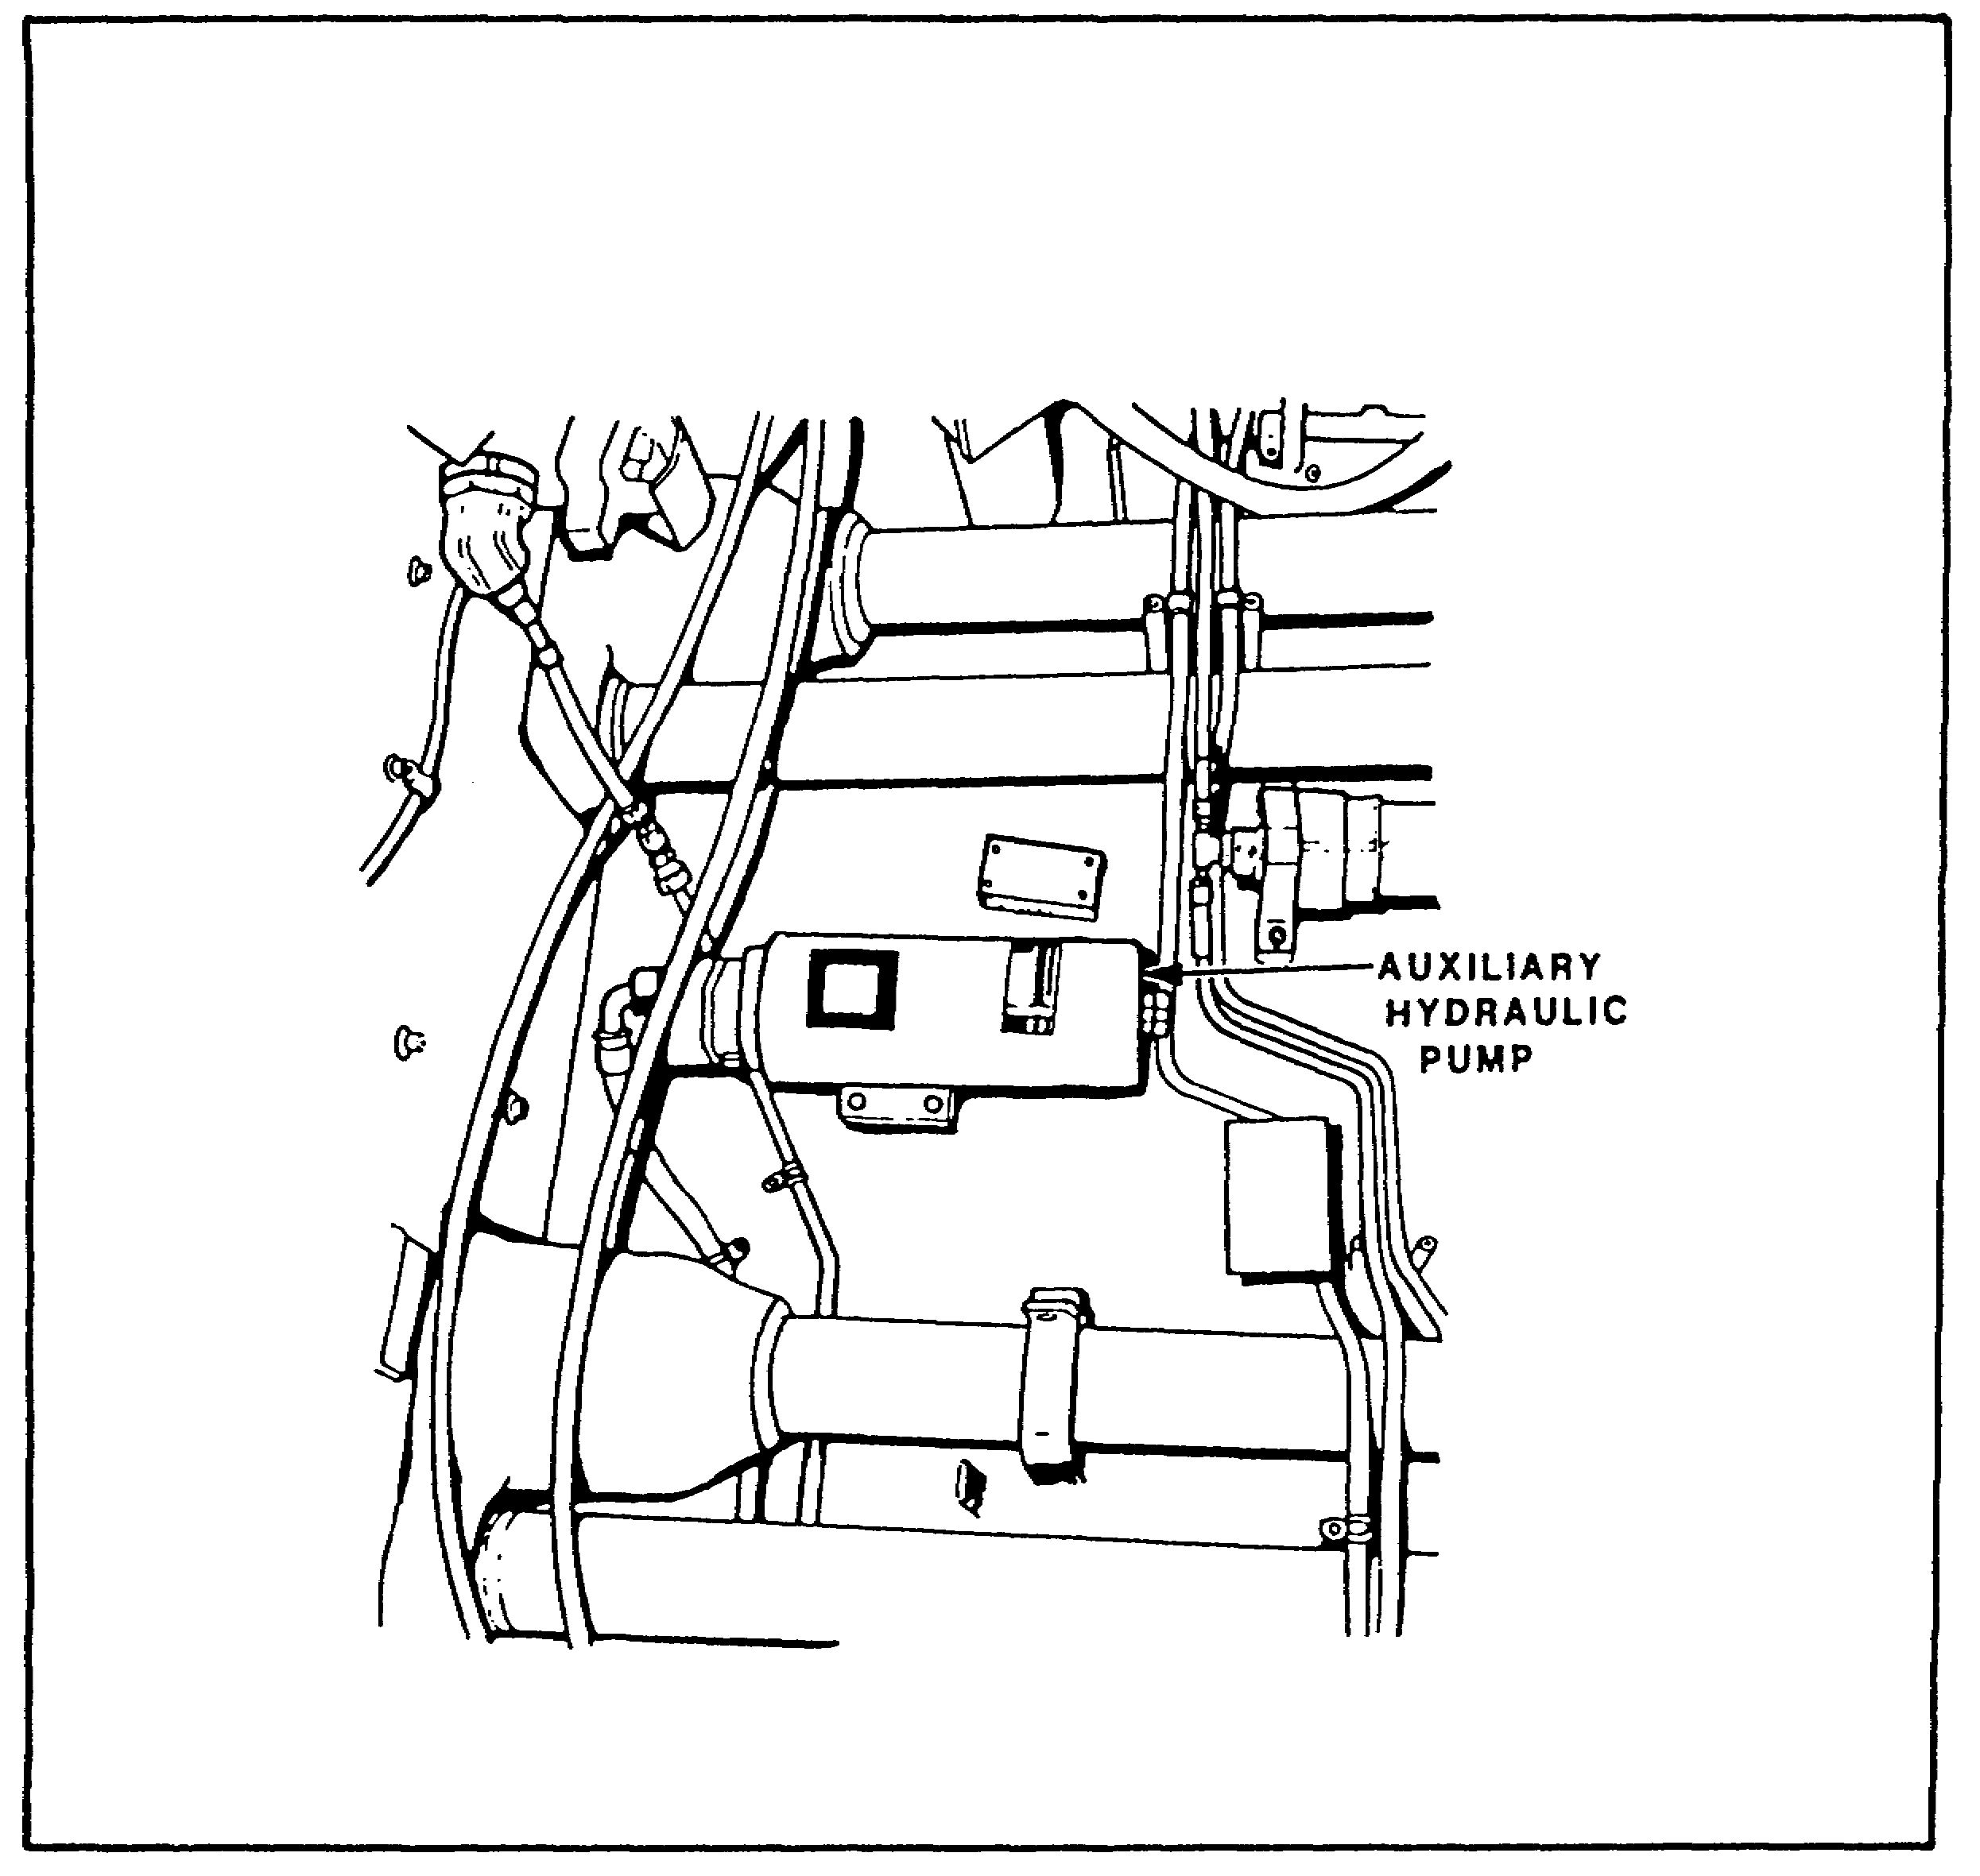

FIGURE 90. AUXILIARY HYDRAULIC PUMP.

105

PRINC. OF M1 HYDRAULICS - OD0475 - LESSON 2/TASK 2

LESSON 2

M1 SERIES TANK HYDRAULICS

TASK 2. Explain the operation and purpose of the M1 series tank hydraulic system components.

CONDITIONS

Within a self-study environment and given the subcourse text, without assistance.

STANDARDS

Within two hours

REFERENCES

No supplementary references are needed for this task.

1. Introduction - M1 Hydraulic System

The M1 hydraulic system consists of components in both the hull and turret (figure 91 on the next page). Normal hydraulic power for the system is generated by an engine-driven hydraulic pump. When the engine is not running, hydraulic power is generated by an electric auxiliary hydraulic pump, located on the hull floor below the turret basket. The hydraulic system operates the bilge pump in the hull. Hydraulic lines and fittings carry oil, under pressure, through the hydraulic distribution manifold to the hull/turret slipring, and from it to a hydraulic turret valve in the turret. The hydraulic turret valve controls hydraulic power to the ammo door hydraulic actuator, the elevation servomechanism, and the traverse servomechanism. hydraulic system dial pressure gage is located at the gunner's station. A hydraulic system warning light on the driver's instrument panel (DIP) warns of main pump case drain line failure. The warning

106

PRINC. OF M1 HYDRAULICS - OD0475 - LESSON 2/TASK 2

light is turned on by a switch in the hydraulic distribution manifold that senses a loss of case drain line fluid flow.

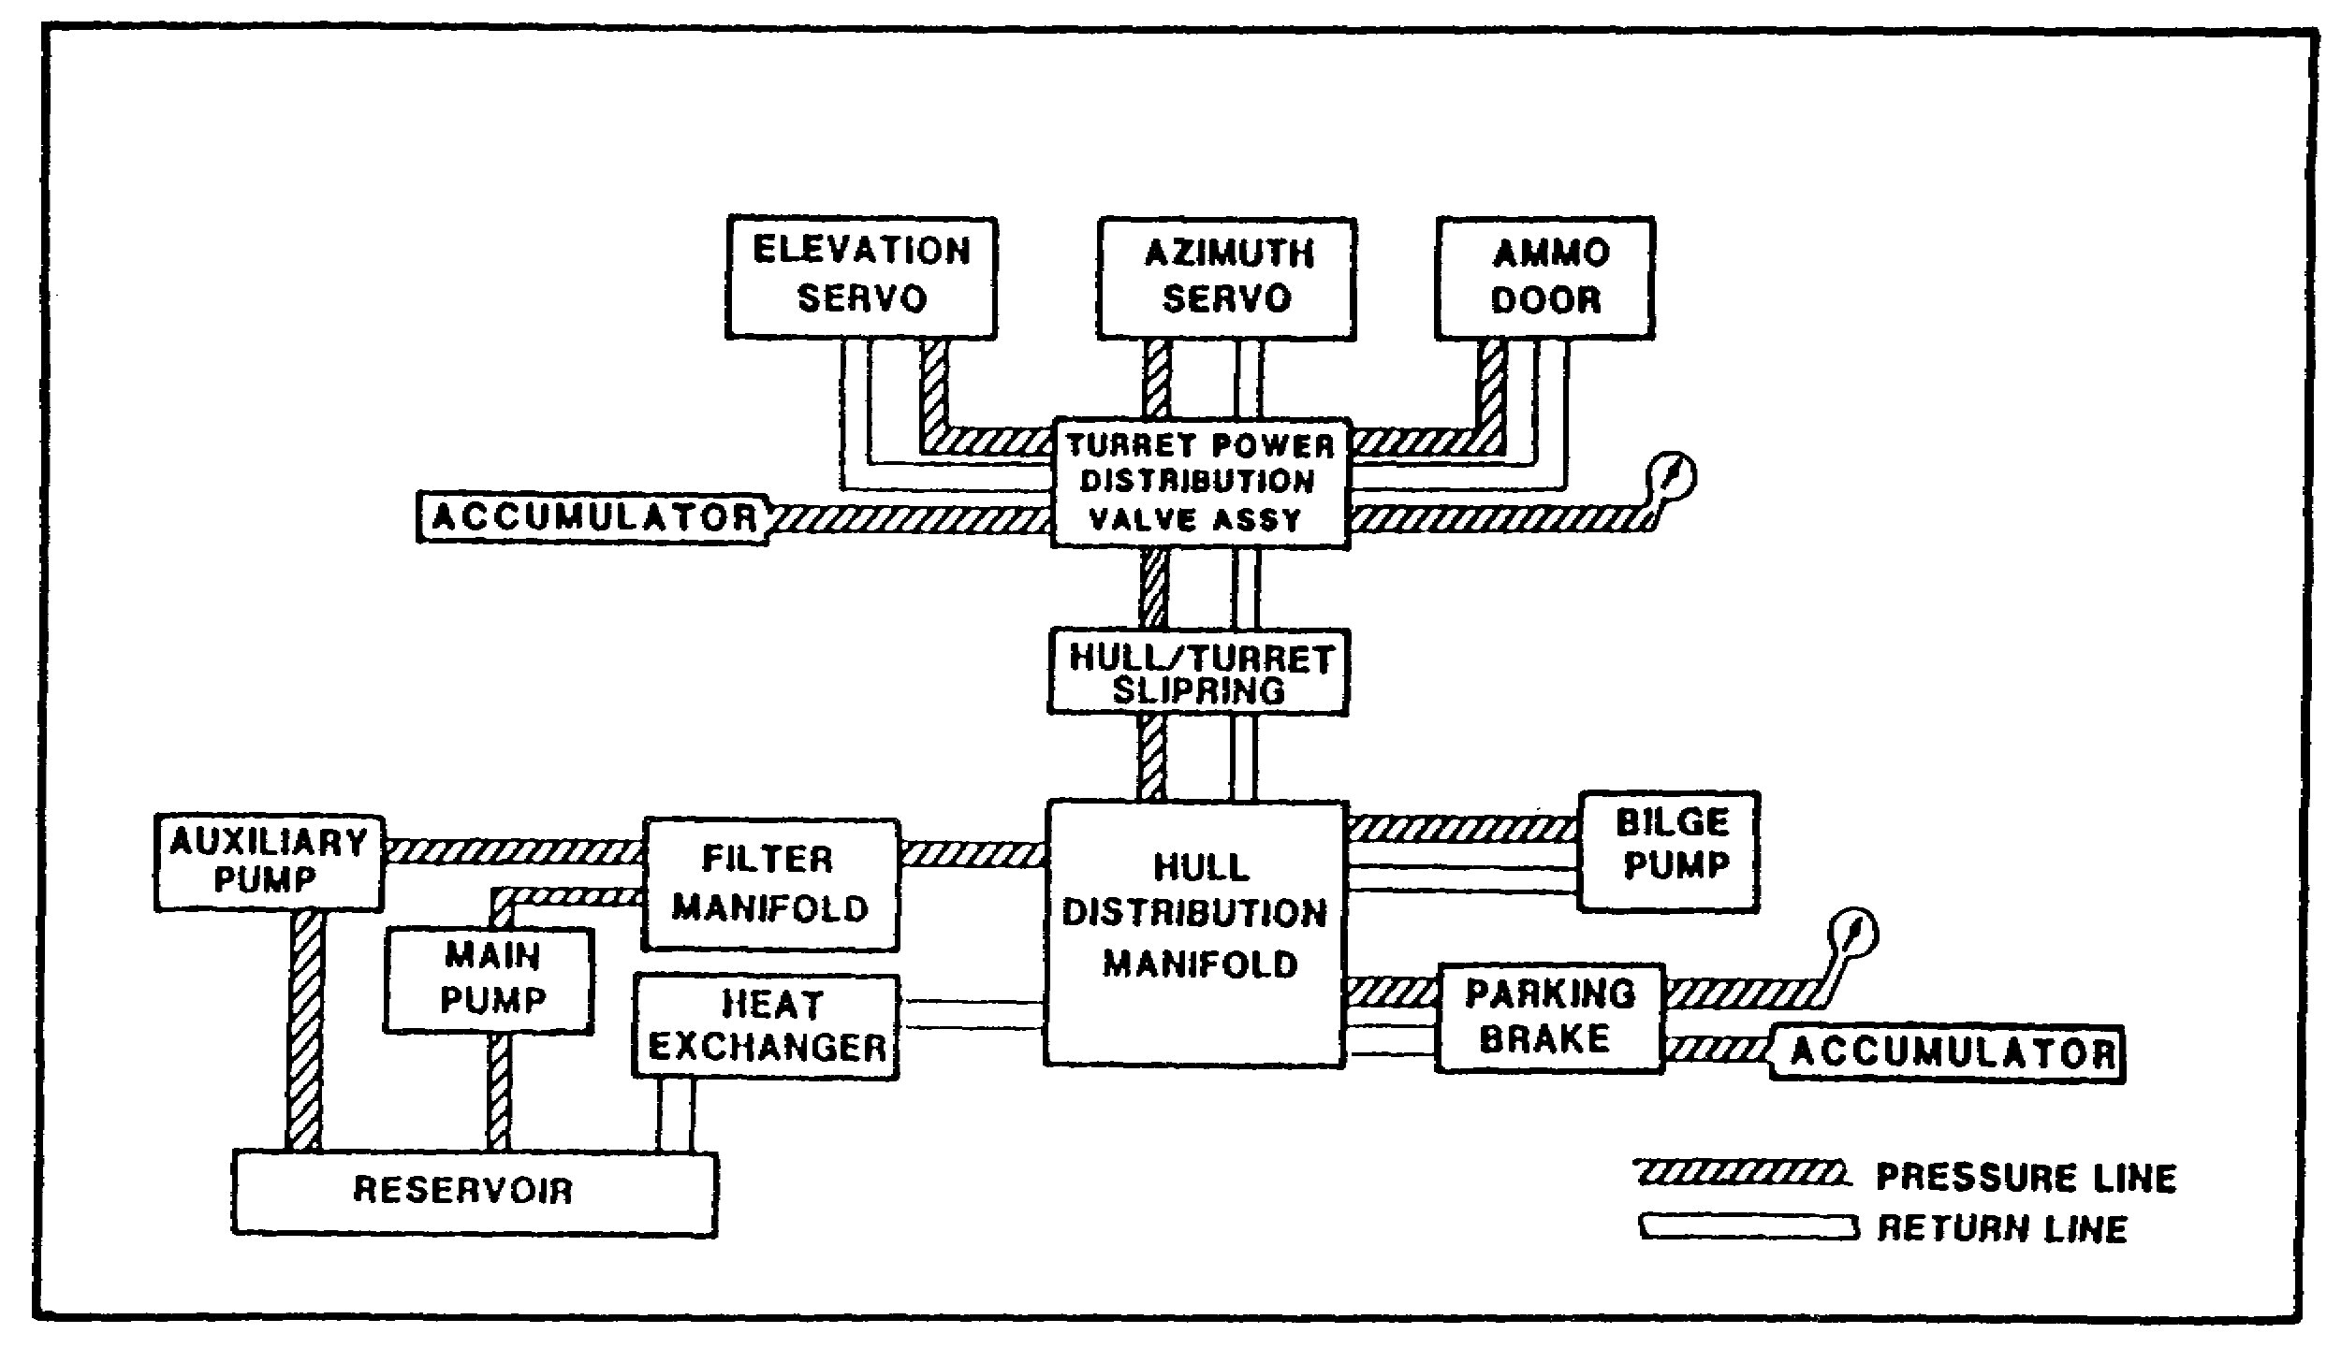
FIGURE 91. M1 HYDRAULIC SYSTEM.

M1 vehicle (hull) hydraulic system components are explained in the following paragraphs.

2. Basic M1 Vehicle (Hull) Hydraulics -Component Function and Purpose

a. Air Bleed Valve, Check Valve, and Pressure Relief Valve.

(1) The air bleed valve is a two position, three connection, valve that allows hydraulic fluid containing air to return to the reservoir (where the air is allowed to escape) instead of going through the system to do work (figure 92 on the following page). Hydraulic oil containing air goes through the orifice readily. As the air is allowed to dissipate, the air to fluid ratio decreases and fluid goes through the orifice less readily.

107

PRINC. OF M1 HYDRAULICS - OD0475 - LESSON 2/TASK 2

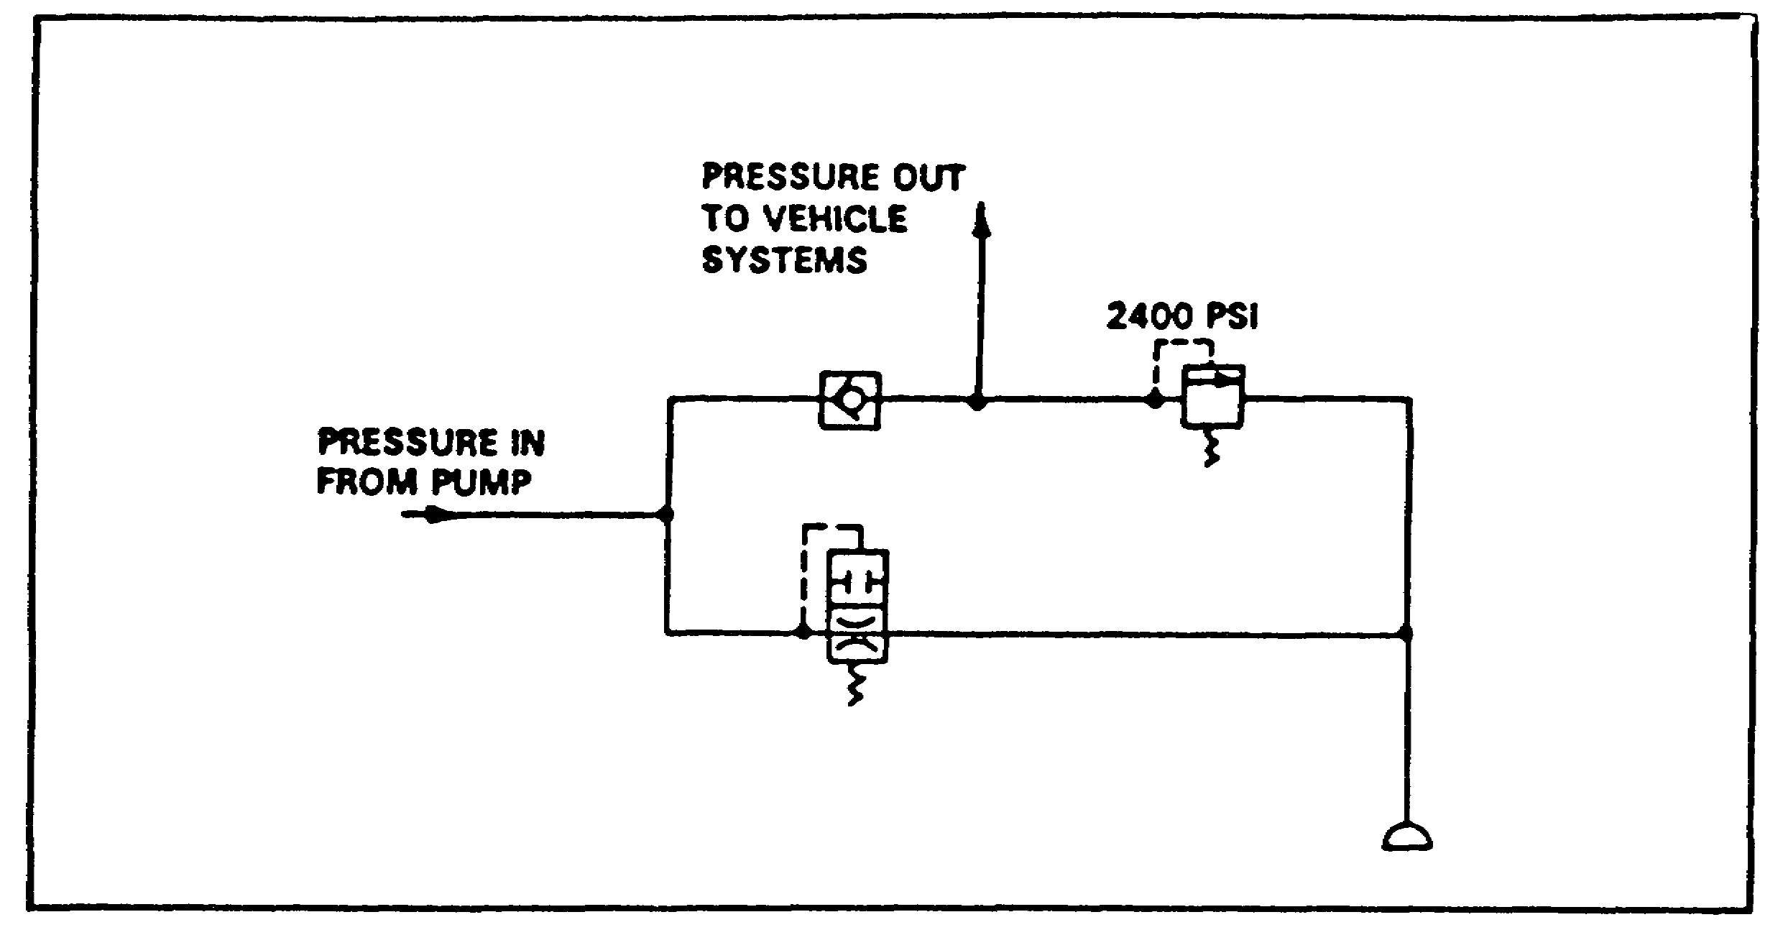
FIGURE 92. AIR BLEED VALVE.

This increases the pressure in the pilot line, and the valve begins to close. When all air has been bled, the valve shuts off (due to the pressure in the pilot line) and the fluid is diverted to the hydraulic system to do work.

(2) The check valve inhibits drainage of the hydraulic fluid from the turret systems when the engine is not running.

(3) The relief valve is the hydraulic "circuit breaker" for the complete hydraulic system. In the event of a system malfunction that causes pressure to increase dramatically, the pressure relief valve will open at 2400 psi, causing all the output fluid from the pump to be dumped directly back to the reservoir.

b. Parking Brake.

(1) The parking brake is a hydraulically applied mechanical brake. Pushing the pedal manually moves a valve that allows hydraulic fluid to flow through to the parking brake cylinder (figure 93 on the following page). The piston moves an equalizer bar, to which cables are connected. These cables set the parking brake in the transmission.

108

PRINC. OF M1 HYDRAULICS - OD0475 - LESSON 2/TASK 2
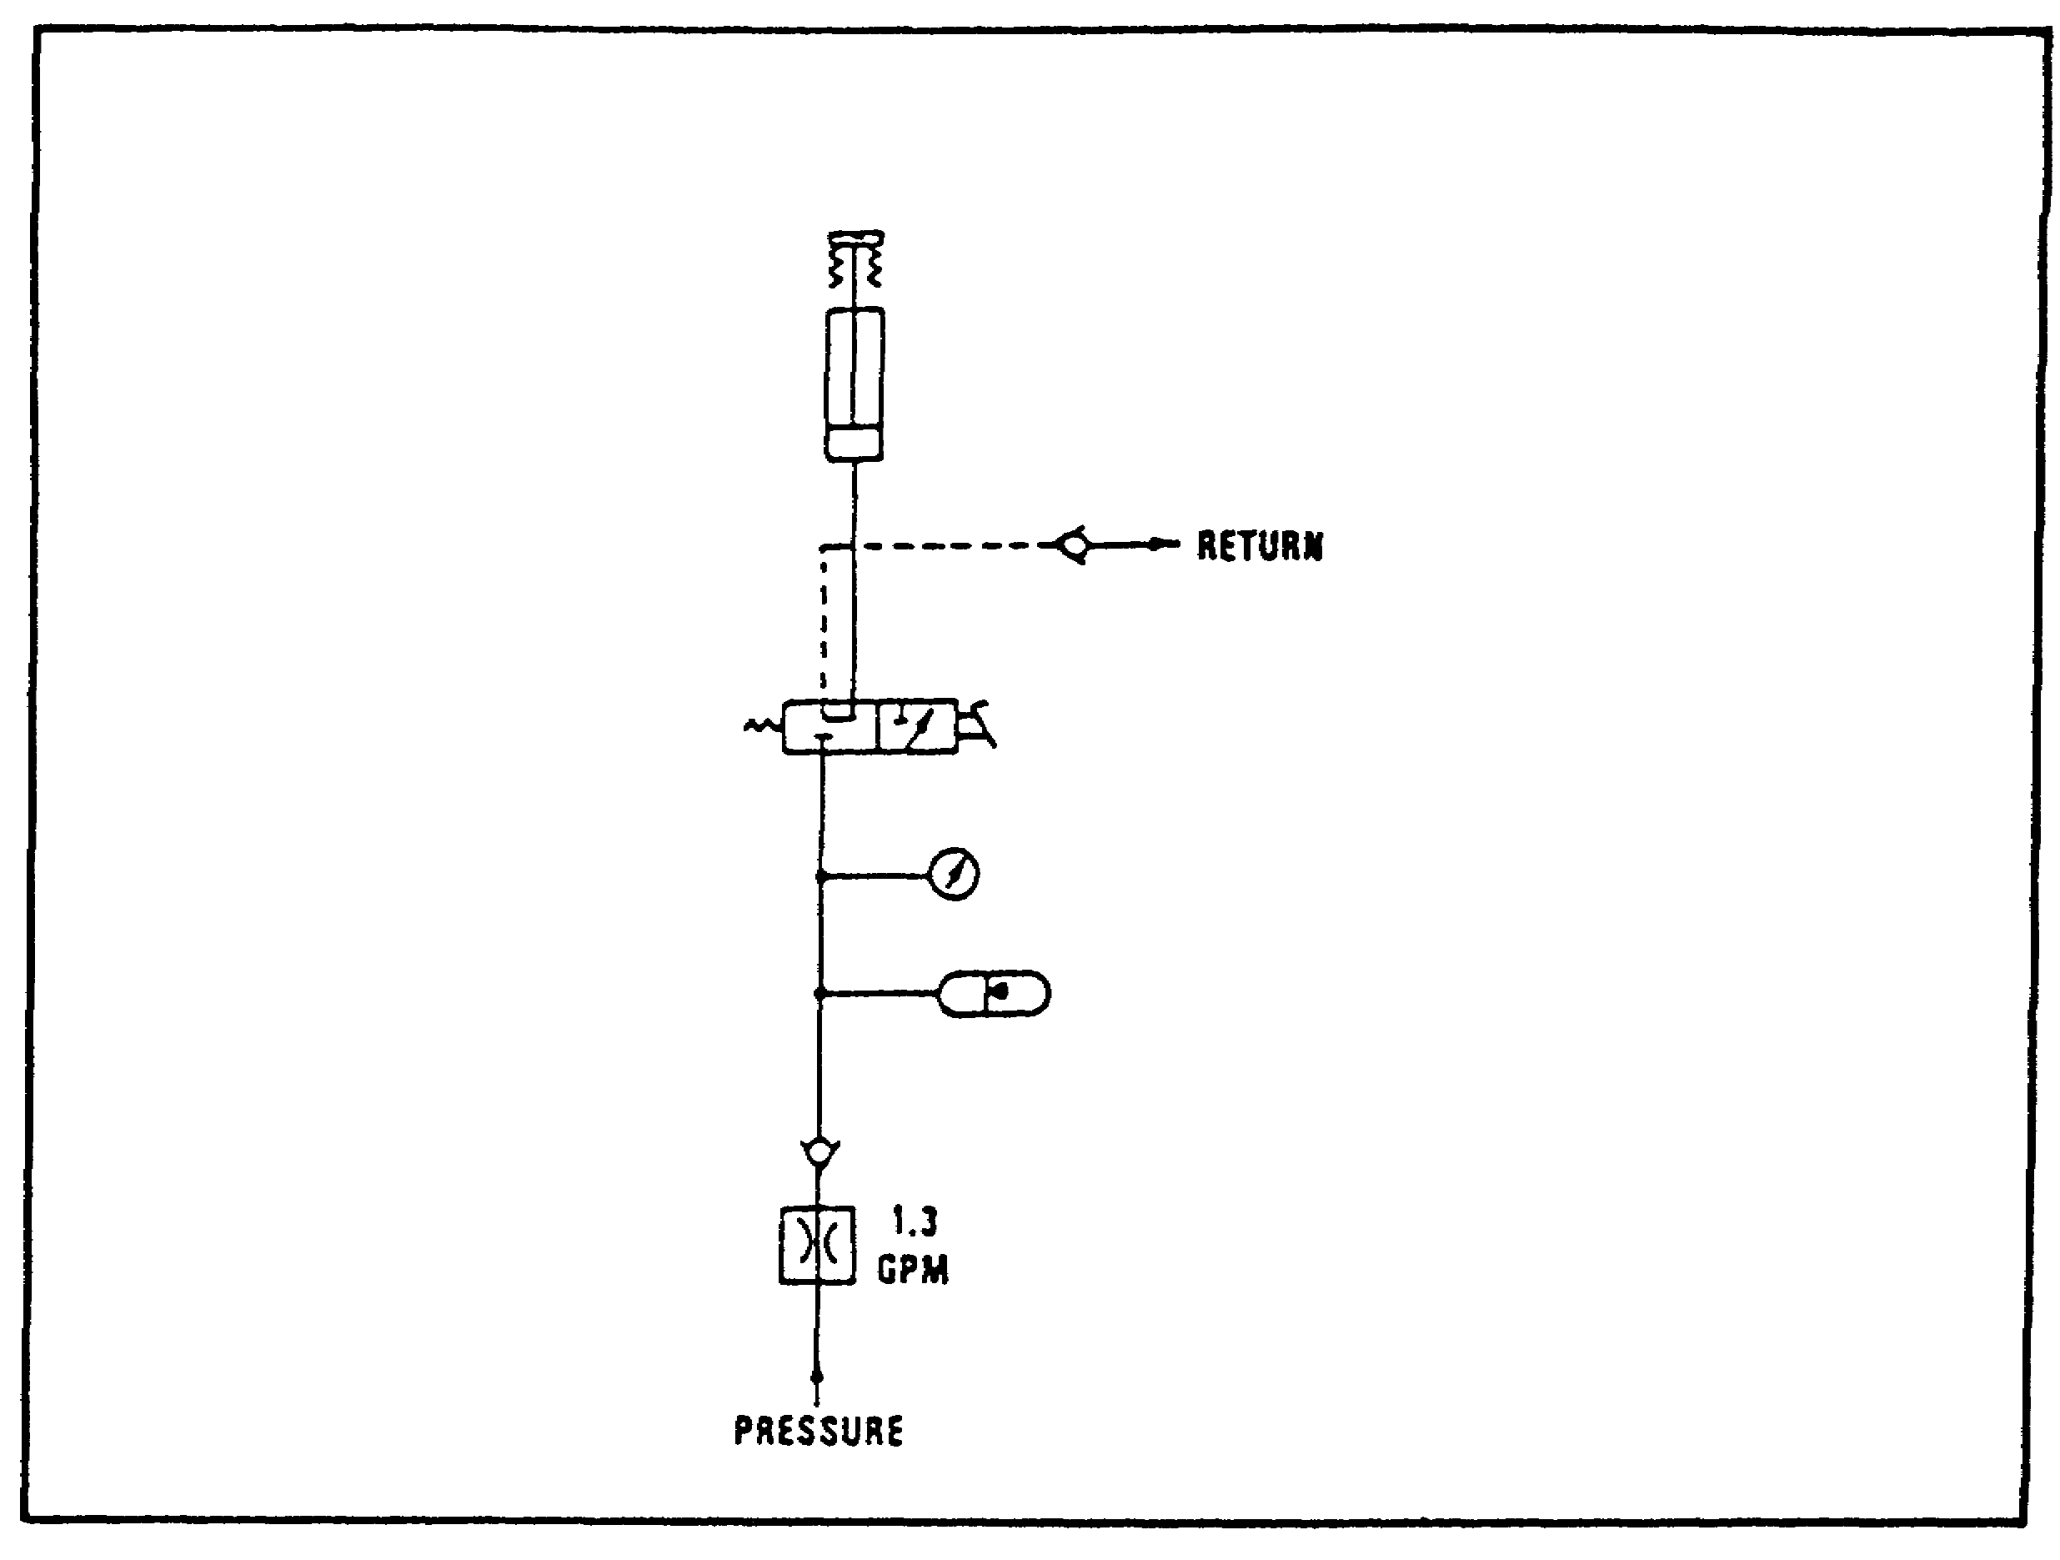

FIGURE 93. PARKING BRAKE.

(2) When the parking brake is released (manual handle), the cylinder returns to its normal position because of the action of return springs.

The fluid is forced out of the cylinder, through the manually operated valve, and out through the return to the reservoir.

c. Bilge Pump.

(1) The bilge pump (figure 94 on the following page) is used in water fording to pump water out of the hull. Hydraulic fluid from the pump goes through the now open valve, driving the hydraulic motor through the heat exchanger and back to the reservoir. The pump is then mechanically driven by the hydraulic motor.

(2) The pressure relief valve (set to open at 1900 psi) protects the hydraulic motor, in the event that a malfunction causes the pressure to dramatically increase.

109

PRINC. OF M1 HYDRAULICS - OD0475 - LESSON 2/TASK 2

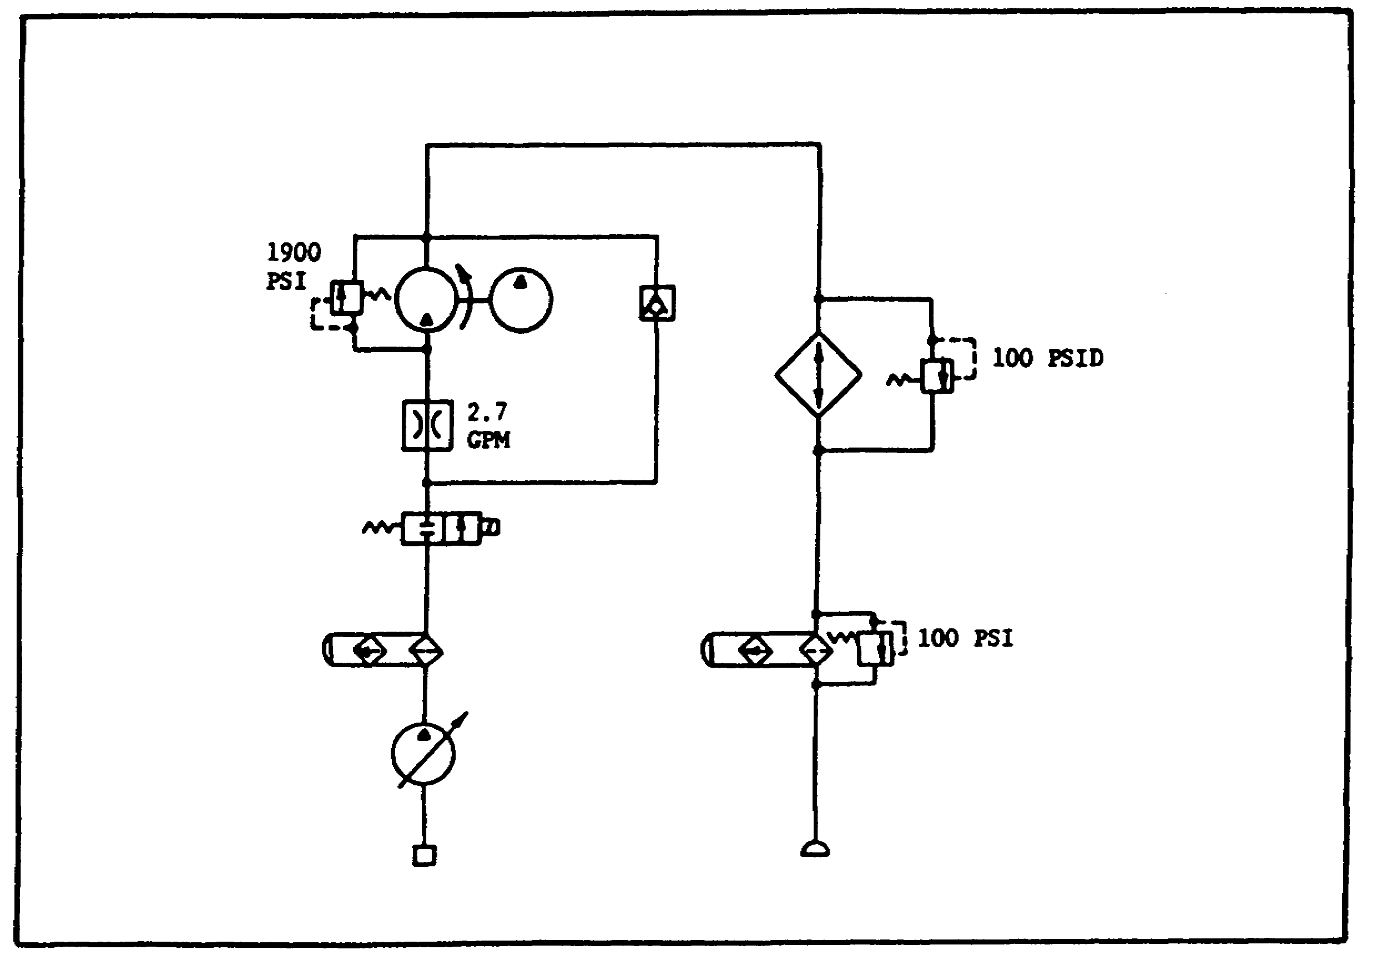
FIGURE 94. BILGE PUMP.

3. Electrohydraulic Servo System

The servo system (figure 95) is a system with an output established by a command signal and controlled by a feedback signal.
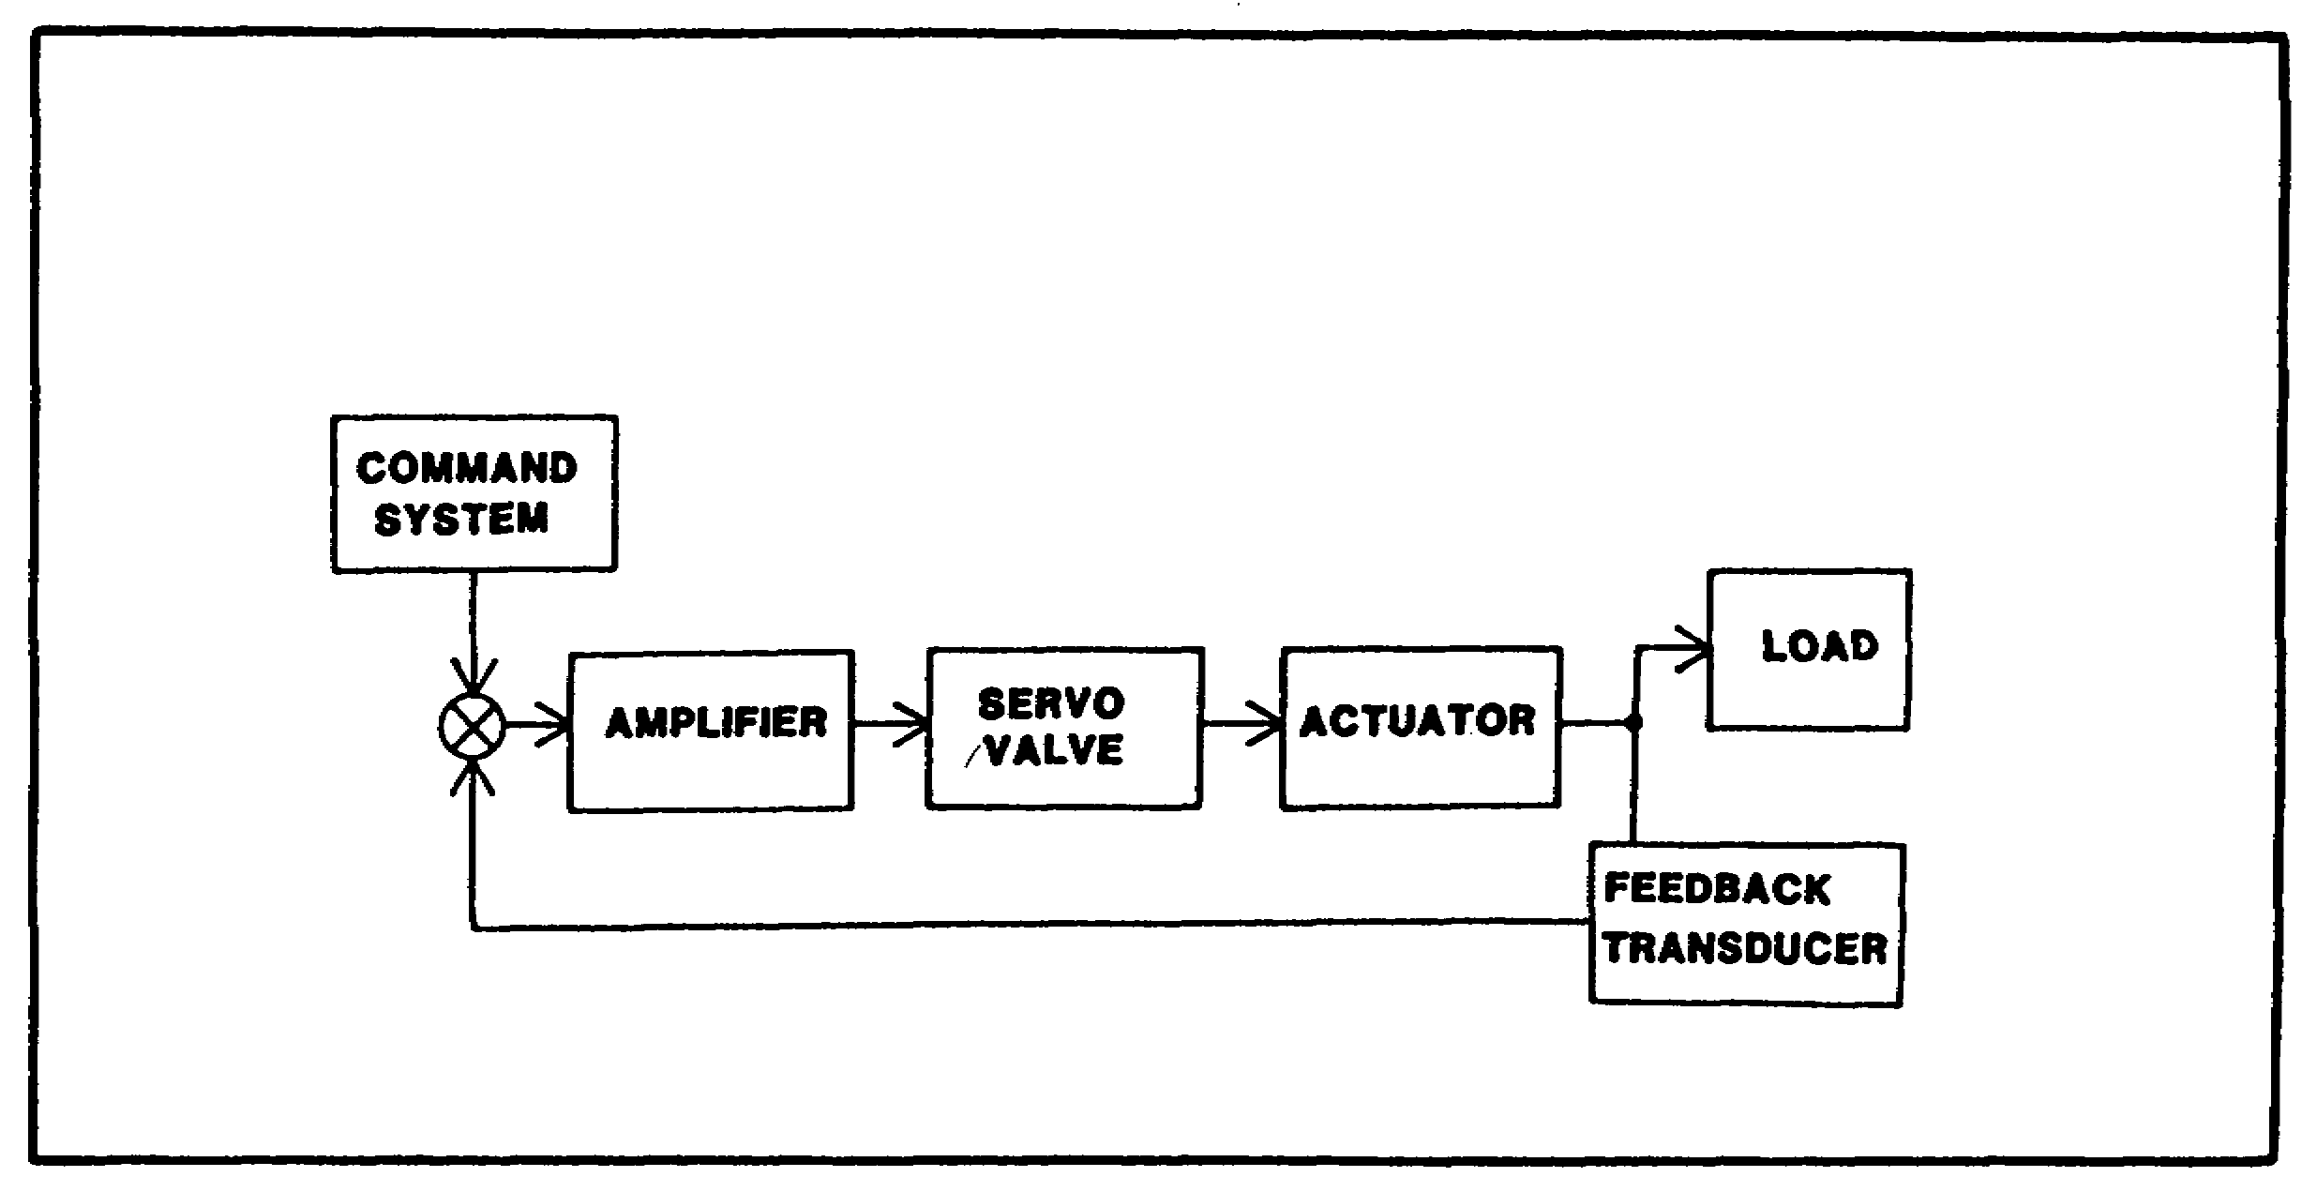

FIGURE 95. ELECTROHYDRAULIC SERVO SYSTEM.

110

PRINC. OF M1 HYDRAULICS - OD0475 - LESSON 2/TASK 2

a. Auxiliary Hydraulic Pump.

(1) The auxiliary hydraulic pump is used when the engine is not running and hydraulic pressure is needed. The auxiliary pump circuitry is an electrohydraulic servo system.

(2) The electric motor which drives the pump is enabled by the On/Off switch on the tank commander's panel. A hydraulic pressure sensor provides the feedback which determines the pump's operation.

(3) When system pressure drops to 1150 psi, the switch closes and the electric motor drives the pump (figure 96). After system pressure has increased to 1650 psi, the switch opens, removing power from the electric motor and shutting off the pump.

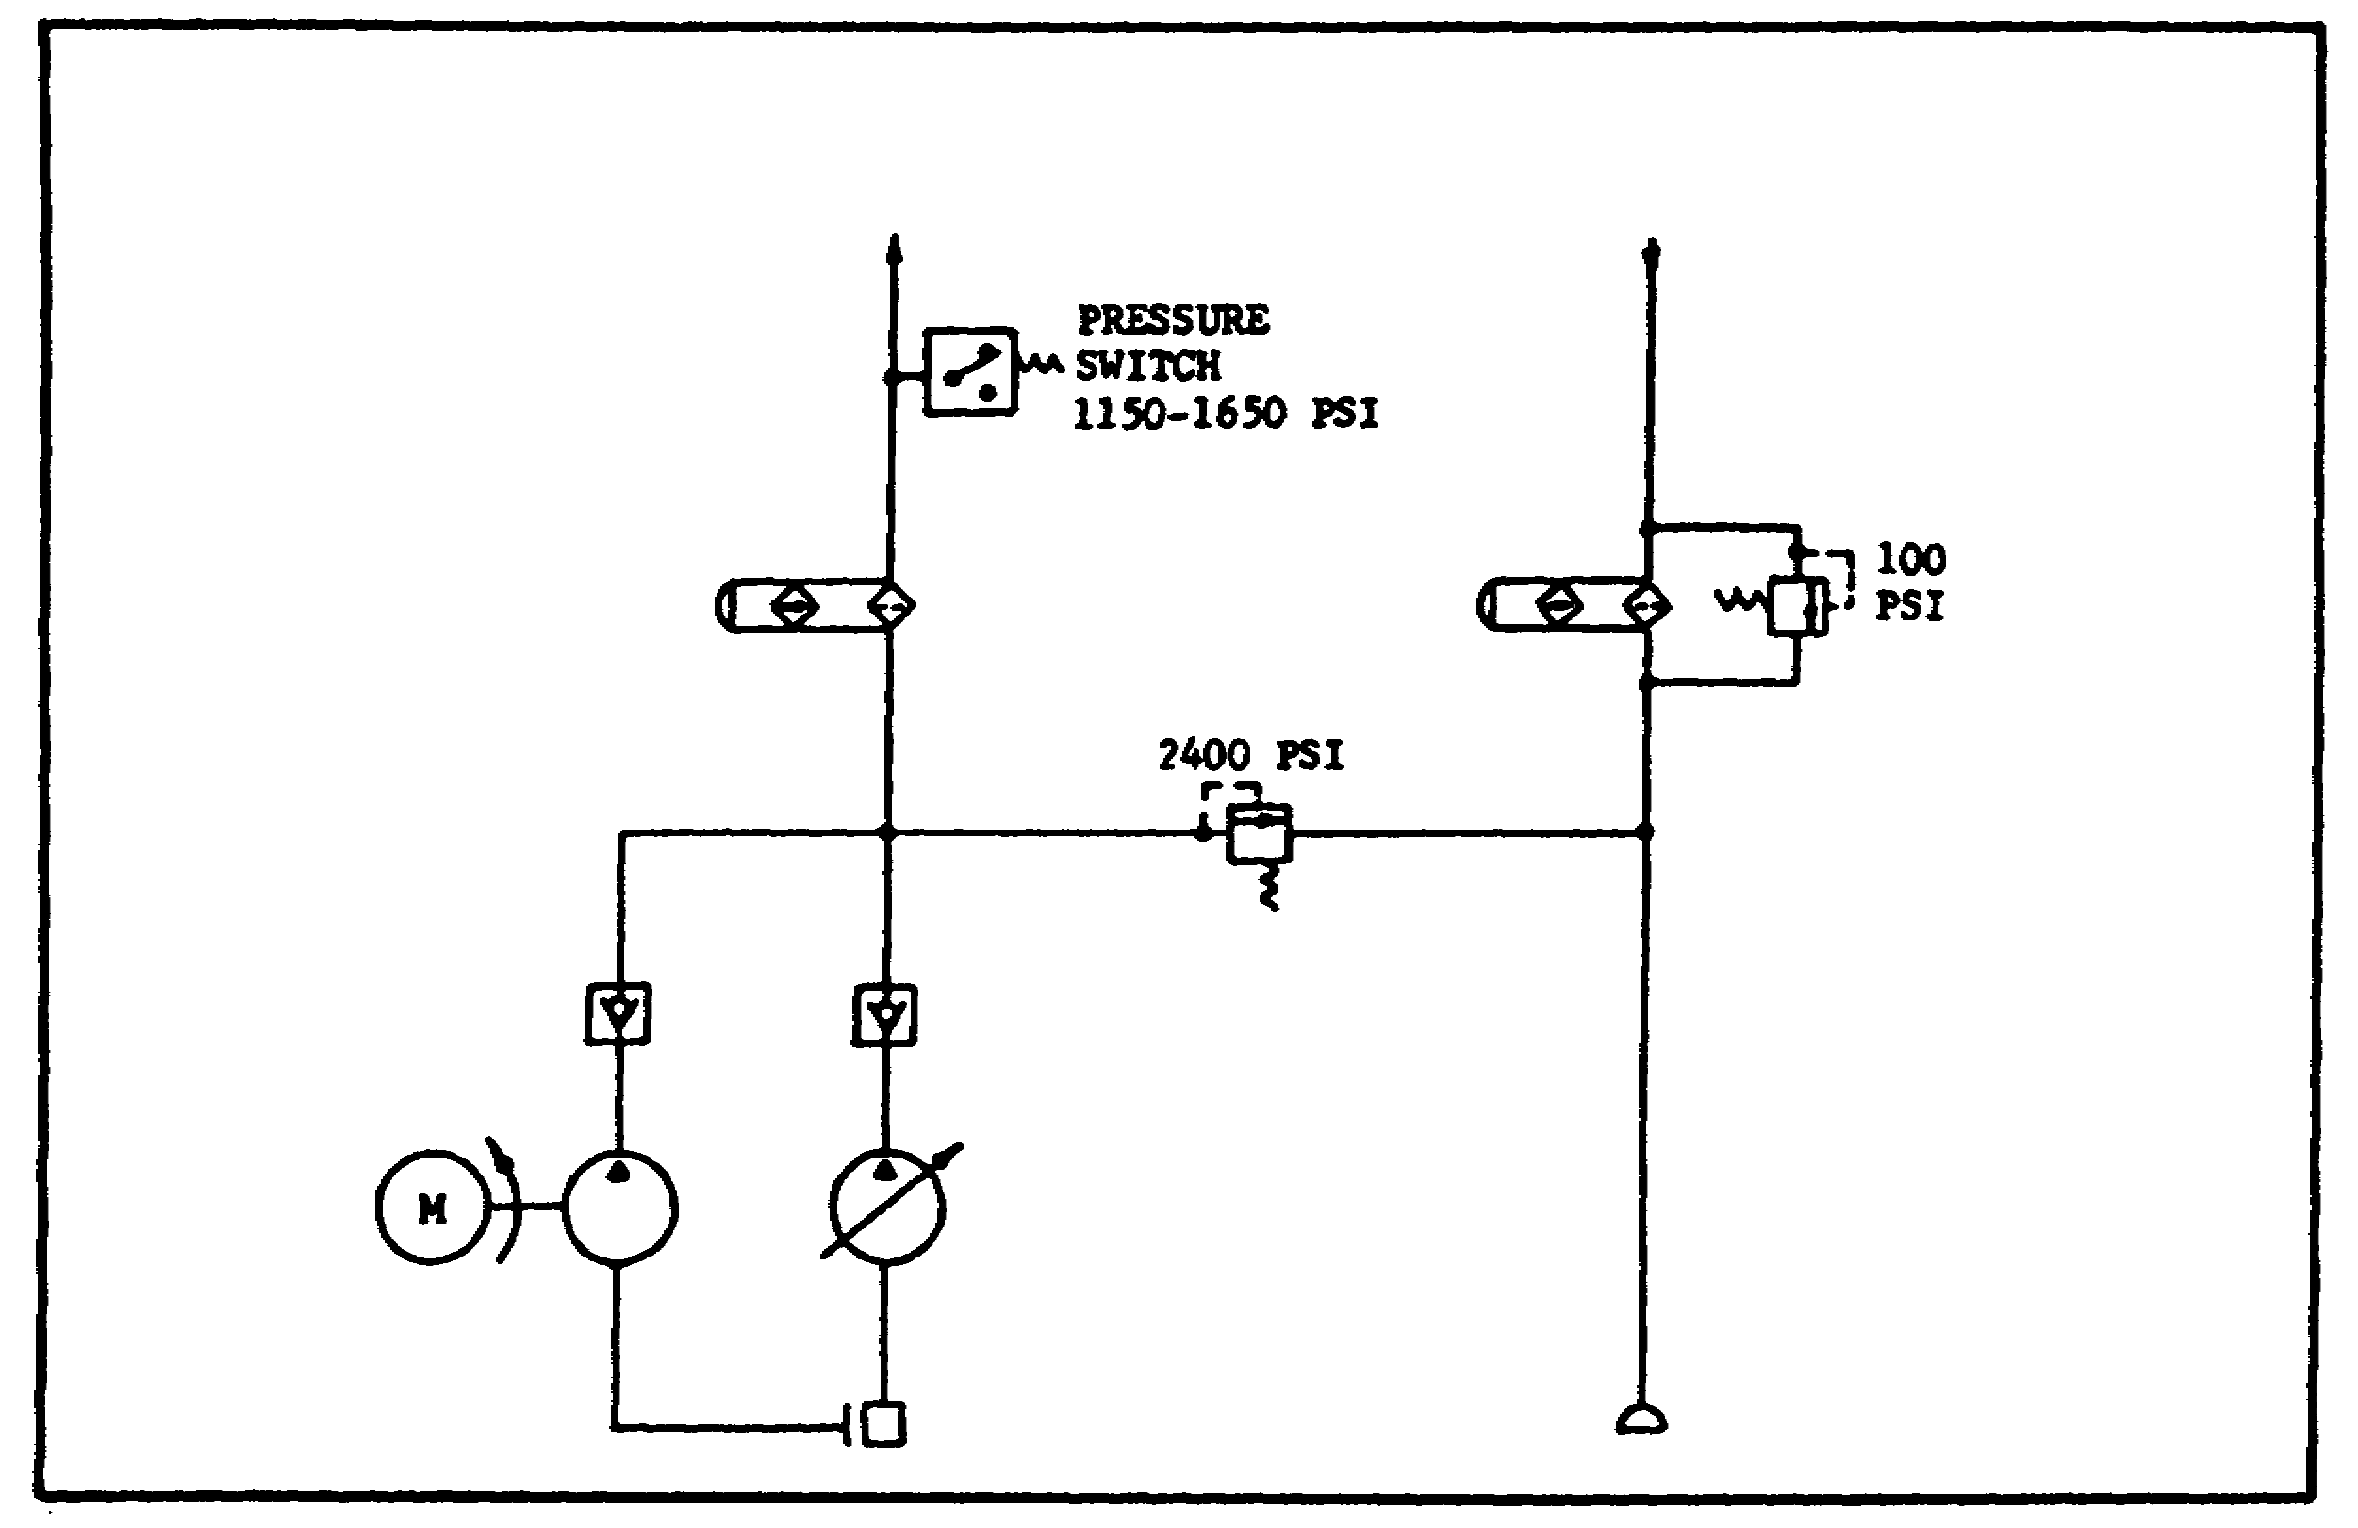
FIGURE 96. AUXILIARY HYDRAULICS.

b. Main Hydraulic Pump.

(1) The function of a hydraulic pump is to convert mechanical energy to fluid energy by pushing hydraulic fluid into the system.

111

PRINC. OF M1 HYDRAULICS - OD0475 - LESSON 2/TASK 2

(2) The main hydraulic pump is a pressure compensated variable displacement pump and is driven by the M1 turbine engine. It regulates around two output pressures: 300 psi and 1600 psi. (figure 97). The pump can supply fluid flow up to 47 gpm.
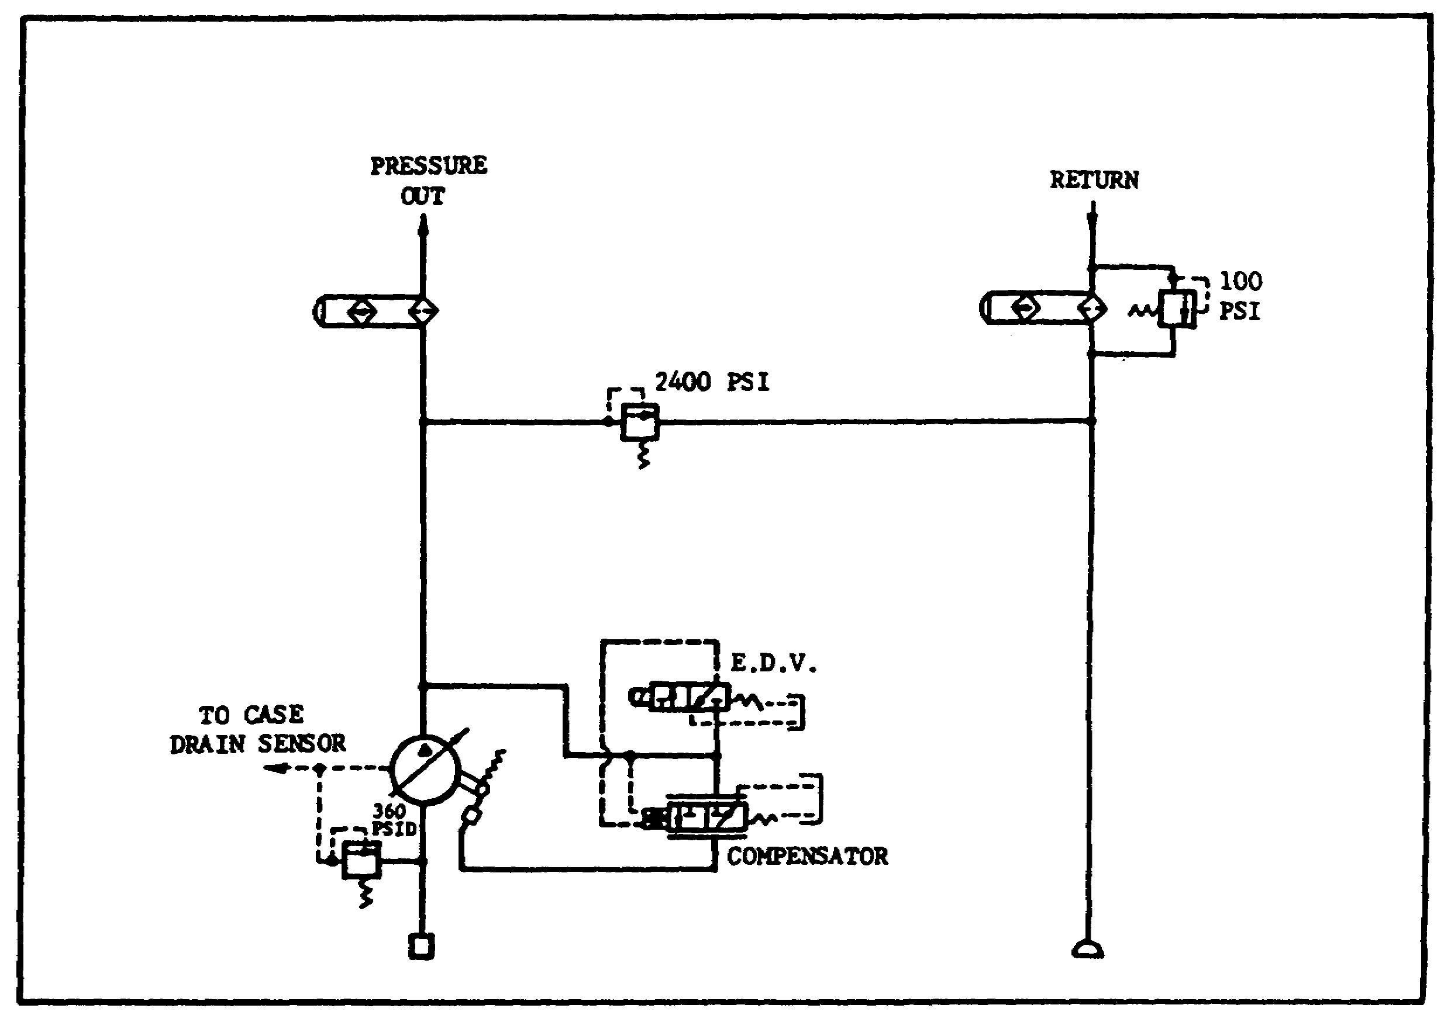

FIGURE 97. MAIN HYDRAULIC PUMP.

c. Variable Displacement Pump.

(1) System pressure is fed back to a valve inside the pump called the "compensator." As system pressure drops, the valve moves, reducing pilot pressure against the cylinder. As the cylinder moves to a more normal position (spring return), the wobble/swash plate moves in a greater angle. The pistons will, therefore, move to greater displacement causing an increase in output flow of hydraulic fluid.

(2) Operation.

(a) As system pressure increases, the valve moves to a more open position, which ports more hydraulic fluid into the pilot line. This causes

112

PRINC. OF M1 HYDRAULICS - OD0475 - LESSON 2/TASK 2

the cylinder to move the swash plate to a lesser (or zero degree) angle. The piston, therefore, moves to a lesser displacement and output flow decreases.

(b) When the engine is started, minimal load from the hydraulic pump is placed on the engine, due to the electrical depressurization valve (EDV).

(c) The EDV puts an artificial demand on the pump so that the compensator valve sees only 300 psi. The wobble plate will be caused to move to a minimal displacement. The pump and compensator will regulate around 300 psi, as long as the EDV solenoid is energized.

(d) During normal operation, the pump has three lines - input (suction), output (pressure), and case drain. Some of the fluid taken up by the pistons in the pump is allowed to move past the cylinders, the shaft, and around the inside of the pump, to keep it cool and lubricated. This fluid exits through the case drain outlet, goes through the hull hydraulic manifold, through the heat exchanger, and returns to the reservoir.

d. Case Drain (Dump Valve).
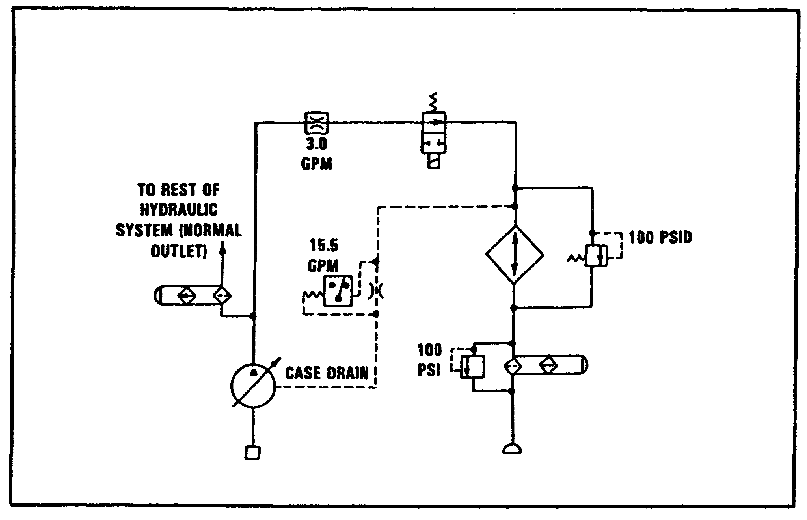

FIGURE 98. DUMP VALVE.

113

PRINC. OF M1 HYDRAULICS - OD0475 - LESSON 2/TASK 2

(1) A flow switch in the hull manifold monitors case drain flow. In the event that case drain drops to .15 gpm or less, the switch closes and a LED on the driver's instrument panel, called HYDRAULIC SYSTEM MALFUNCTION, will become illuminated. The dump valve is shown in figure 98 on previous page.

(2) When the MASTER POWER switch is turned ON, the energized solenoid moves the valve to a NO FLOW condition and remains there until the MASTER POWER switch is turned OFF.

(3) In the situation described above, when case drain drops below .15 gpm and the DIP LED comes on, the valve solenoid is deenergized and the valve moves to the flow condition. An alternate flow path for the hydraulic fluid being pumped out of the pump is now created. Instead of the fluid going out into the hydraulic system, it is diverted through the hull manifold, the heat exchanger, and directly back into the reservoir.

4. Basic M1 Turret Hydraulics -Component Function and Purpose

a. Ammo Door.
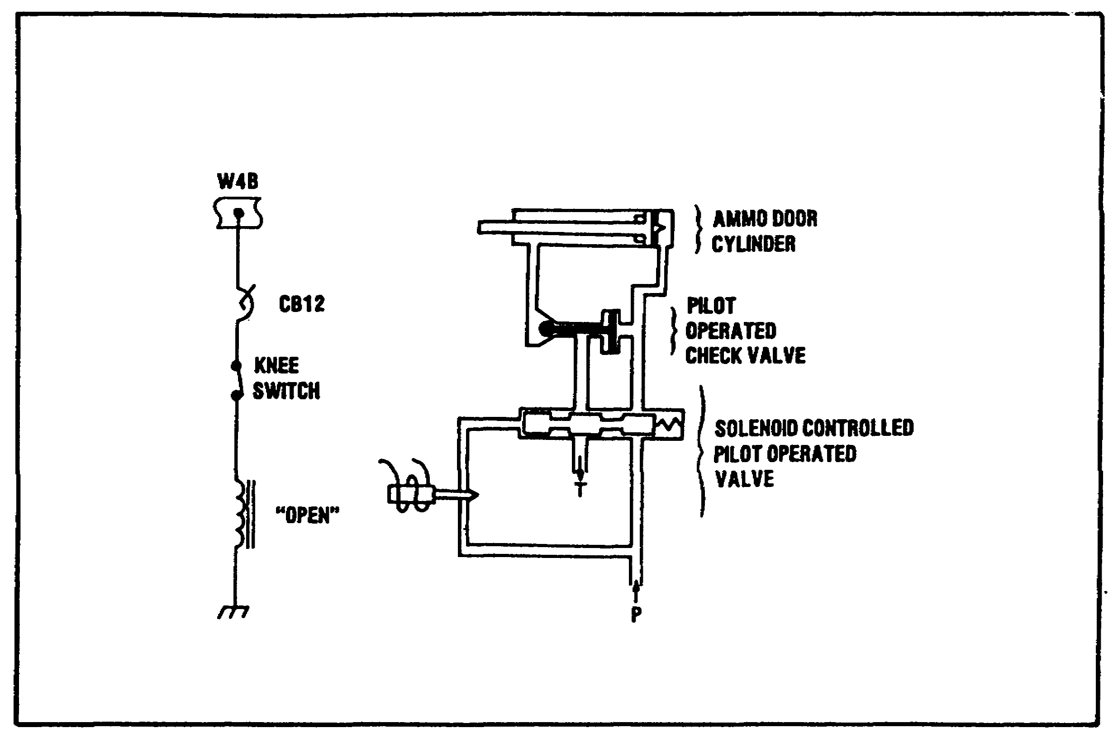

FIGURE 99. OPEN AMMO DOOR.

114

PRINC. OF M1 HYDRAULICS - OD0475 - LESSON 2/TASK 2

(1) Open Ammo Door (figure 99 on the previous page). When the knee switch is pushed, the solenoid is energized, which causes a needle valve to move (pilot stage). The hydraulic pressure in the pilot line causes the main stage (spool valve) to shuttle over. Hydraulic fluid is now ported to the ammo door's cylinder, causing it to extend, thereby opening the door. The door will remain open as long as the knee switch is pushed.
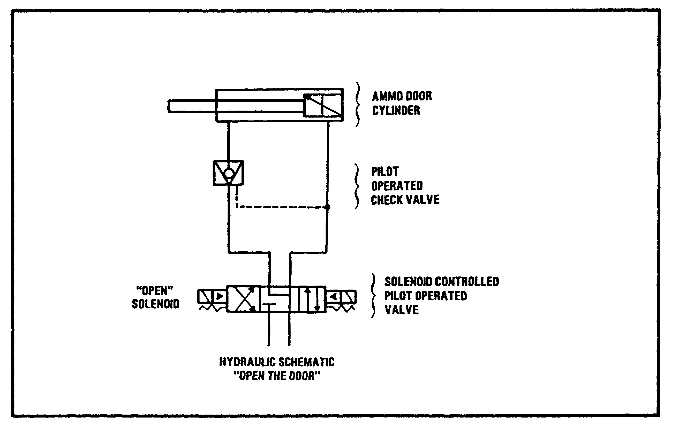

FIGURE 100. OPEN AMMO DOOR HYDRAULIC SCHEMATIC.

(2) Open Ammo Door Hydraulic Schematic (figure. 100). The pilot operated check valve allows the oil coming from the cylinder to drain to the reservoir, when hydraulic pressure is applied to both the valve and the cylinder. The flow of oil from that side of the cylinder is blocked at all other times.

(3) Close Ammo Door. When the knee switch is released, power is applied to the time delay. Two seconds later, the time delay allows K13 relay coil to be energized (figure 101 on the following page).

115

PRINC. OF M1 HYDRAULICS - OD0475 - LESSON 2/TASK 2

The normally open K13 relay contacts close, allowing another solenoid to energize, opening another needle valve. The hydraulic pressure in the pilot line causes the main valve (the spool valve) to shuttle. Hydraulic fluid is now ported to the other side of the cylinder, thereby closing the door.
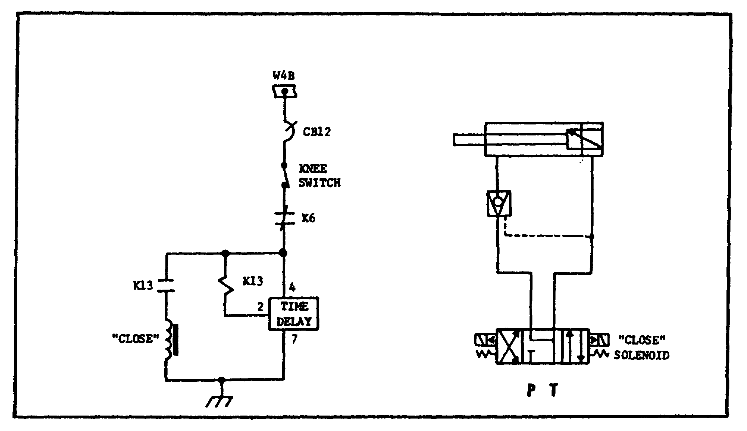

FIGURE 101. CLOSE AMMO DOOR.

b. Manual Elevation.

(1) The main gun is elevated by cranking the manual elevation handle in the following situations:

(a) Electrical power failure.

(b) Hydraulic power failure.

(c) When the GPS or loaders panel switches are set to manual mode.

(d) While elevating and depressing the gun in a shop, bay, or other enclosed area (safety).

(2) The gun is moved by cranking the manual elevation handle which, in turn, pumps the closed manual elevation hydraulics system. Cranking the handle in one direction pumps hydraulic fluid into

116

PRINC. OF M1 HYDRAULICS - OD0475 - LESSON 2/TASK 2
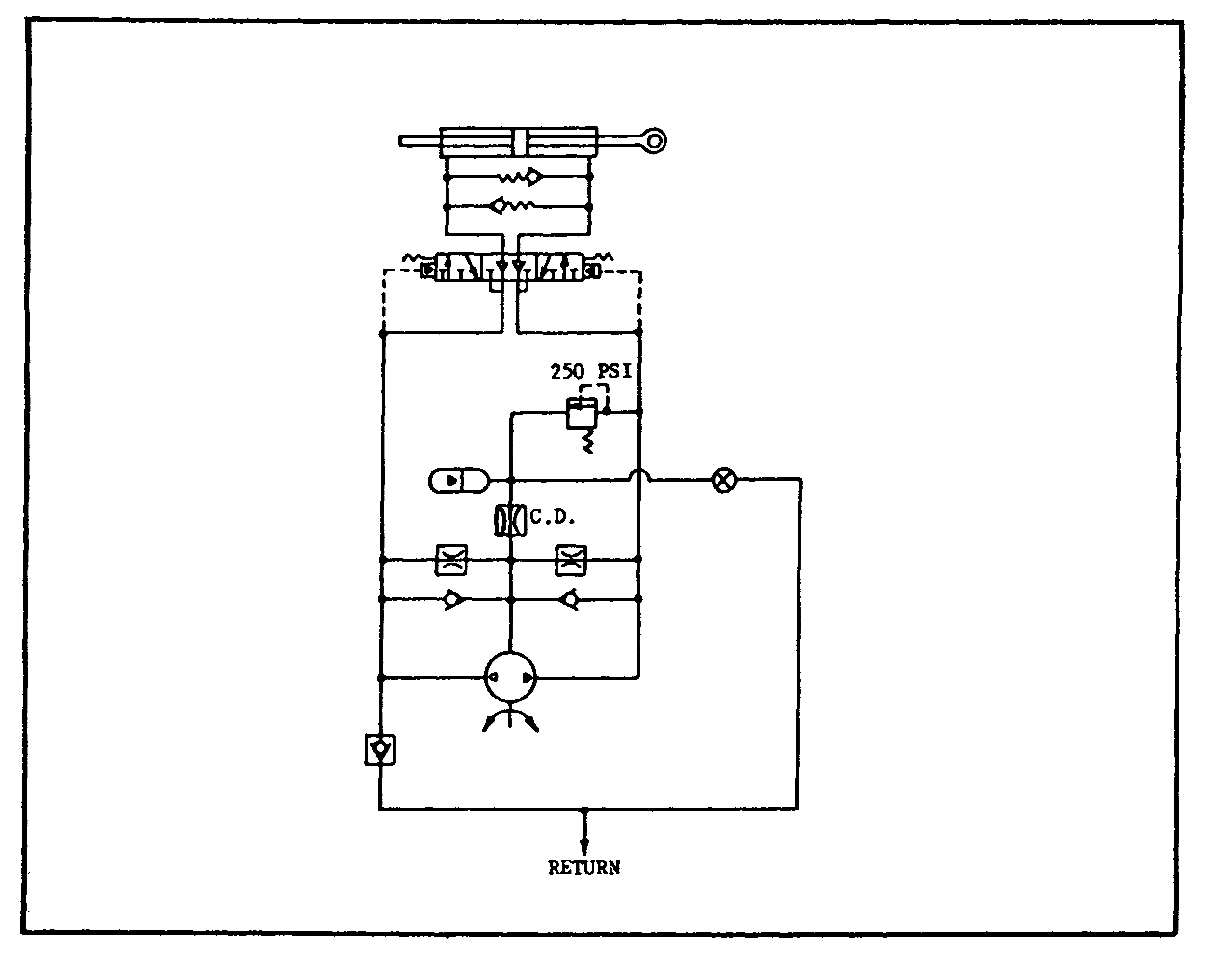

FIGURE 102. MANUAL ELEVATION.

one side of the main gun cylinder, causing it to elevate; cranking in the opposite direction pumps fluid to the other side of the cylinder, causing the gun to depress. Refer to figure 102.

(3) The check valves and orifices are internal to the pump construction. The orifices provide a case drain flow. The check valves allow pressure relief, in the event of an increase in case drain pressure.

(4) The accumulator assists the operator in manually pumping the hydraulics to raise and lower the gun, decreasing the effort exerted by the operator.

(5) During gun elevation, when the hydraulic pressure-from the pump increases above 250 psi, the pressure relief valve opens, allowing a flow of hydraulic fluid through to charge the manual elevation accumulator.

117

PRINC. OF M1 HYDRAULICS - OD0475 - LESSON 2/TASK 2

(6) The manual hand valve is normally closed. It is opened, when servicing is performed on the manual elevation hydraulics, to allow the fluid to drain out and return to the reservoir.

c. Elevation Circuit.

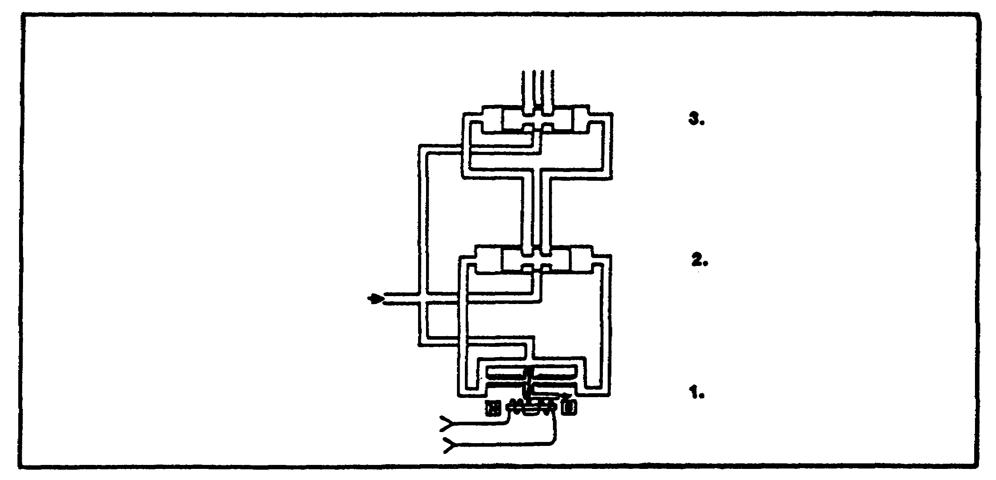
FIGURE 103. THREE STATE SERVO.

(1) The elevation system is an electrohydraulic servo system. The electrical/hydraulic conversion takes place in the elevation servo package, which contains the three state servo (figure 103).

(2) The first stage, or pilot state, is the double flapper valve. A line above and below the second and third stage valves indicates that they are multiple position valves.

(3) Feedback Transducers.

Feedback signals are provided by the linear variable differential transformer (LVDT) and the delta P (differential pressure) transducer (figure 104 on the next page). The LVDT is connected and driven by the third valve of the three-state servo. The two strain gauges of the delta P are in the two output lines of the three-stage servo.

118

PRINC. OF M1 HYDRAULICS - OD0475 - LESSON 2/TASK 2

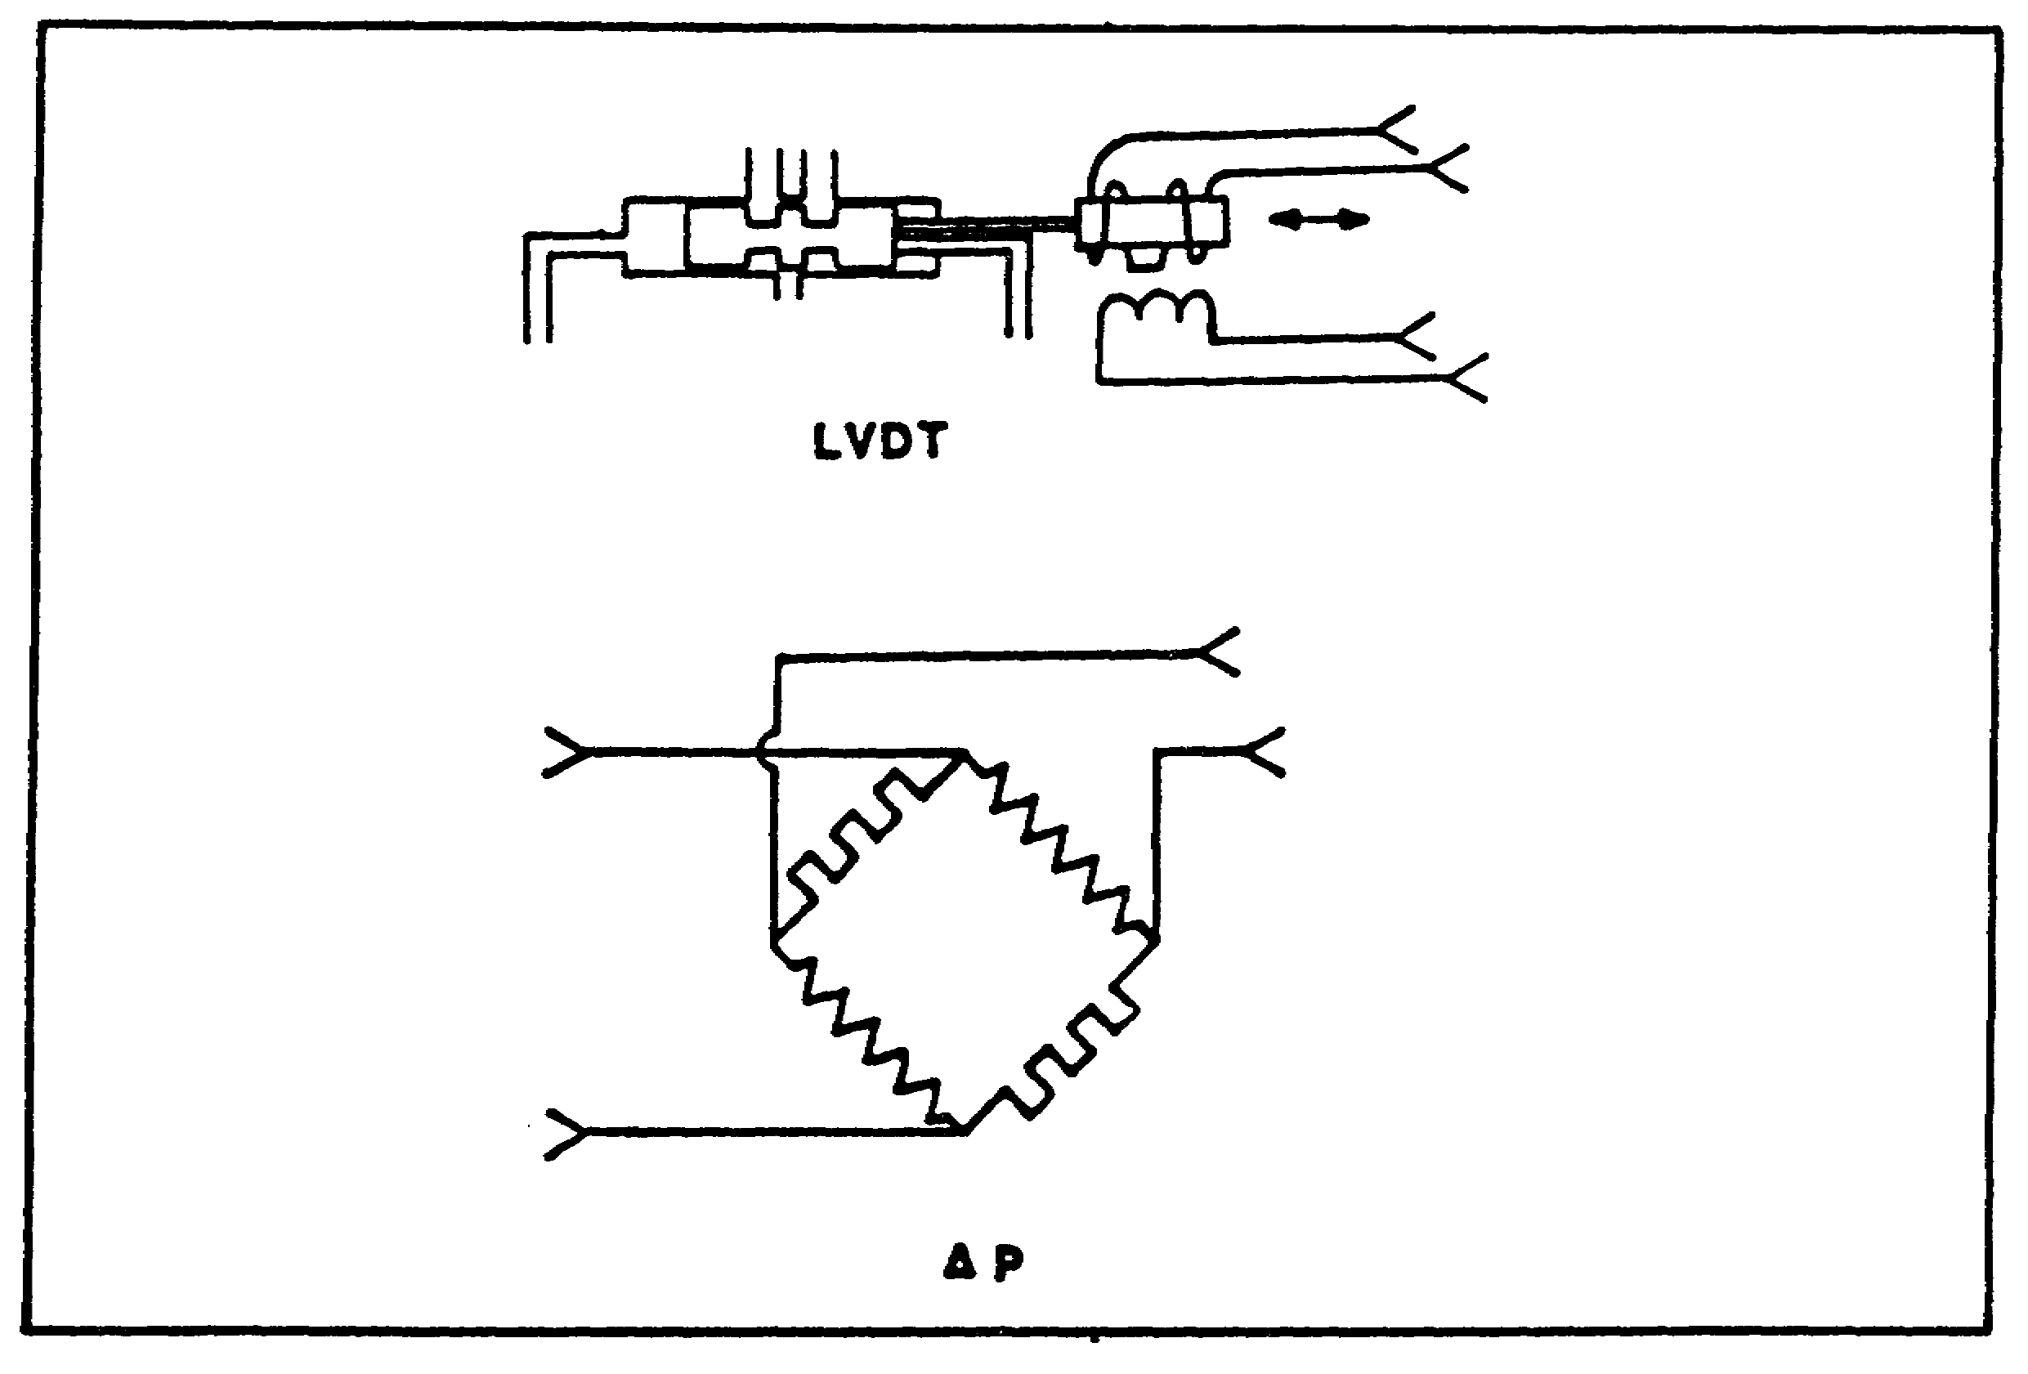
FIGURE 104. FEEDBACK TRANSDUCERS.

(4) Solenoid Controlled Pilot Operated Valve (Elevation).

Depressing the palm switches on the gunner's or commander's handles enables the elevation hydraulics. When the palm switch is depressed, an electrical signal energizes the solenoid of the needle valve. The hydraulic pressure in the pilot line then causes the next enabling valve to move. In turn, the hydraulic pressure in the next pilot line causes the final enabling valve to shuttle over.

(5) Elevation Enabling Valves.

With the enabling signal from the palm switch (the three enabling valves shuttling over) and a signal from the elevation LVDT in the handle (hydraulic fluid is then ported through the three-stage servo), one side of the elevation cylinder fills with fluid for main gun elevation, or the other side of the cylinder for depression (figure 105 on the following page).

119

PRINC. OF M1 HYDRAULICS - OD0475 - LESSON 2/TASK 2

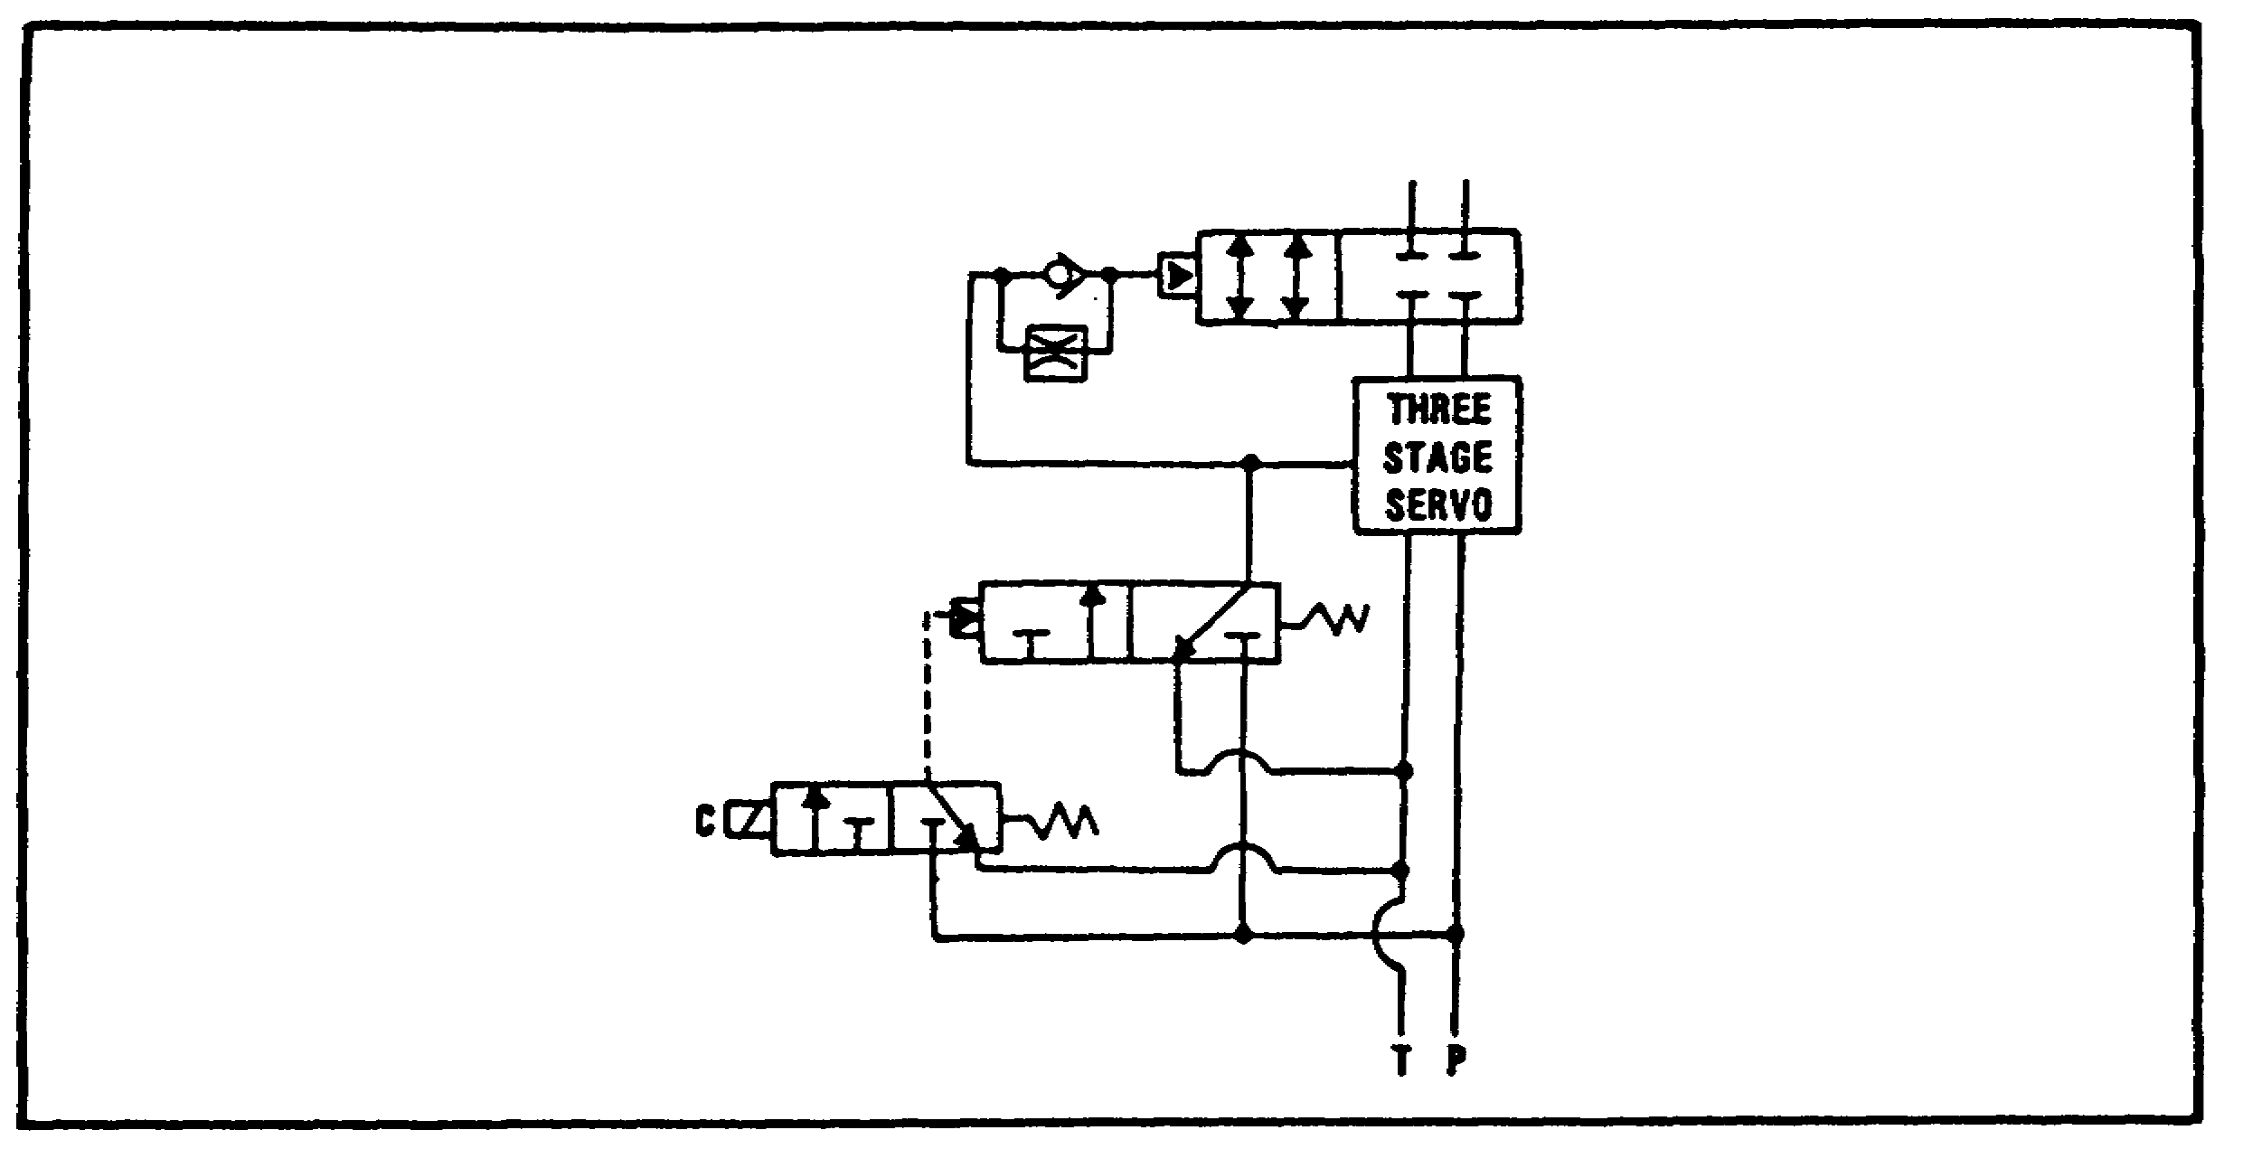
FIGURE 105. ELEVATION ENABLING VALVES.

(6) Elevation.

The relief valve in the return line inhibits drainage, unless the cylinder is actuated. The valve will open and regulate a flow when the pressure differential is 28-23 psid (pounds per square inch differential)(figure 106 on the following page).

120

PRINC. OF M1 HYDRAULICS - OD0475 - LESSON 2/TASK 2
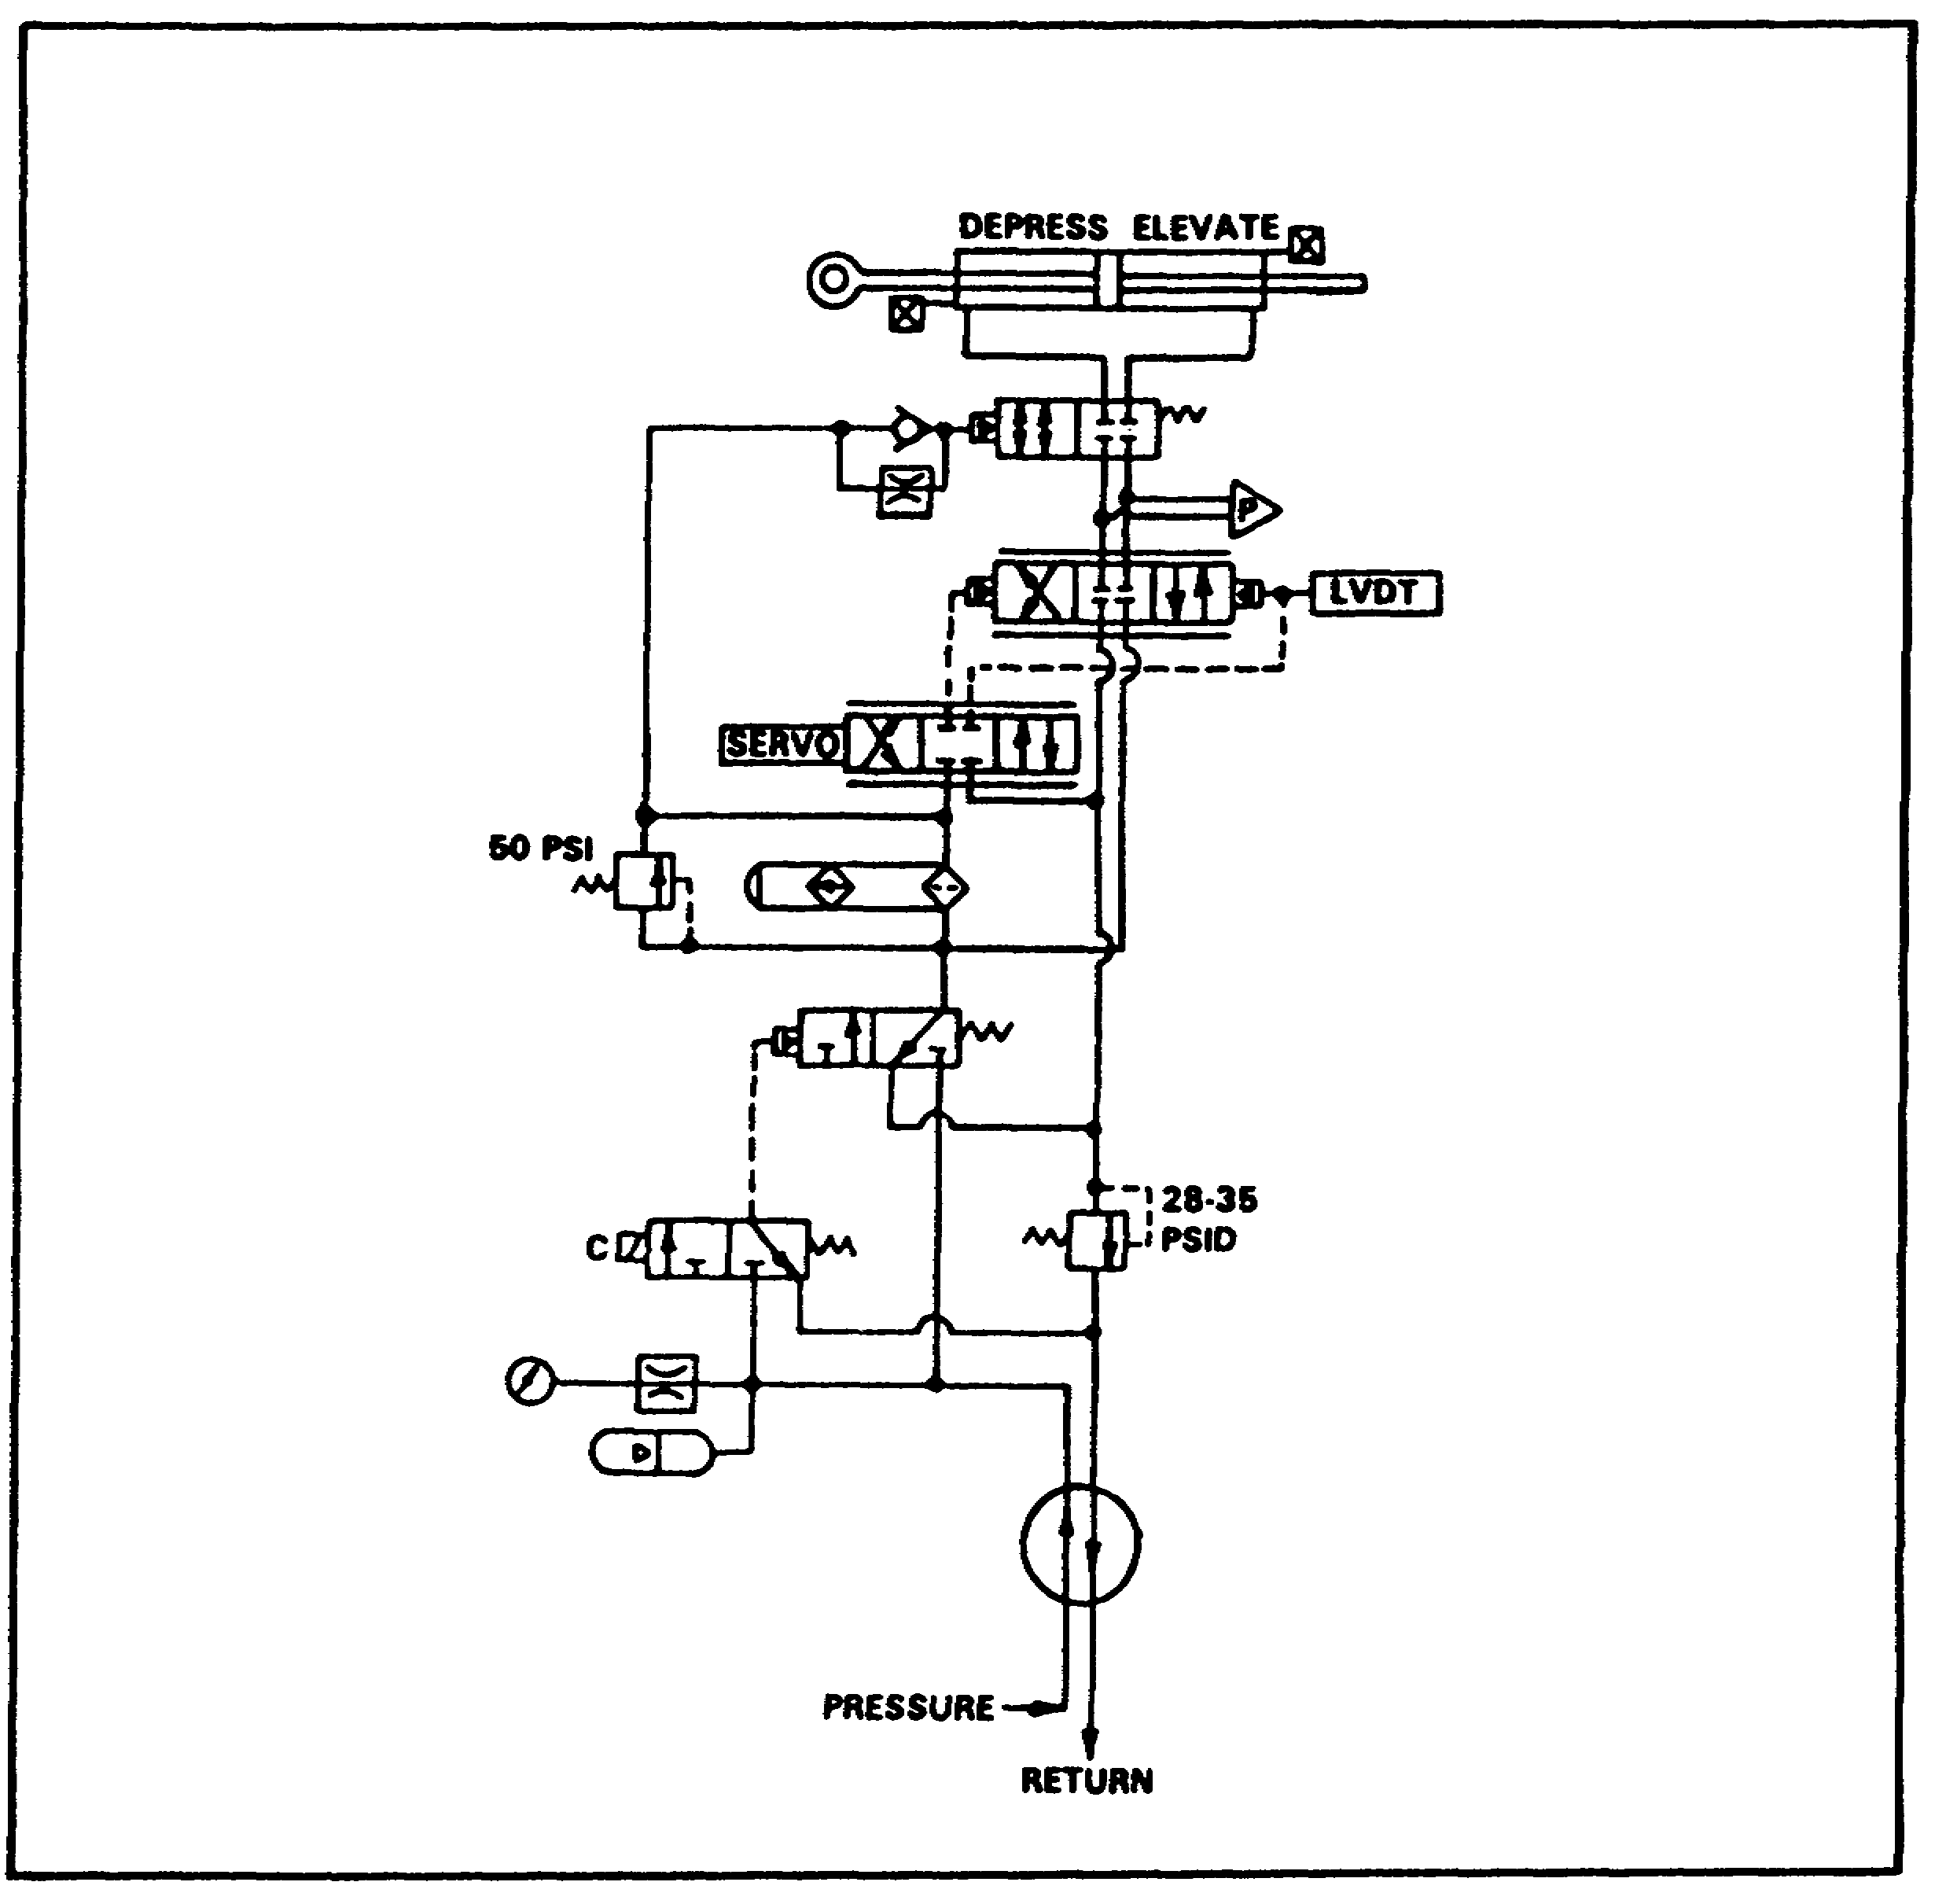

FIGURE 106. ELEVATION.

(7) Azimuth -Complete Circuit.

(a) The relief valve in the return line inhibits drainage, unless the azimuth motor is actuated (flow of oil through it). The valve will open and regulate a flow when the pressure differential is 28-35 psid (figure 107 on the following page).

121

PRINC. OF M1 HYDRAULICS - OD0475 - LESSON 2/TASK 2
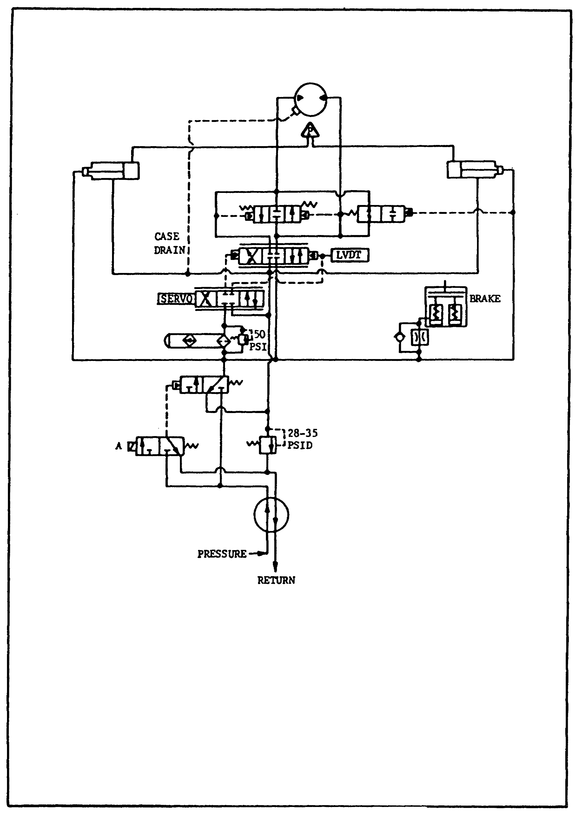

FIGURE 107. AZIMUTH - COMPLETE CIRCUIT.

122

PRINC. OF M1 HYDRAULICS - OD0475 - LESSON 2/PE 2

PRACTICAL EXERCISE 2

1. Instructions

Read the scenario and respond to the requirements that follow the scenario.

2. Scenario

You have been asked to teach a lesson on the M1 Abrams tank hydraulic system, to include the identification, location, and function of the various hydraulic components. When you finish writing the lesson, you hand it in to your supervisor, who has a very interesting way of validating it--he makes you take your own lesson. The questions which follow came from your posttest to the lesson.

3. First Requirement

Using your knowledge of the M1 Abrams hydraulic systems and this subcourse, prepare an answer sheet for the questions listed below, regarding M1 hydraulic components.

a. The M1 Abrams tank uses hydraulic pressure for two primary purposes, name them.

b. Briefly describe the type of main hydraulic pump used on the M1.

c. Name the hydraulic component that sits on top of the reservoir.

d. The component that is the interconnection point between the hull and turret for both electrical and hydraulic power is called what?

e. The elevation servo package contains several valves (stages). Name the number of valves contained in the servo package.

f. Identify where the hull distribution manifold is located.

123

PRINC. OF M1 HYDRAULICS - OD0475 - LESSON 2/PE 2

4. Second Requirement

Using your knowledge of the M1 hydraulic system and this subcourse, prepare an answer sheet for the questions regarding the function and operation of M1 hydraulic system components.

a. Describe the purpose of the air bleed valve.

b. At what pressure is the pressure relief valve set to open?

c. Name the component that drives the auxiliary hydraulic pump.

d. Describe the function of the main hydraulic pump.

e. The elevation system uses what type of servo system?

f. Describe what transpires when the gunner's or commander's palm switches are depressed.

124

PRINC. OF M1 HYDRAULICS - OD0475 - LESSON 2/PE 2

LESSON 2. PRACTICAL EXERCISE - ANSWERS

1. First Requirement

a. (1) Elevating the main gun.
(2) Move the turret in azimuth.

b. The main hydraulic pump used with the M1 is a variable displacement pressure compensated pump.

c. The reservoir manifold.

d. The slipring.

e. Three.

f. On the hull floor.

2. Second Requirement

a. The air bleed valve allows hydraulic fluid containing air to return to the reservoir where air is allowed to escape.

b. 1900 psi.

c. An electric motor.

d. The main hydraulic pump is to connect mechanical energy to fluid energy by pushing hydraulic energy into the system.

e. Electrohydraulic.

f. When the palm switch is depressed, an electrical signal energizes the solenoid of the needle valve. The hydraulic pressure in the pilot line then causes the next enabling valve to move.

125

PRINC. OF M1 HYDRAULICS - OD0475 - REFERENCES

REFERENCES

126

PRINC. OF M1 HYDRAULICS - OD0475 - REFERENCES

REFERENCES

The following documents were used as resource materials in developing this subcourse:

TM 5-350
TM 9-2350-255-10-1
TM 9-2350-255-20-2-2-1

127

